Geography
History- Vehicles
By the end of this unit children will know...

Vocabulary

Year 1 Summer 2 – By the Seaside

To develop an awareness of the past, using common words and phrases relating to the passing of time.
To use a wide vocabulary of everyday historical terms.
To ask and answer questions.
To understand some of the ways in which we find out about the past and identify different ways in which it is represented.
To understand some basic that’s that transport has developed over time.
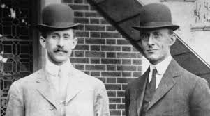

Transport, past, present, electric, steam, famous, aeroplane, rocket, design.

Intention

In this unit children will learn how transport has developed over time. The will learn about historical figures Thomas slavery, the Wright Brothers and Neil Armstrong.

Previous Learning
In Reception the children explored the history of bikes.

History- Vehicles
Key Objectives  Key Objectives  - To be able to observe or handle evidence to ask questions and find answers to questions about the past.  - To use artefacts, pictures, stories, online sources and databases to find out about the past.  - To be able to describe significant people from the past.  - To use words and phrases such as: a long time ago  - To know how to ask and answer questions about old and new objects.  - To know how to spot old and new things in a picture. | Lesson 1  How has Transport developed over time?  To identify whether transport is from the past or present.  Teaching:  Create KWL grid to show what children already know about Transport and how it has changed over time. Discuss questions they will want to ask.  Introduce children to our new topic and explain that today we will be looking at the all different types of transport and when each area of transport was created.  Discuss how transport has changed over time (use the ppt) and discuss dates using vocabulary including a long time ago.  https://www.youtube.com/watch?v=FaLCQo8NJFA&t=71s  Travel and transport | KS1 topics | BBC Teach - YouTube  Activities:  Reds-  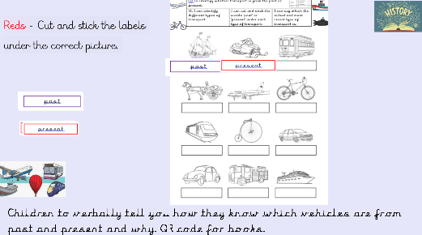  Yellows, Greens, Blues  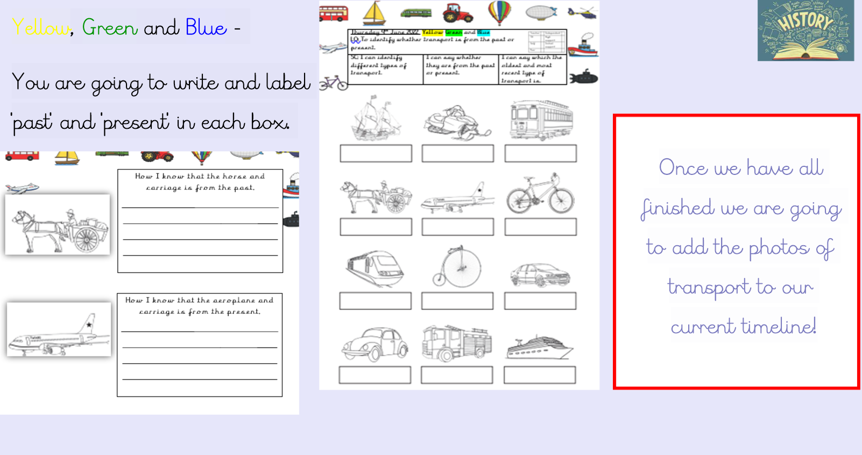  Plenary:  Take children to the school time line. What can we spot that is connected to the history of transport? |  | Lesson 2  How have trains changed over time?  To be able to describe significant people from the past. To learn about the inventors Tomas Savery and George Stephenson.  Teaching:  Recap what we have learnt so far by adding to the KWL grid.  youtube.com/watch?v=FaLCQo8NJFA&t=71s  Introduce Tomas Savery, ask the children if they know who he is? Explain to the children he created the first steam train. Go through ppt and discuss Thomas Savery – Send children to complete fact file about him and his work. Provide Students with sources on their table to use.  Bring children back to the carpet and continue through ppt, Introduce George Stephenson, ask the children if they know who he is? Explain to the children he created the first locomotive train. Go through ppt and discuss George Stephenson – send children to complete fact file about him and his work. Provide Students with sources on their table to use.  Look at how trains have changed over the years.  Activities:  Children to create fact files about Thomas Savery and George Stephenson.  Blue and Green, create fact file and draw pictures.  Yellow to write sentences about the pictures on the fact file sheet.  Red to write key words and match sentences to pictures.  Extra Activities:  Colour in the pictures of the inventors.  Plenary:  Children to present their fact file to the class. QR code for books. | Lesson 3  What is the history of flight and who were The Wright Brothers?  To be able to describe significant people from the past. To learn about the inventors The Wright Brothers.  Teaching:  Recap what we have learnt so far. Ask the children what they think of when they hear the word airplanes? Watch the video https://www.bbc.co.uk/bitesize/clips/zdm6n39  and discuss what they have seen. Do they recognise planes like that today? How are they different? Introduce the wright brothers and explain they invented the first ever plane. Go through ppt.  Activities:  Write a fact file about the Wright Brothers. Provide Students with sources on their table to use.  Blue and Green to write full sentences.  Yellow, write key facts about The wright brothers.  Red copy facts about the wright brothers. Label the planes.  Extra Activities:  Children design their own plane.  Make their own paper aeroplane.  Plenary:  Take children to the school time line. Can we find the Wright Brothers?
Lesson 4
What are rockets and who was Neil Armstrong?

To be able to describe significant people from the past. To learn about Neil Armstrong. To design my own mode of transport using the information I have learnt this half term.
Teaching:
Recap what we have learnt so far. Ask the children what they think of when they hear the word rocket? Go through ppt. and show children different types of rockets. Introduce Neil Armstrong, who was he and what did he do?

Drama- How would you walk if you had landed on the moon?
Activities:
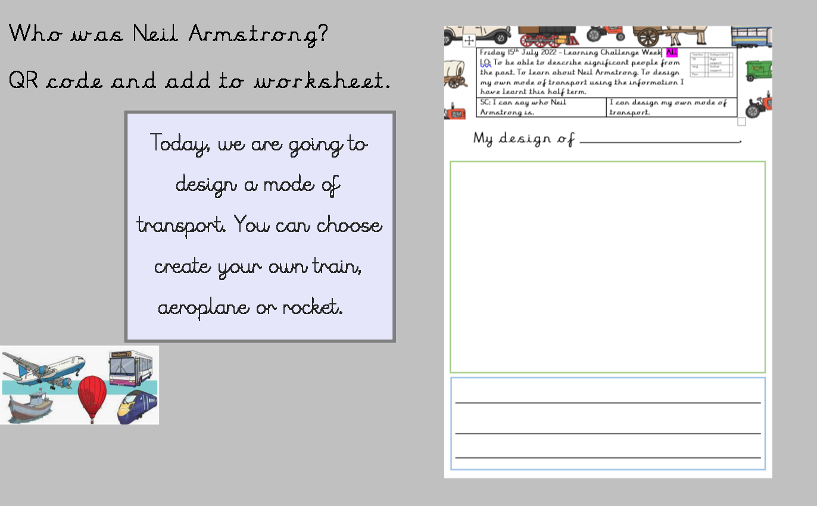
Extra Activities:
Children create transport poster.
Plenary:
What have children learnt? Finish off KWL grid.
Learning Challenge Week
Design Technology: to design their own transport using the different ideas learnt within the topic. Children will design, create and then evaluate making their vehicle move to link to Mechanisms, Wheels and axles.
Cross curricular links  Art – Creating a transport Poster  English – Creating fact files and research inventors. |  | Through this unit of work the following essential skills will be developed:  English  - Listen and respond appropriately to adults and their peers  - Ask relevant questions to extend their understanding and knowledge  - Give well-structured descriptions and explanations for different purposes, including for expressing feelings.  - Speak audibly and fluently with an increasing command of Standard English.  - Participate in discussions and presentations.  Art  - To use a range of materials creatively to design and make products.  Design Technology  - To create a vehicle which has moving wheels and axles.
Assessment
History
- I can use words and phrases like old, new and a long time ago.
- I can observe or handle evidence to ask questions and find answers to questions about the past.
- I can use artefacts, pictures, stories, online sources and databases to find out about the past.
- I can describe significant people from the past.
- I can how to ask and answer questions about old and new objects.
- I can spot old and new things in a picture.

