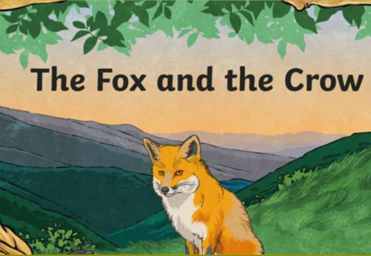
The Fox and the Crow
In this unit we will discover what a fable is and discuss fables we know. We will read the fable ‘The Fox and the Crow’ and discuss the answers to a range of questions about this fable.
Key Objectives:  • To retrieve information from a text.  • To develop pleasure in reading, motivation to read, vocabulary and understanding by listening to and discussing a wide range of stories. | Lesson 1  L.O- To retrieve information from a text.  S.C- I know what is special about a fable. I can answer questions about 'The Fox and the Crow’.  Show the children the front cover of ‘The Fox and the Crow’. Explain this is a special type of story called a fable. Read the fable.  Discuss- Have you heard of any other fables? Show the children other fables and discuss if they have ever heard of any of them.  Read a page at a time. Discuss questions on notebook about each page. Suggest ways to improve children’s answers if further information is needed.  Children to have sections of the text to read and questions to answer based on what they have read. | Lesson 2  L.O- To retrieve information from a text.  S.C- I know what is special about a fable. I can answer questions about 'The Fox and the crow.  Recap- What can you remember about the fable? What is a fable?  Re-read fable.  Read a page at a time. Discuss questions on notebook about each page. Suggest ways to improve children’s answers if further information is needed.  Children to have sections of the text to read and questions to answer based on what they have read.  Children to have sections of the text to read and questions to answer based on what they have read. Then children to have pictures from the text to cut and stick in the correct order to re-tell the fable.
Through this unit of work the following essential skills will be developed:

Literacy
- Discussing word meanings, linking new meanings to those already known.
- Drawing on what they already know or on background information and vocabulary provided by the teacher.
- Participate in discussion about what is read to them, taking turns and listening to what others say.
- Explain clearly their understanding of what is read to them.

Assessment
Speaking and Listening
- I speak clearly and confidently in front of my class.
- Reading
- I can use what I already know to understand texts.
- I can develop pleasure in reading, motivation to read, vocabulary and understanding by listening to and discussing stories.
- Writing
- I can sit correctly at a table, holding a pencil comfortable and correctly. I can form lower case letters in the correct direction, starting and finishing in the right place. I can form capital letters and digits 0-9. I can compose a sentence orally before writing it. I can re-read what I have written to check that it makes sense. I leave spaces between words. I can combine words to make a sentence. I can separate words using finger spaces. I can use capital letters to start a sentence. I can use a full stop to end a sentence

