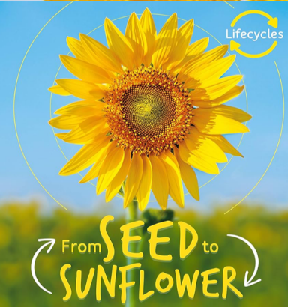
From Seed to Sunflower
In this unit we will discover and learn new vocabulary and ensure we can use these words in sentences correctly. We will read
non-fiction text and answer retrieval questions about what we have read.
Key Objectives:  To answer questions about a non-fiction text.  To learn new vocabulary and use it in sentences. | Lesson 1  L.O- To learn about a sunflower seed.  S.C- I know what the word protects mean.  Show the children the front cover of the book. Discuss- What type of book is this? (Non-fiction) What does non-fiction mean?  What do you think this book is going to be about? Encourage children to look at the picture and the title.  Show children a sunflower seed. Discuss- What do you think this is?  Show the children pages 6 and 7. Read these pages several times. Ask children questions to show comprehension:  What is the story of how a seed grows into a plant called?  How many stages are there in a sunflower life cycle? What are they?  How big is a sunflower seed?  Does it surprise you that sunflowers grow so tall?  Sit in a circle and pass a sunflower seed around. Ask children to share words that describe the seed. Make sure the word hard is used. Discuss-Why is the seed hard? Explain that it is hard to protect the embryo and that we will learn more about it tomorrow.  What does the word protects mean?  Share the sentence- The seed is protected by a hard shell. Discuss- What protects us? Children share ideas and then show photos (plaster, seat belt, oven glove, cast, goggles and cycle helmet) To give further ideas.  Recap- What does protect mean?  Children to write a sentence to describe what protect means. Draw things that protect us. Then write a sentence to describe how seeds are protected. | Lesson 2  L.O- To learn about the first stage of a  sunflower growing.  S.C- I know what the word embryo means.  Recap- Give the children a small piece of paper.  Ask the children to write on it what the word protects means and describe how a seed is protected.  Show the children pages 8 and 9. Read these pages several times. Ask children questions to show comprehension:  What does the seed contain? What does a sunflower seed look like? What is an avocado seed called? Can you describe an avocado? Where do avocados grow?  Read the following text:  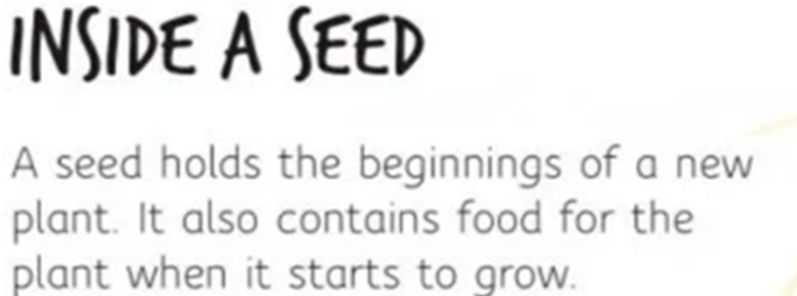  Explain that this is called an embryo.  Look again at the seeds. Discuss- How can we  describe the seeds in relation to their  size? So if the seed is tiny, what  else is tiny? The embryo. What is an embryo?  Watch to find out more:  https://youtu.be/tkFPyue5X3Q  Ask children to share words that describe the embryo. Make sure the word tiny is used.  What other things are tiny?  (Compare to the size of the sunflower seed.)  On sheet children write the answer to:  How can we describe the size of an embryo?  Children to draw other thing that are tiny. | Lesson 3  L.O- To learn about the first stage of a  sunflower growing.  S.C- I understand that a seed splits open.  Recap- What does protect mean?  What size is an embryo?  Read pages 4-11. Look closely at pages 10 and 11. Look at the picture of the seed splitting. Discuss- What is happening here?  Tell the children seed splits open for the shoot to come out.  Discuss- What else splits open? Show the children photos of a banana, melon and conker splitting open to give further ideas. Discuss- What does splits mean?  Children to draw and label a seed splitting. Write sentences to explain what happens when a seed starts to grow and what happens when the seed splits. Ask the children to use the information from the text to draw what happens next.
Cross curricular links  Science – Plants |  | Through this unit of work the following essential skills will be developed:  Literacy  - Discussing word meanings, linking new meanings to those already known.  - Drawing on what they already know or on background information and vocabulary provided by the teacher.  - Participate in discussion about what is read to them, taking turns and listening to what others say.  - Explain clearly their understanding of what is read to them.
Assessment
Speaking and Listening
- I speak clearly and confidently in front of my class.
- Reading
- I can use what I already know to understand texts.
- I can develop pleasure in reading, motivation to read, vocabulary and understanding by listening to and discussing non-fiction.
- Writing
- I can sit correctly at a table, holding a pencil comfortable and correctly. I can form lower case letters in the correct direction, starting and finishing in the right place. I can form capital letters and digits 0-9. I can compose a sentence orally before writing it. I can re-read what I have written to check that it makes sense. I leave spaces between words. I can combine words to make a sentence. I can separate words using finger spaces. I can use capital letters to start a sentence. I can use a full stop to end a sentence

