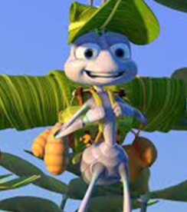
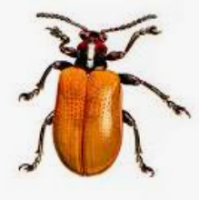
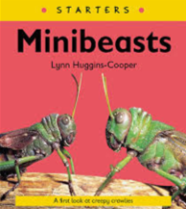

Summer 1 On Safari: Mini beast, bugs or invertebrates?

Essential Knowledge

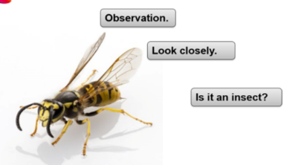
By the end of this term, children will demonstrate independently how to...

- Describe and invertebrate.
- Build a bug hotel.
- Categorise mini beasts.
- Explore, find and discover mini beasts in the local environment.
- Use simply equipment for the above.
- Speak about how humans are similar and different to invertebrates.
- Speak about how mini beasts in the UK are different to mini beasts in Africa.
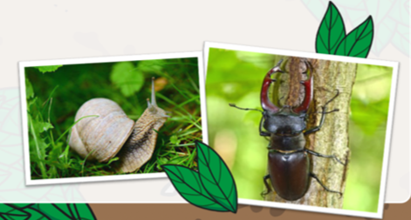
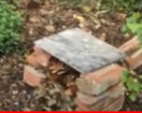

Mini beast, Bugs or Invertebrates?

Vocabulary

Invertebrate, Minibeast, Bug, equipment, insect, antenna, arachnid, Mollusk, arthropods, ant, beetle, ladybird, spider, butterfly, dragonfly, grasshopper.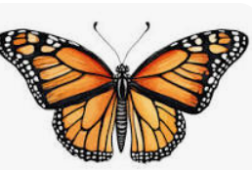
For Summer 1 Science the children will be learning about ‘Minibeast, bug or invertebrate?’ The topic will teach the children what scientific in equipment is needed to hunt for minibeasts; by packing a bag. They will learn to build a bug hotel to attract more minibeast to our school environment. The children will learn the different categories of invertebrates and classify minibeasts found in the school environment. They will then explore how humans actually share some similarities with invertebrates by researching using laptops, non-fiction books and iPads. We will bring together our English learning of ‘The Ugly Five’ by comparing UK invertebrates with African invertebrates. Finally, we will evaluate our Bug Hotels to encourage even more wildlife to the school. The topic offers lots of hand on experiences to engage the children.

In Summer 2 of Reception the children learnt about ‘Marvellous Minibeasts’ and went on a minibeast hunt around the school grounds. Also in Reception, the children looked at different animal habitats, as part of their ‘Spring is Sprung’ topic. In Year 1, the children learnt about plants and animals and how to complete a tally chart when they were bird watching.

Mini beast, Bugs or Invertebrates? – Previous Learning

Learning Links
This unit looks at collecting and handling data about minibeasts. The children will also be handling data as part of their computing unit, Data Handling: An Introduction to Data. This unit builds on children’s previous scientific learning by revisiting key science skills such as observing closely, identifying, classifying, gathering and recording data to answer questions. In Reception and earlier in Year 1, children explored the natural world through observing animals, comparing quantities and noticing simple patterns—foundations that directly support data handling. Throughout this sequence, the children will extend this prior knowledge by collecting real-world data from a minibeast hunt, classifying creatures using observable features and using their observations to suggest answers to questions, as required in the National Curriculum for Science. As children begin to represent information —through pictograms, tally charts, tables and branching databases—they build on their earlier scientific experiences of sorting, grouping, and comparing animals. This unit therefore strengthens essential scientific enquiry while developing recording, representing and interpreting data. This aligns with KS1 expectations that children should be able to identify and name animals, compare their structures, sort them into groups and use simple data to answer questions.

Minibeasts, Bugs or Invertebrates?
Key Objectives:  Observe closely, using simple equipment.  To identify and classify minibeasts.  Describe and compare the structure of a variety of common animals. Observe closely, using simple equipment. Identify and classify.  Ask simple questions and recognise that they can be answered in  different ways.  To understand the climate in Africa is hot.  To understands minibeasts in Africa are generally large.  I understand the habitat of invertebrates in the UK. | Lesson 1- Minibeasts, bugs or invertebrates?  Foundational Skills:  Listening and attention skills – used when children watch short video clips and respond to questions about what equipment will be useful for bug hunting, and when safety guidance is modelled and discussed.  Understanding of spoken language – used when pupils follow multi-step instructions to sort items into useful/not useful for a bug hunt and prepare to go outside.  Expressive language (vocabulary, sentence structure) – used when children explain why the object they chose will be useful and share findings in the plenary.  Curiosity and enquiry skills – used when pupils predict what will happen to their bug hotel and explore where bugs like to live.  Awareness of the natural world – used as children observe minibeasts in the local environment during the hunt.  Fine motor control (hand strength, dexterity) – used when handling equipment outdoors and constructing simple bug hotels from collected materials.  Self-regulation and understanding of rules and boundaries – used when following safety expectations for outdoor exploration and tool use.  Learning Objective:  To observe closely, using simple equipment.  Success Criteria:  I know what equipment I will need to hunt for Minibeasts, bugs or invertebrates in the school grounds  Recap and Recall:  Children look at photos from previous outdoor learning sessions and circle any insects or bugs they remember finding. They talk to a partner about where they found them and what they noticed, then draw one thing they already know about bugs on the KWL grid before beginning the new learning.  Starter:  Fill in KWL grid.  Excite the children into their new topic by watching.  https://www.imdb.com/title/tt0120623/  (A Bugs Life)  Tell the children that today we are going on a bug hunt. Ask- What do you think we will need?  Show the children various scientific equipment and some random objects- kettle, ball etc. Ask- What will be useful to bug hunt? Discuss. Sort the items into 2 groups.  Watch  https://www.youtube.com/watch?v=VG_SziCQBgA  In groups each child to select an object they think will be useful for bug hunting. Ask them to explain why the object they have chosen will be useful. Record children’s ideas for the working wall.  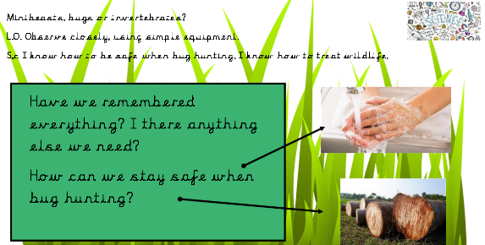  Discuss how to stay safe when bug hunting.  Main:  Children go outside and bug hunt.  Adults- observe children's current knowledge. Note any interesting facts children already know to share later.  Plenary:  Come back inside and discuss findings. Watch:  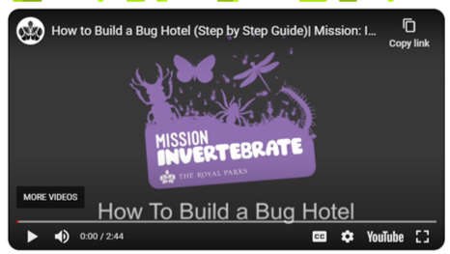  Ask- Where do bugs like to live?  Could we work together to make areas in our outside areas that will encourage bugs to come and live? Share ideas.  Ask- What will we need to build a bug hotel? Record ideas on notebook.  Children go outside to garden area collect and use a range of materials to make their bug hotels.  Come back inside and ask- What do we think will happen to our bug hotel?  Record children’s predictions on Seesaw and print QR code for books. | Lesson 2- Minibeasts, bugs or invertebrates?  Foundational Skills:  Listening and attention skills – used during the recap and teacher input on invertebrates and key vocabulary for body parts.  Subject vocabulary development – used when discussing invertebrates, insects, arachnids, molluscs and arthropods, and applying this language to real finds.  Observing and describing – used when examining pictures of ants, spiders and snails and noting shared and different features.  Identifying and classifying – used outdoors to sort finds into insects, arachnids, molluscs and other groups, and in the plenary when classifying a millipede as an arthropod.  Early scientific thinking – used when pupils justify groupings and refine categories based on observable features.  Fine motor control – used when handling pots, lenses and recording simple notes for the working wall.  Learning Objective:  To observe closely, using simple equipment. Identify and classify.  Success Criteria:  I can explain what invertebrate, insects and mini beasts are.  Recap and Recall:  Children sort picture cards of minibeasts they found last lesson into two groups: creatures they can name and creatures they are unsure about. They then match equipment they used last week (magnifiers, pots, spoons) to pictures of bugs to remind themselves how they used simple equipment to observe closely.  Starter:  Recap from last week, discuss bug hunting and bug hotels. Record on Seesaw and print QR code for books.  Go through the minibeast slides.  Discuss what are invertebrates?  Look at picture of an ant, spider and a snail. Discuss the body parts of each.  Make notes for the children to use later.  Put notes onto the working wall and highlight key vocab.  Ask- What do the ant, spider and snail all have in common?  Main:  Tell the children that we are going to use our new language to hunt for bugs again but this time we are going to sort them into their own groups.  Go outside with bug hunting packs to hunt for minibeasts. Children to split them into four groups-  - Insects  - Arachnid  - Molluscs  - Other  Plenary:  Discuss what we have learnt.  Ask- What mini beasts couldn't we sort? (millipede)  Explain that- Centipedes and Millipedes are Arthropods because they have one pair of legs per piece of body.  Classify a millipede. Add findings to working wall.  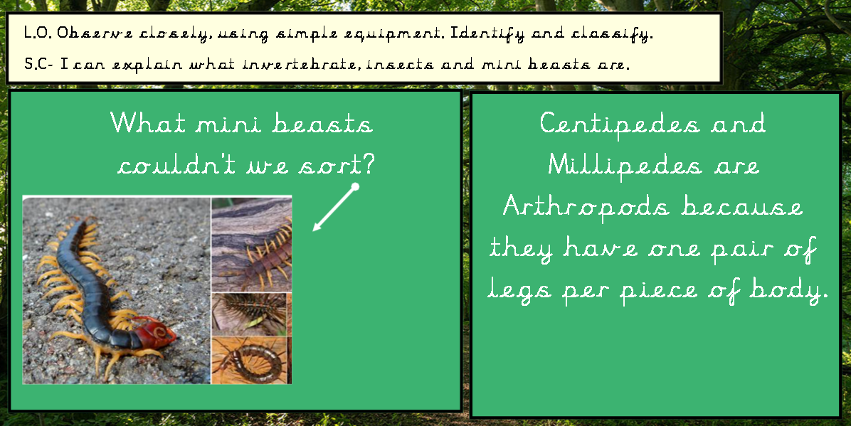 | Lesson 3- How are we similar to invertebrates?  Foundational Skills:  Listening and attention skills – used during recap, video/game input and final quiz to consolidate knowledge.  Expressive language and vocabulary – used when pupils state one-way humans are similar to invertebrates and when higher attainers write a sentence to summarise learning.  Observing closely – used outdoors to collect and study a single invertebrate, focusing on structure and features.  Using observations and ideas to suggest answers – used when pupils research uncertain points with laptops/iPads/non-fiction and explain similarities/differences.  Early reading and information skills – used when pupils consult non-fiction texts and on-screen resources to check facts.  Awareness of the natural world – used through respectful handling/observation of living things.  Learning Objective:  To describe and compare the structure of a variety of common animals. Observe closely, using simple equipment. Identify and classify.  Success Criteria:  I can say how I am similar to an invertebrate.  Recap and Recall:  Children revisit the four categories from last lesson by placing images of an ant, spider, snail and woodlouse into the groups from the working wall. They then work in pairs to act out the movements of different invertebrates as a reminder of how their bodies are structured before comparing these features to themselves.  Starter:  Recap previous learning. Record on Seesaw and print QR code for books.  Children to note down one thing that makes use similar to invertebrates.  Watch and play the bbc btesize video and game about inveribrates. Note any new knowledge and add to working wall.  https://www.bbc.co.uk/bitesize/topics/z484382/articles/z8mbqhv  Main:  Children to go outside and collect one invertibrate to study. Record children explaining what they have collected and add QR codes to books.  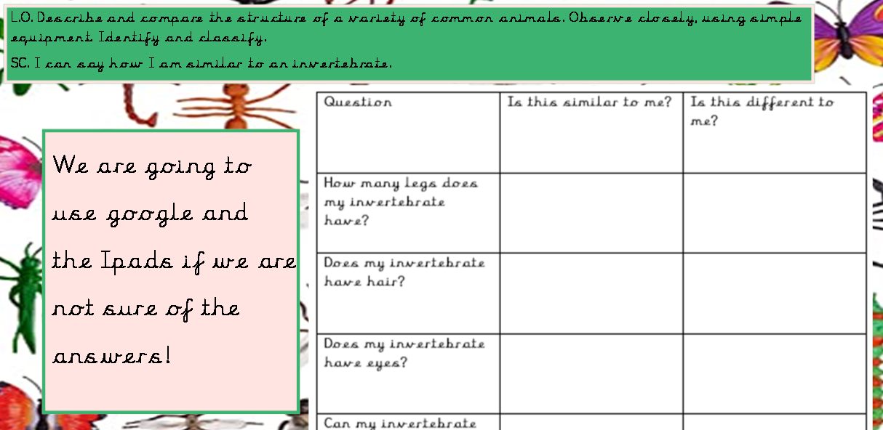  Children to work in pairs with laptop/ iPad/ non -fiction books to research answers that they are not sure of.  Plenary:  Recap what we have learnt by watching-  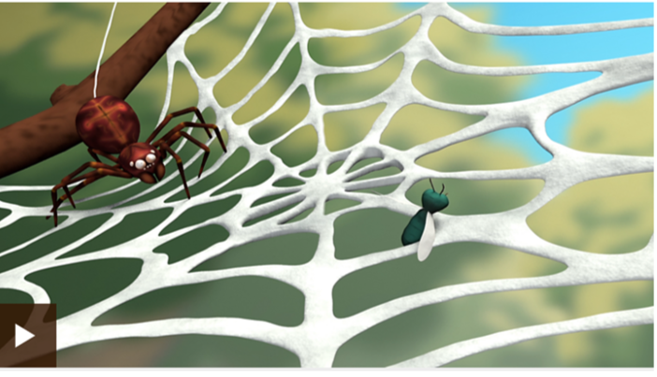  And completing the quiz-  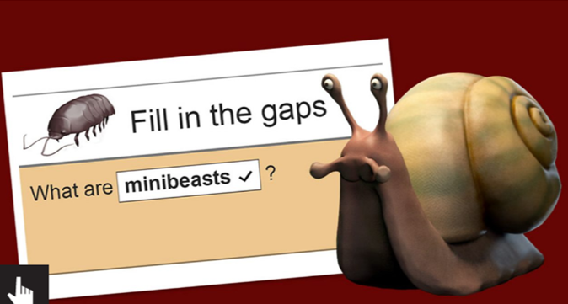  HA- to write a sentence about what  They have learnt about mini beasts. Other children discuss. Record on Seesaw and print QR code for books.
 | Lesson 4- Asking Questions  Foundational Skills:  Listening and attention skills – used during modelling of question openers and whole-class discussion about what scientists ask.  Expressive language (sentence structure) – used when pupils generate and refine their own what/where/why/how questions on sticky notes.  Curiosity and enquiry skills – used as pupils decide what they would like to know about a chosen minibeast and plan how to find answers.  Using observations and ideas to suggest answers – used when researching with laptops/iPads/books and sharing new facts learned.  Early writing skills – used to record questions and brief findings clearly on notes for later reference.  Self-confidence and independence – used when selecting sources and presenting what has been learned to peers.  Learning Objective: To ask simple questions and recognise that they can be answered in different ways.  Success Criteria: I can think of a variety of things I would like to know about different invertebrates. I can write questions which I will later use to research.  Recap and Recall:  Children look back at minibeast photos from Lesson 3 and choose one creature they previously collected. They write or draw one thing they remember about it on a sticky note, place it on the board, and then think of a question they still want to know. This activity leads into forming their own scientific questions.  Starter:  Explain that today we are going to become invertebrate experts.  Recap previous learning by watching and playing bbc bitesize learning.  https://www.bbc.co.uk/bitesize/topics/z6882hv/articles/z9fkwmn  Recap what questions are. Watch:  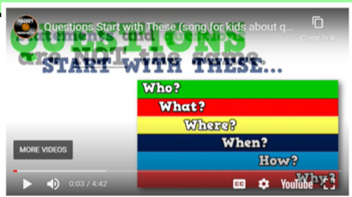  https://www.theschoolrun.com/what-question  Explain that scientists ask lots of questions. What would you like to know about minibeasts?  Discuss what we could ask to learn more about minibeasts.  Adult to model using all the question openers in different ways. Record on notebook.  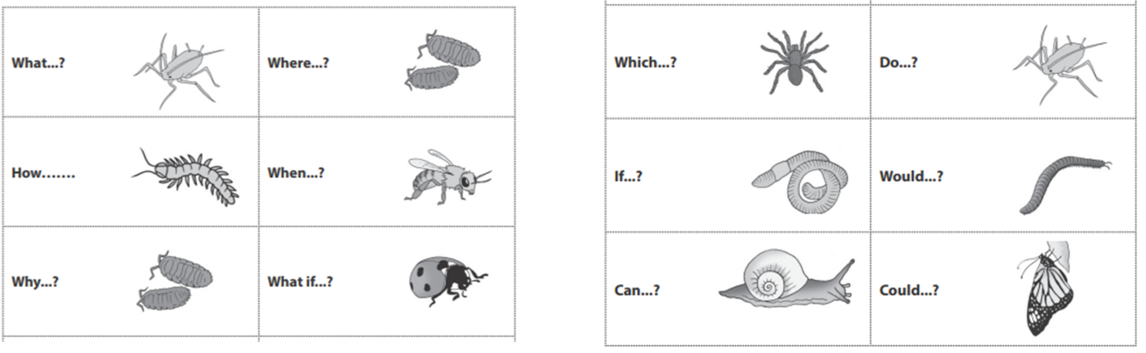  Main:  Use sticky notes to write various questions using different openers about chosen mini beast.  Children use laptops/ I pads/ non-fiction books to research the answers to their questions. Write on sticky note.  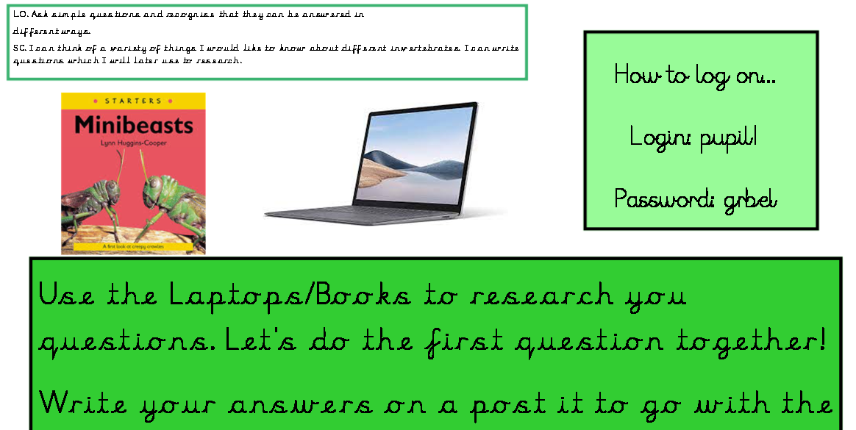  Plenary:  Children to share what they have learnt about their chosen minibeast. Ask- What new fact have you learnt? HA- To write a sentence. Other children say verbally then record on Seesaw and add QR code to books. | Lesson 5- The Ugly Five  Foundational Skills:  Listening and attention skills – used during story context, video input and teacher-led comparison of examples.  Understanding of people, communities and differences – used when discussing how climate and habitat differences between the UK and Africa influence invertebrates.  Subject vocabulary and comparative language – used when recording similarities and differences in a table and contributing key notes for the working wall.  Secure number sense and simple data handling – used implicitly when comparing “more/less” prevalence or size characteristics as part of structured comparison talk.  Awareness of the natural world – used in understanding habitats and adaptation in contrasting climates.  Learning Objective: To understand that Africa is a hot country.  Success Criteria: I can talk about some insects from Africa.  I can talk about the weather in Africa.  Recap and Recall:  Children revisit their bug hotel observations from earlier lessons by sorting laminated pictures into “found near our school” and “would not live here.” They then compare the UK minibeasts they have learned about to pictures of large African insects to activate prior knowledge before exploring habitats and climate.  Starter:  Where is our story 'The Ugly Five' set? (Africa)  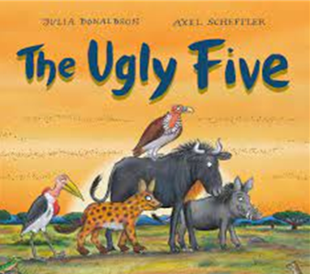  Explain that we are going to find out some differences between insects in Africa and insects in the UK.  Watch: https://www.youtube.com/watch?v=jtOamrNv58M  Main:  Start to work through the slides comparing the differences between the UK minibeasts and the African Minibeasts. Look at and discuss- snails, millipedes and spiders. Children to record how the African mini beasts are similar and different to those in the UK in table. Then say verbally what they have learnt and record on Seesaw. Add QR codes to books.  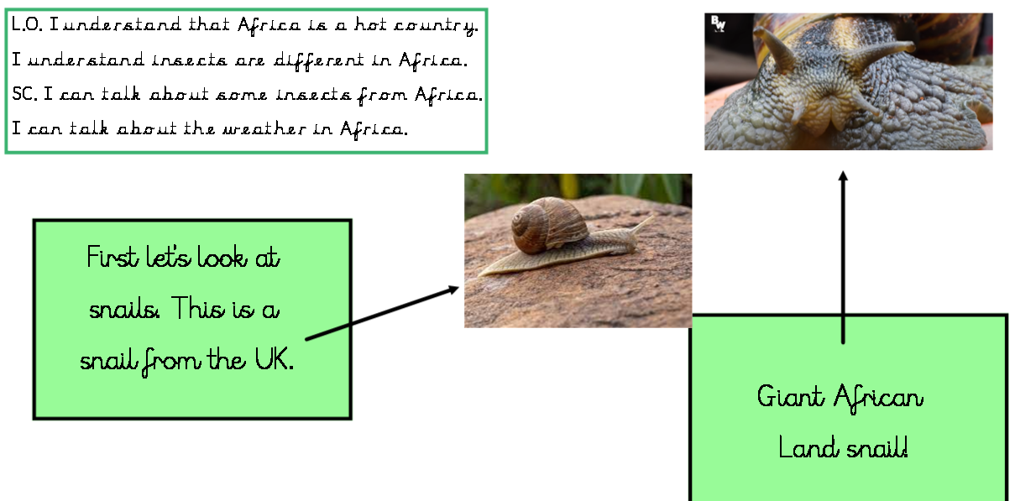  Plenary:  Make key notes to add to pictures of African minibeasts and add to the working wall. | Lesson 6- Habitats  Foundational Skills:  Listening and attention skills – used during recap of bug hotels, video stimulus and instructions for the field check.  Observing closely – used when inspecting bug hotels to see which minibeasts have arrived and where.  Identifying and classifying – used to categorise minibeasts found and link them to suitable microhabitats.  Gathering and recording data – used when making a tally of different types observed and transferring findings to the class recording sheet.  Understanding of the natural world and simple problem-solving – used when suggesting materials to add to attract more minibeasts based on evidence found.  Fine motor control – used when carefully handling hotel materials and completing tally marks and tables neatly  Learning Objective: To understand the habitat of invertebrates in the UK.  Success Criteria: I can talk about the habitats of a minibeast.  I can evaluate my bug hotel.  I can categorise the minibeasts found in my bug hotel.  Recap and Recall:  Children begin by looking at a simple tally from their first bug hunt and decide whether the same minibeasts are likely to be found in the bug hotel now. They walk around the classroom placing habitat cards (dark, damp, warm, leafy) next to the minibeast images they match, preparing them to check whether their bug hotel provides these conditions.  Starter:  Recap making the bug hotel.  Watch:  https://content.twinkl.co.uk/error.html?__token__=exp=1678304736~acl=%2Fresource%2F39%2F85%2Ft-sc-1647336913-ks1-ages-5-7-activity-video-bug-hotel_ver_1.mp4%2A~hmac=4b7504516be06247c640fe806ea1407050c06b32611e4b453df20ef6eff12a71  Recap what habitats are.  Tell the children that we are going to go outside and carefully see what minibeasts have found their way into our bug hotels. We need to think about the follow:  1. Categorise the minibeasts.  2. What have we founds more or/less off?  3. What materials could we add to attract more minibeasts?  Recap how to make a tally chart.  Main:  Go outside and start to work through the bug hotel. Make a tally of the different types of minibeasts we have found.  Plenary:  Record findings on the following sheet:  

