Firework Poetry –
In this unit we will create our own piece of bonfire night poetry. We will learn about and use onomatopoeia and begin to use these in our poetry. We will discover and learn new vocabulary and ensure we can use these words in sentences correctly. We will plan and then write our own poems using our knowledge of phonics and tricky words to write sentences.
Key Objectives  □ To understand onomatopoeia and be able to use it to create poetry.  □ To listen to and discuss a wide range of poems at a level beyond that at which they can read independently.  □ To be able to read common exception words and use these in speech and begin to write them.  □ To be able to say out loud what they are going to write about.  □ To be able to compose a sentence orally before writing it.  □ To re-read what they have written to check that it makes sense. | Lesson 1  Creating a Word Bank using Onomatopoeia  L.O: To understand what a poem is. To understand onomatopoeia. To create a word bank.  S.C: I know what a poem is. I can describe what is in a poem. I can understand what onomatopoeia is and can begin to use it. I can create a word bank of onomatopoeia words.  Teaching:  Ask the children to talk to their partner about- What is poetry?  Watch poetry video- explaining what poetry is.    Discuss how poems often use rhyming words and share the list that Phillip Waddell uses in his ‘Friend’ poem.  Tell the children that we are going to use our senses to create a poem.  Ask the children- What do we taste/ see/ hear/ smell/ feel with? Reveal pictures on notebook to show answers.  Ask children- What is happening on 5th November? Discuss with the children- Do you celebrate Bonfire night? How do you celebrate Bonfire night? Do you celebrate at home or go out to a big display? Watch video showing how Bonfire night is traditionally celebrated in the UK.  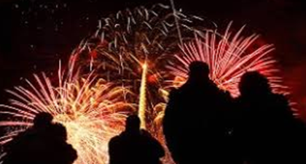  Discuss the video- What did the family see? What did the family do? How did the family feel? What did the family eat? How did it taste? Draw out words like hot, sweet, sticky, chewy.  Tell the children that: Onomatopoeia is when a word describes a sound and mimics the sound of the object or action it refers to when it is spoken.  Watch video to find out more:  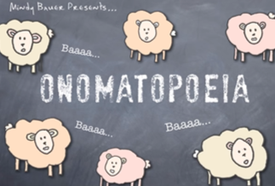  Tell the children that at a firework display there are lots of examples of onomatopoeia. Watch fire work video:    Discuss: What can you see? What can you hear?  Teacher to type children’s ideas onto working wall sheet.  Activities:  Children use word mats to write examples of onomatopoeia on sheet. Red group to give 3 examples. Yellow, Green and Blue to give 6 examples. | Lesson 2  Creating a Word Bank using the 5 Senses  L.O: To understand what a poem is. To understand  onomatopoeia. To create a word bank.  S.C: I know what a poem is and can describe what is in a poem. I understand what onomatopoeia is and can begin to use it.  I can describe what I can see, hear, smell,  touch and taste.  Teaching:  Recap from yesterday- What celebration is happening this week? Do you celebrate Bonfire night? How do you celebrate? Do you celebrate at home or go to a big display?  Tell the children that we are going to remind ourselves how Bonfire night is traditionally celebrated in the U.K by reading the story ‘Sparks in the Sky.’ Read story to children.  Discuss what happened in the story:  What did the family do?  What did they see?  How did they feel?  What did the family eat?  How did it taste?  Recap from yesterday- What is onomatopoeia? Remind the children that: Onomatopoeia is when a word  describes a sound and mimics the sound of the object or action it refers to when it is spoken.  Watch onomatopoeia video from yesterday to recap ideas. Show the children the fire work display video from yesterday.  Discuss: If you were there what could you see/ hear/ smell/ taste/ feel?  Teacher to record the children’s ideas on flip chart paper.  Activities:  All children to create a word bank saying what they would be able to see, hear, smell, taste and feel at a Bonfire. Teacher to support the red group. | Lesson 3  Writing a Firework Senses Poem  L.O: To have an understanding of what a poem is. To understand onomatopoeia. To create a bonfire night senses poem.  S.C: I know what a poem is and can describe what is in a poem. I understand what onomatopoeia is and can begin to use it. I can describe what I can see, hear, smell, touch and  taste in my poem.  Teaching:  Tell the children that they are going to listen to some poems about Bonfire night and fireworks. Read: ‘Bonfire Night’ by Irene Yates. Then listen to:    Discuss- What did you like about these poems? What worked well? What would you have done differently?  Look at the word bank on working wall. Read through what you could see/ hear/ smell/ taste/ feel when watching a firework display.  As a class create a poem based on fireworks:  I can see ____.  I can hear____.  I can smell____.  I can feel_____.  I can taste_____.  Activities:  Red and Yellow group- write 1 word for each sense.  Blue and Green group for each of the senses write a sentence. E.g.  I can see colours.  I can hear bangs.  I can smell smoke.  I can feel the cold air.  I can taste toffee apples.
 | Lesson 4  Publishing Poems  L.O: To publish your Bonfire Poem.  S.C: I can publish my poem. I can use my best Letterjoin handwriting.  Teaching:  Listen to:  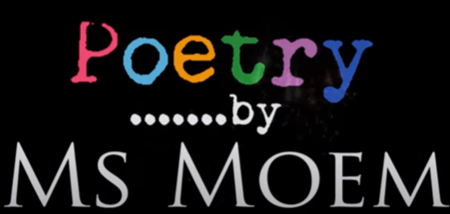  Put some of the children’s poems they wrote yesterday under the visualizer and share.  Discuss: What did you like? What worked well? What would you do differently?  Tell the children that today they are going to publish their firework poems.  Remind the children that they need to use capital letters, full stops, finger spaces, adjectives and onomatopoeia words. Model to the children checking and publishing each sentence using a piece of work done yesterday.  Activities:  Red group to perform their poem they wrote yesterday. Teacher to video and put on Seesaw.  Yellow, Green and Blue Groups to write their poems checking they have used capital letters, full stops, finger spaces, adjectives and onomatopoeia words. | Lesson 5  Independent Writing  L.O: To write about my experience of Bonfire night.  S.C: I can write in sentences.  I can use full stops, capital letters, fingers spaces.  I can include onomatopoeia.  Teaching:  Discuss with the children Bonfires and fireworks that they went to or saw.  Activities:  Children to write sentences about the Bonfires and fireworks that they saw or went to. Teacher to support red group.
Learning Challenge Week

Cross curricular links  History: The Gunpowder Plot.  PSHE- Celebrations – family traditions.  Science – Celebrations – light and sound. |  | Through this unit of work the following essential skills will be developed:  Literacy  - Listening to and discussing a wide range of poems at a level beyond that at which they can read independently.  - Discussing word meanings, linking new meanings to those already known.  - Drawing on what they already know or on background information and vocabulary provided by the teacher.  - Participate in discussion about what is read to them, taking turns and listening to what others say.  - Explain clearly their understanding of what is read to them.  - Spell words containing each of the 40+ phonemes already taught and common exception words.  - Apply simple spelling rules.
Assessment
Speaking and Listening
- I speak clearly and confidently in front of my class. I can re-tell a story and remember the main characters.
Reading
- I can appreciate rhymes and poems, and begin to recite some by heart. I can use what I already know to understand poems.
Writing
- I can identify known phonemes in unfamiliar words. I can sit correctly at a table, holding a pencil comfortable and correctly. I can form lower case letters in the correct direction, starting and finishing in the right place. I can compose a sentence orally before writing it. I can sequence sentences in chronological order to recount and event or experience. I can re-read what I have written to check that it makes sense. I leave spaces between words. I can combine words to make a sentence. I can sequence sentences to form a narrative. I can separate words using finger spaces. I can use capital letters to start a sentence. I can use a full stop to end a sentence. I can use capital letters for names. I can join two sentences using ‘and’.

