Y1– 2 weeks – Narrative – You Choose by Nick Sharrett
Key Objectives

Reading: Being encouraged to link what they read or hear read to their own experiences. Discussing word meanings, linking new meanings to those already known. Drawing on what they already know or on background information and vocabulary provided by the teacher. Participate in discussion about what is read to them, taking turns and listening to what others say. Explain clearly their understanding of what is read to them.

Writing: Begin to form lower-case letters in the correct direction, starting and finishing in the right place. Form capital letters. Saying out loud what they are going to write about. Composing a sentence orally before writing it. Sequencing sentences to form short narratives. Re-reading what they have written to check that it makes sense. Leaving spaces between words. Joining words and joining clauses using. Beginning to punctuate sentences using a capital letter and a full stop and question mark.

Speaking and Listening: Perform their own compositions, using appropriate intonation, volume, and movement so that meaning is clear.

Planning: Identify the audience for the writing- writing to share with parents

Draft and Write: Write their own version of ‘You Choose’ stating why they are super - Differentiated booklets for all children to access successfully.

Evaluate and Edit: Children to evaluate their draft by using blue pen.

Publishing: Children to publish their writing and then read to their parents.

Lesson 1- Hook / Prediction  L.O: To predict, explore and discuss key events of You Choose. S.C: I can predict what the story is about. I can answer questions verbally. I can ask questions. I can give reasoning to my answers.  Have lots of random objects on tray in middle of the circle.  Children to go round and explore objects. Speak to the children modeling correct sentence structure.  Bring the class back together and show them the pass the parcel, each layer to have a question such as ‘What is your favourite food?’ ‘Where is your favourite place to visit in Grantham?’  Once you have finished the game and all children have spoken.  Look at the front cover as a class. Model predicting what is going to happen in the story.  Children to predict what the book is about.  Can the children identify the title and the author? Explain that ‘You Choose’ is going to be the book we are focusing on for the next couple of weeks- Read the book. Teacher to model answering questions on each page from the book. Look at page 1 (going anywhere)  At the end of the lesson explain over the next 2 weeks we will be making our own books all about ourselves that we will read to our Mummy and Daddy. | Lesson 4- Using talk partners/ Mind Mapping  L.O: To create a mind map with a partner.  S.C: I can tell a friend why I am super. I can create a mind map with my friend.  Re-read the book encouraging HA children to read the questions for everyone and LA children to answer questions.  Children talk to their talk partner about what makes Mrs Welbourne super.  Children to share their ideas with the class. Whilst doing this model to the children how to make a mind map.  Blue Group- Mind map ways in which you are super. Then write a caption why you are super using the conjunction ‘because’.  Green and Yellow Groups- Mind Map ways you are super with a friend. Then write a caption why you are super.  Red group- to mind map why you are super work with the teacher. | Lesson 7-Writing  L.O: To explore, identify and ask questions.  S.C: I can use my previous knowledge to ask  questions. I can identify a question mark. I can  write a question. I can read my question to a friend.  Begin the lesson with Super Heros Unite Go Noodle.  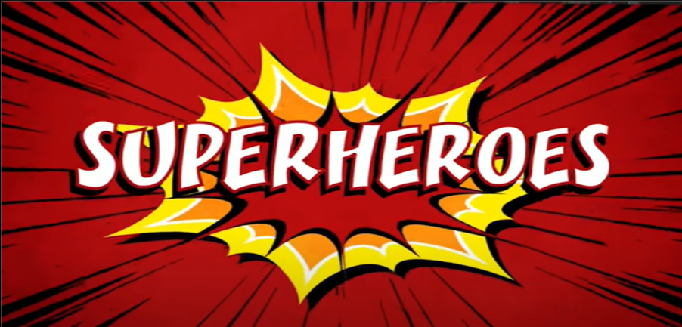  TTYP: What did we do in English yesterday?  Using the ‘Super me’ sentences from yesterday play guess who- Teacher/HA to read out children's work, can they guess who it is?  Use smartnote book with lots of different silly questions, ask children to help read each one. Ask: What do you notice about these sentences? Then circle the question mark at the end of each question.  Look at the family and friends page in the ‘You Choose’ book.  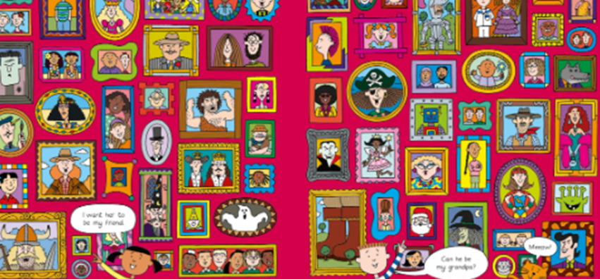  What would you like to know about these people?  Tell your talk partner.  Teacher to model writing a question for Miss Tidwell. E.g. Have you got any pets? Remind the children that the question needs to end with a question mark.  On strips of paper children write a question that they would like to ask a friend. Play music and tell the children that when the music stops that they are going to find their friend and ask their question.
Lesson 2- Writing  L.O: To write a caption about why our family are super.  S.C: I understand what ‘super’ means. I can verbalise why my family are super. I can write a caption using my phonics knowledge.  All children to join in with the Superhero dance.  Remind the children our topic is ‘Super Me’. Discuss what ‘super’ means. Discuss ways in which different people can be super. Use pictures on notebook to give children ideas – (e.g. Firefighter, family members.)  Re-read ‘You Choose’.  Children to answer questions as modelled yesterday.  Explain to the children that we are going to focus on page 2.  Discuss- Why are the people in your family super?  Children draw a picture of someone in their family (refer to Page 2) as a super hero. Children then write a caption of why they are super. Teacher to model saying the caption out loud before writing it down – do this multiple times for different members of family.  Red: Draw a picture of a member of their family then label around the picture of how they are super. Letter mats / key words on table to copy.  Yellow and Green: Draw a picture of a member of their family then write a short caption using the key words on the table. Challenge: Use the correct spelling for any tricky words. (Use word mats for support).  Blue: Draw a picture of 2 family members and write a caption why they are super. Challenge: Can you use capital letters, finger spaces and full stops. | Lesson 5- Writing  L.O: To write sentences about super people.  S.C: I can use phase 2 and phase 3 phonics. I can use capital letters, finger spaces and full stops. I can read my sentence back. I can use ‘because.’  Remind the children that this  week we have thought about why our family are super and why we are super. We are going to finish the week by thinking about other people that are super. Think of as many people as you can in 20 seconds go! Flip chart a list of people the children think of?  Show the children a list that you have made (on notebook) of super people. Model writing a sentence why 1 of these people is super using the word ‘because.’  All children to write a sentence why somebody is super using the word ‘because.’  Teacher to support red group. | Lesson 8- Drafting  L.O: To write up a draft piece of writing on whiteboards ready to be published tomorrow.  S.C: I can write my draft piece of work. I can say my sentences out loud before writing them. I can use a capital letter, finger spaces and full stops. I can read my sentences with expression.  Explain to the children that we are going be creating a draft for our final piece of writing. Put some of the children’s work based on ‘You Choose under the visualiser to share with the class.  Explain to the children that we are going to talk about our interests.  Together read through Mr Mason’s interests and discuss if we have any similar to him.  Ask children to sit in a circle. Pass a ball to one child at a time. When they receive the ball they need to say 1 thing they are interested in. Teacher to record on flip chart.  Model to the children choosing an interest and writing a caption about it.  Ask the children to write their interests on a whiteboard.  I am interested in…..  Because….  Remind the children to use capital letters, finger spaces and full stops.  Model to the children choosing an interest and writing a caption about it.  At the end of the lesson children to read aloud for their friends what they have wrote.  Adult to model how to read using expression.  Photocopy whiteboards for tomorrows lesson.
Lesson 3-Present / Edit  L.O: To practice presenting and editing my work.  SC: I can read my writing to a friend. I can use a blue pen to edit my work.  Show the children some examples of the work done yesterday on the IWB.  Children to sit in a circle and using the speaking stone take turns presenting their work to one another.  Watch:  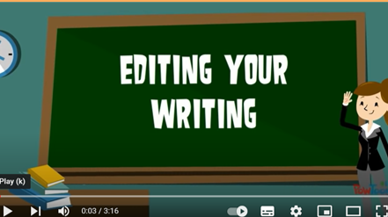  Show the children your work from yesterday (on notebook). Model to the children using a blue pen to edit their work from yesterday.  Children to work with teacher in ability groups to edit work appropriately. Children to use a photocopy of their work to practise editing.  Other children to access ‘You Choose’ activities in the provision. | Lesson 6-Writing  L.O: To use my mind map to write sentences using capital letters, finger spaces and full stops.  SC: I can use my mind map to write a sentence of why I am super. I can use capital letters, finger spaces and full stops. I can use my phonics knowledge to spell words correctly.  Remind the children that last week we were reading a book called ‘You Choose’ by Nick Sharrett. Re-read the book encouraging the children to join in.  Remind the children that we were talking about what super means. Ask children to share their ideas.  Read the dictionary definition of super.  Put one of the children’s mind maps of why they are super under the visualiser. Model writing the points up into sentences. Focusing on using capital letters and full stops.  Reds- Fill in missing words onto worksheet-  ________ _______ super because I am _________________.  (Write 2 captions)  Yellows, Greens and Blues- Write full sentences why they are super in books. Blues- At least 4 sentences. | Lesson 9- Editing and Publishing  L.O: To edit and publish my work.  S.C: I can edit using a blue pen. I can publish my work on best paper. I can read my work to another adult.  Read ‘You Choose’. Encouraging all children to join in with the questions and using expression.  Explain to the children that we are going to edit our work from yesterday. Model editing work from yesterday with a blue pen.  Blue, green and yellow groups to edit their work independently.  Red group to work with teacher to edit their work. Once edited children to publish onto sheet.
Lesson 10-
L.O: To write about why a superhero is super.
S.C: I can use Phase 2 and Phase 3 sounds. I can use capital letters, full stops and finger spaces. I can use ‘because’.
Read ‘You Choose’ for the last time. Encourage the children to join in.
Play ‘Guess the Super Hero’
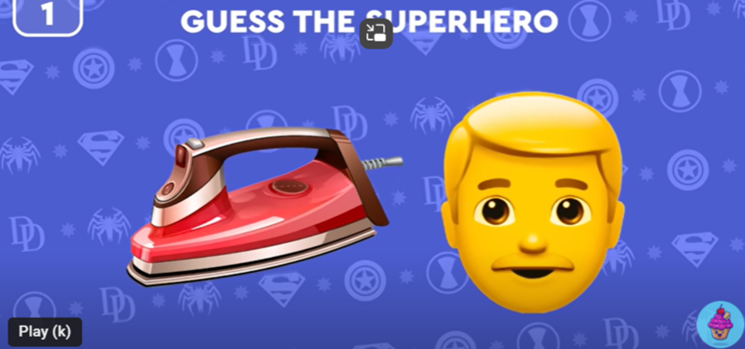
Look at the pictures of the super heroes and ask the children to name them.
Children to pick a super hero and explain why they are super.
Teacher to choose a super hero and to model writing a sentence why that super hero is super. Model using ‘because’ in the sentence.
Children to write own sentences, using ‘because’, why the super hero they have picked is super. Support Red group.

