Y1– 2 weeks (Lessons )– Narrative – The Smartest Giant in Town
Key Objectives

Reading: Being encouraged to link what they read or hear read to their own experiences. Discussing word meanings, linking new meanings to those already known. Drawing on what they already know or on background information and vocabulary provided by the teacher. Participate in discussion about what they watch – using short bursts of the film, taking turns and listening to what others say. Explain clearly their understanding of what is read to them.

Writing: Begin to form lower-case letters in the correct direction, starting and finishing in the right place. Form capital letters. Saying out loud what they are going to write about. Composing a sentence orally before writing it. Sequencing sentences to form short narratives. Re-reading what they have written to check that it makes sense. Leaving spaces between words. Joining words and joining clauses using. Beginning to punctuate sentences using a capital letter and a full stop and question mark.

Speaking and Listening: Perform their own compositions, using appropriate intonation, volume, and movement so that meaning is clear.

Planning: Identify the audience for the writing- writing to create a book for the school Library.

Draft and Write: To write a letter to the Smartest Giant.

Evaluate and Edit: Children to evaluate their draft by using blue pen.

Publishing: Children to publish their writing and then read out loud to Reception children.

Lesson 1- Hook & Prediction  LO: To design a smart outfit for a giant and label the items of clothing.  S.C: I can recognise different items of clothing and be able to label them.  Children come into the classroom in the morning to find some clothes lying around- crown, white shirt, tie and sock. Ask children to collect the clothes up together and so we can work out where they have come from. Allow discussion between the children.  Class discussion: Who could these belong to? Do we know anybody that wears these smart clothes? Why would they be in our classroom? Why is there a crown?  Teacher to write children’s answers on flip chart paper for working wall.  Then as a whole class create a prediction sheet (Teacher to type in children’s ideas) for their books.  Reveal book that is covered up in paper with various flaps. Reveal different flaps to give the children clues to what the book could be. Looking at the title: What could this story be about? What do we think might happen? Who has read this book before?  Return back the note book and discuss what they would wear when they get dressed up. Make a class list of all the smart clothes they can think of.  Activity: Design and label their own smart outfit for a giant. What will they need? How could you describe what the clothes would look like?  Reds – cut and stick label. Add sound buttons.  Yellow/green/blue – write labels. Use phonics knowledge.  Challenge: Write a caption ‘I feel smart when I wear…….’ | Lesson 4- Sequencing  L.O: To sequence the key events of the story of 'The Smartest  Giant in Town.'  S.C: I can recognise the key events of the story and order  them correctly. I can add a caption to describe what is  happening.  Explain to the children that today we are going to be using our sequencing skills. Explain that  this means we are going to be thinking about the key events that happen in the story and what order they go in.  Recap: Which characters are in the story?  Red Group: Give the children 8 pictures of pages in the book. Work as a group to put the pictures in order then order. Ask the children if they can add any 3 letter words to go with the pictures. Take photos for pic collage.  Yellow Group: Give children 8 pictures from the book. Ask them to put them in order and stick them down on their sheet. Then ask the children to use their phonics to label their pictures and add adjectives to describe the characters.  Blues and Green Groups: Give children 8 pictures from the book. Ask them to put them in order and stick them down on their sheet. Then ask the children to use their phonics to write a caption for each picture. Add adjectives to captions to describe the characters. | Lesson 7- Writing Adjectives  L.O: To understand what an adjective is. To choose an  adjective for the Smartest Giant in Town.  S.C: I can think of adjectives to describe the pieces of clothing. I can use my phonics to spell words  phonetically.  As a class recite George’s letter using the talk for writing actions.  Discuss what a map is. What is a map used for? When have you used a map?  Show the children a story map for ‘The Smartest Giant in Town.’ Explain that this is a story map and helps us find our round a story. Tell the children that they are going to be adding adjectives to the animals and pieces of clothing on the story map.  Discuss: What is an adjective?  Watch: What is an adjective.  Ask children to think of three adjectives for a pencil, toy dinosaur and the sand tray. Teacher to write the adjectives on the flip chart.  Ask the children to think of and share some adjectives for George’s tie, shirt and Shoes. Teacher to write on a new sheet of flip chart paper.  Children to add adjectives to the story map.  Red - Adult to write the adjectives the children would like to use on post it notes. Children to copy the post it note.  Yellow - use the flip chart paper to copy how words are spelt.  Green and Blue - Use flipchat for ideas but use their phonics knowledge to spell.
Lesson 2- Drama/ Role Play  LO: To identify the main characters in the story and to act out the characters.  S.C: I know how to use different dramatic skills to be able to act out an animal or person.  Recap- What do we think the story is going to be about? Who did we discover had been in  our classroom yesterday? What was he wearing? Can you  remember all the items?  Ask children to sound out some of the items of clothing as teacher writes them on the flip chart. Show the children the front cover of ‘The Smartest Giant in Town’.  Discuss:  What can we see?  What animals can you notice?  How do you think they are feeling?  Teacher to record ideas on Seesaw and create a QR code. Add to pic collage for books.  Start reading the book. Stop when the giant meets the giraffe.  Discuss:  What do you think is going to happen? What do you think the Giant is feeling? Why? What would you do if you were the Giant? Have you ever been in a similar situation?  Continue reading the story. Stop once George has lost all his items of clothes.  TYYP: What is a character? Who are the characters?  Activity 1: Explain to the children that we are going to play a game to practise our acting skills. Read cards and ask children to follow the instructions doing their best acting.  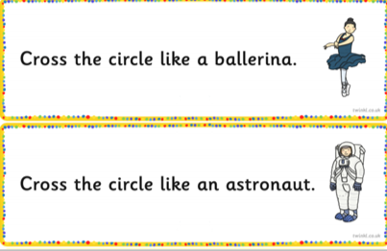  Activity 2: Ask the children to act like the characters from the book. Put the children into groups of 6. Ask the children to decide who is each character (George, Giraffe, goat, mouse, fox, dog).  Teacher to take photos of each group for Seesaw and to create a pic collage. | Lesson 5- Talk for Writing  LO: To begin to learn George's letter using Talk for Writing.  S.C: I can think of pictures to help me remember the letter. I can think of actions to help me remember the letter.  Read the story to the children. Encourage the children to join in with the teacher.  Show the children the back page (letter). Discuss: What is this? Model to the children on a copy of the letter underlining words they can read.  Work as a class to come up with some pictures and actions for the letter. Start creating a talk for writing script up to fox.  Record on Seesaw and create QR code for books. | Lesson 8- Writing Adjectives  L.O: To understand what an adjective is. To choose an adjective for an animal from the ‘Smartest Giant in Town’.  S.C: I can think of adjectives to describe the  animals. I can use my phonics to spell words phonetically.  TTYP- What did we learn yesterday? What is an adjective?  Explain to the children that we will be focusing on the animals at the beginning of the story. Show the children a picture of the giraffe, goat and mouse. Ask the children to think of and share adjectives for each of the animals on the pictures. Teacher to write adjectives on the flip chart.  Children to add adjective for the items of clothing to the story map.  Red - Adult to write the adjectives the children would like to use on post it notes. Children to copy the post it note.  Yellow - use the flip chart paper to copy how words are spelt.  Green and Blue - Use flipchart for ideas but use their phonics knowledge to spell.
Lesson 3- Characters  L.O: To know who the main characters of the book are and to be able to describe them.  S.C: I can use my phonics to help me label different characters in the book.  Recap from yesterday- What is a character? Ask children if they can remember some of the characters from yesterdays lesson.  Show children the book. Discuss: What do you think will happen in the end?  Read the whole book so that the children know what happens at the end. As teacher reads the books ask the children to listen out for new characters being introduced. When they hear one shout out ‘New Character’.  Show children a list of the characters. Ask the children to sound out each character and match it to a picture of that character on the notebook.  Explain to the children what an adjective is.  Watch: What is an adjective?  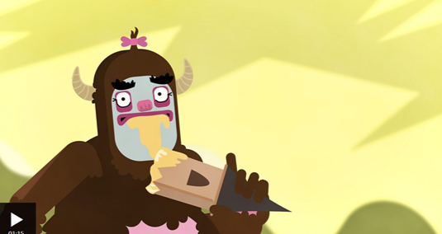  Look back at the list of characters. Ask the children to think of some adjectives to describe each character.  Red Group: Trace over the characters names, first in pencil, then in colour.  Yellow, Green and Blue Group: Say the characters names in the pictures on their sheet. Say the sounds in the words, then write the characters.  Challenge the children to think of an adjective for each of the characters. | Lesson 6- Sequencing  L.O: To be able to sequence the events of the giant’s letter chronologically.  S.C: I can identify the correct item of clothing and link it to the correct animal. I can sort the items and characters into the order they happen in the story.  Point out an envelope in the classroom. Open envelope. Discuss with the children what they think it is. Ask: Who is it from? Who is it to?  Read the beginning of George’s letter using the talk for writing actions the practised last week.  Finish adding talk for writing pictures and actions to the rest of the letter.  Ask children to cut and stick the pictures for the missing words on the letter. Ask them to make sure that it is in the correct order. Yellow, Green and Blue groups also to add words. | Lesson 9- Building Sentences  L.O: To write a short caption.  S.C: I can use write a short caption. I can write a caption using a repeated phrase. I can use a capital letter, finger space and full stops.  Starter: Read the sentences from the flip chart. Ask the children to spot the mistakes.  Read the full book. Ask the child  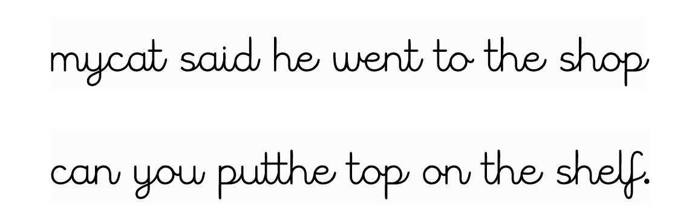  Read the full book. Ask the children to join in with the letter at the end- use talk for writing actions.  Blue, Green and Yellow: Children to write captions about pictures from the story. Challenge children to use adjectives in their writing. Remind the children to use capital letters, full stops and finger spaces.  Red group: To write adjectives for each of the pictures.
Lesson 10- Editing and Publishing  L.O: To begin to learn how to edit and publish work.  S.C: I copy my previous work, correcting mistakes if needed.  Explain to the children that  in Year One we don't use rubbers we use blue pens if we make a mistake this is called editing. Today we are going to practice copying our work up in neat. This is called 'publishing'.  Read the sentence from the notebook. Model editing the sentence with a blue pen.  Use photocopies of some of the children's work to show how I have edited it under the visualizer. Can the children spot the mistakes?  Give children sentence to edit sheet. Ask them to edit them with a blue pen.  Model to the children coping their work into need that you have edited.  Children to copy up work. | Lesson 11- Writing  L.O: To be able to plan my own caption based on the Smartest Giant's letter.  S.C: I can choose an animal and a piece of clothing for my caption.  I can write a simple caption remembering a capital letter, finger space and full stop.  Recap with the children the activities that we have done based on ‘The Smartest Giant in Town.’  Explain that today we're going to create our own captions which includes a piece of clothing and a different animal. Tell the children that there are 2 pots. In the 1st pot there are clothes, in the 2nd pot there are animals. You need to pick ONE piece of clothing, and ONE animal.  Model to the children how to stick the 2 pictures into their books so they are next to each other. Model to the children how to write a caption in the same format as used last week. E.g- A tutu for a penguin. Remind the children to use capital letters, full stops and finger spaces.  Children to take 2 pictures. Then use to write a caption as modelled. Repeat for more sets of pictures. | Lesson 12- Improving Writing  L.O: To add an adjective to my caption.  S.C: I can think of an adjective to describe the clothing object. I can think of an adjective to describe my animal.  TTYP: What did we do yesterday?  Discuss- What do we call a describing word?  Watch: What is an adjective if children need reminding.  Quick Flash- Children to share adjectives to describe the party hat and the pumpkin on the notebook.  Explain that we wrote our captions after we chose the pictures out of the pot.  Today we are going to add adjectives to the same caption.  Model to the children adding adjectives to the sentence on notebook.  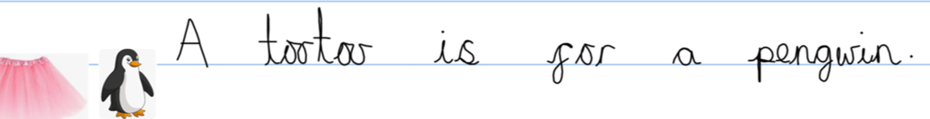  Children to re-write their captions from yesterday- adding in an adjective for each animal and each item of clothing.  Red group to work with the teacher to think of adjectives.
Lesson 13- Publishing
LO: I can publish my caption in my neatest Letterjoin handwriting.
S.C: I use my letterjoin handwriting. I can make
sure my letters are formed correctly.

Yellow, Green and Blue groups to publish their sentence. Remind children about using letterjoin handwriting and making sure their letters are formed correctly.

Red group to work with the teacher using the adjectives, animal and item of clothing to write a sentence together.

