eography
Religious Education- What do some People believe God looks like?
By the end of this unit children will know...

Vocabulary

Year 1 Autumn 2- Twinkle Twinkle

What they and their families think and believe in relation to content be learnt.
Where some of their beliefs have come from.
It is natural for people to think and behave differently from one another.
Their ideas might change over time.
Some people believe God exists as a powerful, non-human being. In some religions, followers believe in one supreme being or God who is loving. People have different ways of understanding God on Earth (incarnation). There are different names for God. There are different ways to refer to and represent God. People have different ideas about the role of God. Some religious people use art, objects and special times to represent and remember incarnation of God (of the presence of God on Earth). Religious stories can help us to understand religious beliefs. Similarities and differences help us understand worldviews better. It is important to only use positive language when discussing others’ beliefs.

In Reception the children shared their ideas about God. They talked about Diwali, Hanukkah, Christmas and Easter. They were introduced to the words; Christian, Bible, church, Muslim, Mosque, Koran, Hindu, Diwali and temple.

Allah, belief, believe, Brahman, Christian, Christian Bible, Christmas, God, Hindu, idea, Jesus, Muslim, religion, respect, worldview, incarnation, Islam, describe, compare, explain, discuss, recognise, respect, investigate

Intention

Children will explore how other people understand God on Earth; considering different representations of God and understanding why this is challenging.

What do some People believe God looks like?

Children will build on their previous learning about talking about God and sharing ideas about their beliefs. This will support them as they begin to learn more about how different religions understand and represent God. Children will develop their listening and attention by listening carefully to explanations about different beliefs and traditions. Their understanding will deepen as they learn why some Muslims avoid images of God and why this is important in Islam. Through expressive language, children will discuss religious ideas respectfully, sharing their thoughts and listening to the views of others while developing an appreciation of different beliefs and practices.
Learning Links

R.E – What do some people believe God looks like?
What do some people believe God looks like? - Throughout this unit the children will explore the Gods of Christianity, Hinduism and the Islamic faith.
Knowledge Progression Across the Unit:  Lesson 1 – Explore ideas about how God might be represented  Lesson 2- Discuss what Muslims believe about God?  Lesson- 3- What do some Hindu people believe God looks like?  Lesson 4- What do some Christian People believe God looks like?  Lesson 5- Do people all share the same beliefs about what God looks like?  Lesson 6- Why do people have different names for God?  Key Objectives:  I can express ideas about God.  I can explain how some Muslim people use art to express their ideas about God.  I can recognize some different forms of God in the Hindu worldview.  I can recognise that some Christian people believe Jesus is the son of God and God on Earth.  I can discuss different ways people refer to and represent God.  I can recall different names people use for God. | Lesson 1- How might ideas about God be represented?  Foundational Skills:  Listening and attention – listening to ideas about God.  Expressive language – sharing personal ideas about God.  Create and think critically – considering different beliefs.  Learning Objective: To express ideas about God.  Success Criteria: I can create a piece of art that expresses my understanding about how people might view God.  I can share my ideas about my artwork.  I can listen to and respect the ideas of my peers.  I can understand that people have different beliefs.  Recap and Recall: Activity – Think and share: What do people believe about God?  Questions:  • What is a belief?  • What words might people use to describe God?  Vocabulary recall: belief, God  Starter:  Recap what can you tell me about God?  Ask the children to make a circle and pass a special object around, make a list of adjectives that they use to describe the object. Explain that like the object God can be described in many way.  Answer the Assessment question as a class and print screen for books.- What do you think God might look like?  Ask the children to explain what their ideas are based on.  Work through the symbols presentation.  A heart to symbolise love and kindness.  A sun to represent warmth, light and the idea of God being everywhere.  A mountain to symbolise strength and eternity, showing the idea that God may be powerful and everlasting.  A tree to symbolise life, growth and interconnectedness, showing how God may be seen as a source of life and creation.  Hands to represent care and creation, referring to their understanding of God as a caring creator.  Main:  Explain to the children that they are going to use the crafting materials to make their representation of God. Ensure that they are able to explain why they have used certain materials and why they have used them in such a way.  Plenary:  How have you shown God in your creation? (Answers may include: using nature to show that God is a creator, using symbols such as a hand to show God cares or using colours to show feelings.)  (Children may suggest: in a heart, a mountain,  the sun, a hand, a tree or a question mark.)  What gave you this idea? (Children may refer to the creation story.)  Why did you choose to use this image/colour/symbol? (Various answers may include: to represent that God is powerful and a creator  or to represent God’s love and kindness.)  How do you feel making your own image to represent God?  Plenary:  Can you find a picture or symbol on the board that you like or find interesting, even if it is not your own?  How does looking at all the different pictures and symbols together make you feel?  If you could add one more idea, what would it be and why?  Create a pic collage of the children’s work and assessment question answers for Seesaw. | Lesson 2- What do Muslims believe about God?  Foundational Skills:  Listening and attention – listening to explanations about Muslim beliefs.  Understanding – recognising why some Muslims avoid images of God.  Expressive language – discussing religious ideas respectfully.  Learning Objective: To explain how some Muslim people use art to express their ideas about God.  Success Criteria: I can explain why some people do not represent God as a person.  I can respect the beliefs of others.  I can explain how some Muslim people use art to demonstrate their beliefs about God.  Recap and Recall:  Display the Presentation: Gimme five! Ask the children to think of five ways people might represent their ideas about God from the previous lesson.  The children may suggest:  A heart to symbolise love and kindness.  A mountain to symbolise strength and eternity, showing the belief that God is powerful and everlasting.  A tree to symbolise life, growth and interconnectedness, showing how they understand God as a source of life and creation.  Hands to represent care and creation, referring to their understanding of God as a caring creator.  A question mark as they are unsure.  Starter:  Display the Presentation: Gimme five! Ask the children to think of five ways people might represent their ideas about God in a drawing.  Give the children all a whiteboard. Display Abstract Noun presentation and invite them to try and draw the feeling. Allow them time to think independently and express their ideas how they would like.  Explain that Muslims believe God is so incredible he cannot be drawn!  Main:  Explain to the children that in Islam, Muslim people believe in one God – Allah in Arabic. Display the Presentation: 99 names and explain that some Muslim people describe Allah using 99 names, each representing a different characteristic. Point out that these names do not describe how God looks but instead describe his qualities.  Explain that Muslims use patterns and designs to show God. Watch the video-  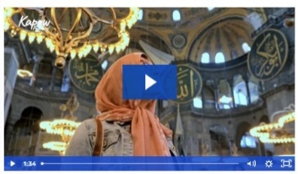  Point out the beautiful patterns and writing of God’s names and Qur’anic verses. Explain that many of these designs are inspired by nature because Muslim people believe that the beauty in nature is a reflection of God being beautiful and loving beauty in creation.  Activity:  Explain- You will each now colour a tile, I am expecting beautiful colouring.  (Some children could paint)- Choose colours that you think represent God- Should you use black?  We are then going to put it together to make our own God like design.  Plenary:  Put the tiles together.  Explain to the children that we could not see the big picture until we put all our tiles together. This is just like the Muslim worldview that God is so unique and special, it is too difficult to describe God in one way. Each tile shows a tiny part of the big butterfly picture. In the same way, people who follow the Muslim worldview believe every name for God describes different characteristics of God. The more tiles you have, the clearer the butterfly picture looks. Similarly, the more names for God, the fuller the picture of God is revealed.  Take photos for the children’s books of their own designs. | Lesson- 3- What do some Hindu people believe God looks like?  Foundational Skills:  Listening and attention – listening to explanations about Hindu beliefs.  Expressive language – discussing religious ideas respectfully.  Create and think critically – considering different beliefs.  Learning Objective: To recognise some of the different forms of God in the Hindu worldview.  Success Criteria: I can describe the symbolism of different Hindu deities.  I can give an example of one form that God might take in Hindu beliefs.  I can explain why some Hindu people believe God has many forms.  I can respect other people’s beliefs.  Recap and Recall:  Activity – Symbol memory.  Questions:  • What did we learn about representing God?  • Why might some people avoid drawing God?  Vocabulary recall: Allah, symbol  Starter: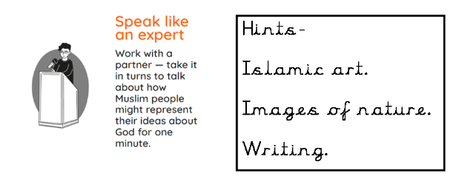  Discuss that Jesus had followers – why might people have followers? Explain what follower’s means and introduce term disciples.  Draw it!- Give the children white boards and ask them to draw what is being described.  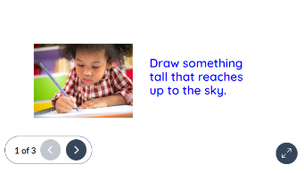  Ask some children to explain their work.  Explain to the children that they heard the same instructions but created different drawings.  This is like how some Hindu people believe that Brahman (the Hindu name for God) can take on many forms.  Recap that many Hindu people believe in one God with many forms (deities). When he creates, like in the creation story, he is called Brahma. Some Hindu people believe that God is too big to understand so they need to use many forms. Compare this similarity to some people who follow the Muslim worldview.  Main:  Hindu deities  Explain that different characteristics of Brahman are shown in gods and goddesses called avatars. Avatars show a form or character taken by God on Earth, just like you may have created a character called an avatar in a computer game to represent you. This is called incarnation (one of the many ways some people understand God – a powerful, non-human being on Earth).  Work through the presentation-  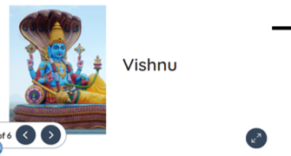  Can anyone remember a special feature of one of the deities? (Any feature like Brahma’s four heads.)  Why do you think each deity looks different? (They represent different forms of God.)  What does it mean when we say, “God has many forms”? (It means God can appear in different ways.)  Activity- Bingo!  Give all the children a Bingo card. Teacher to describe the Avatar, children to mark it off if they think they have it  Plenary:  Children to look at their Bingo sheet and discuss:  - What features can you see?  - What is similar?  - What is different?  Take photos/ video for Seesaw
Lesson 4- What do some Christian People believe God looks like?  Foundational Skills:  Listening and attention – listening to the Christmas story.  Understanding – recognising Christian beliefs about Jesus.  Expressive language – discussing religious symbols.  Learning Objective: To recognise that some Christian people believe Jesus is the son of God and God on Earth.  Success Criteria: I can explain why the Christmas story shows some people believe Jesus is the son of God and God on Earth.  I can identify symbols in the Christmas story that show Christian beliefs about Jesus being the son of God.  Recap and Recall:  Activity – Story recall.  Questions:  • What story did we learn about last lesson?  • Who do Christians believe Jesus is?  Vocabulary recall: Jesus, Christian.  Display the Presentation: Brain dump. Ask the children to discuss everything they learnt last lesson about what some people who follow the Hindu worldview believe God looks like.  Starter:  Explain to the children that they will investigate the question ‘What do some Christian people believe God looks like?’  Read Christmas story from Kapow presentation.  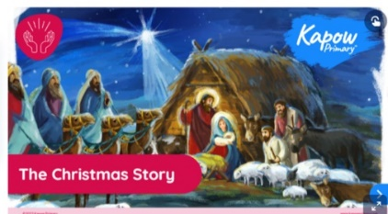  Ask and discuss:  How do you think Mary and Joseph felt when Jesus was born? Can you tell me why? (Children may suggest that: Mary and Joseph felt happy when Jesus was born because they had been waiting for him for so long; they knew that he was very special as he was the son of God.)  Can you remember who visited baby Jesus in the story? (The Three Wise Men and the shepherds.)  Why do you think they travelled so far to see him? (Because they believed he was the son of God.)  How did the shepherds know where to find baby Jesus? (The Angel told them where to find baby Jesus.)  Explain that some Christian people believe that God came to Earth in human form as Jesus to show his love to the world. Because of this, some Christians picture God as a human. Explain that this is similar to the Hindu worldview of incarnation (one of the many ways some people understand God on Earth).  Display slide 7 and identify some of the ways many people who follow the Christian worldview celebrate Christmas such as attending church services, giving gifts and retelling the Christmas story.  Main:  Provide the children with the Activity: Christmas story images (one between two). Ask the children to work with their partner to circle any symbols in the images which show that some Christian people believe Jesus is the son of God and is God on Earth.  Display slide 8 of the Presentation: Christmas story. Click to zoom in on each image one at a time and ask the children:  Plenary:  What do some Christian people believe God looks like? (Some Christian people believe that Jesus is the son of God and is God on Earth; they may believe God did this to show his love to the world and celebrate Christmas to remember when Jesus was born.)  What symbols did you include in your Christmas card to show that some Christian people believe that Jesus is the son of God and is God on Earth? (Answers may include: a star showing that Jesus was a very special baby; baby Jesus in the centre of the picture showing how important he is; the angels; the wise men saw the star in the east and came to worship Jesus bringing gifts; the halo above baby Jesus’ head showing how special he is.) | Lesson 5- Do people all share the same beliefs about what God looks like?  Foundational Skills:  Listening and attention – listening to others’ ideas about religion.  Understanding – recognising similarities and differences.  Expressive language – discussing different representations.  Learning Objective: To discuss some different ways to refer to and represent God.  Success Criteria: I can name and explain how some Christian, Muslim and Hindu people refer to God.  I can identify and describe one symbol or representation of God from each different religion.  I can identify and describe how God is represented in different religions.  I can respect the differences and similarities in how different religions represent God.  Recap and Recall:  Activity – Religion match.  Questions:  • How do Muslims refer to God?  • How do Hindus represent God?  Vocabulary recall: Muslim, Hindu, Christian  S.C: I can name and explain how some Christian, Muslim and Hindu people refer to God.  I can identify and describe one symbol or representation of God from each different religion.  I can identify and describe how God is represented in different religions.  I can respect the differences and similarities in how different religions represent God.  Main:  Display the Presentation: Making links and encourage the children to find links between the images.  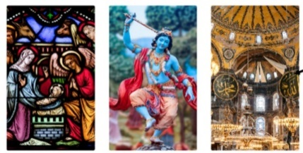  Display the Presentation: Representations of God and click to zoom in on the images of different representations of God that some people who follow the Muslim, Hindu and Christian worldviews may use.  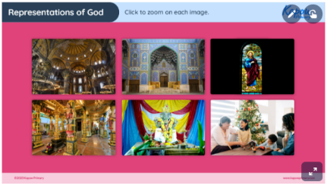  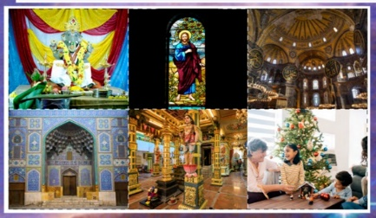  Discuss what are the links between these pictures?  Match up the linked pictures. Then play pairs with the cards. Explain how to play the game:  Shuffle all six cards and place them face down in a grid.  In turns, flip over two cards.  If the cards are connected (for example, two images of God in the human form of Jesus), the child keeps the pair and has another turn.  If they are not connected, they turn the cards back over and their partner takes a turn.  As the game progresses, the children will start to remember where certain cards are, helping them find the pairs.  The game continues until all the pairs have been found. The child with the most pairs wins.  Plenary:  Encourage the children to discuss what they see on the cards, promoting an understanding of how God may be represented in each religion.  Discuss with the children:  Do people all share the same beliefs about what God looks like? (No, some Christian people believe that Jesus is the son of God and is God on Earth; some Hindu people believe that Brahman (God) has appeared on Earth in many forms (deities); some Muslim people believe that Allah (God) does not take a human form.)  Why do you think it is important to respect other people’s beliefs? (Children may suggest that everyone is different and has the right to their beliefs.)  How can we show respect for different beliefs in our everyday life? (Various answers may include listen to others; do not make fun of their beliefs.)  Encourage the children to discuss what they see on the cards, promoting an understanding of how God may be represented in each religion. | Lesson 6- Why do people have different names for God?  Foundational Skills:  Listening and attention – listening to explanations about names for God.  Expressive language – sharing ideas respectfully.  Create and think critically – considering why people use different names.  Learning Objective: To recall some of the different names people use for God.  Success Criteria: I can recognise that God can be called by different names by different people. I can list different names for God. I can explain why people might use different names for God. I can respect the fact that people have different names for God.  Recap and Recall:  Activity – Name brainstorm.  Questions:  • What names have we heard for God?  • Why might people use different names?  Vocabulary recall: Allah, Brahman  Starter:  Display the Presentation: Agree or disagree and ask the children to discuss the statement in pairs.  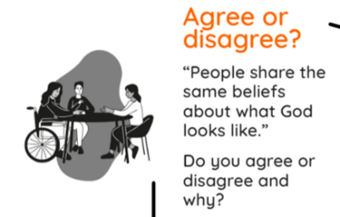  Watch: https://www.youtube.com/watch?v=472AnCrHYVs  Bring a teddy bear or a familiar classroom mascot to the lesson and display the Presentation: Teddy.  Gather the children in a circle. Show them the teddy bear and introduce him as ‘Teddy’. Ask them to think of a different name for him. This could be based on how he looks, what he reminds them of or purely from their imagination.  Pass Teddy around the circle, allowing each child to call Teddy by their chosen name.  Once Teddy has travelled around the circle, discuss the idea that the same teddy can have different names. Record some of these on the presentation and point out that although we called it by different names, it was still the same teddy bear.  Ask the children:  Why did you choose this name for the teddy? (Answers may include cultural reasons.)  Tell the children that there are many different words for Teddy in different languages. In Spanish, teddy is oso de peluche. Play the audio clip on the presentation for the children to listen to the pronunciation. Explain that just like Teddy can have many different names in different languages, people worldwide have different names for their God or gods. Teddy does not give himself a name; other people think of different names for him.  Activity 1: Whole Class:  Ask the children to think about their name and then think about all the different words they would use to describe themselves (e.g. son/daughter, brother/sister, footballer, dancer, singer, friend or helper).  Use yourself as example- mother, teacher, sister etc.  Recap that this is similar to how some Hindu people believe that when God creates, like in the creation story, he is called Brahma. While he is looking after the universe, he is called Vishnu. Some Hindu people believe this is part of a cycle and will be recreated many times. When God replaces a universe, he is called Shiva.  Remind the children that some Muslim people use the Arabic word Allah for God but they also have 99 other names for God. Many people who believe in the Muslim worldview believe Allah created and cares for the world.  Plenary:  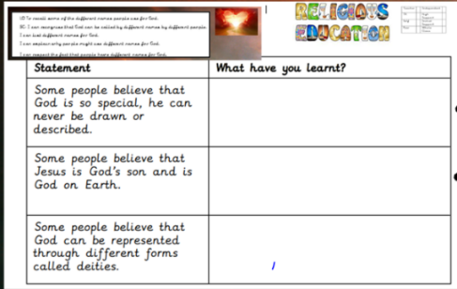  Ask the children: What do some people believe God looks like? (Some Christian people believe that Jesus is the son of God and is God on Earth; many Hindu people believe in one God with many deities that represent the different characteristics of God; some Muslim people believe God is so special, he cannot be described by how he looks.)  Does everyone share the same belief? Does this matter? (Children may suggest no, people have different beliefs; it does not matter because when we gave Teddy different names, he was still the same teddy bear.)
Cross Curricular Links  Literacy – Spoken Language  PHSE – Thinking about own thoughts and beliefs.  Learning Challenge Week- Visit to St Wufrums Church. Explore Christmas Story. Make Christmas cards. Christmas craft afternoon. Take part in Nativity Play.  RSE- Working together and respecting the beliefs of others. |  | Through this unit of work the following essential skills will be developed:  Talking about simple ideas and things that puzzle them about belief in God.  Sharing opinions respectfully about what is important to them and what is important to others.  Expressing their own ideas and opinions based on personal experience and the beliefs of family members.  Asking their own questions about the world around them.  Talking about simple ideas and things that puzzle them about belief in God.  Sharing opinions respectfully about what is important to them and what is important to others.  Expressing their own ideas and opinions based on personal experience and the beliefs of family members.  Asking questions about things that interest them.  Beginning to ask ‘big’ questions (e.g. Why are we here? What is real?).  Retelling stories in their own words.  Recognising lessons or teachings within stories and relating to their own experiences.  Finding religious symbols in stories and other sources.  Recognising some religious terminology in sources.  Listening to others’ ideas and comparing them to their own.  Talking about what their answer to a question is based on.  Identifying things that are important to people.  Noticing differences and using respectful language to discuss them.  Talking about their own experiences in relation to their learning.  Sharing things that make them wonder and what they think about these things.  Talking about what they believe.  espectfully sharing opinions about what is important to them and what is important to others.
Assessment:
Pupils who are secure will be able to:
Recognise that different people have different beliefs about God’s form and appearance.
Explain how art can be used to express feelings towards God.
Recognise that some Hindu people believe God has many forms.
Understand and explain that the story shows some people believe Jesus is the son of God and God on Earth.
Recognise and explain how Christian, Muslim and Hindu people refer to God.
Identify and describe one representation of God from these religions.
Show respect for differences and similarities in how different religions represent God.
Explain why people use different names for God and show respect for the different names for God across religions.

