eography
Music- Musical Symbols (Under the Sea)
By the end of this unit children will know...

Vocabulary

Year 1 Autumn 2- Twinkle Twinkle

How to recognise and name the following instruments: Up to three instruments from Group A and B.
That notation is read from left to right.

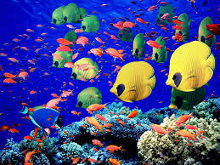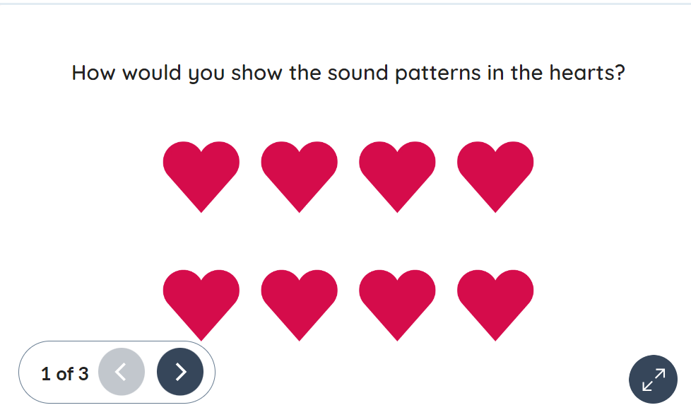
Dynamics, pitch, rest, sound pattern, tempo identify, describe, compare, explain, perform, listen, respond, evaluate

Intention

In this new unit, the children combine all the musical concepts learned throughout Year 1 for an underwater-themed performance incorporating instrumental, vocal and body sounds.

In Reception the children used instruments to tell the story of ‘We’re Going on a Bear’. The children learnt about the tempo and pitch of music and used instruments to play along to songs and tap a steady beat.
unt.’
Musical Symbols (Under the Sea) – Previous Learning

Children will build on their previous learning from Reception where they used instruments to help tell the story ‘We’re Going on a Bear Hunt’. This experience of using sound to represent parts of a story will support them as they continue to explore music and respond to it in different ways. Pupils will develop their listening and attention by listening carefully to pieces of music and noticing changes in sound and tempo. Through active learning, children will respond to the tempo of the music through movement, showing how the speed and feel of the music can influence how we move. Using expressive language, pupils will also discuss what the music might represent and share their ideas about the sounds and feelings they hear.
Learning Links

Music – Musical Symbols (Under the Sea)
Diving into the unknown, children explore the depths of the sea through music, movement, musical symbols, and the playing of tuned percussion instruments. They engage in activities that allow them to express the mysterious underwater world, such as using their bodies to mimic the movement of sea creatures. They learn to interpret musical symbols to translate visual cues into sounds and play tuned percussion instruments, to represent the wonders of the underwater world.
Knowledge Progression Across the Unit:  Lesson 1 – Explore tempo through movement.  Lesson 2 – Explore dynamics using instruments.  Lesson 3 – Clap rhythmic patterns while keeping the pulse.  Lesson 4 – Interpret pitch symbols using voice and instruments.  Session 5 – Perform a piece combining pitch, rhythm and dynamics.  Key Objectives:  ∙To explore tempo changes through movement.  ∙To explore how dynamics can be represented by different symbols.  ∙To clap simple rhythmic patterns while keeping the pulse.  ∙To interpret symbols to demonstrate a pitch pattern.  ∙To perform as part of a group to demonstrate dynamics, pitch and rhythm  National Curriculum:  Pupils should be taught to:  Experiment with, create, select and combine sounds using the inter-related dimensions of music.  Play tuned and untuned instruments musically. | Lesson 1- Showing Tempo  Foundational Skills:  Listening and attention – listening carefully to music.  Active learning – responding to tempo through movement.  Expressive language – discussing what the music represents.  Learning Objective: To explore tempo changes through movement.  Success Criteria: I can move to reflect the tempo of the music. I can change the tempo of my actions to show different speeds of movement.  Recap and Recall:  Retrieval Activity – Music memory.  Questions:  • What is tempo?  • How can we move to show slow or fast music?  Vocabulary recall: tempo, speed  Starter:  Play the Audio: Under the sea.  Explain that the music represents a diver swimming under the sea.  Invite the children to play the role of the diver and ‘swim’ around the room to the music.  Questions  What speed were you swimming at? Why? (The children may have moved slowly as the music was slow.)  What might the diver have seen under the water? (Fish, seaweed, sand, rocks, coral reef, pebbles, other divers.)  What speed would these things move at? (For example, fish swimming very fast or seaweed swaying slowly.)  Main:  Explain that the children will use tempo and body movements to tell a story about a busy day under the sea.  Display slide 1 of the Presentation: A busy day under the sea and split the children into three groups:  Group 1: turtles.  Group 2: divers.  Group 3: dolphins.  Activities:  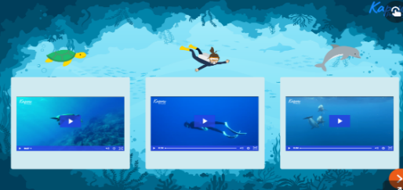  Ask each group to come up with a movement and a sound for their character. The movement chosen by each group will be repeated at different tempos during the story. Ideas could include:  Divers:  swimming stroke arm movements;  lying on their front and kicking their legs;  blowing through the mouth to make breathing sounds or making vocal sounds to represent water splashing.  Dolphins:  jumping quickly on the spot;  fast vocal sounds to represent water splashing.  Turtles:  slow and steady arm and hand movements.  gliding slowly around the room;  a low, steady humming sound to represent a slow pace of movement.  Using slides 2-7 of the Presentation: A busy day under the sea, invite the groups to perform their movements and sounds as you tell the story.  Optionally, use the Audio: Under the sea (see Attention grabber) and play the piece of music to accompany the children’s movements while displaying the presentation slides.  If time allows, retell the story several times, with children swapping groups to perform different movements and sounds. Pause the action at different points to ask the children how the tempo of their movements changes with each character.  Plenary:  Discuss with the children what other creatures may be found in the ocean.  Choose one and suggest the children create a movement and sound for it, thinking about an appropriate tempo (for example, sliding slowly as an octopus or darting quickly like a small fish swimming away from a whale). | Lesson 2 - Exploring Dynamics  Foundational Skills:  Listening and attention – listening to changes in volume.  Understanding – recognising loud and quiet sounds.  Active learning – experimenting with instruments.  Learning Objective: To explore how dynamics can be represented by different symbols.  Success Criteria: I can hear loud and soft (quiet) sounds in a piece of music. I can use an instrument to play loud and soft. I can read symbols to play loud or soft.  Recap and Recall:  Retrieval Activity – Loud or quiet game.  Questions:  • What does loud mean in music?  • What does quiet mean in music?  Vocabulary recall: loud, quiet, dynamics  Starter:  Arrange the children into pairs. Play the Audio: Deep Ocean (0:00-0:30).  Ask the children:  How does the tempo change? (It starts off slow, speeds up and then slows down before stopping.)  How could this tell a story about what is happening underwater? (Answers could include: the music representing fish swimming slowly underwater before swimming faster as more join or a diver swimming slowly then faster as they follow a fish.)  Play the rest of the audio and ask the children to move like a dolphin or a diver in time to the piece of music.  Main:  Display the Presentation: Fish and play the audio.  Explain that under the sea, there are fish of all different sizes. Ask the children what they think the different-sized fish could represent when thinking about sounds.  Reveal that the different size fish tell us about the different volumes in music (some sounds are louder than others).  Explain that in music we can use dynamics (volume) to show size. A small fish would make a quiet sound, but a big fish would make a loud sound.  Activities:  Place the instruments (one each) in front of the children.  Explain that the sounds these instruments make represent the different-sized colourful fish seen in the Presentation: Fish (see Attention grabber). Continue to display this throughout the following activity for support if needed.  Invite the children to experiment with their instruments to create soft and then loud sounds to represent the fish in the picture, by reading them left to right. Remind the children to treat the instrument with care when playing loudly; model how to do this if required.  Ask a few children to demonstrate how they have created soft or loud sounds on their instruments. Discuss the difference in the way these are played.  Invite the children to practice looking at the picture in the presentation and following it (point to each area of the picture separately if needed) to make a sound representing either the large or small fish. The children are not expected to play the exact number of fish in each picture; rather to show the ability to demonstrate a contrast between soft and loud.  Divide the class into two and explain one half will play the sounds representing the large fish, while the other half will play the sounds representing the small fish. Signal for the class to play these sounds at the same time, representing the whole picture. Allow groups to swap over which fish they are representing.  Activities:  Pupils needing extra support: Would benefit from using the Dynamics movement visual prompt resource to show them when to be loud/quiet.  Pupils working at greater depth: Should be encouraged to use musical terminology when describing the music and challenged to give their own definitions of these terms and explain them to their peers.  Plenary:  Ask the children to perform their pieces once more, this time recording them on a device.  Listen to or watch back their pieces, discussing if the dynamics they have used represent the images of the fish accurately. | Lesson 3- Rhythm  Foundational Skills:  Listening and attention – listening to rhythmic patterns.  Understanding – recognising repetition in sound patterns.  Active learning – clapping rhythms together.  Learning Objective: To clap simple rhythmic patterns while keeping the pulse.  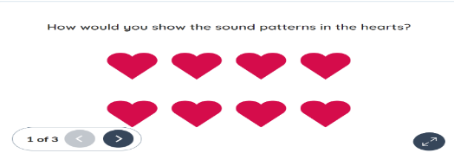  Success Criteria: I can recognise and describe repetition In two sound patterns. I can read sound pattern symbols from left to right. I can clap simple rhythmic patterns comprising one beat sound and one beat rest.  Recap and Recall:  Retrieval Activity – Clap the pattern.  Questions:  • What is a rhythm?  • What is a pulse?  Vocabulary recall: rhythm, pulse  Starter:  Arrange the children into pairs and display the Presentation: Explain the answer.  Ask them to think of a sound effect that represents the image, such as the sound of bubbles or the diver swimming.  Encourage them to consider what they learnt in the previous lesson on dynamics (volume).  Explain and answer presentation. Look at pictures and explain what sound would match them. Take feedback.  Some children may present their own sound effects vocally, whereas others may describe a sound effect that could be produced using an instrument.  Encourage the children to explain why their sound effect represents the image.  Praise efforts to describe their sound effect using the words loud and soft.  Main:  Display the Presentation: Underwater diver.  Play the audio button (camera click) and ask the children:  What could the sound be? (The click of a camera as the diver is taking photos.)  What might she take photos of? (For example, fish, dolphins or coral reefs.)  Explain to the children that they can find out how many photos the diver takes by listening carefully to the following audio (you may need to play the audio more than once).  Listen to Camera click rhythm 1 and 2.  Ask the children:  How many sounds were in the first clip? (2)  How many sounds were in the second clip? (4)  Were there any gaps in the sounds? (Yes, there were 2 gaps in the second clip)  Play both audio files again, asking the children to clap back each rhythm, respectively.  Activities:  Display the Presentation: Camera rhythms.  Explain that each heart represents a beat. Ask the children to suggest how they would represent the Audio: Camera click rhythm 1 in the hearts using a line inside the hearts to represent when the click happens. (The pattern would be a vertical line in the first heart, a blank heart, a line in the third heart and a blank fourth heart).  Once various suggestions have been taken, display slide 2 with the correct pattern.  Repeat with Audio: Camera click rhythms 2, displaying slide 3 with one line in each heart to match the rhythm.  Arrange the children in pairs and invite them to practice clapping each pattern in turn, then both patterns after each other without a gap. Emphasise the need for a steady beat. Model this first if needed.  Listen to different pairs, offering feedback.  Plenary:  Play the Audio: Underwater and invite the children to show the pulse by nodding their heads.  Say, “Ready, steady, off we go,” and invite the children to clap the two rhythms one after the other to the Audio: Underwater, while keeping the pulse with their heads. Model this first if the children are struggling.  Repeat the rhythms a few times.  Divide the class into two groups.  Ask one half to clap to the first rhythm and the other half to the second rhythm.  Finish with the whole class clapping both rhythms together and nodding their heads to the pulse.  Ask:  How did we show the pulse? (With our heads.)  How is the pulse represented in the picture? (By the hearts.)  What did we use our hands for? (To clap the sound pattern of the camera clicks.)
Lesson 4- Using Pitch  Foundational Skills:  Listening and attention – listening to changes in pitch.  Understanding – recognising high and low sounds.  Active learning – playing pitch patterns using instruments.  Learning Objective: To interpret symbols to demonstrate a pitch pattern.  Success Criteria: I can use my hand and body to show high and low. I can use my voice to show high and low. I can use an instrument to play high and low sounds, while reading high and low symbols. I can read symbols from left to right. I can make high, low, loud and soft sounds. I can read different sound patterns. I can follow a leader.  Recap and Recall:  Retrieval Activity – High or low.  Questions:  • What does pitch mean?  • How can we show high and low sounds?  Vocabulary recall: pitch, high, low  Starter: Play Audio: Underwater and ask the children to close their eyes and listen to the audio, imagining what they might see considering the piece is called ‘Underwater’.  Take feedback. Children’s answers may include:  Swimming fish.  A diver slowly swimming under the sea.  Slow waves.  Waving seaweed.  Swimming dolphins  Main:  Ensure you can access the Presentation: Vertical glockenspiel without displaying it to the children.  Explain that sounds can be loud or soft (this is called dynamics) or high or low (this is called pitch).  The children will listen to sounds that are going to change in pitch.  Explain that if they hear a note that is higher than the last, they will stand up; if they hear a note that is lower than the last, they will sit down.  Using the Presentation: Vertical glockenspiel, click on the bars on the glockenspiel (up to six) to play sounds that vary in pitch to the class. It may be useful to play notes that are far apart first, as this makes it easier to identify a change in pitch (e.g. C, B, D, B, E, G).  Repeat the sequence and discuss with the children how the pitch changed.  Repeat the exercise, this time inviting the children to remain seated and use their hands to show the change in pitch. They may close their eyes if appropriate. On the last go, play a note that is the same (e.g. C, A, D, B, E, E). Again, repeat the sequence, drawing the children’s attention to the last two notes. See if they identified the notes as the same and, therefore, kept their hands in the same place.  Activities:  Display the Presentation: Underwater diver and ask the children the questions below:  What do you notice about the patterns of the divers? (Some are high and some are low, there are groups of divers similar to each other.)  If the divers were sounds, would they be high or low notes? Why? (The ones at the top of the screen would be high and the ones at the bottom would be low because that is how we represent high and low notes.) Reference the first three divers (towards the top of the screen) and make two high vocal sounds, a low sound and a final high sound with your voice.  Ask the children if the sounds you made accurately represent those divers. (No, as there are only three divers (symbols) in that part of the picture, not four and the divers are all ‘high’ up in the picture and therefore should all be represented with high notes).  Group the children into pairs and ask them to use their voices to make sounds that represent the first three diver symbols. Circulate and guide any children who are unsure (the first part should use three high sounds).  Point to the other diver symbols and ask what the difference is between them (two symbols are lower down the page, and two are higher up). Ask the children to work in their pairs and create vocal sounds to match this part of the picture.  Ask selected pairs to demonstrate their vocal sounds and give feedback on whether the sounds match the picture (two low sounds that are the same and two high sounds that are the same).  Ask the class to use vocal sounds to show the whole picture and to sit down if they use a low sound and stand up if they use a high sound.  Display the Presentation: Vertical glockenspiel  Ask the children where the highest and the lowest sounds are (the lowest sound is at the bottom, on the longest bar, and the highest at the top, on the shortest bar).  Click to play the notes to confirm the children’s responses.  Hand out the instruments placing them just in front of the children.  Remind the children to use the instruments carefully and holding the beaters lightly. Model this if needed.  Display the Presentation: Underwater diver. Using their voices to help them, invite the children to work in pairs and use the instruments to play the different symbols, creating a sound pattern (high, high, high, low, low, high, high).  Plenary:  Invite different pairs to demonstrate their sounds matching the symbols on the Presentation: Underwater diver using their instruments.  Ask the rest of the class if they could hear three high sounds, two low sounds and two high sounds.  Invite the class to play the picture together while pointing to the different symbols. | Session 5- Under the Sea Performance  Foundational Skills:  Listening and attention – listening to group performance cues.  Active learning – performing together using instruments and voices.  Create and think critically – combining musical elements.  Learning Objective: To perform as part of a group to demonstrate dynamics, pitch and rhythm.  Success Criteria: I can read symbols from left to right. I can make high, low, loud and soft sounds. I can read different sound patterns. I can follow a leader.  Recap and Recall:  Retrieval Activity – Symbol check.  Questions:  • What musical symbols have we used?  • What do the fish, divers and bubles represent?  Vocabulary recall: symbol, perform  Starter:  Display the Presentation: Agree or disagree?  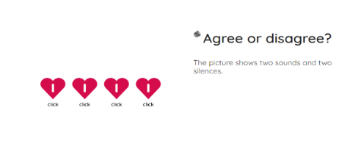  Main:  Display the Presentation: Under the sea.  Discuss:  What different symbols can you see in the picture? (Fish, divers, bubbles, cameras and some hearts.)  How did you use the instruments when looking at the fish? (Playing loudly and softly.)  How did you use the instruments when looking at the diver? (Playing high and low sounds.)  What did you do when you looked at the rhythms in the hearts? (Clapped out the patterns.)  Activities:  Group the children into four or five groups and display the Presentation: Under the sea.  Explain that the children will need to follow the presentation from left to right; the divers (pitch – high), rhythms, divers (pitch – low) and finishing with the fish (dynamics – loud then soft).  Emphasise that the rhythms in the bubbles should be clapped, so that the children will need to practise putting their instruments down, clapping the rhythms, then picking them back up to continue with the piece.  Check that the children understand what each symbol represents. Model this if needed.  Allow each group some time to work out how to play each element. Praise groups that are looking at the presentation and trying to represent the different symbols in the correct order (e.g. playing three high sounds in a row).  Appoint a leader for each group and encourage them to signal when each element of the piece should start and when they should stop. These signals can be modelled first and you may wish to explicitly practise this with the children.  Plenary:  Allow each group to perform their piece representing the symbols in the  presentation. Record each performance.  After each performance, ask the rest of the class:  Did the group represent the diver, bubbles and fish correctly? (Three high sounds, one clap, one rest, one clap, one rest, four claps (no rest), two low sounds, some loud sounds, finishing with some soft sounds.)  Optional – provide each child with the Quiz – pupil answer sheet and display the Unit quiz (see link: Assessment – Music Y1: Musical symbols). Read each question aloud and allow the children time to answer. Reveal the answers and ask them to self/peer mark their answer sheets.
Cross Curricular Links:  English: Writing – transcription - name the letters of the alphabet  English: Spoken Language - participate in discussions, presentations, performances, role play, improvisations and debates.  Physical Education- Moving to music. |  | Through this unit of work the following essential skills will be developed:  Listening with concentration to short pieces of music or excerpts from longer pieces of music. Engaging with and responding to longer pieces of music. Coordinating the speed of their movements to match the speed of the music (not the beat). Beginning to articulate how a piece of music affects them (e.g. it makes them feel sleepy, it makes them want to dance, it makes them happy). Identifying some common instruments when listening to music. Relating sounds in music to real-world experiences (e.g. “it sounds like squelching mud”). Talking about the tempo of music using the vocabulary fast and slow. Talking about the dynamics of the music, using the vocabulary loud, quiet and silent. Talking about the pitch of music, using the vocabulary high and low. Stating what they enjoyed about their peers’ performances. Reading different types of notation by moving eyes from left to right as sound occurs. Creating sound responses to a variety of physical stimuli, such as nature, artwork and stories. Experimenting with creating different sounds using a single instrument. Experimenting with creating loud, soft, high and low sounds. Selecting objects and/or instruments to create sounds to represent a given idea or character. Offering positive feedback on others’ performances. Showing awareness of the leader, particularly when starting or ending a piece.
Assessment -
Pupils with secure understanding indicated by: Moving to reflect a character. Creating sounds to reflect a character. Moving at a speed that reflects the tempo of the audio. Responding to dynamic changes without prompting. Demonstrating a sound pattern correctly to a pulse. Singing and play high and low sounds. Reading symbols representing high and low sounds correctly. Demonstrating an awareness of pitch, rhythm and dynamics within a performance and recognise the symbols representing these.
Pupils working at greater depth indicated by: Coordinating the speed of their movements to match the speed of the music (not the beat). Beginning to move in time with the beat of the music. Relating sounds in music to real-world experiences. (e.g. it sounds like squelching mud). Talking about the tempo of music using the vocabulary of fast and slow. Talking about the dynamics of the music, using the vocabulary of loud, quiet and silent. Talking about the pitch of music, using the vocabulary of high and low. Developing an awareness of how dynamics are affected by the force with which an instrument is played.

