eography
Design Technology- Mechanisms: Making a moving storybook
By the end of this unit children will know...

Vocabulary

Year 1 Autumn 2- Twinkle Twinkle

A mechanism is the parts of an object that move together.
A slider mechanism moves an object from side to side or up and down.
A slider mechanism has a slider, slots, guides and an object.
Bridges and guides are bits of card that purposefully restrict the movement of the slider.

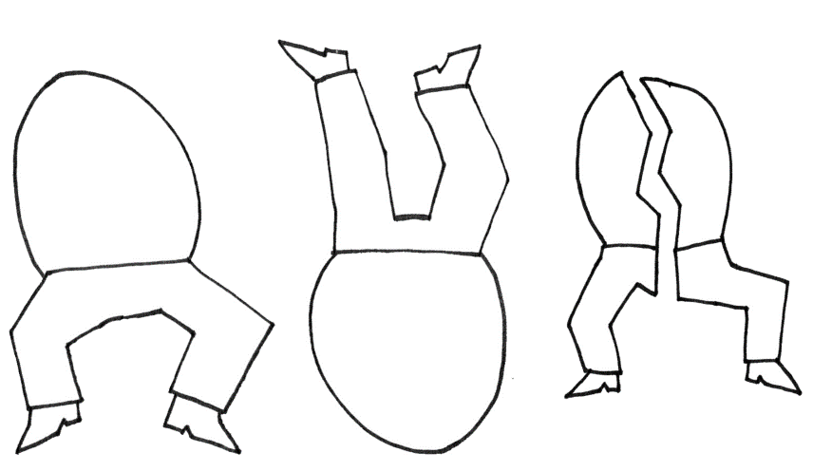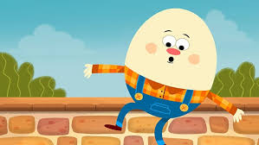

Adapt, assemble, compare, describe, design, design criteria, evaluate, input, improve, lever, mechanism, model, sliders, slot, test

Intention

In this unit the children will explore slider mechanisms and the movement they output to a design. They will then use slider mechanisms to make and evaluate a moving storybook based on ‘Humpty Dumpty’.

In Reception the children made models in the model making areas. They developed their joining, cutting and sticking skills. The children design and make boats and talk about how the boat move.

Mechanisms: Making a moving storybook- Previous Learning

Children will build on their previous learning from Reception where they made models in the model-making area and developed their joining, cutting and sticking skills. This experience will support them as they begin to explore simple mechanisms in their designs. Pupils will develop their listening and attention by carefully listening to explanations about how mechanisms work. Their understanding will grow as they recognise how levers and slots can be used to create movement within a model. Through active learning, children will explore and experiment with creating their own mechanisms, applying their previous model-making skills while developing new ways to make parts move.
Learning Links

Design Technology- Mechanisms: Making a moving storybook
In this unit the children will explore slider mechanisms and the movement they output to a design. They will then use slider mechanisms to make and evaluate a moving storybook based on ‘Humpty Dumpty’.
Knowledge Progression Across the Unit:  Session 1 – Explore levers and slots.  Session 2 – Design a moving storybook.  Session 3 – Construct a moving storybook using sliders.  Session 4 – Evaluate a finished moving storybook.  Key Objectives:  To explore making mechanisms  To design a moving Jack in the Box.  To construct a moving Jack in the Box.  To evaluate my finished product.  National Curriculum:  Pupils should be taught to:  Explore and evaluate a range of existing products  Explore and use mechanisms [for example, levers, sliders, wheels and axles]  Design purposeful, functional appealing products for themselves and other users based on design criteria  Generate, develop, model, and communicate their ideas through talking, drawing, templates, mock-ups and, where appropriate, information and communication technology  Select and use a range of tools and equipment to perform practical tasks (for example, cutting, shaping, joining and finishing)  Select from and use a wide range of materials and components, including construction materials, textiles and ingredients, according to their characteristics  Explore and evaluate a range of existing products  Evaluate their ideas against design criteria | Lesson 1 -Levers and Slots  Foundational Skills: Listening and attention – listening to explanations about mechanisms.  Understanding – recognising how levers and slots create movement.  Active learning – exploring and creating mechanisms.  Learning Objective: To explore levers and slots.  Success Criteria: I can say what a lever and slot is. I can demonstrate how to use a lever and a slot. I can make a lever and a slot.  Recap and Recall:  Retrieval Activity – Movement discussion.  Questions:  • What objects move around us?  • What might make something move?  Vocabulary recall: move, mechanism  Starter:  Watch: ‘The Mighty Mathematics of the Lever.’  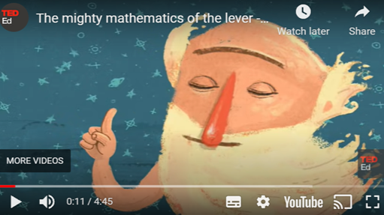  Discuss what a lever is.  Watch (up to 38 seconds):  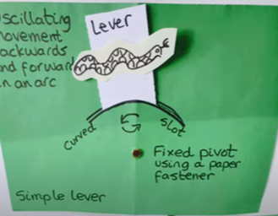  Explain to the children that this shows where the lever and slot is. TTYP: What have you noticed?  Ask the children: How do we make a slot?  Main:  To start:  Yellow and green groups colour and cut out the car picture. Then glue the car to a lollipop stick. The lollipop stick will act as a handle. Tell the children that this will be the slider.  Blue and red groups choose a road and fold it in half lengthways and cut down the middle of the road.  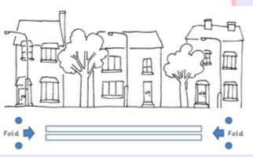  Once children have finished their first activity ask them to change over to complete the other activity.  Plenary:  Children then place their lollipop stick car into the slot and ask them to demonstrate how the car can move along the road. Video the children doing this for Seesaw.  Discuss:  What have you done well?  Did you make any mistakes?  How could you make your lever and slot better next time?  Video the children’s answers for Seesaw. Then add QR code to back. | Lesson 2- Moving Story Book  Foundational Skills:  Listening and attention – listening to story events.  Expressive language – discussing ideas for a design.  Create and think critically – planning how movement will work.  Learning Objective: To design a moving story book.  Success Criteria:  I can design three pages of my moving storybook by: Drawing background pictures. Drawing the moving parts. Deciding whether I will use a side-to-side slider or an up-and-down slider on each page. Labelling the movement of each type of slider.  Recap and Recall:  Retrieval Activity – Mechanism memory.  Questions:  • What did we learn about levers and sliders?  • How do sliders move?  Vocabulary recall: lever, slider, slot  Starter:  TTYP: What did you learn last week about how things can move?  Main:  Watch: ‘Humpty Dumpty’:  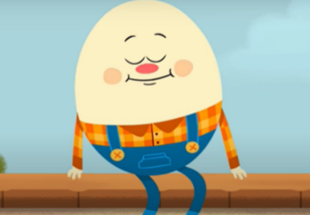  Ask the children to recap the three main events in the story: Humpty Dumpty sitting on a wall. Humpty Dumpty falling off the wall. The King’s men trying to put Humpty Dumpty together again. As children say each event uncover event on notebook.  TTYP: What can you remember about last week?  Tell the children that they’re going to plan a moving story board like they made last week. Tell the children that they are going to present their story boards to the children in reception. Tell the children that the reception children are called their target market. Ask the children what we know about the target market (reception aged children). Get the children to think about what reception aged children like and dislike about books. (Do they want colourful pictures, funny pictures, big or small pictures?) Ask the children to share their thoughts with the class.  Explain that we can’t use words in our moving story. The children need to make sure that their moving pictures tell the story without using words. Give the children time to discuss how they could do this with a partner. TTYP: How could we do this?  When you have gathered enough of the children’s ideas, write a ‘design criteria’ on the board based on what they have said (for example, bright colours, cartoon pictures, varied movements, large and sturdy sliders so that the moving parts don’t break easily). Tailor the number and the complexity of points in the design criteria to the class. Make sure the design criteria is saved, as this will be needed to refer to in this unit’s third and fourth lessons.  Discuss the following points with the children in relation to the three different parts of the story: How will you tell the part of the story through a picture? What movement might there be in that part of the story? Where might that part of the story be set? What would the background look like? Explain that we need to plan what we will do before making anything. In Literacy, we use story mountains, mind maps and paragraph plans but in Design and Technology, we have a different word for a plan: a ‘design’. Discuss: How will we put our design on paper? What details might we want to record on our design?  Explain to the children that first they are going to design the background. Children to draw the background they are going to use for each of the events in ‘Humpty Dumpty’.  TTYP: Who are the moving parts? Children to write the names of the people/horses on the sheet for the moving parts. Ask the children to think about how they want the characters to move. Ask them to add the word; lever or slider for each event. Ask them to then draw an arrow to show the direction of travel.  Children to complete their story book templates.  Plenary:  Number the children one and two, and ask all ‘ones’ to find a ‘two’ and explain their plan. Then repeat, finding a different partner. Now do the same for twos so that they can share their ideas; again, repeat. The children may want to adapt or amend their plans based on what they have seen or heard from others. Allow them a few minutes to amend their ideas as/if necessary. | Lesson 3- Constructing a Moving Story Book  Foundational Skills:  Listening and attention – following instructions carefully.  Active learning – constructing a product using tools and materials.  Understanding – recognising how sliders create movement.  Learning Objective: To construct a moving storybook.  Success Criteria: I can make my moving picture by: Drawing my background. Drawing and cutting my moving parts. Making sliders for my moving parts. Putting all my parts together to create my moving picture. Possibly making guides and bridges.  Recap and Recall:  Retrieval Activity – Design check.  Questions:  • What story are we using for our book?  • What movement will your design include?  Vocabulary recall: design, movement  Starter:  Ask the children of they agree or disagree-  All things move up and down like a ball.  Ask the children to explain why they think this.  Tell the children that today they are going to make their moving story. TTYP: Can you remember which story we are going to make?  Show the children the class design criteria created in Lesson 2: Design (see the Attention grabber). Go over the points, reminding the children of what they are going to make and for whom it will be made.  Display the design template created and modelled with the help of the children in Lesson 2: Design to remind the class of the project and what they are going to make. Ask the children if they remember how they made slots in Lesson 1. The children may need to be directed to use a ruler. Remind the children that all sliders should be made from either a lollipop stick or stiff card.  Main:  Watch the Kapow Pupil video: Construction  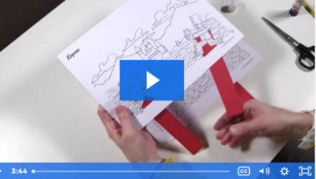  Explain that this is what we are doing today.  They start by colouring their background. Children to draw just one background then teacher photocopy to create 3 identical backgrounds.  Give the children the Humpty Dumpty templates. Ask them to colour them and cut them out neatly. Remind the children to put their names on the back of them. Then give the children the kings men templates. Ask them to colour them and cut them out neatly. Remind the children to put their names on the back of them.  Remind the children how to make the levers and slots by watching:  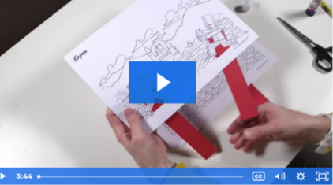  Giving these resources to the children will allow them to concentrate on making the sliders and the assembly of their project. If the children’s backgrounds are printed, or the Activity: Storybook page template is used, these should be glued onto card to make them stronger.  Plenary:  Ask children to sit quietly for a moment, looking at their finished products. Ask them to ask a friend:  - What was the easiest part?  - What was the hardest part and WHY?  - What would you do next time?  Film children’s answers for Seesaw.
Lesson 4- Evaluating Moving Story Book
Foundational Skills:
Listening and attention – listening to feedback from others.
Expressive language – evaluating a finished product.
Create and think critically – suggesting improvements.
Learning Objective: To evaluate a moving story book.
Success Criteria: I can review the success of my product by testing it (reading it to reception children). I can evaluate my product against the design criteria. I can consider what I have learnt from making my moving storybook.
Recap and Recall:
Retrieval Activity – Product review.
Questions:
• What did you build last lesson?
• Did your slider move the way you expected?
Vocabulary recall: evaluate, improve
Starter:
TTYP: 3 things that you have learnt about sliders and movement from last week and 1 question about sliders and movement.
Main:
Show the children a selection of pictures (on notebook). Ask the children what they would change about each of the designs and why? Ask the children if they can think of anything in their homes that they could adapt to make even better. Tell the children that designers often make many prototypes (drafts) before they get everything right. Making small adjustments to a design is an important part of the design process as it makes the end product better and easier to make.
Plenary:
Tell the children that they are going to test their moving storybook designs and decide on what adjustments need to be made. Explain that they are going to share their books with children in reception. Ask the Willows to share their books with the Acorns and the Maples to share their books with the Caterpillars. Go into the reception classes. When the year 1’s are with the reception children remind them to ask:
-What do you like about my storybook?
- What don't you like about my storybook?
- What would make my storybook better?
Thank the reception children for looking at the story books and for answering questions about them. All children to complete the evaluation sheet for their moving story book by colouring a word that why they like/dislike it, writing an idea of how they could make it better and finally giving it a star rating.
Learning Challenge Week:
Make a Pop-Up Christmas Card using a lever and slot mechanism – Father Christmas popping out of a chimney.
Cross Curricular Links:  English- Reading and reciting Nursery Rhymes |  | Through this unit of work the following essential skills will be developed:  Explore and use mechanisms [for example, levers, sliders], in their products. Evaluate their ideas and products against design criteria. Explore and evaluate a range of existing products. Select from and use a wide range of materials and components, including construction materials, textiles and ingredients, according to their characteristics. Select from and use a range of tools and equipment to perform practical tasks [for example, cutting, shaping, joining and finishing. Generate, develop, model and communicate their ideas through talking, drawing, templates, mock- ups and, where appropriate, information and communication technology.
Assessment:
Pupils with secure understanding indicated by: Identifying whether a mechanism is a side-to-side slider or an up-and-down slider and determining what movement the mechanism will make. Able to cut slots and insert sliders to demonstrate mechanism. Clearly labelling drawings to show which parts of their design will move and in which direction. Having made a picture, which meets the design criteria, with parts that move purposefully as planned. Evaluating the main strengths and weaknesses of their design and suggesting alterations.
Pupils working at greater depth indicated by: Identifying if a mechanism is a side-to-side slider or an up-and-down slider, determining what movement a mechanism will make. Able to cut slots and insert sliders to demonstrate mechanism. Able to predict what mechanism would be needed to achieve given movements. Clearly labelling the moving parts and mechanism of a design that has multiple parts, moving in different ways on each page. Having made a finished product with multiple parts that move purposefully as planned. Where parts do not move as planned they are able to explain why and how they would be fixed. Evaluating the main strengths and weaknesses of their design and suggesting meaningful alterations that will address these weaknesses.

