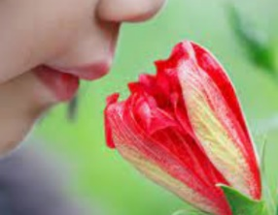
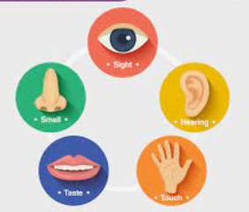
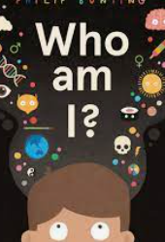

Autumn 1 Who Am I?

Essential Knowledge

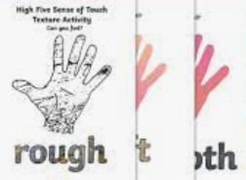
By the end of this unit, children will demonstrate independently...

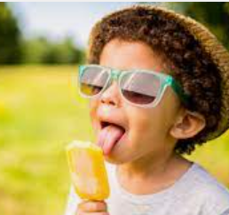
- Knowledge of the human skeleton, including naming different parts and bones.
- Knowledge of the five senses.
- Name the five senses.
- How to describe different textures.
- How to describe different tastes.
- How to describe different sounds.
- How to describe different smells.

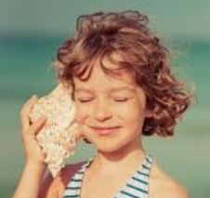

Who Am I?
Vocabulary

Body, skeleton, bones, leg, arm, chest, ribs, fingers, toes, hands, feet, head, sight, hearing, taste, touch, smell, senses, experiment, predict, listen, see, feel, protect, organ, heart, lungs, brain, texture

For Autumn 1 Science the children will be learning about ‘Who am I?’ the topic will teach the children how to name the parts of their body and some bones, focusing on bones that protect organs in the body. After learning about the skeleton the children will move on to learn about the five senses; touch, sight, hearing, smell and taste. They will learn to conduct a basic experiment and focus on using describing words associated with these senses. For example, ‘the pineapple feels hard and prickly’. The children’s learning will be enhanced during learning challenge week when they will have opportunity to design their own ‘senses station’ to share their knowledge with the EYFS children.

In Reception the children read ‘Funnybones’ and discussed parts of the body. They used the names of parts of the body when they learnt about being a doctor, during ‘The Helpful Patrol’ unit of work in Spring 1. They also build on previous knowledge gained in PE lessons, in which they discussed affects of exercise on the body. The children talked about their family on Well-Being Day as part of PSHE. They also bought in photos of themselves as babies discussed how they have grown and changed.

Who am I?- Previous Learning

Children will build on their previous learning from reading Funnybones and discussing parts of the body, as well as their experiences in the ‘Helpful Patrol’ unit where they explored the role of a doctor. They will also draw on their knowledge from PE lessons where they discussed the effects of exercise on the body. In this learning, pupils will listen carefully to explanations about different parts of the body, developing their listening and attention skills. Through discussion and activities, children will use expressive language to name and talk about body parts, reinforcing vocabulary they have previously learnt. Through active learning opportunities, pupils will identify and label different body parts, helping them to deepen their understanding of how the body works and why it is important to look after it.
Learning Links

Who am I?
Key Objectives:  To be able to identify, name, draw and label the basic parts of the human body.  To understand bones protect organs.  To be able to say which part of the body is associated with which sense.  To be able to describe different smells, tastes, textures and sounds. | Lesson 1- Parts of the Body  Foundational Skills:  Listening and attention – listening to explanations about the body.  Expressive language – naming body parts.  Active learning – identifying body parts.  Learning Objective: To identify, name, draw and label basic parts of the human body.  Success Criteria: I can verbally say what the basic parts of the body are. I can recognise where those body parts are. I can label the basic body parts using real bodies.  Recap and Recall:  Activity – Point to the body part game.  Questions:  • What body parts can you name?  • Which body part helps you see?  • Which body part helps you hear?  Starter:  Explain to the children that we will be doing science. Discuss with the children what science is. Watch the 2 ‘What is Science?’ videos. (Links on notebook)  Introduce a new KWL grid – explain what each part is. Explain we will be filling this in as a class.  Show children the first box. What goes in this box? Add the children’s ideas.  Sing ‘Head, Shoulders, Knees and Toes.’ Ask the children to join in. TTYP: Can we add any other body parts into the song?  Watch the parts of the human body.  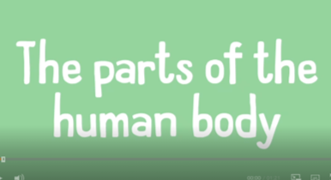  Main:  Talk partners – what part of the human body can they name? Write down a list on the board. Add any that the children might have missed. Be sure to include: ear, back, elbow, eye, hip, rib, tongue, fingers, feet, knee, back, nose, toes, wrist, chin, head, neck, ankles and thigh.  Run down the list created and ask children to point to each part of the body.  Watch X-rays video. (Link on notebook)  Show children a selection of x-rays. Ask children to  write on their whiteboard the part of the body they think the X-ray is showing.  Tell the children that they going to have a go at labelling each other and all the different body parts. Put the children in mixed ability groups and give them a set of stickers to label the body parts of 1 of the children in the group. ear, back, elbow, eye, hip, rib, tongue, fingers, feet, knee, back, nose, toes, wrist, chin, head, neck, ankles and thigh. (Remind the children that they need to work as a team.  Take photos for pic collage.  Plenary:  Work through the labels asking the children to point at the various parts. Video for Seesaw and add QR code to pic college sheet. | Lesson 2- Creating a Skeleton  Foundational Skills:  Listening and attention – listening to explanations about skeletons.  Understanding – recognising bones protect organs.  Create and think critically – asking questions about bodies.  Learning Objective: To identify, name, draw and label the basic parts of the human body.  Success Criteria: I can create my own skeleton and label the basic parts of the skeleton. I can make comparisons between different bodies and question how we are all different.  I can explain how some bones protect the human body.  Working Scientifically: To use observations and ideas to suggest answers to questions.  Recap and Recall:  Activity – Body part quick draw.  Questions:  • What body parts did we learn last lesson?  • What bones do you remember?  • What do bones protect?  Starter:  Introduce the idea of a skeleton with a model skeleton. What do we notice? Are there any bones we can name? Can you find those bones on your body?  Watch the skeleton video:  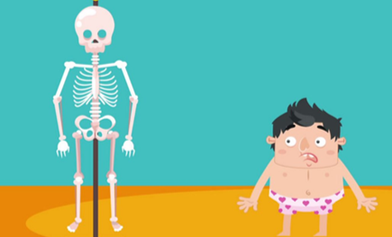  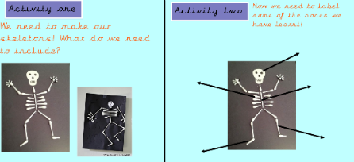  Main:  Then read through quiz asking if the children can suggest the missing words.  Show the children the bone pictures on the smart notebook. Ask the children if they can name any of the bones.  Work through the bones and speak about how they protect the heart, lungs and brain.  Explain to the children that all our bodies are different, shapes, heights and sizes. Show the children pictures of the worlds tallest man and the worlds shortest adult. Compare heights to teachers heights.  Go outside. Ask children to draw round each other. Use string to measure heights.  Activity:  Tell the children that they are going to be creating a skeleton. Ask: What do you need to include?  Ask children to create a skeleton picture using cotton buds on black paper. Use chalk to label some of the key parts of the skeleton.  Plenary: Discuss any misconceptions identified in the lesson. | Lesson 3- The 5 Senses Taste  Foundational Skills:  Listening and attention – listening during the taste experiment.  Expressive language – describing tastes.  Active learning – carrying out an investigation.  Learning Objective: To be able to say which part of the body is associated with taste.  Success Criteria: I can conduct an experiment, using my sense of taste. I can say what I like and don't like about different tastes.  Working Scientifically: Gather and record data to help in answering questions.  Recap and Recall:  Activity – Sense match.  Questions:  • What are the five senses?  • Which body part helps us taste?  Recap from week 1- What is science? Watch 2 ‘What is Science?’ videos. (Links on notebook)  Recap-What did we learn about skeletons last lesson? Teacher to write children’s ideas.  Starter:  Explain that today we are learning about our senses. Ask children: What are our senses? Discuss children’s ideas.  Ask: What do we see/hear/smell/ taste/ feel with? Uncover pictures on notebook to show pictures of eyes/ears/nose/mouth/hands  Watch the video on all the senses.  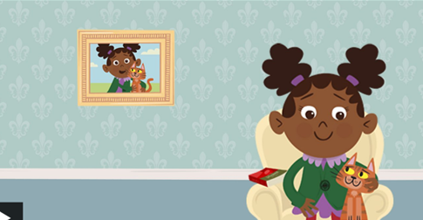  Then do quiz.  Input on the sense taste: What is on our tongue to help us taste? Discuss what tastes good and what tastes bad. What are the different flavors we can taste?  What tastes sweet, sour, bitter, spicy?  Main: Tell the children that we are going to be doing our first experiment in science. Ask: What is an experiment? Discuss children’s ideas. Tell the children that we are going to be using our sense of taste- to taste different things.  We will collect data to see what the most popular thing is to taste.  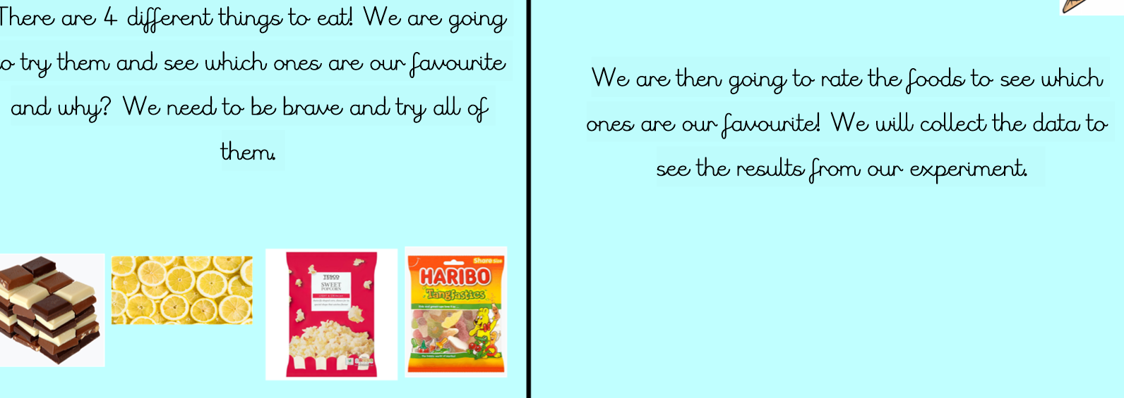  Experiment on taste:  Class in a circle on the carpet and teacher to take round different foods to try. Take photos of the children tasting for pic college.  Children to fill in the ‘taste table’  Plenary:  What does the results table show us. Record on Seesaw and add QR code to sheet.
 | Lesson 4- The 5 Senses- Hearing  Foundational Skills:  Listening and attention – listening to different sounds.  Expressive language – describing sounds.  Understanding – identifying ears as the hearing organ.  Learning Objective: To be able to say which part of the body is associated with the sense of hearing. To be able to describe what you can hear.  Success Criteria: I can talk about how our sense of hearing can help us. I can describe sounds. I can name different sounds.  Working Scientifically: To be able to identify and classify.  Recap and Recall:  Activity – Guess the sound.  Questions:  • What do we hear with?  • Can sounds be loud or quiet?  Recap what science is.  What did we learn last lesson? Ask children to share what they learnt last lesson about taste. Teacher to write children’s ideas.  Starter: Ask: What do we see/hear/smell/ taste/ feel with? Uncover pictures on notebook to show pictures of eyes/ears/nose/mouth/hands.  Watch the video on all the senses.    Main:  Explain to the children that today we are learning about hearing. What do we use to hear ?  Watch video : How do humans hear?  Play Guess the sounds.  What do we hear with? Do we need both ears to be able to hear? Tell the children that not everyone can hear.  What do some people need to help them hear? Look at pictures of hearing aids.  Watch video: How do hearing aids work.  Children to listen carefully to the sounds inside. Then listen carefully to the sounds outside.  Red and yellow groups- draw what they can hear.  Blue and green groups- draw and label what they can hear.  Plenary: Discuss the different sounds the children heard, | Lesson 5- The 5 Senses- Smell  Foundational Skills:  Listening and attention – listening during smell activity.  Expressive language – describing smells.  Understanding – recognising the nose is used for smell.  Learning Objective: To be able to say which part of the body is associated with the sense of smell and to be able to describe what you can smell.  Success Criteria: I can talk about how our sense of smell works. I can describe different smells we can smell.  Working Scientifically: To be able to identify and classify.  Recap and Recall:  Activity – Smell detective.  Questions:  • What body part helps us smell?  • Can smells be strong or weak?  Recap what science is.  What did we learn last lesson? Ask children to share what they learnt last lesson about hearing. Teacher to write children’s ideas.  Starter:  Ask: What do we see/hear/smell/ taste/ feel with? Uncover pictures on notebook to show pictures of eyes/ears/nose/mouth/hands  Watch the video on all the senses.  Discuss: What do we smell with? How do you know if something is a nice smell or a horrid smell? Look at the sense of smell powerpoint.  Watch: How the sense of smell works. 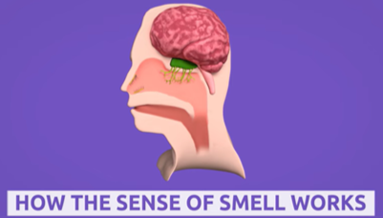  Main:  Have socks containing different things that smell- lemon, curry, garlic and chocolate pass them around the circle.  Children to describe each of the different smells. Teacher support red group.  Plenary:  Children to describe their favourite and least favourite smell. | Lesson 6- The 5 Senses- Touch  Foundational Skills:  Listening and attention – listening to instructions for touch tasks.  Expressive language – describing textures.  Active learning – exploring objects using touch.  Learning Objective: To be able to say which part of the body is associated with the sense of touch and to be able to describe what you can touch.  Success Criteria: I can talk about how our sense of touch works. I can describe different textures.  Working Scientifically: To be able to identify and classify.  Recap and Recall:  Activity – Texture sort.  Questions:  • What body part helps us feel?  • What words describe texture?  Recap what science is.  What did we learn last lesson? Ask children to share what they learnt last lesson about the sense of smell. Teacher to write children’s ideas.  Starter:  Ask: What do we see/hear/smell/ taste/ feel with? Uncover pictures on notebook to show pictures of eyes/ears/nose/mouth/hands  Watch the video on all the senses.  Discuss: What do we touch with?  How do you know if something is a nice feel or a horrible feel?  Watch video on touch.  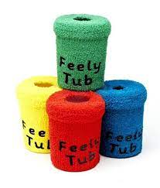  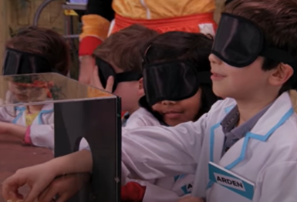  Main:  Ask the children to go round the classroom. What can you feel that is hard/ soft/ bumpy/ rough/ sharp?  Show the children the ‘mystery box’ and ‘feely tubs’. Model to the children feeling in the tub and describing the objects. Focus on key vocab-  Hard  Soft  Rough  Spikey  Prickly  Cold  Warm.  Ask children to feel a pencil, some baked beans, a pineapple and some sandpaper. Ask children to think of some describing words for each item. Once they have described each item they can find out what it is.  Children to record the words to describe each item on sheet.  Teacher to support red group.  Plenary:  Children to share words to describe each item.
Lesson 7- The 5 Senses- Sight
Foundational Skills:
Listening and attention – listening to explanations about sight.
Understanding – recognising the role of the eyes.
Active learning – exploring movement safely.
Learning Objective: To be able to say which part of the body is.

Success Criteria: I can talk about how our sense of sight
works. I can follow instructions when my sense of sight is taken away.
Recap and Recall:
Activity – Sight quiz.
Questions:
• What body part helps us see?
• What can help people who cannot see?
Recap what science is.
What did we learn last lesson? Ask children to share what they learnt last lesson about the sense of touch. Teacher to write children’s ideas.
Starter:
Ask: What do we see/hear/smell/ taste/ feel with? Uncover pictures on notebook to show pictures of eyes/ears/nose/mouth/hands
Tell the children that today we are learning about sight.
Watch: How does the human eye work? Then work together to complete the human eye quiz.
Ask: Can we see everything with our eyes? What do people use to help them see? Look at pictures of glasses.
Watch: Why do people need eye glasses?
Watch: How animals help people who can’t see.
Talk about what it would be like if you couldn’t see. Explain that not everyone can see.
Main: Tell the children that we are going to work in pairs to see what other senses we can use if we don't
have our sight. One of you is going to be blindfolded and the other person needs to make sure they are safe. Then swap. Take photos for pic college.

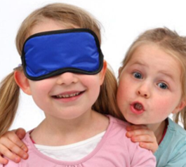
Plenary:
Discuss: What can you do to help you move around if you can't see? What can you use if you don't know what is around you? Record answers and create QR code for sheet.
National Curriculum Links-
Pupils should be taught to- identify, name, draw and label the basic parts of the human body and say which part of the body is associated with each sense.

