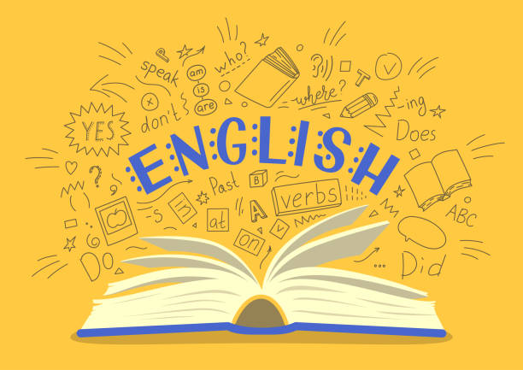
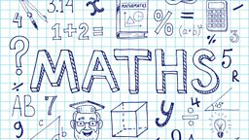
Year 6
Curriculum Newsletter
Spring Term 2026

Our initial learning will revolve around “The Three Little Pigs” and an award winning film which will make us wonder if the wolf really was the “bad guy?”
The rest of our English texts will link to our geography work. We will use a film clip from The Impossible – a film about the Boxing Day Tsunami. From the film, we will write a setting description before our attention turns to the Michael Murpurgo story, Running Wild. This will allow the children’s imaginations to literally “run wild” as they create their own narrative adventure story. Our final piece of writing will involve us using all our learning from geography to create a non-chronological report about natural disasters.
In maths, our Monday focus will be fractions ensuring the children feel confident to find common denominators, add, subtract, multiply and divide fractions. They will also solve word problems involving fractions.
We will be looking in depth at ratio and proportion as well as different units of measure for length, capacity and volume. We will revisit the formal methods for addition, subtraction, multiplication and division with a focus on using them to solve two and three step word problems. As the term progresses, our focus will turn to statistics and the use of pie and line charts to interpret data.
Multiplication Tables
We will be regularly testing multiplication tables and it is imperative that the children learn them. If your child has a good knowledge of their multiplication tables we ask they practice the related division facts and work on answering the questions with accuracy and speed.

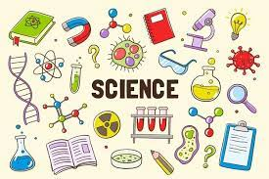

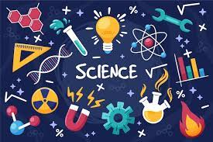
In science this term our focus will be on ‘Light’. Children will learn about the concept of light travelling in straight lines. We will look at beams of light and how light travels to enable children to understand how we see things. Afterwards, we will look at shadows and how light is reflected and then onto rainbows and white light.

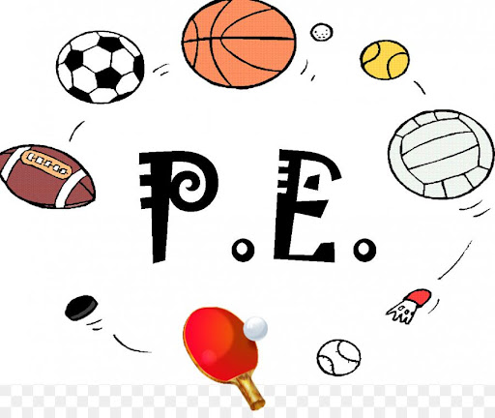
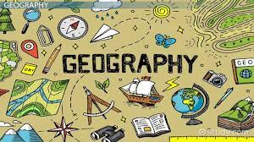
Our focus in Religion and Worldwide views children find out about significant religious and non-religious journeys and pilgrimages and why going to a particular place is so important to some people.

This half term our PE lessons will fall on Tuesdays and Fridays. We will be focusing on gymnastics and badminton in term 3, basketball and fitness in term 4. In gymnastics, pupils use their knowledge of compositional principles. Basketball will be delivered by Coach Smith building on previous skills of dribbling, shooting and team games. Badminton will develop and enhance their rallying skills and fitness will be linked to stand alone skills aimed at raising heart rates.




Through developing their photography skills, children cover useful artistic concepts in a new context, looking at: composition, colour, light, abstract images and underlying messages. By familiarising themselves with new photography artists, children can gain a new perspective on the way they look at the people and objects around them, capturing and presenting images in different ways
It feels at times that our world is fighting against us. In this topic, we will be discovering the science behind earthquakes, volcanic eruptions and tsunamis. We will be exploring the make-up of our Earth below the surface and the effects that natural disasters have had on those who have been unfortunate enough to be in Mother Nature’s way. Looking a little closer to home, we will explore the effects of erosion on our coastline.. After half term, we will find out about the continent of Europe., and the countries that form it. We will then focus on France, finding out about its landscape, climate, and cuisine location. We will also develop their map and atlas skills and practise reading and writing coordinates.
In this topic, children build upon their knowledge of how networks and the Internet are able to share information. They will learn how big data can be used to design smart buildings to improve efficiency, before designing their own smart schools. They will also explore the potential dangers of big data.
Working in groups, children research and design a waistcoat for a class mascot. The children will need to practise previously taught sewing skills and work effectively together as a team to make this project a success. Afterwards they will use their evaluation skills to assess their finished product.

