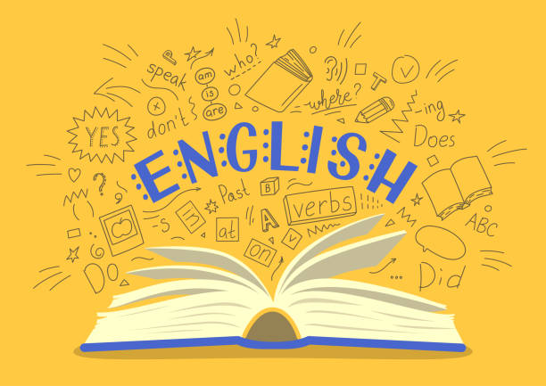
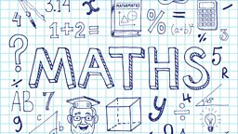
Year 4
Curriculum Newsletter
Spring Term 2026
We will start the term looking at shapes- exploring their properties and comparing them. We will explore angles and symmetry within shapes and interpret and present data. Following that our focus will turn to money where we will compare and estimate- solving simple problems. Then, we will re-visit the four methods of computation- addition, subtraction, multiplication and division- ensuring children are building up confidence and fluency in these key areas, alongside building our understanding of fractions.
Multiplication Tables
It is more important than ever to make sure the children are practicing multiplication tables. They will be completing multiplication tables daily and need to be on TTRS at home. It is also useful for the children to learn their multiplications by rote reciting them out loud. We will be testing the children regularly on their tables as our Year 4 National Times table Test approaches.
Our English continues from last term with a focus on the classic book “Wind in the Willows” where we will explore the different characters with a focus on the wonderful Mr Toad! He will provide a stimulus for our writing when we contemplate the events that happened prior to his car ending up in the lake! Some great fun to be had with this piece of work!
Following on from this we will create a Flash Back Story. Continuing with the Wind in the Willows, children will create their own story for how Toad ended up in the river. They will learn to use progressive tense, switching between the present and past. Our English will also incorporate research from our history topic and we will use it as a stimulus for our non-chronological report about Romans.



We will be looking at ‘Teeth and Eating.’ Children will learn about digestion and different types of teeth, before moving on to exploring deadly predators and their prey, in their exploration of food chains after half term.
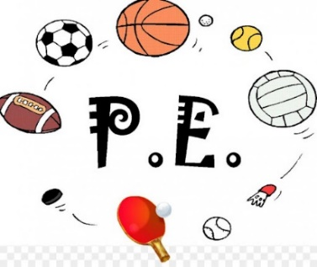

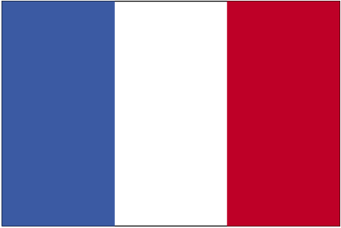
PE DAYS – MONDAY AND WEDNESDAY
Initially, 4S will be swimming on a Wednesday afternoon. 4B will be swimming on a Wednesday afternoon after February half term. PE days will be Monday and Wednesday and the children will be participating in gymnastics, tag- rugby and netball.
Please could we remind you that PE kits should be in school every day and children must remove earrings in order to participate in PE. As we are doing outdoor PE, please make sure they have warm clothing and suitable footwear.
Children will be learning about ‘Computational Thinking’ this term. They will learn the four pillars- abstraction, algorithm design, decomposition and pattern recognition. They will apply the four pillars to plugged and unplugged activities and will identify the skills used to solve problems.
French - We will be counting in French, recognising and using numbers to twelve. We will ask how old someone is and answer the same questions, compare sentence structures in French and English and put this into practice by playing some traditional French games.
In history, we will be learning about Ancient Rome. We will look at how the Roman Empire was created and will investigate how they invaded other countries within Europe. We will learn about the lifestyle of the people living in Rome, inventions they made and how they influenced the wider world.



In art, the children will be investigating tints and shades through a variety of media. They will be experimenting with creating 3D effects through use of colour and they will consider proportion and composition when planning a still life painting. At the end of the unit, they will create a final painting that shows an understanding of how colour can be used to show light and dark, and therefore show three dimensions.
In RE we will be asking ‘Just how important are our beliefs?’
We will be considering how actions and practices demonstrate the importance of beliefs and whether we can tell what a person believes from the outside.




Mechanical Systems- Making a Roman Chariot
In this topic, children will explore the ways in which the Romans entertained themselves and others in the Empire by holding gladiator fights and chariot racing! Children will design and build their own chariot before racing them learning about how chassis, wheels and axles work.
In this topic, pupils will experiment and get creative with their music making. Drawing upon their understanding of repeating patterns in music, pupils will be introduced to the concept of motifs. They will develop their skills further by adapting and transposing motifs before performing them to their peers.

