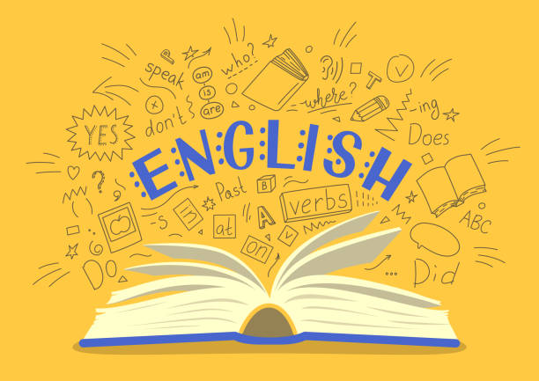
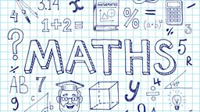
Year 6
Curriculum Newsletter
Autumn Term 2025

Our English texts link to our history work and we will be focusing on Charles Dickens, his life and two of his most famous books – Great Expectations and Oliver Twist! Our writing will focus on the life of Charles Dickens; producing a non-chronological report about him. We will write about the conditions that the poor endured whilst in the workhouse and write a heartfelt letter from Oliver to his Mother.
After half term, our attention will turn to stories from Mayan Culture and investigate the exciting Mayan Gods through the Rain Player, where we will become journalists and write a newspaper report about the lethal Pok-a-Tok game! Throughout this piece of writing, we will develop our drama skills to become the characters from the book.
In maths, we will be initially focusing on place value and number. The children will be reading, comparing and ordering number up to 10,000,000. We will be learning how to round numbers to the nearest 10/100/1000 and rounding decimals. Throughout the term, we will cover the formal methods for addition, subtraction, multiplication and division. The children will be concentrating on fluency and ensuring they have a concrete understanding before moving onto applying their knowledge to problem solving and reasoning questions. Every Monday, we will be focusing on arithmetic methods and working through a variety of questions; learning and practicing different methods so the children feel confident tackling the questions.
Multiplication Tables
We will be regularly testing multiplication tables and it is imperative that the children learn them. If your child has a good knowledge of their multiplication tables we ask they practice the related division facts and work on answering the questions with accuracy and speed.

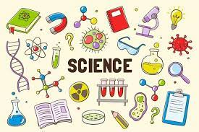
The Titanic
The children engage in a different approach to their science, linking it to a historical event in context; the sinking of the Titanic. This topic is based around applying the working scientifically skills that they have learned so far in their science lessons, to explore some of the scientific concepts behind the Titanic, e.g. floating and sinking.

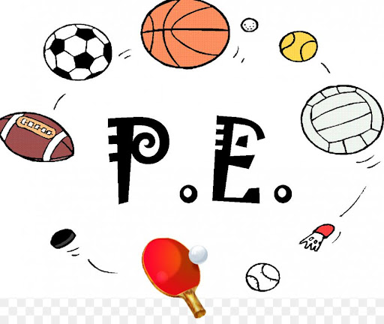
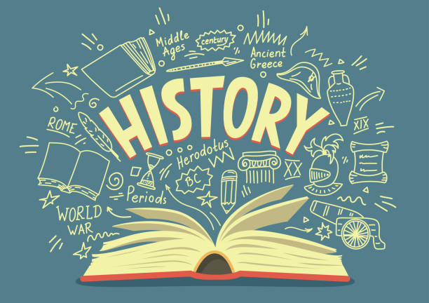
Both classes will have swimming lessons during this term. When not swimming, the children will engage in lots of different activities from our new PE scheme Get Set 4 PE!
6R will be swimming on Wednesday afternoons, 6F will be doing PE on Tuesdays and Fridays each week.
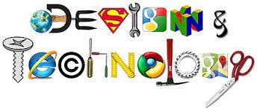
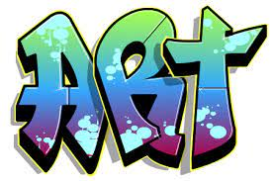


Our focus in RE is Worldwide beliefs. The children will be exploring the different denominations within different religions and starting to understand and be able to explain how faiths builds a sense of community. They will explore and understand how different milestones are celebrated.

Mechanical toys
Using woodworking materials and skills, pupils construct a window display using an automata mechanism; measuring and cutting their materials, assembling the frame, choosing cams, designing the characters that sit on the followers and also finishing with a foreground and background.
We will revisit their still life skills, creating a variety of pieces influenced by different artists and using a range of mediums. They use charcoal, erasers and paint to depict their chosen composition of special objects before using them to construct a memory box to showcase their work.
Using programming language, which is used in business and industry, children create designs, Islamic art and Mondrian-inspired art. They learn how to create loops and nested loops to make their code more efficient, while becoming more familiar with a text-based programming language.
Before half term, we will be exploring what life was like for all groups of people living during the Industrial Revolution and throughout the reign of Queen Victoria. We will study famous Victorians such as Isambard Kingdom Brunel and Dr Barnardo and their impact during the time period.
After half term, our attention will turn to the Mayans where we will explore their civilisation with a particular focus on their lifestyle, culture, religion and professions.

