DT- Textiles- Waistcoats.

Year 6- Spring Term DT

Essential Knowledge

By the end of this unit, children will demonstrate independently...

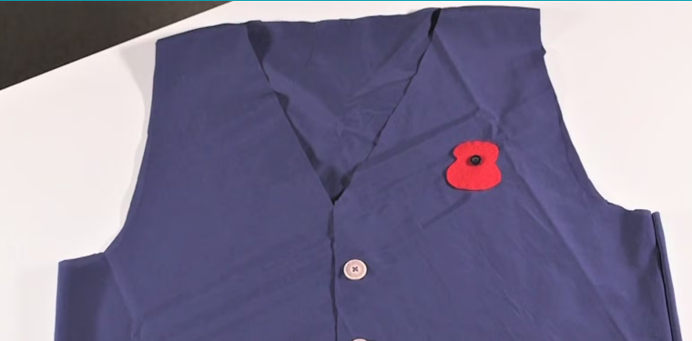

- An understanding that it is important to design clothing with the client/target customer in mind.
- The knowledge that using a template (or clothing pattern) helps accurately mark out a design on fabric.
- An understanding of the importance of consistently sized stitches.
- Consider a range of factors in their design criteria and use this to create a waistcoat.
- Attach a secure fastening, as well as decorative objects.
- Evaluate their final.

Vocabulary

Annotate, decorate, design criteria, fabric, target customer, waistcoat, waterproof.
DT- Textiles- Waistcoats.
Learning Links
Fossil research in science- children will be using their research in their recent science topic to inspire the creative element of their clothing.
Spring term
In this unit, children will be using their sewing and design skills to design an appropriate waistcoat or lab coat for a science themed teddy bear.
Key objectives:  - Designing a waistcoat in accordance with a specification and design criteria to fit a specific theme.  - Annotating designs.  - Using a template when pinning panels onto fabric.  - Marking and cutting fabric accurately, in accordance with a design.  - Sewing a strong running stitch, making small, neat stitches and following the edge.  - Tying strong knots.  - Decorating a waistcoat – attaching objects using thread and adding a secure fastening.  - Learning different decorative stitches.  - Sewing accurately with even regularity of stitches.  - Evaluating work continually as it is created. | Lesson 1  Focus: To design a waistcoat.  Success Criteria:  - I can annotate my designs.  - I can design clothing to a set of design criteria.  Explain to the children that in this unit of lessons, they will design and create a waistcoat or a laboratory coat with a science theme.  Display slides 1–9 of the Presentation: Fashion designers. These allow children to express their opinions about different designs by agreeing and disagreeing with statements. There is also an opportunity to learn about some important British fashion designers.  During the agree and disagree activities, you could ask the children to move to one side of the room if they agree and the other if they disagree. If someone is unsure, ask them to stand in the middle. This offers an opportunity for discussion. Ask some children why they chose to stand where they did.  Once you have looked at all the designs, ask the children the questions on slide 10.  Main task:  Display slide 1 of the Presentation: Waistcoat design ideas and ask the children if they can think of when they have seen waistcoats or lab coats being worn. Show the class some examples of waistcoats on slide 2.  Ask the children the questions on slide 3. Make sure they consider the following:  - Who is it for? (This will impact the size of the garment and the design, as it needs to appeal to its target customer group.)  - What materials will work best? (The children can link this to their understanding of the properties of materials by considering whether the fabric needs to be waterproof, warm, thin, soft, etc.)  - How practical would it be to wear? (It should be comfortable and secure and not scratch the wearer.)  Discuss the questions on slide 4. Whatever the purpose, the children must consider who they are making a waistcoat for and why.  Design  Using the design booklet, encourage the children to create a unique design, considering:  - Who their waistcoat is for.  - What they will need to include (design criteria).  The children will then consider the images, symbols or words they want to include.  Show slide 5 to give the children some ideas for different shapes for their waistcoats.  Display the Pupil video: Waistcoat ideas. Only the first half of the video is relevant to this lesson, but you may want to play the whole video so the children know what will happen in the next lesson.  Ask the children to draw their waistcoat designs in detail (front and back) and annotate the materials they will use and where they will sew. They should include the colour of the fabric and thread.  Plenary:  Allow the children to show their designs to their partner, explaining how it matches their design criteria.  Ask the children to consider any special items or materials in their designs that they may need to bring into school themselves or that you may need to source. | Lesson 2  Focus: To mark and cut fabric according to a design.  Success Criteria:  - I can explain the differences between my design and the template.  - I can accurately mark out the outline of the panels for my coat.  - I can cut neatly and accurately.  Starter:  Hand out a copy of the Resource: Waistcoat template to each table and ask one child to cut the template out. HA children should be encouraged to include sleeves, they will need to incorporate this into their template.  Hand out the children’s waistcoat design booklets from the previous lesson and ask them to compare the design sheets to the shape of the template. Suggest how the children may need to adapt the template to suit their design.  It is important at this stage to mention that if the children have included a fastening, the two front panels of their fabric must be large enough to overlap. The template provided allows this space but they can narrow the front panels if they want to omit the fastening.  Main task:  Model how to draw around parts of the template onto the fabric but stress that they will need to adapt the shape of the template at the bottom according to their design. The Pupil video: Waistcoat design can be replayed and left on a continuous loop while the children are working so they can refer back to it.  Demonstrate how to lay the template on the piece of fabric and mark the outline of the panels on the material in chalk. Explain that the children should adapt the bottom of their outline to match their design.  Ask the children to draw dashes across the parts of the fabric that will be sewn (the top of the shoulders and the sides). Explain that this is a reminder to leave a 1 cm gap when cutting this out.  Allow the children to carefully cut out their shapes, remembering to leave the 1 cm gap on the edges they will sew.  Once the children have cut out their fabric pieces, demonstrate how to pin them together, ensuring the waistcoat is inside out and ready to be sewn together in the next lesson.  Plenary:  Ask the children to discuss their waistcoat designs with a partner and plan what they will need to do in the next lesson to assemble them.  Ask the children to remind you why they need to sew it inside out (to hide the stitches and give it a neater finish). | Lesson 3  Focus: To assemble a coat.  Success Criteria:  - I can sew a strong running stitch.  - I can ensure my stitches are small, neat and follow the edge.  - I can tie strong knots to secure the thread in place.  Starter:  Model how to use a simple running stitch to join two pieces of fabric.  The children will have chosen the colour of thread they want to use and should be familiar with threading a needle from the previous textile topics.  Main task:  Explain to the children that they will sew the parts of their waistcoats that they pinned together in the previous lesson. Before they start, they should double-check that:  - All of the edges line up.  - There is enough of an overlap at the front to fix a fastening.  - The waistcoat is inside out so the stitches will be neater when they finish sewing.  Explain that the children should use a running stitch across the shoulders first, then sew the sides to the back panel, keeping as close to the edge as possible.  Point out that care should be taken to ensure knots are tied and that stitches are close together and consistent in size.  Once they have finished, they will turn their waistcoats the right way around so that the stitching is on the inside.  Plenary:  Ask the children to peer-assess their partner’s stitching, referring to the success criteria.
Lesson 4

Focus: To decorate your coat.

Success Criteria:
- I can secure a fastening.
- I can attach objects for decoration using thread.
- I can evaluate my work according to the design criteria.
Starter:
Hand back the children’s design booklets and coats, which should have the seam on the inside.
Ask them to look at their design sheets and tell their partner what parts of decoration they will work on first; mention that they should begin by attaching the fastening if they have included one in their design.
Ask them to consider the available time and adjust their plans if they still have to finish sewing any pieces from the previous lesson.
Once they have a realistic plan for finishing their waistcoat, ask them to gather the necessary materials to be ready to start.
Ask:
- What patterns and materials are included in your design?
- How will you replicate this?
- What materials have you noted on your design?

Main event:
Remind the children how to attach beads and buttons by looping thread through the holes at least three times, securing each stitch to ensure it stays in place.

Allow the children to add details and decorations to their waistcoats for the rest of the lesson. Encourage them to refer regularly to their design sheets. Explain that they can adapt their designs as they work but they need to include any changes on their design sheets.

Once they have finished, ask the children to hold up their waistcoats, ensuring that everything is securely attached, and evaluate it according to their design criteria. Discuss this as a class, highlighting good examples of decoration, stitching or overall design.

Ask the children to write an evaluation of their finished product in their design booklets. Explain that they should mention anything that deviates from their original design, including their reasons behind this and how well it works as a piece of clothing.

Plenary: Discuss with the children what they have learnt and how they could adapt their patterns to make a jacket.
Finish with a fashion show, with the teddies wearing their new waistcoats.

