Moth: An Evolution Story: Year 6
Purpose: To explain to the reader about the evolution and natural selection of the peppered moth Audience: Writing for the authors of the book
Form: Explanation – Peppered moth
Reading comprehension
- asking questions to improve their understanding
- drawing inferences such as inferring characters’ feelings, thoughts and motives from their actions, and justifying inferences with evidence
- predicting what might happen from details stated and implied
- summarising the main ideas drawn from more than one paragraph, identifying key details that support the main ideas
- identifying how language, structure and presentation contribute to meaning
Writing Composition
Plan their writing by:
- identifying the audience for and purpose of the writing, selecting the appropriate form and using other similar writing as models for their own
- noting and developing initial ideas, drawing on reading and research where necessary
- selecting appropriate grammar and vocabulary, understanding how such choices can change and enhance meaning
- précising longer passages
- using a wide range of devices to build cohesion within and across paragraphs
Evaluate and edit by:
- assessing the effectiveness of their own and others’ writing
- proposing changes to vocabulary, grammar and punctuation to enhance effects and clarify meaning
- ensuring the consistent and correct use of tense throughout a piece of writing
- ensuring correct subject and verb agreement when using singular and plural, distinguishing between the language of speech and writing and choosing the appropriate register
- proof-read for spelling and punctuation errors
Specific grammar objectives:
- using semicolons, colons or dashes to mark boundaries between independent clauses
- using a colon to introduce a list
- punctuating bullet points consistently
- to use persuasive language
Spelling objectives
- use dictionaries to check the spelling and meaning of words
- use the first three or four letters of a word to check spelling, meaning or both of these in a dictionary
- use a thesaurus.
- Statutory 5/6 word list
Day | Focus | Whole Class | Independent/Guided work | Plenary
1 | To explore the features of an explanation text  Success Criteria  I can identify some of the features of an explanation text  I can identify explanatory language  I can identify the structure of the piece of writing  I can predict what a text may be about | Watch clip from Bee Movie –  https://www.youtube.com/watch?v=oNWAiWBup2Q  How to bees collect nectar?  As a class, write bullet points. Then children create written paragraph  Read How do Bees make Honey?  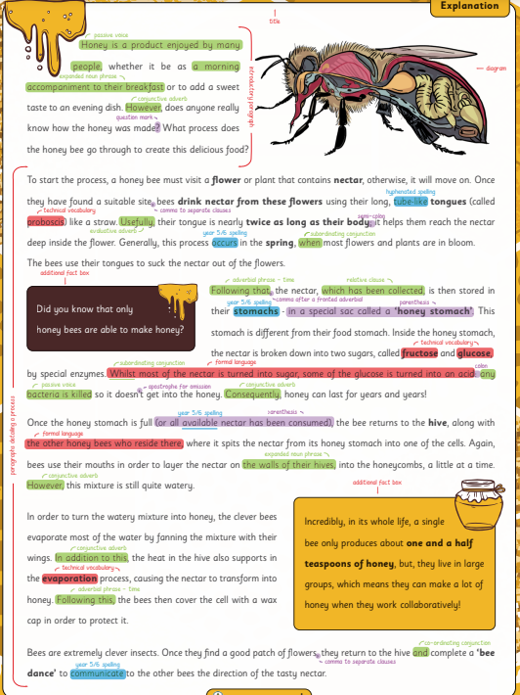  With children identify the features of the text.  Children to annotate their own copy.  Is there any generic language that we can magpie for the working wall? | Write a brief explanation about how bees (in the bee movie) collect honey.  Children to annotate their own copy of the text  Identify any language that could be magpied – edit own explanation from earlier. | Show the front cover of the text as seen below  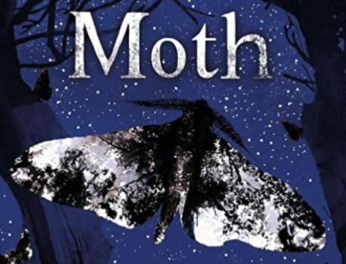  What could our text be about?  Prediction skills
2 | Focus: To predict  Success Criteria  I can predict what I think may happen in a story  I can adapt my predictions by what I see | Revisit the predictions from yesterday  Look at the blurb of the book  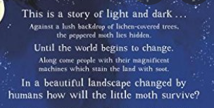  What predictions do we now have?  Read story to quiver in the breeze.  As we did with the bees – bullet point what has happened.  Children to write a brief explanation of how the moth comes to life. Think about explanatory language from yesterday. Limit to 5 sentences. | Children to write a brief explanation of how the moth comes to life. Think about explanatory language from yesterday. Limit to 5 sentences. | Look at a where’s wally picture.  How can we find Wally? Why can’t we find wally?  Encourage use of the word camouflaged.  Explain we will need this language tomorrow.
3 | Focus: To explain similarities and differences  Success Criteria  I can use explanatory language – cause and effect AfC  I can show the differences and similarities between the two moths | Read from quiver in the breeze to Until the world began to change  What have we found out?  Create a table of the similarities and differences between the two types of moth.  Areas you could look at - colouring, predators, movement, family, camouflage.  Look at the use of cause and effect AfC  Model writing some sentences for similarity and difference using the C and E AfC | Children to write, with partner, sentences using AfC.  Share with class throughout the session. | Share sentences and add to the working wall.
4 | Focus: To predict and give evidence from the text to support your prediction  Success Criteria  I can predict what I think may happen  I can give evidence form the text to support my prediction by quoting the text or rewriting in my own words. | Read from People built factories….Which moths will survive.  Predict – which moths do you think will survive and why?  Look at the repetition of the language from earlier parts of the book. What does this do for us as a reader?  As a class, think of reasons and bullet point the answers with evidence. Encourage the children to give multiple reasons and evidence for their prediction. Link back to the earlier parts of the book. | Write their answer giving evidence from the text to answer the questions.  Use a PEE format for the answer. | Listen to each other’s predictions – does the evidence support?
5/6 | Focus: To explain what happened to the moths  Success Criteria  I can explain verbally what happened to the moths  I can use pictures to help me explain  I can use Cause and Effect AfC in my explanation  I can work collaboratively with my group. | Read the remainder of the book and then re-read the whole book.  Make bullet pointed list of what happens in the book on flipchart paper – think about chronology – TAKE PHOTO BEFORE CHUNKING UP  Work with the class to chunk this into sections.  Ideas  - Moth being born and flying away  - Difference between the moths  - Salt and pepper winged Peppered moth ability to camouflage and reproduce.  - Industrial revolution – the changes people made to the world- darker place  - Charcoal winged moths – ability to camouflage and reproduce  - Changes in the world again – balance and hope.  Using bullet points – as a class create an explanation of the moth – see example below. Include AfC so children can see how they are used. Include 5/6 words which are appropriate.  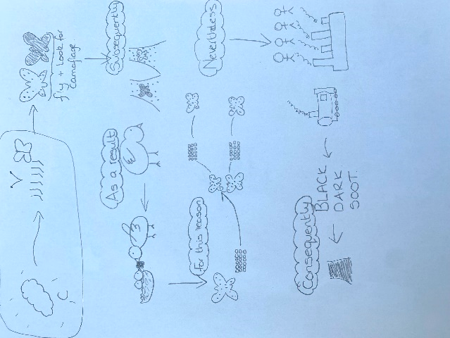  Give children plenty of time to verbally rehearse their writing.  Teacher model using the plan to write. Write first section with the children.  Photocopy  - Bullet pointed list on flipchart – can be stuck in books  - the plan for all children to have - NOT to be stuck in books | Children to work in groups of 2/3 to explain what has happened to the moths.  Using the class plan, verbally explain the natural selection/adaptation of a moth. Encourage the children to act it out and add in actions to help them remember what they are saying (this will support their writing)  Children to then begin writing – the first section can used by all children. | Use post its – everyone go round and read someone else’s work – tell them something they have done brilliantly and suggest 1 thing to make their work even better.
7 | Focus: To write an explanation  Success Criteria  I can use cause and effect adverbials of cohesion  I can explain what happened to the moth in chronological order.  I can use 5/6 words in my writing  I can use technical vocabulary | Teacher remodel using the plan to write from. Model using the adverbials for cohesion.  Model saying the sentence then writing it down.  Stress this is not a long, descriptive piece of writing it is factual scientific explanation. | Children to edit what was written yesterday and then continue to write. | Use post its – stick a post it next to your writing. Everyone goes round and positively comments on the work – if there is something that needs changing – tell them how to put it right!
8 | Focus: To write an explanation  Success Criteria  I can use cause and effect adverbials of cohesion  I can explain what happened to the moth in chronological order.  I can use 5/6 words in my writing  I can use technical vocabulary | Teacher remodel using the plan to write from. Model using the adverbials for cohesion.  Model saying the sentence then writing it down.  Stress this is not a long, descriptive piece of writing it is factual scientific explanation. | Children to edit what was written yesterday and then finish their writing. | Use post its – stick a post it next to your writing. Everyone goes round and positively comments on the work – if there is something that needs changing – tell them how to put it right!

