Running Wild: Year 6
Purpose: To entertain my reader Audience: Form: Narrative – Adventure story – what happened next?
Class Reader:
Reading comprehension
- asking questions to improve their understanding
- drawing inferences such as inferring characters’ feelings, thoughts and motives from their actions, and justifying inferences with evidence
- predicting what might happen from details stated and implied
- summarising the main ideas drawn from more than one paragraph, identifying key details that support the main ideas
- identifying how language, structure and presentation contribute to meaning
Writing Composition
Plan their writing by:
- identifying the audience for and purpose of the writing, selecting the appropriate form and using other similar writing as models for their own
- noting and developing initial ideas, drawing on reading and research where necessary
Draft and write by:
- selecting appropriate grammar and vocabulary, understanding how such choices can change and enhance meaning
- précising longer passages
- using a wide range of devices to build cohesion within and across paragraphs
Evaluate and edit by:
- assessing the effectiveness of their own and others’ writing
- proposing changes to vocabulary, grammar and punctuation to enhance effects and clarify meaning
- ensuring the consistent and correct use of tense throughout a piece of writing
- ensuring correct subject and verb agreement when using singular and plural, distinguishing between the language of speech and writing and choosing the appropriate register
- proof-read for spelling and punctuation errors
Specific grammar objectives:
- active and passive voice
- using expanded noun phrases to convey complicated information concisely
- using relative clauses beginning with who, which, where, when, whose, that or with an implied (i.e. omitted) relative pronoun
- using brackets, dashes or commas to indicate parenthesis
- using semi-colons, colons or dashes to mark boundaries between independent clauses
- use hyphens to avoid ambiguity

Spelling objectives
- use dictionaries to check the spelling and meaning of words
- use the first three or four letters of a word to check spelling, meaning or both of these in a dictionary
- use a thesaurus.
- Statutory 5/6 word list (3/4 list)
- Exploratory Talk Presentational Talk Parallel Writing Process Writing Product Writing
Day | Learning Objective | Whole Class | Independent/Guided work | Plenary
1 | Session 1  Reading focus: Prediction and questions  Focus: to predict  Success criteria  I can make predictions through what I can hear  I can adapt my predictions through what I see  I understand that my senses and previous experiences help me to predict | Play music only – and predict what the story could be about. https://www.youtube.com/watch?v=QE_jOCqKE3w  In groups, give children envelopes numbered 1-5. Children open envelope 1 and use picture to predict what they think the story is going to be about – write next to the photograph – think about setting, characters, plot, problem, solutions  - mum and son, grave of dad  - Aeroplane – holiday aircraft – Indonesian airline??  - Beach – white sands  - Elephant – being ridden, mum waving goodbye  DO NOT reveal that the story is Running Wild. | Children to write notes predicting what is going to happen and how all the pictures connect.  Children write a prediction as to what they think will happen in the story. | Children to read out their predictions – make a class chart of different ideas
2 | Reading focus: Learning the story through summarising  Focus: to sumamrise  I can identify the main elements of the story so far  I can explain a characters thoughts and actions | Introduce the children to Running Wild – have large picture on the board – see PowerPoint.  Explore the front cover of the text – predictions as to what the story could be about. Can you connect to yesterday’s work?  Slide 2 - Explore the blurb of the book – what characters do we have? What do we know about the story so far?  After making predictions  Read the story with the children – chapter 1 and 2.  Re-read and Stop throughout the story and make notes about the different parts of the story. | Write an informed prediction which connects with the front cover of the book.  Stick picture in books and write underneath | Children to read out their predictions – make a class chart of different ideas
3 | Focus: to summarise  I can identify the main elements of the story so far  I can explain a characters thoughts and actions | Recap what we learnt yesterday about the story. Discuss with partners etc.  In groups, document the story in chronological order using freeze frames – working in groups create a freeze frame with thought bubbles (use whiteboards for thought bubbles) that show a characters, what their thoughts are or give detail about what is happening. Each group to do a freeze frame for part of the story, use iPads to take photos. Put them together to create a freeze frame of chapter 1 and 2. | Create freeze frames at different parts of the chapters – main points/problem/solution. | Create a class vocabulary bank for the “beach/jungle” setting.
4 | Reading focus – Vocabulary  Focus: to learn the meaning of new vocabulary  Success criteria  I can identify unfamiliar vocabulary  I can read around the word to try and identify its meaning  I can use a dictionary to look up the meaning  I can use the word in the right context | Photocopy pages from Running wild – chapter 2 – each table has a copy of chapter 2 from which to work.  Each pair reads and highlights the words they are unsure about. Discuss as a table and then choose 2 words from each pair to go onto the  Highlight words which would be unfamiliar to the children - See word document  Using a group never heard the word grid – vocabulary with definitions. Children to find out what particular words mean and then write a definition and the word in context – on post its and stick altogether on A3 – photocopy for each child’s book. | Children to explore vocabulary on different pages from chapter 2.  Write the word, a definition and then a sentence using the new vocabulary. | Children to share the definitions of the words they have found.
5  Do Not Use???? | GPS focus – Tense  Focus: To identify the tense in which the book is written  To identify different tenses.  I know what past tense is  I know what present tense is  I know what past progressive tense is  I know what present progressive tense is | Look at running wild text – use chapter 2 which we highlighted for the NHTWG  What tense is the book written in? How do we know?  Take a sentences and change it into lots of different tenses.  Past perfect  Present perfect  Past progressive  Present progressive | Children to choose a sentence and change the tense – identify the tense in which it is now written.
6 | Focus: To identify, use and apply passive and active voice  Success criteria  I can identify active voice  I can identify passive voice (by zombies)  I can change active voice to passive | Recap active and passive voice – by zombies.  Use descriptosaurus as a WAGOLL - page 251  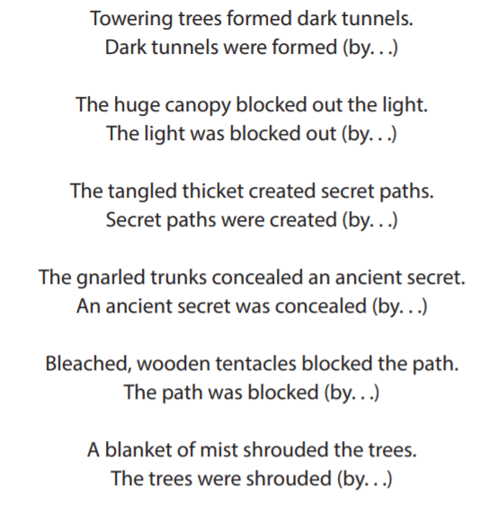  Children to discuss the active and passive voice. highlight the passive and active voice in the sentence and then use the structure to write their own – context – the jungle  Use vocab bank from lesson 3 to help | Write own jungle passive/active poem.  (These lines can feed into the story writing) | Peer assessment – does the poem go active – passive – active- passive?  Perform your poem
7 | Focus: To plan a narrative – what happens next?  I can use my imagination to create and draw my story  I can think about the main characters and the plot including 2 problems, 2 solutions and an ending. | Explain to the children they are going to write their own narrative story and plan it.  Brainstorm ideas – what could happen? Children to discuss and collate as a class on flipchart paper.  Think about having a problem, solution, another problem and another solution then the ending.  Talk about the transitions and what they are – they connect the different parts of the story together.  Model drawing part of own story map – copyright 1 of the problem/solutions, the other can be “magpied” (complete when children set onto their story map) | Draw a story map of your “what happened next story” on A3  Problem (Transition) solution (transition) problem (transition) solution (transition) ending.  LAPS to discuss and plan a story together | Present your story map to your partner – tell them your story
8 | Focus: To explore the features of a narrative  I know the features of a narrative story  I can identify the passive/active voice in the story | Using part of Running wild – focus on chapter 2 – identify the different features of a narrative.  Complete the boxing up success criteria – working backwards from the text as a class | Complete box it up success criteria for your own story. | Begin to look at vocabulary from your success criteria grid and see where it can fit onto your story plan.
9 | Focus: To plan a narrative – what happens next?  I can include grammatical features on my story plan  I can bullet point the main events of my story thinking about the characters, setting, problem and solution. | Look at the vocabulary list – discuss ideas and create some expanded noun phrases which could be used in stories. Collate on the wall.  Discuss the power of 3 – the impact it can have on a reader.  Use Boxed up criteria to add detail to the story map – add on expanded noun phrases and vocabulary for each section. | Expanded noun phrases using vocab wall.  Add onto story plan – expanded noun phrases and vocabulary.  Add on power of 3 – where will it be and what will it be? | Present your story map to your partner – tell them your story using the expanded noun phrases/ vocab
10 | Focus: to write a problem and solution  I can include grammatical features on my story plan  I can write in full sentences  I can use my story map to help me write my paragraph | Tch to choose a problem and solution to model writing it – thinking about using the expanded noun phrases and vocabulary. TENSE – PAST PROGRESSIVE  Make the transition very clear – show the children the problem does not get solved straight away. | Children to write their first problem and solution including the transition.  Use plan and expanded noun phrases | Peer assessment – Can you find?  Look at your partners work. Find 3 expanded noun phrases and underline them.
11 | Focus: to plan and write a problem and solution  I can include grammatical features on my story plan  I can write in full sentences  I can use my story map to help me write my paragraph | Model editing problem 1 and solution 1  Model transition from solution 1 to problem 2.  Continue into problem 2…. No need to go further. Recap transition into solution (not needed to write) | Children to write transition from solution 1 to solution 2. (including problem 2) | Peer assessment – choose one sentence from your partners work that you think needs sharing with your table. Tch collate some ideas on flipchart for everyone to magpie.
12 | Focus: to plan and write an ending  I can include grammatical features on my story plan  I can write in full sentences  I can use my story map to help me write my paragraph | Model editing transition, problem 2 and solution 2  Recap the transition from solution 1 to problem 2 – revisit to remind the children what they need for transition to ending. | Write transition and ending. | Read through your entire story
13 | Focus: To edit my writing using my own success criteria  I can use my success criteria box it up grid as a checklist for my own writing.  I can check my work makes sense  I can identify expanded noun phrases | Read and edit final piece of writing | Read and edit final piece of writing | Author’s chair

