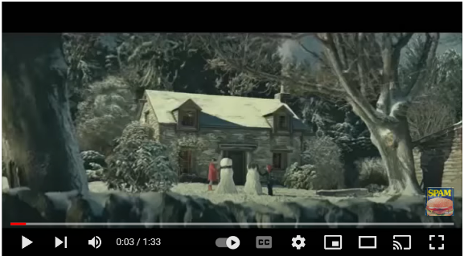
2012 -John Lewis Snowman advert

Exploratory Talk Presentational Talk Parallel Writing Process Writing Product Writing

Reading comprehension
- asking questions to improve their understanding
- drawing inferences such as inferring characters’ feelings, thoughts and motives from their actions, and justifying inferences with evidence
- predicting what might happen from details stated and implied
- summarising the main ideas drawn from more than one paragraph, identifying key details that support the main ideas
- identifying how language, structure and presentation contribute to meaning
Writing Composition
Plan their writing by:
- identifying the audience for and purpose of the writing, selecting the appropriate form and using other similar writing as models for their own
- noting and developing initial ideas, drawing on reading and research where necessary
- selecting appropriate grammar and vocabulary, understanding how such choices can change and enhance meaning
- précising longer passages
- using a wide range of devices to build cohesion within and across paragraphs
Evaluate and edit by:
- assessing the effectiveness of their own and others’ writing
- proposing changes to vocabulary, grammar and punctuation to enhance effects and clarify meaning
- ensuring the consistent and correct use of tense throughout a piece of writing
- ensuring correct subject and verb agreement when using singular and plural, distinguishing between the language of speech and writing and choosing the appropriate register
- proof-read for spelling and punctuation errors
Specific grammar objectives:
- use direct speech correctly
- punctuate sentences correctly using capital letters and the correct demarcation at the end of the sentence.

Spelling objectives
- use dictionaries to check the spelling and meaning of words
- use the first three or four letters of a word to check spelling, meaning or both of these in a dictionary
- use a thesaurus.
- Statutory 5/6 word list
Speech and Language – Exploratory and Presentational Talk
- listen and respond appropriately to adults and their peers
- ask relevant questions to extend their understanding and knowledge
- use relevant strategies to build their vocabulary
- articulate and justify answers, arguments and opinions
- give well-structured descriptions, explanations and narratives for different purposes, including for expressing feelings
- maintain attention and participate actively in collaborative conversations, staying on topic and initiating and responding to comments
- use spoken language to develop understanding through speculating, hypothesising, imagining and exploring ideas
- speak audibly and fluently with an increasing command of Standard English
- participate in discussions, presentations, performances, role play/improvisations and debates
- gain, maintain and monitor the interest of the listener(s)
- consider and evaluate different viewpoints, attending to and building on the contributions of others
- select and use appropriate registers for effective communication

Purpose – To write a set of instructions for the parallel class. – Hook lessons to introduce children into the
To describe Mr Snowman’s journey to Mrs Snowman.

Day | Learning Objectives | Whole class | Independent / guided work | Plenary
 | L.O: to understand the features of instructions.  Success criteria:  I know what an imperative verb is  I know what | Hook – Give the children a set of instructions in pairs to follow.  What did they think made the instructions useful/ easy to follow? – Discuss.  Then discuss the features of a set of instructions / when they might need to use them.  Focus in on imperative verbs – explain what they are and model writing command sentences using them. | Children to follow the instructions – can they draw a snowman?  Then children then to label the features of the instructions in mixed ability pairs.  Finally children to write a set of commands using imperative verbs, | As a class, create success criteria with the children for the instructions.  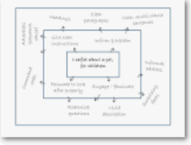
 | L.O: to plan a set of instructions.  Success criteria:  I know what the features of instructions are  I know what I need to include in my instructions. | Remind the children about what they did yesterday - we are going to create a plan for a set of instructions.  Show the children the video of making the biscuit.  Together act out the different sections of the process.  Tell the children that we are going to write a set of instructions for the process for kingfishers to follow.  What do we need to include?  Model recording the plan.  What do we need to include – discuss. | Children to record their ideas on a plan to use for the writing session using the headings of the features. | Plenary – children to work in partner pairs using picture prompts to verbally rehearse the instructions for the next lesson.
3. | L.O: to write a set of instructions. | Remind the children of their previous learning and why we are writing this set of instructions.  Model writing a set of instructions using the plan for support.  Ensure that you are checking against the success criteria as you are modeling. | Children to record a set of instructions explaining how to decorate the biscuit like a snowman.  LAPS/SEN to have the pictures of the proves to order and annotate. | Presentation language read out
 | L.O: to evaluate a set of instructions. | Children to be given a set of instructions from the previous class. Then are then given the tools to follow the instructions.  Children then to evaluate the instructions – what worked well what could be improved next time. | Children to decorate the biscuit following the instructions and then evaluate what was good what was not good about them. | Plenary – highlight success in the classroom.
4. | L.O: To make a predictions | Watch video until 20 seconds https://www.youtube.com/watch?v=UriR8FCI52E  What do the children think might happen next – create a mind map of ideas for things that might happen later on in the story?  Model recording a prediction using ideas from the freeze frames from the video.  I wonder if the snowman will …  I wonder why the snowman is … | Children to record their prediction supported with sentence starters. | Watch the entire film.  Discuss if their predictions were correct.
5 | L.O: to infer | Watch the whole of the video remind the children what we have been learning about so far.  Discuss where the snowman goes on the journey and how he feels on the journey – how can they tell he is feeling at different points.  Give the groups a freeze frame of the snowman and children to recreate the shot and discuss how they are felling and why they know that.  Then children to use this information to complete the speech bubbles. Model some of these ideas before the children complete independently. | Children to complete the speech bubbles for the snowman. | Look at a picture of a setting and begin to add ideas.
6 | L.O: to write a setting description. | Start with collecting ideas about the setting.  Children to imagine they are there – what do they think they can see see/hear/feel on the journey.  Together create an ossie grid.  Then use it to model write a setting description reminding the children on the success criteria. | Children to write their own setting description – including some of the vocabulary that the class have created together. | Share ideas.
7 | L.O: to create a plan for writing. | Remind the children that we are to write a narrative from the perspective of the snowman.  Remind them about what we have learnt so far that will help us.  Model creating a plan including interesting vocabulary to help them order their ideas. | Children to create their plan for writing.
8 | L.O: to write a description from the snowman’s point of view. | Remind the children of the plan they created last lesson.  Remind them of the expectations of writing.  Model writing the first part of the snowman’s journey, checking the plan. | Children to write the snowman’s journey.  LAPS/SEN – pictures of the journey to write about.
9 | L.O: to record the ending of the story | Continue to write the snowman’s journey.  Model re reading what they have written last lesson and model recording the next part of the journey. | Children to finish writing write the snowman’s journey.  LAPS/SEN – pictures of the journey to write about. | Author’s’ chair
10 | L.O: to revise and edit | To revise and edit the piece of work.  Model talking the children through a edit.  - Check punctuation  - Check capital letters  - Check spelling  - Add magic to your sentence  Take it one step at a time and model it for the children to look to see if they can correct it. | Children to revise and edit their work. | Author’s chair

