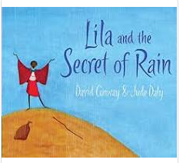
Lilia and the secret of rain Year 2

Reading comprehension
- asking questions to improve their understanding
- drawing inferences such as inferring characters’ feelings, thoughts and motives from their actions, and justifying inferences with evidence
- predicting what might happen from details stated and implied
- summarising the main ideas drawn from more than one paragraph, identifying key details that support the main ideas
- identifying how language, structure and presentation contribute to meaning
Writing Composition
Plan their writing by:
- identifying the audience for and purpose of the writing, selecting the appropriate form and using other similar writing as models for their own
- noting and developing initial ideas, drawing on reading and research where necessary
- selecting appropriate grammar and vocabulary, understanding how such choices can change and enhance meaning
- précising longer passages
- using a wide range of devices to build cohesion within and across paragraphs
Evaluate and edit by:
- assessing the effectiveness of their own and others’ writing
- proposing changes to vocabulary, grammar and punctuation to enhance effects and clarify meaning
- ensuring the consistent and correct use of tense throughout a piece of writing
- ensuring correct subject and verb agreement when using singular and plural, distinguishing between the language of speech and writing and choosing the appropriate register
- proof-read for spelling and punctuation errors
Specific grammar objectives:
- use direct speech correctly
- punctuate sentences correctly using capital letters and the correct demarcation at the end of the sentence.

Spelling objectives
- use dictionaries to check the spelling and meaning of words
- use the first three or four letters of a word to check spelling, meaning or both of these in a dictionary
- use a thesaurus.
- Statutory 5/6 word list
Speech and Language – Exploratory and Presentational Talk
- listen and respond appropriately to adults and their peers
- ask relevant questions to extend their understanding and knowledge
- use relevant strategies to build their vocabulary
- articulate and justify answers, arguments and opinions
- give well-structured descriptions, explanations and narratives for different purposes, including for expressing feelings
- maintain attention and participate actively in collaborative conversations, staying on topic and initiating and responding to comments
- use spoken language to develop understanding through speculating, hypothesising, imagining and exploring ideas
- speak audibly and fluently with an increasing command of Standard English
- participate in discussions, presentations, performances, role play/improvisations and debates
- gain, maintain and monitor the interest of the listener(s)
- consider and evaluate different viewpoints, attending to and building on the contributions of others
- select and use appropriate registers for effective communication

Book families

Purpose – Writing the end of the story for the other Year 2 class.

Day | Learning Objectives | Whole class | Independent / guided work | Plenary
 | L.O: to predict | Hook – children to go on a weather walk. Note what the weather is like and observe the plants and trees and surroundings. What are they doing? How could you describe it?  Show chn the front cover and the first page without text.  In group children to discuss what they notice:  Where is the setting?  Who is the character?  What do we think the story will be about?  What is interesting about this picture?  Children then to work together to share these ideas.  Then ask the children what the book is going to be about? | Children in mixed ability groups to annotate the pictures with their ideas and observations. Answering the questions.  Children then write a short prediction about what will happen in the story.  I predict that … | Children to share their ideas and explain them.
 |  | Starter read the first 6 pages on the book.  Look closely at the suffices – how many can they find?  Look at commas in the list (It was too hot to gather firewood, too hot to weed the village garden and even to hot milk the cow) - use them to write lists of things they can see around the classroom.  Tell the children about where they are – in Kenya,  Share some information with the children and model using ipads and skimming text to gather information. | HAPS/MAPS  To research Kenya and create a mind map of information.  SEN  Children to write I can see sentences about a picture of Kenya. | Children to share the information their have discovered about Kenya
3. | L.O: to writ e a no Chronological report. | Children to discuss the facts they know about Kenya.  Model writing a short report about Kenya using the plan that you wrote yesterday.  Go over what makes a successful non chronological report and what you must include. | HAPS/Maps  To write a non-chronological report. | Children to check their work for capital letters and full stops.
3. | L.O: to writ e a no Chronological report. |  | SEN  To write I can see sentences about a picture of Kenya.
4. | L.O: to create a plan for writing | Tell the children that we are not going to read anymore. We are going to write the end of the story.  How can Lilia make it rain? Together create a mind map of ideas of how Lilia could make it rain.  Then model using the plan format – what Lilia will do and how she will do it and what will happen when it begins raining. | Children create a plan for their writing.  Detailing what Lilia will do to make it rain and what will happen when it rains. | Children to retell the story out loud. Recording themselves on IPADS so they can hear what sounds good.
5. | L.O: to write the end of the story | Children to spend the first part of the lessons – using their plan to retell their story to their talk partners.  Then model writing the first part of the end of the story. | HAPS/SEN  Children to write the end of the story using their plan. | Check their work for adjectives.
5. | L.O: to write the end of the story |  | Sen-  Cut up sentences. | Check their work for adjectives.
6 | L.O: to write the end of the story/ to | Children to carry on writing their story.  Model writing the second half of it. Remind the children to read their work back so they do not repeat themselves. Remidn them to use their plan. | HAPS and Laps  To continue writing their story and if finished to edit an dpublish.  SEN  To match initial sounds to pictures.
7 | Children to share the story with Reception or Year 1 / Year 2 class and read aloud.
8. | L.O: to create for writing. | Use youtube clip of rain https://www.youtube.com/watch?v=ubNfkpbxXUs&t=3049s  If it is raining take the children outside.  https://www.youtube.com/watch?v=QKk6IWuduSU  Mode using the ossie grid to record ideas. Up level the children’s ideas and extend them. | Children to create an Ossie grid about rain to use in their poem the next day.
9. | L.O: to write a poem | Remind children of the ideas they came up with yesterday.  Model writing a poem using the Ossie grid to create a poem thanking the rain. | 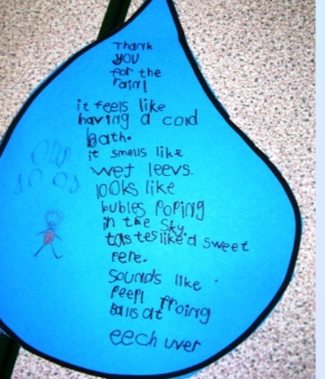 | Children to read their poems aloud for the class.

