Hansel and Gretel

Learning objective from the national curriculum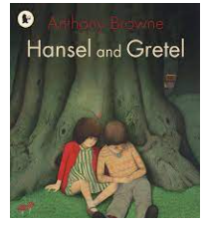
Listening and responding Listen to others in class, ask relevant questions and follow instructions
Group discussion and interaction
Work effectively in groups by ensuring that each group member takes a turn challenging, supporting and moving on
Drama
Adopt appropriate roles in small or large groups and consider alternative courses of action
Word recognition: decoding (reading) and encoding (spelling)
Read independently and with increasing fluency longer and less familiar texts
Spell with increasing accuracy and confidence, drawing on word recognition and knowledge of word structure, and spelling patterns
Know how to tackle unfamiliar words that are not completely decodable
Read and spell less common alternative graphemes including trigraphs
Read high and medium frequency words independently and automatically
Word structure and spelling
Spell with increasing accuracy and confidence, drawing on word recognition and knowledge of word structure, and spelling patterns including common inflections and use of double letters
Read and spell less common alternative graphemes including trigraphs

Engaging with and responding to texts
Engage with books through exploring and enacting interpretations
Explain their reactions to texts, commenting on important aspects

Creating and shaping texts
Sustain form in narrative, including use of person and time
Text structure and organisation
Use planning to establish clear sections for writing

Book families
Fairy tales
Twisted
tales

Purpose – Writing a story to read to a reception child.

Day | Learning Objectives | Whole class | Independent / guided work | Plenary
Preparation | Read fairy tales / traditional tales.
1 | Hook  L.O: to predict | Reveal  Witches cauldron and get clues out - guess the story  Clues :  - Sweets  - Bread  - Witches nose  - Witches finger nail  - Twigs  - Jewels. | Write a short prediction - what story is it about?  SEN  Record predictions for Seesaw | Hide and reveal the story,  Read the story up the part where the are walking into the woods.  What do they think will happen next?  Together begin to draw a story board  Discuss the new vocab :  Woodcutter  Famine  Fretting  Cried bitterly  Lagging  Read the story at the end of the day :  Up to them seeing the witches house :  Discuss vocab:  Risen  Widespread  Grieved  Scolded  reproached
2 | L.O: to investigate new vocabulary | Drama – play the rumours game. What happened to Hansel and Greatel?  Continue to read the story until the end  Discuss following vocab and finish story map:  - Pretence  - Lure  - Short-sighted  - Seized  - Kneaded  - Familiar  Share the new vocabulary with the children. | Children to complete the lessons based on vocabulary.  Complete a word web / match the pictures with the words. / Sentence strips with missing words.  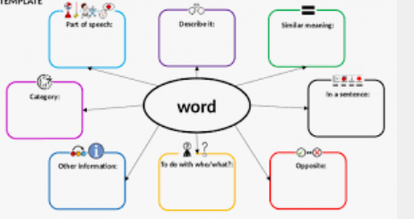  Sen :  Colourful semantics – hansel and Gretel | Plenary.  Read the text again reminding them about the vocabulary.
3 | L.O: to create a plan for writing.  Osie grid | Walk around the woods outside as you are walking around remind the children about the senses what can they see hear etc.  Watch the YouTube walk on the woods and read Bill Brysen’s the woods section.  Model using the ideas to fill in the ossie grid. | Complete the Ossie grid.  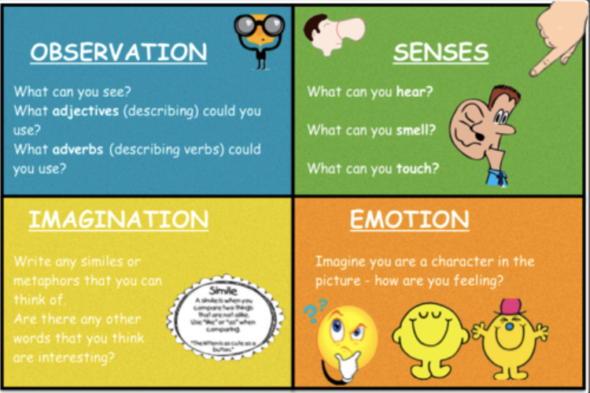  SEN  Senses grid | Share ideas vocabulary and ideas from the grids.
4 | Setting description. | Model writing the setting description.  Highlight the word classes.  The children sat at the bottom of a towering tree and the gnarled branches seemed to wrap around them. The wind whistled through the canopy and leaves rustled and crunched. Hansel shivered as the embers of the fire glowed less brightly with every gust of icy wind. When Gretel looked up the mood hung in the sky shining brightly, it comforted her in the darkness. As the children gazed around the wood seem to groan with terror, animals with bright yellow eyes darting between the branches. | Write a setting description – using ideas from the planning.  SEN  Beat dyslexia  Write senses sentences | Read out settings descriptions to the class. Talk about what was good about them.  Edit the work and peer assessment.
5 | L.O: to create a plan for writing | Hot seating as character  Show clip of the witch from snow white.  Children in small groups to pretend to be the witch.  Then model completing an ossie grid for the witch. | Ossie grid completed to describe the witch. | Share ideas at the end – children to magpie from each other.
6 | L.O: to write a character description | Share writing of the witch description. Model making use of the plan and extending using conjunctions. | Children to write the character description of the witch. | Children to share their work.
7 | L.o sequencing | Freeze frame – class to split into groups and take a section of the story.  Children then to perform the freeze frame in sequence.  Then model sequencing the story using pictures and key words. | Children to sequence the parts of the story in their books.  Children to add in new vocabulary that they have learnt. | What do the children think might happen next in the story?
8 | L.o: to create a plan for writing | Together create success criteria grid - As a class discuss what we will need when writing a recount.  The model using boxing up grid and creating an alternative ending. | Talk partner discussion about what their alternative ending could be.  Children to complete boxing up grid – adding as much detail as they can to help them with their writing. | Re read the text – highlighting vocabulary that they could use in their writing.
9/10 | L.O: to write a recount | Starter - create their own success criteria – what elements of writing do we need to include?  Model recount writing / shared writing. | Children to write recount using their plan and success criteria.  3 times throughout the lesson stop and children to work with their partners to check against their own targets. | Children to share their pieces.
11 | L.O: to edit | Model editing piece of writing from the other classes.  Use alternative’s class work to model. | Editing stations – peer review partners working on their own targets.
12 | L.O: to publish | Remind the children who they are writing for and why it has to be so neat. | Children to publish their work. | Showcase finished pieces.

