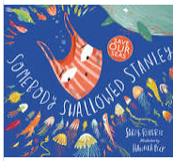
Someone Swallowed Stanley
Learning objective from the national curriculum

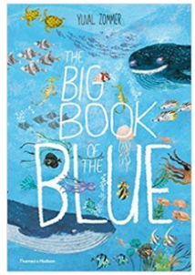
Book families
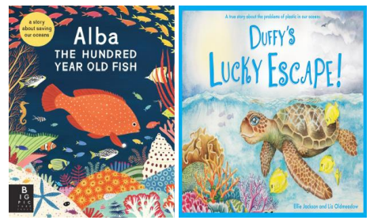
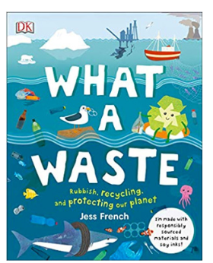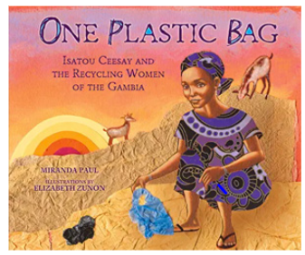

Day | Learning Objectives | Terminology | Whole class | Independent / guided work | Plenary
Preparation | Earth day and the tin forest.
1 | Prediction | Prediction | Show children the book covered in sugar paper. Recap together what we do when we make a prediction (what we know from the text + what we know from our background knowledge). Tear off the corner of the paper to show some of the jellyfish. Discuss with children what they think they are and what they know about them. Have they ever read another book with these creatures in it? Model making a verbal prediction then writing it. Tear off the corner that shows the whale. How does this change our prediction? Create a shared prediction using the two pieces of information so far. Encourage children to try to justify their predictions. Repeat the process showing Stanley. Encourage children to try to justify their predictions. Repeat the process showing the full cover. Children to make their own final prediction using all the evidence. Encourage children to try to justify their predictions. Share the blurb together and discuss children’s predictions. Share the text together. Discuss whether children’s predictions were correct. | Children to record a prediction in their independent writing. | Share the text with the children – how close was their prediction?
2 | Inference | Inferences  Literal questions | Re read the book and discuss the pictures.  Focus on the ending of the text, where the turtle swallows Stanley. Discuss with children how this makes them feel. Recap how to make an inference with children. Using a ‘what we know’ and ‘what we think’ graphic organiser, model creating inferences about the turtle’s feelings throughout the last part of the story. Use this to shared write thought bubbles to add to the illustrations. Children to complete thought bubbles showing how the young boy feels during the final part of the story – how do his feelings change between first finding the turtle and flying his kite at the end? | Children to complete the speech bubbles and think about what the characters are thinking. | How would you feel in that situation?
3 | Hook day / Ocean day |  | Resources for the years ocean day closer to the time. | Brain breaks: https://worldoceanday.school/video-take-a-blue-breath-with-a-champion-freediver-and-ocean-explorer/
4. | L.O: to understand what an explanation text is | Questions  Explanation | Recap on the text – talk partners to retell the story to each other.  Tell the chn that they will be writing a explanation text over the next week.  What do they think an explanation text is?  Look at an example of an explanation text –what do the chn think the success criteria of this genre is? | In mixed groups children to annotate the explanation text and find examples of other year 2 expectations. | What else could we write an explanation text about?  Share what they have found in their explanation texts examples.
5. | L.O: to create a plan for writing | plan | Recap yesterday’s learning. What do we need to include in an explanation text?  Model researching and recording information in a planning format.  research – remind the children that they will be using this to write tomorrow.  What format will they record in? | Children to record the research in a planning format. | Share the research and remind children that we will use this research tomorrow.
6/7 | L.O: to write an explanation text. S | Explanation text | Recap previous learning.  Together record a success criteria ready for today.  Model writing an explanation text referring to the success criteria.  Ensure plan is referred to and word banks. | Children to write independently an explanation text. | Share ideas/ read out their explanation texts.
8 | L.O: to evaluate writing | Edit | Model editing a piece of kingfishers work.  Use the success criteria to model editing their work.  What could they add in? How could they make this better? | Children to use editing stations. | Chn to peer assess each others work.

