Religious Education Autumn 2
London’s Burning!

Essential Knowledge

Vocabulary

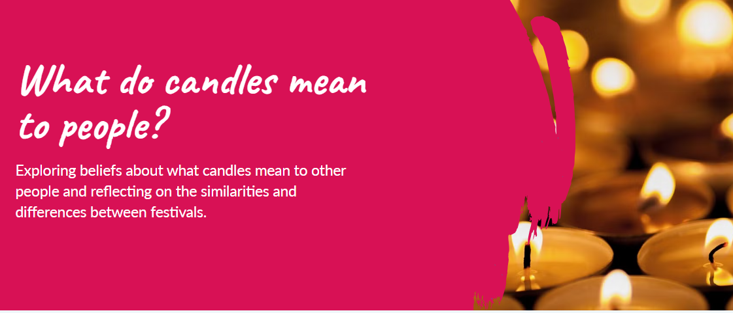
Diwali
festival
Hanukkah
prayer
sacred
symbol
temple

- Some people believe God performed miracles in the past.
- Some people believe that God has made a promise between himself and his people.
- There are some festivals which are celebrated by religious and non-religious people.
- Festivals usually celebrate a special or miraculous event from the past.
- Festivals often use light symbolically as part of celebrations.
- There are some objects that are special to followers of religious traditions.
- A festival is celebrated by many people and happens regularly.
- Practices associated with festivals have special meanings.
- People from the same faith may celebrate a festival differently.
- Objects, words and actions can represent an idea of belief.
- Many festivals are often celebrated as a community.

- Members of the same community may have similar or different ways of life.

By the end of this unit children will know...

Key objectives | - Share examples of where they have seen and experienced candles.  - Identify three practices associated with Diwali.  - Understand that some Hindu people use diyas as symbolism.  - Understand the meaning of Advent to some Christian followers.  - Identify what is important to some Jewish people at Hanukkah.  - Explain what a hanukiah symbolises.  - Understand their own positionality on what candles mean to them.  - Provide some examples of what candles mean to some people
Session | Main Teaching | Activity | Those children needing more support. | Those children needing extra challenge.
Session 1  L.OTo express and compare ideas about the meaning of candles.  SCs  - I can talk about what candles mean to me.  - I can explain what candles mean to others.  - I can develop and share my ideas.  - I can represent my ideas through art. | Starter Turn the lights off in the classroom and ask the children what they notice and how this makes them feel. Explain that to be able to see we need light.  Ask the children how an LED candle is different to a real candle (a real candle is made of wax, has a wick and a burning flame). Point out the different parts of the candle:  - The wax.  - The wick.  - The flame.  Play the Pupil video: What are candles? to explain the parts of a candle and how candles are used.  Display the Presentation: What do candles mean to you? and allow time for the children to answer the questions.  Bring the class back together and ask for volunteers to share something positive about what they have seen and any ideas that interested them.  Introduce and read the story of ‘Little Glow’ by Katie Sahota, about a candle that goes on a journey and finds out about other people’s celebrations and festivals. Alternatively, play the video introduction using the link: 'Little Glow by Katie Sahota' | Hand out the Activity: What do candles mean to people? (one each). Provide each table group with a set of drawing materials and ask the children to express their ideas about what candles can mean to people by drawing or writing in the boxes. | Should talk through their ideas first and draw pictures or symbols to represent their ideas about the uses of candles; could use an A3 copy of the Activity: What do candles mean to people? to provide more space for writing and drawing their ideas. | Could create a mindmap of their ideas about what candles are used for, writing labels for each of their drawings stemming from the centre of a blank page; should write a response to the key question ‘Why are candles important to some people?’.
Session 2  LO To recognise why candles are used to represent stories and beliefs.  SC  - I can listen to and understand the story of Rama and Sita.  - I can recall the main parts of the story.  - I can think about why candles are important to some Hindus. | Display the Presentation: Gimme five! Invite the children to think of five different scenarios where someone might see or use lights or candles and share these with a partner.  Explain to the children that festivals are often linked to special stories. The story of Rama and Sita, which they will explore, celebrated at Diwali – a festival that many Hindu people celebrate. It is commonly known as the Festival of Lights.  Remind the children that people who follow a Hindu worldview generally believe in one God (Brahman) who can take on many forms. These beliefs are called a religion. Explain that some Hindu followers believe that Rama and Sita are representations of God or deities.  Many Hindu followers believe that Rama is an incarnation of Vishnu, the God of protection. Sita is an incarnation of Lakshmi, the Goddess of wealth and prosperity.  Inform the children that the story of Rama and Sita is known by some Hindu people as the journey of Rama. Some Hindu followers believe that this story has been written in a book that is special to many Hindus, called the Ramayana. The Ramayana is considered to be ‘Smriti’ which means ‘that which is remembered’.  Play the video using the link: BBC Teach - The story of Rama and Sita.  Revisit the main events of the story using the Presentation: Who were Rama and Sita?  Place LED tealights (approximately ten) on the floor, lighting a pathway in the classroom. In pairs, ask the children to take turns walking down the pathway pretending to be Rama and Sita coming home.  Reflect on the significance of people placing lights to help Rama and Sita find their way home by asking the children: | Hand out a copy of the Activity: Storyboard to each pupil. Ask the children to complete the storyboard by drawing and writing about the main events in the story. | Could order the events of the story as a group and complete a three-part storyboard, drawing a beginning, middle and end; should use the Resource: Who were Rama and Sita? (support) to write a keyword in each section. | Should write their own story of Rama and Sita, detailing the key events in full sentences and using the key vocabulary correctly; should write a sentence explaining why candles are important to many Hindu people.
Session 3  LO To know that the festival of Diwali can be celebrated in different ways.  Scs  - I can explain how the story of Rama and Sita relates to the festival of Diwali.  - I can describe the significance of light and candles.  - I can reflect on the different ways people might celebrate Diwali. | Display slide 1 of the Presentation: Share a story and ask the children to work in pairs to recall the key events from the story about Rama and Sita.  Explain to the children that they are going to be learning more about the festival of Diwali, known as the Festival of Lights. This festival is celebrated by many Hindu people worldwide. Play the CBeebies video using the link: My First Diwali.  Replay the part in the video when the little girl makes a path and hangs lights in the trees (0:40-0:50) and ask the children:  Display the Presentation: Diwali celebrations and discuss the images that depict different practices associated with celebrating Diwali.  Point out to the children that while some Hindus may celebrate using some, all or different practices, many people use diyas, small lamps made of clay with a candle, to symbolise light triumphing over evil. | Children to create rangoli patterns using chalks | Children to be given patterns to copy. | Children to create their own patterns.
Session 4  To understand that some people believe Krishna is special by exploring a Hindu  story.  - I can identify that Krishna is an avatar of Vishnu.  - I can explain how the story suggests Krishna was a special child.  - I can discuss how the story reflects some Hindu beliefs. | Display the Presentation: Agree or disagree.  Arrange the children in pairs and ask them to discuss whether they agree or disagree with the statement ‘We can find out why some people are considered special by reading stories’.  Explain that people who follow a Hindu worldview generally believe in one God (Brahman) who can take on many forms. These beliefs are called a religion.  Recap that different characteristics of Brahman are shown in gods and goddesses called avatars (a form or character taken by God on Earth – incarnation). Some recognise Vishnu (an avatar of God or Brahman) to have many different forms, including that of Krishna.  Tell the story of Krishna and the fruit seller using either the Resource: Krishna and the fruit seller (one teacher copy) or the Resource: Krishna and the fruit seller: props version with the story sack objects or the Resource: Story sack pictures.  Stick the pictures from the Resource: Special stories in each corner of the room.  Explain to the children that you will read out a statement and they should move to a picture that it links to. Explain that some statements might link to more than one image so they can choose which to stand by.  Read the following statements, allowing time for the children to move around the classroom after each one:  - Angels appeared to show it was a special baby. (Jesus’ birth story.)  - Some people believe this was a miracle. (All of the stories.)  - They are believed to be special from when they were born. (Jesus and Guru Nanak’s birth stories.)  - Some people believe they are a form of God. (Stories about Jesus and Krishna.)  - They were protected from being hurt in the story. (Daniel and the lions and Guru Nanak and the cobra.)  - Some surprising happened in the story. (All of the stories.)  After each statement ask some children to explain why they have chosen the picture they are standing near. | Hand out the magnifying glasses (one between two, from Lesson 1) and the Activity: Krishna and the fruit seller (one between two).  Ask the children to look for and circle clues in the story that suggest why some people might think Krishna is special.  Hand out the Activity: Discussion spinner (one per group of six), a paper clip and a split pin (one per group of six).  Ask the children to place the tip of the split pin through the loop in the paper clip and onto the centre of one of the spinners.  Explain that the children should take turns spinning the paper clip and then read out the sentence starter that it lands on. They then need to talk together about how they could complete the sentence. | Could follow the story map as it is read out on the Resource: Krishna and the fruit seller; could be given a recording of the teacher reading the story to listen to again. | Could write their own sentence stems using the Activity: Blank spinner; should suggest why more than one story might link with the statements in the Wrapping up; should make links between the story and Hindu beliefs.
Session 5  To recognise why Muhammad is special to many people by exploring a story.  - I can recount the miracle in the story of Muhammad’s encounter with Angel Jibril.  - I can describe the practice of saying ‘peace be upon him’ (pbuh) and its purpose in showing respect.  - I can identify elements in the story that show Muhammad’s special status for many Muslims. | Display the Presentation: 3,2,1.  Ask the children to discuss:  - Three things they remember about the story of Krishna and the fruit seller. (Various answers include: in the story, the grains turned into gold; some people believe that Krishna was a special child with the miracle of the grains turning into gold; some people believe that Krishna is a form of God on Earth and that God can perform miracles; some people believe that if you do something good, this goodness can come back to you.)  - Two things they found interesting about stories that suggest people can have a special connection to God. (Various answers include: some people believe that Krishna is a form of God on Earth and that God can perform miracles; some people believe Krishna to have special powers, to be kind and generous, and extra special.)  - One question they still have about people with a special connection to God. (The children may suggest: Are there any other stories about avatars that have a special connection to God?)  Presentation: 3,2,1  Explain that people who follow a Muslim worldview generally believe in one God (Allah in Arabic) and are guided by the Qu’ran (Muslim scripture). These beliefs are called a religion.  Begin by telling a short story about someone who receives a special message from a mysterious messenger using the Resource: The Angel Jibril’s visit (one teacher copy). Explain that this story is important to many Muslim people.  Display the Presentation: The Angel Jibril visits Muhammad and listen to the story, revealing Muhammad’s name  Explain that ‘read’ in Arabic can also mean ‘recite’ (saying something aloud from memory).  Point out that a prophet is a special messenger chosen by God to share important lessons and messages with people  Display the Presentation: Discussion time and ask the children to discuss the prompts in pairs. | Hand out the Activity: Angel Jibril visits Muhammad (one between four). Ask the children to cut up the pictures and hold one each.  Ask the children to work in groups of four to look for clues and highlight any to answer the following questions and stand up if they think the picture they are holding answers the question asked. | Could relisten to the audio of the story on the Presentation: The Angel Jibril’s visit; could use the Resource: The Angel Jibril’s visit which is a transcript of the audio in the Presentation: Angel Jibril’s visit. | Could suggest which of the images from the story best answer each question when more than one is possible; should explain how saying ‘peace be upon him’ and not drawing Muhammad reflect Muslim beliefs.
Session 6  To recognise why many Christians believe Jesus was a special adult by investigating a story.  - I can retell key events from the story of Jesus healing a man.  - I can explain why the story might suggest to some people that Jesus was special.  - I can recognise how some religious stories may reflect beliefs. | Hand out the Resource: Knowledge organiser: Religion and worldviews – How do we know some people feel a special connection to a god? and display the Presentation: Knowledge organiser.  Ask the children to come up with some questions about the unit for their partner.  Display the image on the Presentation: What happens when we are sick.  Display the Presentation: Jesus heals a man and read the story to the children up to slide 3.  Ask the children to predict what might happen next. Allow a few children to share their predictions.  Finish reading the rest of the story. | Explain to the children that they are going to do some hot seating.  Display the Presentation: Hot seating. Working in pairs, ask the children to think of some questions they would ask the man Jesus healed or one of the man’s friends about what happened.  Place a chair at the front of the classroom and ask for volunteers to come up to the ‘hot seat’ to play the role of the man Jesus healed. Ask some of the children to ask one of their questions. Repeat with volunteers in the role of one of the man’s friends. | Could use the Presentation: Jesus heals a man to recap the story during the Main event; could use the Knowledge organiser during the Wrapping up. | Should explain their thoughts by referring to specific parts of the story when taking part in the hotseating activity; should say which part of the story is most important in suggesting Jesus was special and why; could annotate the Activity: Jesus heals a man with why parts of the story suggest to some people that Jesus was special.
Cross Curricular links | Art and design  Geography  English: Spoken language.
Learning Challenge Week
Assessment | - Share examples of where they have seen and experienced candles.  - Identify three practices associated with Diwali.  - Understand that some Hindu people use diyas as symbolism.  - Understand the meaning of Advent to some Christian followers.  - Identify what is important to some Jewish people at Hanukkah.  - Explain what a hanukiah symbolises.  - Understand their own positionality on what candles mean to them.  - Provide some examples of what candles mean to some people

