Design and technology Autumn 2
London’s Burning!

Essential Knowledge

Vocabulary

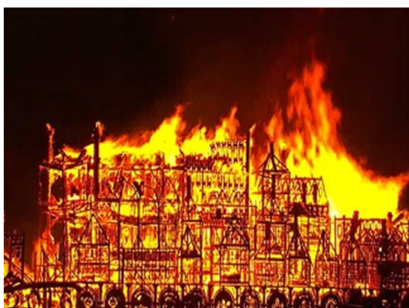

By the end of this unit children will know...

Key objectives | - National Curriculum -  - Explore and evaluate a range of existing products  - Generate, develop, model and communicate their ideas through talking, drawing, templates, mock-ups and where appropriate, information and communication technology  - Explore and use mechanisms in their product  - Explore and evaluate a range of existing products  - Design purposeful, functional, appealing products for themselves and other users based on design criteria  - Generate, develop, model and communicate their ideas through talking, drawing, templates, mock-ups and, where appropriate, information and technology  - Select from and use a range of tools and equipment to perform practical tasks  - Evaluate their ideas and products against design criteria  To sew a running stitch  - To use a template to create my design
Session | Main Teaching | Activity | Those children needing more support. | Those children needing extra challenge.
Session 1  Running stictch | Explain to children that in today’s lesson we will be learning how to sew. Ask if anyone knows what equipment we might need for this (needle, thread).  Model how to prepare the needle and thread for sewing, showing each of the following steps whilst the children do the same:  - threading a needle  - tying a knot  - sewing the stitch  - tying the final knot  Show children how to thread a needle by cutting the thread, dampening one end and squeezing the threads together before poking it through the eye of the needle.  Once they have threaded their needles, they tie a knot approximately 2cm from the end of the thread. Now, they are ready to sew. | Children to practice running stitch on a small piece of fabric. | To work in a small group so they can be supported at the point of need. | To thread needle independently.
Session 2  Designing a puppet. | Provide children with the Puppet Design Sheet of their choice and ask them to start designing their character.  Designs should be in colour and should be labelled with the colour, material and preferably the method they wish to use to join the fabrics. Then, hand out the appropriate Puppet Template or an extra copy of the Puppet Design Sheet to each child. (see Before the Lesson)  Model lining up your template with your fabric, pinning it and cutting around the edge of it. If you are using regular scissors and not fabric ones, you may want to point out the part of the scissor blade which is most able to cut fabric (the lower parts of the scissor blades). | Children to create their designs.  Children then to cut out their fabric using a template. | Use accessible scissors. | Children to ensure they are labeling their designs using previously learnt information.
Session 3/4  Making a puppet | Before sewing, ask children to carefully choose the colour of their thread, taking into consideration the colour of the puppet itself and the rest of their design.  They should also carefully pin their fabrics together, ensuring that the edges line up perfectly before sewing the three sides together with neat, even stitches, tying a knot at the end.  Once they have completed their sewing and have made a puppet, they should consider how they might decorate the front of it.  Get children to look at each other’s stitches to see if they are consistent, close together and tied up.  Do any parts need more stitches or to be re-sewn? Children should assess each other’s stitches according to the Success Criteria then discuss their findings in a class discussion. | To sew the two sides of the fabric together.  Children to assess each other’s sewing and improve where necessary. | Children to work in a small group with support able. | Differentiated by outcome.
Session 5 Evaluate | Children to do a stride of pride and go around the room and pick out features that they particularly like from the puppets they see. They should then share these with the class.  Then discuss what was difficult about making them. This could refer to parts of the process which happened during previous lessons or this one. Ask children if they have any ideas for how they would do things differently if they had the chance. | Children to follow the evaluation template and evaluate their own work. | Children to use technology to support them to record information or information to recorded by a adult.  Work also differentiated. | Children expected to include information their have learnt throughout the topic.
Cross Curricular links | Through this unit of work the following essential skills will be developed  Literacy  - read fluently, listen and respond critically to texts of all kinds, on paper and on screen, in order to access ideas and information  - talk clearly and confidently about their thoughts, opinions and ideas, listening carefully to others so that they can refine their thinking and express themselves  - effectively  - write, present and broadcast a range of ideas, in a wide variety of forms and with awareness of different audiences and purposes; communicate these ideas with  - accuracy on paper, on screen and through multimodal texts  - analyse, evaluate and criticise a range of uses of language in order to draw out meaning, purpose and effect.  Computing  - collaborate, communicate and share information using connectivity to work with, and present to, people and audiences within and beyond the school  Learning and thinking  - communicate, interacting with different audiences in a variety of ways using a range of media  - evaluate, developing criteria for judging work and suggesting refinements and improvements.  Personal and emotional skills  - reflect on past achievements and experiences to manage future learning and behaviour  - set goals for their personal development and learning, and work towards them  work independently, knowing when to seek help, dealing with pressures and deadline
Learning Challenge Week | The task of creating the pouch will be completed over learning challenge week and use the felt they created in Art.
Assessment | - I can thread a needle  - I can sew a running stitch  - I can use neat and evenly spaced stitches to join fabric  - I can design a puppet  - I can build my design on a template  - I can join fabrics together  - I can align two pieces of fabric  - I know how to use a template  - I can fit my hand into my puppet  - I can remember how to use a template  - I can cut fabric neatly  - I can pin fabric accurately  - I can design a purse
DT – still life and sculpture Textiles – Making Puppets. By making their own template, children can ensure that their pieces of fabric will be exactly the right size. With their fabric cut out, pupils use a simple running stitch to join two pieces together before decorating the front of it, according to their designs

