Computing Autumn 2
London’s Burning!

Essential Knowledge

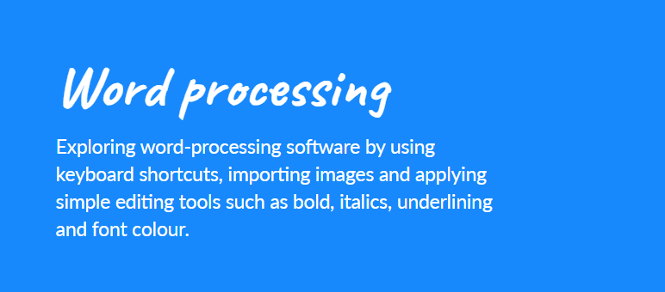
- Developing confidence with the keyboard and the basics of touch typing.
- Developing word processing skills, including altering text, copying and pasting and using keyboard shortcuts.
- Using word processing software to type and reformat text.
- Searching for appropriate images to use in a document.
- Understanding what online information is.
- Identifying whether information is safe or unsafe to be shared online.
. To know:
- Touch typing is the fastest way to type.
- I can make text a different style, size and colour.
- Copy and paste is a quick way of duplicating text.

By the end of this unit children will know...

Vocabulary

- author
- back button
- backspace
- bold
- copy
- copyright
- cut
- delete
- forward button
- highlight
- image
- import
- italics
- keyboard
- keyboard shortcut
- navigate
- paste
- redo
- search
- space bar
- text effects
- touch typing
- underline
- undo
- word-processing software

Key objectives | - Developing confidence with the keyboard and the basics of touch typing.  - Developing word processing skills, including altering text, copying and pasting and using keyboard shortcuts.  - Using word processing software to type and reformat text.  - Searching for appropriate images to use in a document.  - Understanding what online information is.  - Identifying whether information is safe or unsafe to be shared online.
Session | Main Teaching | Activity | Those children needing more support. | Those children needing extra challenge.
Session 1  Learning objective  - To begin to learn to touch type.  Success criteria  - I can find keys on a computer keyboard.  - I can type capital letters using shift.  - I can identify that the keyboard is an important input device. | Session 1  LO: to be able to identify and use the keys on a keyboard.  Begin by giving the children the opportunity to explore the computer keyboard and familiarise themselves with the layout of the keys.  Before you start, ask children to explain how you would communicate with a computer. They might talk about using a mouse or keyboard, or be familiar with AI devices like Alexa or Siri.  Draw attention to the keyboard being the most useful form of input to a computer as it allows us to type a large amount of characters that the computer knows how to interpret. In fact, coders type words and numbers on the keyboard and the computer is able to translate them into its own language to turn them into cool things like websites or computer games!  Now that we’ve taken a look at the keyboard, we’re going to learn how to type a little more quickly on it!  People who type really quickly learn something called ‘touch typing’, which means that they know how to find the letters without looking at the keys.  The best way to learn is to practise a little bit every day so that you can become quicker and start to recognise where the letters are.  In this lesson we will be looking at TypingClub, which is a website that introduces touch typing skills, building right up to typing special characters and even Shakespeare!  If you have any children who are already familiar with keyboard layout, you may want to encourage them to take a placement test to start, but for the majority of your class, you’ll want to start at the beginning!  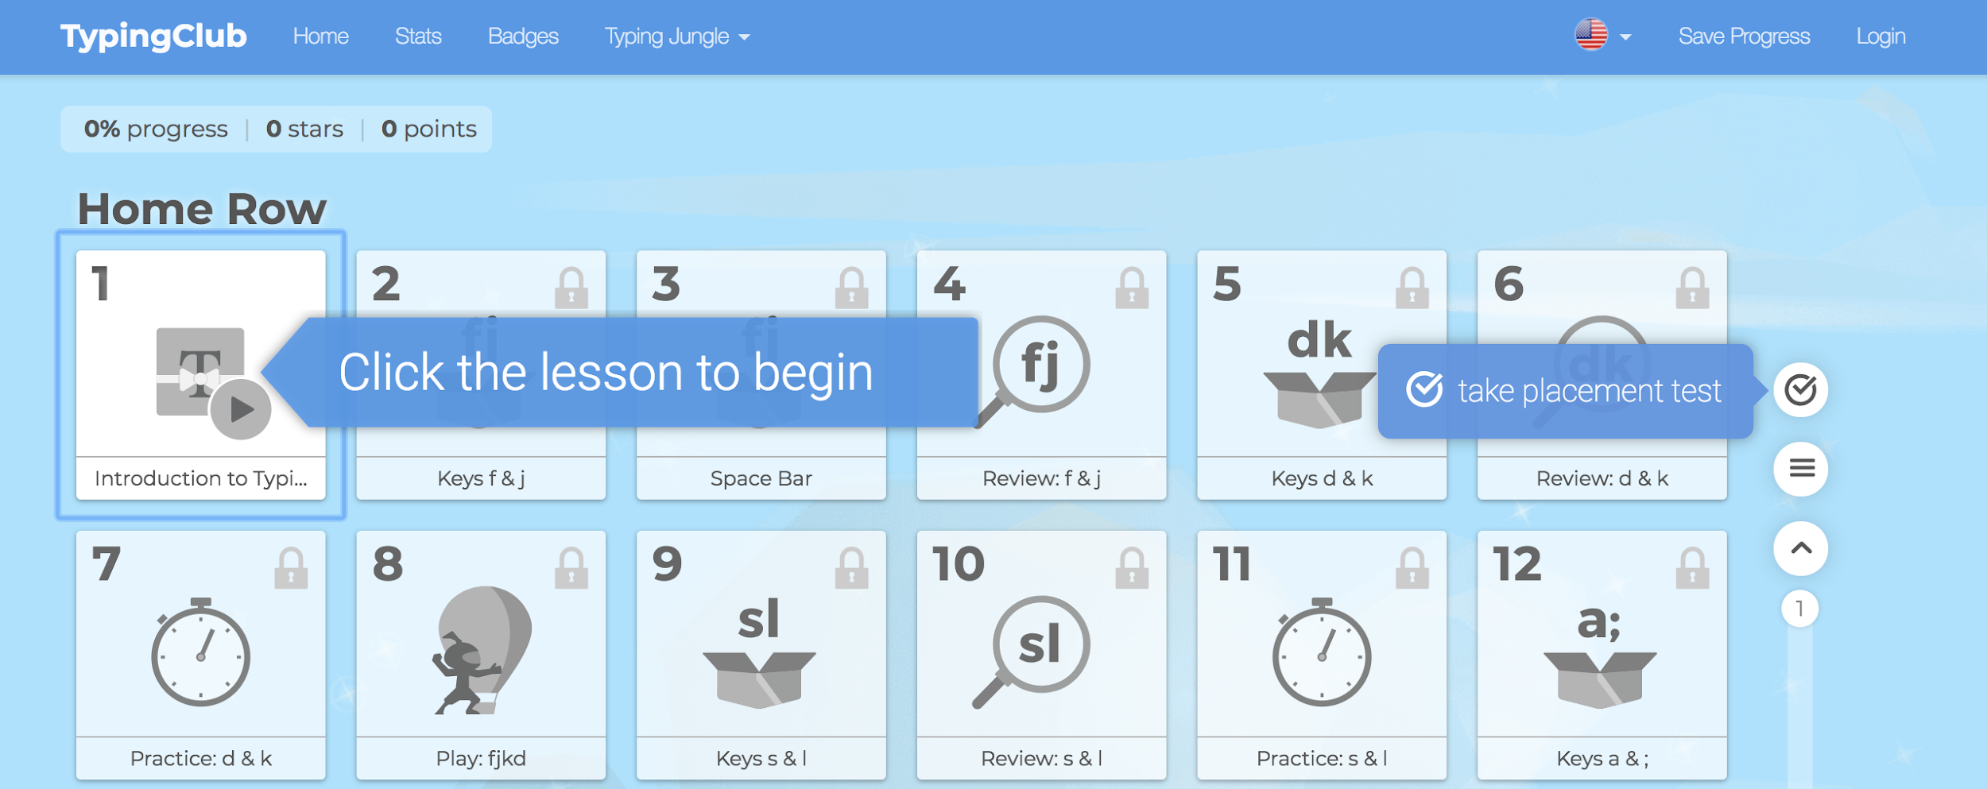  Explain to your class that the aim is to type the letters without looking at the keys, but that they are allowed to look at the beginning. It’s ok if they make mistakes, it’s better to get things wrong and learn to correct! | In pairs, children complete the Keyboard Detective Quiz. Ask them to log in to a computer and navigate to any word processing software which will allow them to type and test out keys (eg: Word, Google Docs, Pages).  Before they start, give pupils a practice question:  - Which key on the keyboard is called the ‘spacebar’ and what does it do?  Pupils to work at their own pace to get as far as they can working through the TypingClub lessons.  Ask children to discuss how many letters they are able to type. Then ask them to open up a word processor and take turns trying to type:  ‘the quick brown fox jumps over the lazy dog’  Can anyone figure out why this sentence is special? It has every letter in the English language in it. Were they able to find them all? Which letter was hard to find?  Did anyone figure out how to delete a letter that they typed by mistake? Take a look at the ‘Backspace’ key which allows you to delete the previous letter!  Encourage pupils to continue practising typing using TypingClub at home. | Could write the answers to the Activity: Keyboard detectives quiz on paper. | Could be given some timed challenges (e.g. how many names can you type in one minute?).
Session 2  Learning objective  - To understand how to use a word processor.  Success criteria  - I can type a sentence using a word processor.  - I can select text and make it bold or italic.  - I can explain how to make other changes to a document. | Recap the work from the previous lesson in identifying keyboard layout.  Ask pupils to access TypingClub and work through exercises for 10 minutes to develop their typing speed and keyboard familiarity.  If you are using individual accounts, pupils can start from wherever they ended the previous lesson; however, if you haven’t set up accounts, they will need to start again from the beginning.  In this lesson, we are going to look at some basic word processing skills. The focus is still on increasing typing speed as well as exploring the word processing software. | Pupils are going to type up the first page of the book that they have chosen.  Before they start, ask if they know how to type a capital letter. Discourage them from using the Caps Lock key, instead explain that it is easier to hold down the Shift key and tap the letter.  Introduce some keyboard shortcuts. First demonstrate that:  - Ctrl/cmd + A highlights all of the text that you have typed.  What happens if you hit Backspace? Everything has been deleted. Fortunately, we don’t need to panic because if we use:  - Ctrl/cmd + Z we can ‘undo’ whatever we just typed, and  - Ctrl/cmd + Y to redo.  Remember: on a Mac, you use Command (cmd) for shortcuts, but on a PC you will need to use Control (Ctrl). We are just exploring a few shortcuts in this lesson, but a full list can be found in the Keyboard Shortcuts resource.  Make sure children understand how to use these three key keyboard shortcuts:  - Ctrl/cmd + A  - Ctrl/cmd + Z  - Ctrl/cmd + Y  Once children have typed their first paragraph, page or sentence (depending on their typing speed), it’s time for them to explore what they can do within a word processor.  Demonstrate using Ctrl/cmd + A to select all of the text and click on the bold button (usually represented by a capital B).  Demonstrate that it can be toggled on or off by clicking on it again. Discuss what the button does to the text. Ask children what they think the other buttons in this section do? Remember to model clicking away from text to ‘deselect’ everything and view your changes.    The children then tinker with the tools available. By using the shortcut keys they can make changes to all of the text and then use ‘undo’ to try a different tool.  Challenge children to find out what the different buttons on their word processor do.  Come together to discuss what the children have discovered and the buttons they’ve explored. Explain that there’s a keyboard shortcut for lots of the functions we have tried out.  We can use:  - Ctrl/cmd + B  - Ctrl/cmd + I  - Ctrl/cmd + U  to use bold, italics or underline.  Challenge children to try and remember some of the keyboard shortcuts for next time or show how you can often hover over a button to display its shortcut. | Could type only the first sentence or two; could select a page without any special characters within the text. | Should look for a page with special characters or more advanced keyboard features such as speech or question marks; should aim to type the whole page.
Session 3  Learning objective  - To understand how to add images to a text document.  Success criteria  - I can use keyboard shortcuts to alter text.  - I can search for and find an appropriate image.  - I can import and alter an image in a document. | Session 3  LO: to understand how to add a images to a text document.  Ask pupils to access TypingClub and work through exercises for 10 minutes to practise typing pace and keyboard familiarity.  If you’re using individual accounts, pupils can start from wherever they ended the previous lesson; however, if you haven’t set up accounts, they will need to start again from the beginning.  Then read ‘The Gingerbread Man’ (or another well known tale) to the class.  In this lesson, we will be looking at how to insert images into a document. You may need to revisit some skills that the children learnt in Year 1, about finding images and importing them.  The children’s goal is to create a newspaper page based around a well known story. The key skills we are focusing on are image imports and building keyboard shortcuts.  Take a look at a newspaper, ideally a copy of ‘First News’, and show children the front cover or go the the 'Newsround' website. What can the children spot that makes it interesting? They will probably spot different colours, images and font sizes.  Explain that they’ll be reporting on the story that you read at the start of the lesson.  On a document on your interactive whiteboard, type a title for your newspaper and make a few changes like altering the size and colour of the font. Ask children if they can remember any of the keyboard shortcuts:  - How do we undo or redo something we’ve typed or altered? Cmd/ctrl + Z and Y.  - Can anyone remember how to make text bold or italic using a keyboard shortcut? Cmd/ctrl + B and I.  Model typing a sentence about the story they looked at in the ‘Attention Grabber’, encouraging them to consider:  - What happened?  - Who was involved?  - Where did it happen?  - When did it happen?  - Why did it happen? What caused it?  In Word, a menu will open when you right click the image so that you can then look for ‘Wrap Text’ and a drop down will appear to select the text wrapping you want. 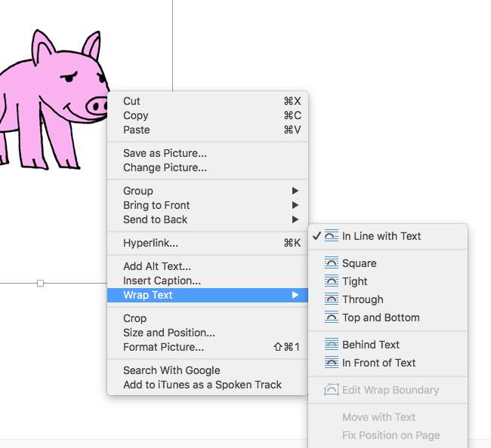  Ask children to use images and text editing to create a newspaper article about ‘The Gingerbread Man’, reminding them that they should show off all of their skills learned in the topic so far rather than spending too much time finding an image or typing the story.  Emphasise the importance of using keyboard shortcuts to make the text more interesting; for example: bold and italics.  *If you feel wary about searching for images with the children, look at your school’s online safety policy to check the procedure so that if you or they come across an inappropriate image you know the steps to take. Also, talk to the children about what words to search for before they start.  Explain to pupils how to print off their finished work. If possible, collect their work and put it in the middle of the classroom and give the children time to look at each other’s work. Or ask children to look at each other’s screens, encouraging them to point out any editing that they found unusual and explain how it was done.  Make sure children save their work before you finish up the lesson. | Let pupils know that you are not expecting pages of text and that they should instead focus on experimenting with images, layout and text effects. An important part of their work will  Demonstrate how to do this by going to ‘Google Image Search’ (go to Google.com and look in the top right-hand corner to select ‘Images’). Look for ‘Gingerbread man’ (or something relevant to the book you have chosen).  For ease, demonstrate choosing the image you want and dragging it to your desktop so that you can then drag the picture into your document. Show children that they can alter the positioning of a picture by choosing whether to make it ‘in line’ ‘wrap text’ or ‘break text’. You will need to click on the image to alter this.  In Google Docs, the image will have a choice of alignments underneath.  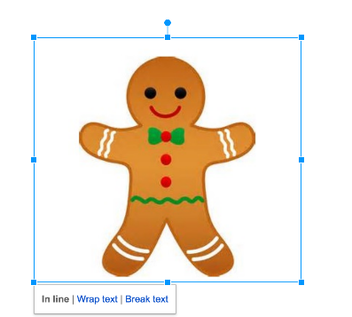  In Pages, a menu will open when you click on the image and you can edit the positioning by selecting the ‘Arrange’ tab and choosing ‘Text Wrap’.  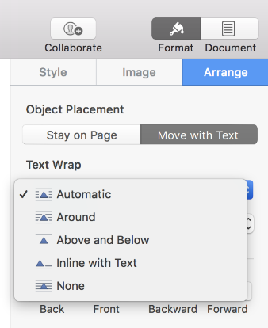 | Could use the Download: The Gingerbread Man newspaper text (support) to allow them to modify and insert images to personalise it rather than create it from scratch. | Should create a second page for their newspaper with a greater variety of appropriate fonts.
Session 4  Learning objective  - To create a poetry book using sources from the internet.  Success criteria  - I can use text styles to create headings and subtitles.  - I can copy and paste text into a document.  - I can identify the importance of crediting source materials. | LO: to create a poetry book using sources from the internet.  Ask pupils to access TypingClub and work through exercises for 10 minutes to practise typing pace and keyboard familiarity.  If you are using individual accounts, pupils can start from wherever they ended the previous lesson; however, if you haven’t set up accounts, they will need to start again from the beginning.  Review the keyboard shortcuts you’ve looked at so far: undo, redo, bold, italic, underline. Explain that they’re now going to learn one of the most useful keyboard shortcuts: copy and paste.  Explain that sometimes we find information on the internet or in another document that we want to copy. We can do this by highlighting the text we want and then typing Ctrl/cmd + C to copy and Ctrl/cmd + V to paste the text into a new document. You can also use Ctrl/cmd + X to ‘cut’ text if you want to move it to a different place in a document.  Discuss the importance of citing sources when you copy something from the internet. Explain that when someone puts something online, it still belongs to them. We can often use their text or images, but we must say where we got the image from.  We are going to use copy and paste to create a poetry book using poems from the internet - you may want to look at Kenn Nesbitt’s site www.poetry4kids.com and ask children to choose some of their favourite poems.  They will then need to copy and paste a poem they like, add a relevant picture and alter the formatting, text and layout to make it look more attractive.  They can then repeat this process for a second and third poem, but they should only copy one poem per page. | Remind children that they must include who wrote the poem and which website they copied it from. You may need to show the children how to select the URL of a website by clicking on it, using Ctrl/cmd + A and then Ctrl/cmd + C to copy.  Ask children to print out their work for review or look at each other’s work on screen. This can then be put together as a class poetry book. Encourage pupils to comment on each other’s work. What features did they like in their classmate’s poetry books?  As a class, get them to direct you to create a front cover for the poetry book they have made. How will they change the size, colour and font of their title page? This book can then be stored in a book corner or displayed elsewhere in the classroom to be used when pupils need inspiration for vocabulary or poetry of their own. | Could be encouraged to select short, simple poems; could be given the Resource: Keyboard shortcuts for them to refer to. | Could be challenged to determine how to format text in new ways (for example, centre text, add bullet points, change font, etc.).
Session 5  Learning objective  - To create a digital piece of writing.  Success criteria  - I can use keyboard shortcuts.  - I can use different text styles.  - I can import and alter an image in a document.  - I can evaluate my writing. | In this lesson, we are going to be looking at 'Lee and Kim', an online safety video created by ThinkUKnow which is the education programme of the Children Exploitation and Online Protection Command (or CEOP command).  As we have been working on familiarising children with typing, it is important that we take a look at online chat and how dangerous this can be.  Before watching the video, ask children to discuss whether they use the internet at home and establish what they might use it for (chatting to friends, looking at videos, etc).  Watch the ‘Lee and Kim’ video as a class.  After watching the video, ask children what they noticed about the ‘children’ that Lee and Kim met online. Try to steer them away from talking about the man who wanted to give the children treasure for now - we will talk about him later.  They may have observed that some of the children were kind and helpful, but that one child was not very nice at all. Start by focusing on the child who was rude. Do children think he would have said those things in real life?  Discuss why it’s important to be kind and polite online, just as it is in the real world. It can be hurtful when people say unkind things and we mustn’t think that just because they can’t see us, it doesn’t matter.  Talk about the last person that Lee and Kim meet. Was he honest about who he was? People online don’t always tell the truth and can sometimes lie about who they are. It’s important that we don’t give out too much personal information to strangers as we don’t want them to know where we live or who we really are.  Finally, ask children to tell you what they think they should do if someone makes them feel uncomfortable online. Who might they talk to? | Our task for this lesson is to make an Online Safety poster based on Lee and Kim’s story - if you’ve downloaded the resource pack you could use the ‘Sid’s Top Tips’ file as a basis for your poster. Remind children about the work we’ve done in the last three weeks using word processing software and choosing images from the internet and don’t forget to credit images!  you are able to, print out posters for review in the middle of the classroom or review on screen. You could even laminate posters and send them home.  Discuss what they think is the most important ‘tip’ on their posters and ask them to think about how they can help each other to be responsible digital citizens. | Could use the Download: Writing template (see Have ready) to allow them to modify and insert an image; could refer to the Resource: Features checklist to ensure they have utilised the features available; could use the Resource: Keyboard shortcuts to help them remember and use shortcuts. | Should include multiple images and select an appropriate layout; should include a hyperlink to an appropriate website in their document.
Cross Curricular links
Learning Challenge Week | Children to use their typing skills to create a card insert for a Christmas card.
Assessment | - Explain which the home row keys are and how to find them when typing.  - Use the spacebar and backspace correctly.  - Type and make simple alterations to text using buttons on a word processor.  - Search for, import and alter appropriate images for a text document.  - Modify text in a document.  - Use copy and paste to copy text from one document to another.  - Explain what information is safe to be shared online.

