Art Autumn 1
Essential Knowledge

Around the world in 80 days

Around the world in 80 days

This unit focuses on helping pupils develop their ability to tell a story through drawing. It includes lessons on creating textures, observational drawing, character expression, and storytelling through illustrations, enhancing pupils' mark-making techniques, observational skills, and imagination in art. Use this unit hub to inform your medium-term plan and to navigate to related resources.

Vocabulary

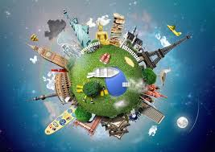
Art – Formal elements –Landscapes. Responding to a design brief, children create a piece of art that represents their local area using a map as their stimulus. They learn three techniques for working creatively with materials (felt making, recreating stained glass effects and adapting simple tile prints) and at the end of the project, evaluate their design ideas, choosing the best to meet the brief.
- blending
- charcoal
- concertina
- cross hatching
- emoji
- emotion
- expression
- frame
- hatching
- illustrations
- illustrator
- lines
- mark-making
- re-tell
- scribbling
- sketch
- stippling
- storyboard
- texture
- thick
- thin

Pupils who are secure will be able to:
- Suggest ways to draw a word through marks.
- Use relevant language to describe how an object feels.
- Suggest ways to create different textures through drawn marks.
- Freely experiment with different tools, receiving encouragement when needed.
- Describe and then draw shapes that make up an object.
- Use good observational skills to add details to their drawing.
- Use an interesting range of marks that show an understanding of how to draw different textures.
- Make sketches, which may be of basic stick-like figures or may imply more shapes.
- Develop sketches into a character, with some support, adding details to enhance their character.
- Demonstrate an understanding of how drawing facial features in different ways conveys expressions.
- Recount a story and select key events to draw.
- Create scenes from their own imagination, with some support.

By the end of this unit children will know...

Key objectives | - National Curriculum -  - To use drawing, painting and sculpture to develop and share their ideas, experiences and imagination  - To develop a wide range of art and design techniques in using line, shape, form and space  - About the work of a range of artists, craft makers and designers, describing the differences and similarities between different practices and disciplines, and making links to their own work  - To use a range of materials creatively to design and make products  - To create repeating patterns  - To explore different textures  - To create a picture using collage and frottage
Session | Main Teaching | Activity  Children to discuss what they like/ don’t like about a artists’s work. | Those children needing more support. | Those children needing extra challenge.
Session 1  Responding to an artist | Look at Susan Stockwell’s map of North America made of electronic components and her dress made from maps which explores Dutch colonial history:  https://www.susanstockwell.co.uk/artwork  Key questions  - What can you see?  - What is it made from?  - Do you like it?  - If you could meet the artist, what would you ask her?  Ask them to think, then tell their partner: If the map you drew today could become 3D, what would you make? Share their ideas. | 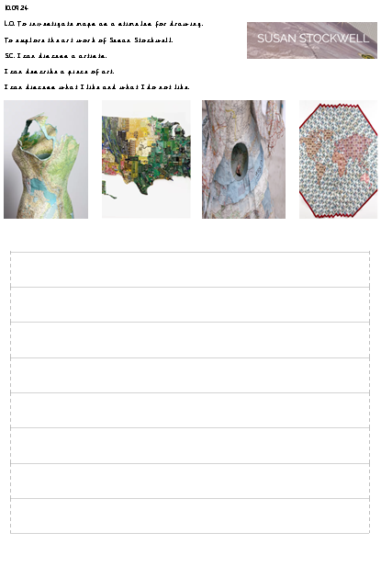 | Children to work in a group to discuss their opinions and model how they could answer the question. | Children to be encourage to extend their ideas using conjunctions and give several reasons for their answer. s
Session 2  Creative journey (Lesson 1 Kapow) | To investigate maps as a stimulus for drawing.  - I can sort images into groups and explain my choices.  - I can draw a familiar journey.  I can make my map interesting by using colour and including detail.  Children look at the works of Susan Stockwell again.  Model creating your journey home using the wax crayons. Remind the children to use all of the space and that they will be using this to help them create their future art work. | Children then to create their own map using wax crayons.  Children to base their design on their route home from school. | Children to supported with examples that they can get ideas from. | Children to encouraged to add detail to their maps.
Session 3  Making felt (Lesson 3 Kapow)  - To learn and apply the steps of the felt-making process.  - I can follow instructions to make felt.  - I can copy the shapes and colours from my map square in wool.  - I can shape wool by twisting and tearing it.  I can adapt my ideas as I work | Recap on previous learning – children to discuss their opinions on Susan Stockwell’s art work.  Tell the children there are going to use the medium of felt to create a piece of art based on their map drawing.  Together watch the video on how to make felt – discuss what we will need and get that out ready. | Children to work in pairs to create their felt design.  Children then discuss how it went and what they might do next time | Support to create a basic design. | Encouraged to add detail to their art work.
Sesssion 4  Abstract maps (Lesson 3 Kapow) Stained glass windows  - To experiment with a craft technique to develop an idea.  - I can make an abstract composition.  - I can simplify a drawn idea, looking for big shapes and important lines.  I can cut, layer and arrange the shapes. | Children to be reminded of their previous Art work and look again at Susan Stockwell’s art. Get children to look at their previous creations. Encourage them to choose their favourite part.  Tell them that we are going to create a stain glass window using different colour cellophane using this design.  Model the creation. | Create a stain glass window based on their map design.  Children to use cellophane and plastic wallets to support them. | Support to create a basic design. | Encouraged to add detail to their art work.
Session 5  Print possibilities (lesson 4 Kapow)  - To develop ideas and apply craft skills when printmaking.  - I can use simple lines and shapes from my map drawing to design a printing tile.  - I can improve my print.  I can make choices about how to use my prints to make an artwork. | Recap on previous learning and look through their art work.  Together watch the video on kapow and discuss what they might need for print.  Children to choose a section of their art work to create their print from.  Model using the piece of polystyrene and a pencil to create your design. | Children to create their own print and copy it 4 times on a piece of paper. | Children to be supported with their design and given a larger piece of polystyrene. | Children to add extra detail to their design.
Cross Curricular links | Geography - Pupils should be able to:  - Devise a simple map.  Computing-  - Use technology purposefully to create, organise, store, manipulate and retrieve digital content  DT  - Design purposeful, functional, appealing products for themselves and other users based on design criteria.  Through this unit of work the following essential skills will be developed  Literacy  - read fluently, listen and respond critically to texts of all kinds, on paper and on screen, in order to access ideas and information  - talk clearly and confidently about their thoughts, opinions and ideas, listening carefully to others so that they can refine their thinking and express themselves  - effectively  - write, present and broadcast a range of ideas, in a wide variety of forms and with awareness of different audiences and purposes; communicate these ideas with  - accuracy on paper, on screen and through multimodal texts  - analyse, evaluate and criticise a range of uses of language in order to draw out meaning, purpose and effect.  Computing  - collaborate, communicate and share information using connectivity to work with, and present to, people and audiences within and beyond the school  Learning and thinking  - communicate, interacting with different audiences in a variety of ways using a range of media  - evaluate, developing criteria for judging work and suggesting refinements and improvements.  Personal and emotional skills  - reflect on past achievements and experiences to manage future learning and behaviour  - set goals for their personal development and learning, and work towards them  - work independently, knowing when to seek help, dealing with pressures and deadline.
Learning Challenge Week | Children to use the felt their created as part of their DT project to create a purse.
Assessment | - I know that a pattern is created by repeating lines, shapes, tones or colours  - I know that pattern can exist in nature and can be made by artists to design all sorts of art, craft and design  - I can choose everyday items to paint with  - I can use these items to create a repeating pattern  - I know how to take a rubbing  - I can identify different textures and record them using a rubbing technique  - I know that the tool that I use will change how my rubbing looks  - I can use colour to create different effects

