Prior Learning

Islands

Children will use prior knowledge of oceans and continents to support their learning in naming the oceans and seas, developing an understanding of what islands are and how they vary depending where they are in the world. Children will be able to say how an island is formed and recognise human and physical features. Children will have an understanding of equatorial regions. By the end of the unit children will be able to name physical and human features of an island.

Geography- Islands

Essential Knowledge

By the end of this unit children will know...

In Geography, children will be able to name the 5 oceans and continents. Be able to say what an island is and identify human and physical features.

Vocabulary

Vegetation, factory, farm, house, shop, symbol, reference, , seasonal, daily, weather, hot, old, equator. Island

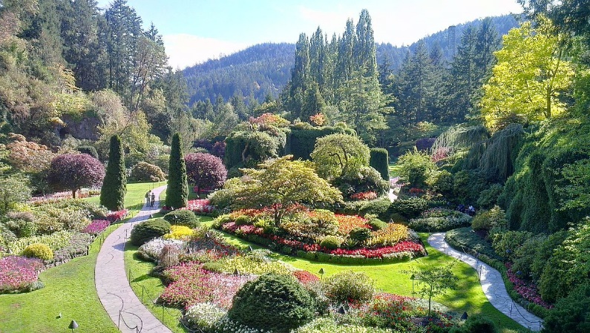
Oceans and continents year 2 geography autumn term.
Polar opposites Year 1 Geography Hot and cold countries
Weather year 1

Key Objectives-  use world maps, atlases and globes to identify the countries, continents and Locational knowledge ♣name and locate the world’s seven continents and five oceans Place knowledge ♣understand geographical similarities and differences through studying the human and physical geography of a small area of the United Kingdom, and of a small area in a contrasting non-European country Human and physical geography ♣identify the location of hot and cold areas of the world in relation to the Equator and the North and South Poles ♣use basic geographical vocabulary to refer to: ♣key physical features, including: beach, cliff, coast, hill, mountain, sea, ocean, season and weather ♣key human features, including: village, farm, house, port, harbour and shop oceans studied at this key stage  ♣use aerial photographs and plan perspectives to recognise landmarks and basic human and physical features; devise a simple map; and use and construct basic symbols in a key  - basic geographical vocabulary to refer to: • key physical features, including: beach, coast, forest, hill, mountain, ocean, river, soil, valley, vegetation and weather. • key human features, including: city, town, village, factory, farm, house, office and shop. C  - In different places on Earth we can expect to find different temperatures and weather. | Session 1  LO: To be able to recall prior learning of oceans and continents.  SC: I recall prior learning.  Children are to create a mind map of what they can remember about oceans and continents.  LO: To understand what an island is  SC: I can define an island  I can locate an island on an atlas  I can say which continent the island is in.  I can say which ocean surrounds the island.  Read the text about Islands together.  Intro: Give children atlases and ask them to turn to the map of the world Explain that a border is where two countries meet each other, and show some examples Ask the children to find some more examples of countries that have borders with each other Revise how the coast is where the sea meets the land Revise how islands are surrounded by water; they do not have borders with other countries and all of their exteriors are coastline Ask the children to find some examples of places that are islands Explain independent work  To identify islands  Explain that they are going to be using their atlases to find some places that are part of another country Explain how to use an atlas to find places that are part of other countries, including how the index is in alphabetical order and how to use grid references Model how to use the atlases to find some places that are not part of the independent work e.g. Java, Hokkaido, Sardinia and some non-island locations Extension: Children to find more examples of their own of places that are and are not islands, correctly identifying this about each place  Main  Children to work in pairs to use an atlas to find islands and say which continent and ocean it is in.  Put children into mixed ability pairs to support pupils needing extra support. | Session 2  LO: To locate different climates.  SC: I know the difference between weather and climate.  I can locate different climate regions around the world.  I can use an atlas to locate islands and say which climate they are in.  Equatorial regions  What is climate?  Loom at diferent climate regions around the world. BBC Teach cimates.  https://www.bbc.co.uk/teach/class-clips-video/geography-ks1--ks2-climate/zjdthbk  Work through PowerPoint identifying different climate types and support children’s knowledge in recognising that countries close to the equator are hot and near the poles are cold.  Main  Children to colour different climates on world map.  Children will then need to use an atlas to identify islands and which climate they are in.  Use google world to look at islands. Discuss from images what climate they might be in. Question children in which continent the islands can be found and discuss whether it is a hot, mild or cold climate.  Pupils needing extra support:  May need support identifying the counties on a map and then again on their individual map.  Pupils working at greater depth:  Identify the hot and old countries, label on a map and write a small fact to go with it. | Session 3  LO:To understand that human creations have a function  SC: I can name some objects and discuss their function.  I can say which items would be most important on an island .  I can justify why these are the most important items.  Explain that everything people make has a function (a job to do)  Give some examples in the classroom e.g. a chair is for sitting on, a table is for writing on etc  Explain that some items are found on a lot of islands because many people on different islands face the same challenges and dangers  Ask the children to think of some of the things that we might find on an island that people have made to help them to live on the island  Show children the items that we will be using for the independent work  For each item, ask them to think, pair, share what they think it is and what they think its function (job) is  Explain the independent work  Main:  Children to match the item and its function for the following items: lighthouse, quay, seawall, air ambulance, lobster pot, lifeboat, lifejacket, lifebuoy, ferry, fishing net, pier and crane  Plenary:  Explain ‘Diamond Nine’ activity to children: they will have nine items from the independent work, with each item on a card. They will need to rank the items in terms of their importance in the shape of a diamond  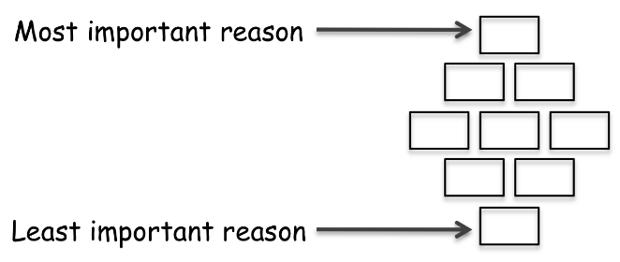  Children to cut out cards and arrange them as above  Emphasise that there is no right or wrong way to arrange them, the important thing is to justify your opinion  Children to share their diamond nines with each other, explaining their choices and discussing any differences  (If the diamond nine activity proves too complicated, can just ask children to choose which item they think is most important and which is least important)  Revise the meaning of the word function and how everything that people create has a function  Pupils needing extra support:  To work with T/TA.  Pupils working at greater depth:  Extension: look up other items found on islands in dictionaries and give their functions: causeway, trawler, flare, buoy and yacht
Session 4  Human and physical features  LO: To know some of the common features of islands  SC:To be able to identify features as being physical or human  I can suggest which features we would find on an island.  Discuss how we can guess if something was made by people or not e.g. comparing a tree and a table, a rock and a step or a road and a field  Explain that when we talk about the geographical ‘features’ of islands we are talking about big things e.g. a chair would not be a geographical feature of an island, but a large building would be or a rock would not be, but a cliff would be  Ask the children to think, pair, share some of the features that we might find on an island  Go through PowerPoint which:  - explains how in Geography we talk about the human and the physical features of a place  - explains how human features of places exist because people (humans) created them, and gives some examples  - physical features of places exist naturally (without people creating them), and gives some examples  - gives image and a sentence of information about the following:  - Physical: beach, waves, birds, hills, cliffs and bay  - Human: hotel, fencing, farm, boat, lighthouse and pier  For each feature, ask the children to think, pair, share whether they think it is a human or a physical feature (while constantly referring back to the definitions of physical and human features that are printed and displayed)  Ask the children to justify their decision of physical or human for each feature  Do not tell the children what each feature is, otherwise they have the answers for the independent work already  Explain independent work  Main:  Children to classify the features from the PowerPoint as being physical or human  Children to complete work in books.  Pupils needing extra support:  children to work on a worksheet  Pupils working at greater depth:  Extension: Ask children to find an image of / look up in a dictionary the following and to decide if it is a physical or a human feature: dock, boulder, airstrip, helipad and lagoon  Ask the children to compare their answers in pairs, discussing any differences  Revise the difference between physical and human geographical features | Session 5  Life on an island  LO: To discuss what life is like on an island.  SC: I can gather information about life on an island.  I can compare life on different islands.  Children to re-define what an island is. How might an island be different from life in Grantham? What is there more/less of on an island? Encourage children to think about physical and human features.  Watch videos below:  https://www.bbc.co.uk/teach/class-clips-video/geography-ks1-ks2-your-world-shetland-iqaluit-remote-islands/zn8fbdm  https://www.bbc.co.uk/teach/class-clips-video/william-whiskerson-life-on-the-isles-of-scilly/zmmmhbk  Children to make notes about life on each island. Share notes with each other.  Children to write a short comparison about the different islands.  SEN – Draw and label (using widgit)  Pupils needing more support – To have writing frames.  Pupils working at greater depth – To use subheadings to compare the islands, include more comparisons and use descriptive language.
Learning Challenge Week

Cross Curricular Links
- Science – where does food come from? Plant or animal? Process of growing.
Assessing Pupils Progress and Understanding

