Letters from a Lighthouse
Purpose: To report on the eradication of the lighthouse Audience:
Form: Newspaper report
Reading comprehension
- Predicting what might happen from details stated and implied
- Discussing and evaluating how authors use language, including figurative language, considering the impact on the reader •
- Drawing inferences such as inferring characters’ feelings, thoughts and motives from their actions, and justifying inferences with evidence •
- Distinguishing between statements of fact and opinion
- Participating in discussions, building on their own and others’ ideas and challenging views courteously
Writing Composition
Plan their writing by:
- Plan writing by:
  - Identifying the audience for and purpose of the writing, selecting the appropriate form and using other similar writing as models for their own
- Draft and write by:
  - Selecting appropriate grammar and vocabulary, understanding how such choice can change and enhance meaning
  - Using a wide range of devices to build cohesion within and across paragraphs
- Evaluate and edit by:
  - Assessing the effectiveness of their own and others’ writing
  - Proposing changes to vocabulary, grammar and punctuation to enhance effect

Specific grammar objectives:
- Relative clauses beginning with who, which, where, when, whose, that or an omitted relative pronoun

- Indicate degrees of possibility using modal verbs [for example, might, should, will, must]
- Use expanded noun phrases as a descriptive device [revision from LKS2]
- The difference between structures typical of informal speech and structures appropriate for formal speech and writing (for example the use of subjunctive forms)
- Indicate grammatical and other features by:
  - Using commas to clarify meaning or avoid ambiguity in writing
  - Using semi-colons, colons or dashes to mark boundaries between independent clauses (To get the GD writers)
  - Linking ideas across paragraphs using adverbials
  - using brackets, dashes or commas to indicate parenthesis
Spelling objectives
- Use further prefixes and suffixes and understand the guidance for adding them
- Spell some words with ‘silent’ letters [for example, knight, psalm, solemn]
- Continue to distinguish between homophones and other words which are often confused
- Use dictionaries to check the spelling and meaning of words
- Statutory 5/6 word list
Speech and Language – Exploratory and Presentational Talk
- listen and respond appropriately to adults and their peers
- I can work collaboratively
- I can put myself in someone else’s shoes and express clear understanding of character opinions and actions with justifications
- I can express my feelings.
- I can make deductions from audio sounds
- I am showing my understanding of how a character might feel.
- I can discuss the different emotions and difficulties the poet was trying to convey.
- ask relevant questions to extend their understanding and knowledge
- use relevant strategies to build their vocabulary
- articulate and justify answers, arguments and opinions
- give well-structured descriptions, explanations and narratives for different purposes, including for expressing feelings
- maintain attention and participate actively in collaborative conversations, staying on topic and initiating and responding to comments
- use spoken language to develop understanding through speculating, hypothesising, imagining and exploring ideas
- speak audibly and fluently with an increasing command of Standard English
- participate in discussions, presentations, performances, role play/improvisations and debates
- gain, maintain and monitor the interest of the listener(s)
- consider and evaluate different viewpoints, attending to and building on the contributions of others
- select and use appropriate registers for effective communication

Exploratory talk Presentational talk Parallel writing process writing product writing peer assessment
Overview
The children will read the story of Letters from a Lighthouse as a class text. We will pick out some parts from the beginning of the story but continue to read until we reach the idea that the lighthouse must be removed.
Exploratory talk Presentational talk Parallel writing process writing product writing peer assessment
Day | Focus | Whole Class | Independent/Guided work | Plenary
1 | To use imperative verbs | Looking back to chapter 1 – Keep Calm and Carry on.  Re-read the scene at the cinema when the air-raid is announced.  Discuss what might need to happen to ensure everyone gets out to the cinema safely.  Imperative verbs – make a list of imperative verbs and talk about what they are for.  Using the list created, add imperative verbs to create a list of instructions which will help evacuate the cinema safely | Create a poster using the list to ensure the cinema is evacuated safely. | Imagine you are Cliff and Olive – how are you feeling about being evacuated from the cinema?
2 | To use modal verbs  Success criteria  I know what modal verbs are  I can rank them according to their possibility | Re-read when Sukie disappears.  Introduce the scale of possibility – modal verbs.  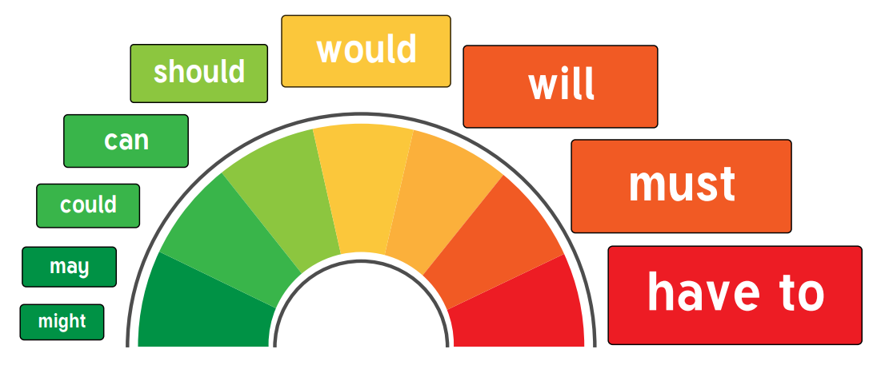  Think about Sukie’s disappearance  Make notes of the details – what do we KNOW?  Think about the facts – what is she wearing, how old, hair colour? Where was she? How long has she been missing? When was she last seen?  Now discuss the possibilities? The things that COULD have happened? The uncertainties.  Think about what is definitely not true and should be at the bottom of the scale. | Draw the scale of possibility in your book and write in some of the points which have been discussed.  Certain at the top and those that are ambiguous further down. | Write a sentence about what has happened to Sukie using a modal verb.
3 | To use modal verbs  Success criteria  I know what modal verbs are  I can rank them according to their possibility | Apply the use of modal verbs to a written piece.  Explain to the children that the local radio station is allowing people to give a short announcement to try and find anyone who may have been hurt/lost/killed in the bomb blast near the cinema.  Using the scale of possibility from lesson 2, model writing the short radio message you could give about Sukie.  For example - Sukie was definitely wearing a green coat and she was wearing red lipstick. Sukie could have been alone but she may have had a tall blonde haired man with her. Sukie was outside the cinema but she possibly was not in the cinema when the bomb hit. | Write what would be said in the radio broadcast if you were Oliver looking or Sukie. Use modal verbs to express what you know and what could have happened/been. | Read your radio broadcast out
4 | To explore the features of a newspaper report  Success criteria  I know what a newspaper features are  I can identify a newspaper report | Using a newspaper report – identify the features of it.  Box it up success criteria – do this alongside the features. | Annotate a newspaper to show the features.  Box it up success criteria
5 | To know how to use and punctuate direct speech correctly | ICAPI  https://www.naturalcurriculum.co.uk/grammar/year-5-grammar-lessons/direct-speech/harpy-eagle/screen-1/  use harpy eagle for teaching and verbal grammar bit.  Apply knowledge to LFAL.  Apply the correct punctuation to a conversation in the text between Olive and Esther.  Model writing a conversation between Olive and Cliff when they are being moved from Queenie’s to Ephraim’s.  Verbally model the conversation at the lighthouse steps/ladder. | Edit the conversation between Olive and Esther to show correct punctuation for direct speech.  Write an exchange (4) between Olive and Cliff when Cliff has to clib the ladder to the lighthouse for the first time. | With your partner, read the exchange out loud.
6 | To apply knowledge of direct speech | Recap the lesson from yesterday – ICAPI  Have speech on the board that needs punctuation correctly. Children to change/explain what needs to go where. Edit.  Explain the newspaper report and what it is going to be about.  Explore different characters - Mr Spratt, Mrs Henderson, Olive, Miss Carter, Queenie, One of the local fishermen.  Use children as characters- role play – what would they say? Tch is the reporter and asks the questions. Write on flipchart what the characters say.  Write quotes that these characters may have given to the newspaper reporter.  Prior to children writing – on flipchart make very brief notes about the characters view points. | Children to choose at least 3 characters and write quotes they may have given the newspaper reporter – use ICAPI accurately.  Write into books. | Using flipcharts – compile a list of things these characters would have said when they found out the lighthouse was to be erased!
7 | To plan a newspaper report | Make a list of the facts – bullet points – what do we know? Newspapers write facts.  - Lighthouse to be erased because it is being using as a landmark to guide German planes to Plymouth.  - Why Plymouth?  Plymouth, home to major naval bases for centuries, was one of the most heavily bombed cities in Britain during WWII. Fifty-nine separate air raids killed 1,174 civilians, according to local officials. The raids destroyed almost 3,800 homes, and heavily damaged another 18,000.  Share current news story - https://www.bbc.co.uk/newsround/68390620  - Argument for – will stop Germans being able to bomb the naval bases  - Argument against – perilously dangerous seas – riptides and quicksands along with jagged hidden rocks that will rip boats to shreds. Ephraim’s home.  Use the guided plan sheet to support this discussion.  Introduction  Brief explanation of what has happened. What, who, when, why, how? | Complete What? Who? When? Why? How? On plan for introduction.  LAPs to work collaboratively on one plan with tch. | Choose quotes add to the newspaper report plan.
8 | To write a newspaper introduction | Model writing the intro – who/where/what/when/how/why?  Model finding different elements and underlining in colour. | Children write the intro paragraph using the structure given from the plan  LAPs to use tch modelled as a support. | Use 5 different colours – can you underline the different elements in 5 colours?
9 | To plan a newspaper report | Using the support sheet- complete newspaper plan for paragraph 1 answering in note form the questions on the support sheet  Look back at box it up – add language on to plan in coloured pen – think about 5/6 words and specific vocabulary taken from the newspaper article we explored.  Model writing paragraph 1 | Children to complete plan sheet  Add language on from box it up  LAPs to work with tch to complete plan as a group.  Write paragraph 1
10 | To plan and write a newspaper report | Model editing paragraph 1 – cross check against the plan.  Using the support sheet- complete newspaper plan for paragraph 2 answering in note form the questions on the support sheet  Look back at box it up – add language on to plan in coloured pen – think about 5/6 words and specific vocabulary taken from the newspaper article we explored.  Model writing paragraph 2 | Children edit paragraph 1 – ticking off their plan to ensure all is included.  Children to complete plan sheet  Add language on from box it up  LAPs to work with tch to complete plan as a group.  Write paragraph 2 | Check against plan
11 | To plan and write a newspaper report | Model editing paragraph 2 – cross check against the plan.  Using the support sheet- complete newspaper plan for paragraph 2 answering in note form the questions on the support sheet  Look back at box it up – add language on to plan in coloured pen – think about 5/6 words and specific vocabulary taken from the newspaper article we explored.  Model writing paragraph 3 | Children edit paragraph 2 – ticking off their plan to ensure all is included.  Children to complete plan sheet  Add language on from box it up  LAPs to work with tch to complete plan as a group.  Write paragraph 3 | Check against plan
12 | To plan and write a newspaper report | Model editing paragraph 3 – cross check against the plan.  Using the support sheet- complete newspaper plan for paragraph 2 answering in note form the questions on the support sheet  Look back at box it up – add language on to plan in coloured pen – think about 5/6 words and specific vocabulary taken from the newspaper article we explored.  Model writing paragraph concluding paragraph | Children edit paragraph 1 – ticking off their plan to ensure all is included.  Children to complete plan sheet  Add language on from box it up  LAPs to work with tch to complete plan as a group.  Write concluding paragraph. | Check against plan
13 |  | Publish newspaper – learning challenge week.

