
Computing: E-Safety
- Describe how to search over multiple platforms and be aware of the accuracy of the results presented.
- Describe some of the methods used to persuade people to buy online.
- Explain the difference between fact, opinion and belief and recognise these online.
- Explain what a bot is and give examples of different bots.
- Explain some positive and negative distractions of using technology and small strategies for reducing the time spent on technology.

Essential Knowledge

By the end of this unit children will ...

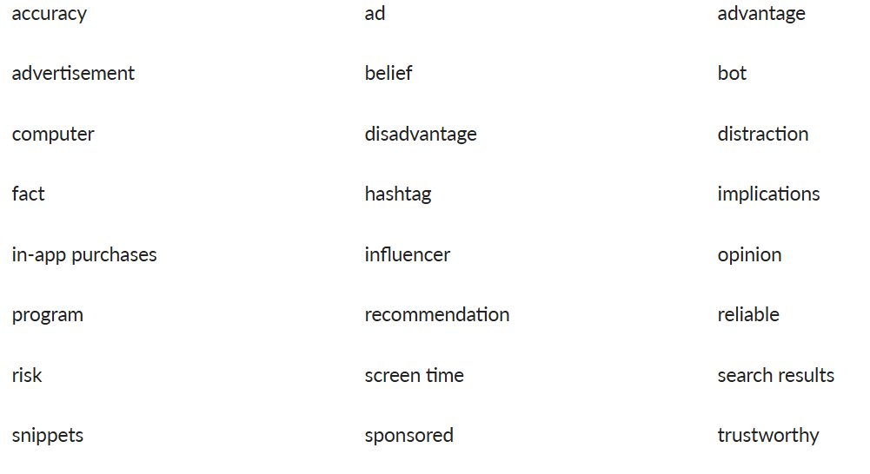
Vocabulary

E-Safety

During the unit the children will understanding why some results come before others when searching. They will also understand that information found by searching the internet is not all grounded in fact and how to make judgements about the accuracy of online searches. They will identify forms of advertising online and reflect on the positives and negatives of time online whilst thinking about respectful and disrespectful online behaviour. They will also begin to recognise that information on the Internet might not be true or correct and that some sources are more trustworthy than others.

Computing

Lesson 1
Focus: To describe how to search for information within a wide group of technologies and make a judgement about the probable accuracy.

Success criteria
- I can describe how to search for information on search engines, social media and image and video sites.
- I can make judgments about the accuracy of the information I am presented with.
Discuss with the children how being online allows us to search for many things. Ask them:
- What does the word online mean? (Being connected to or using the internet.)
- What does the word search mean? (To look for something.)
- What types of things can you search for online? (Answers may include facts for homework; pictures or places around the world; funny videos; information about my favourite things.)
Display slide 1 of the Presentation: How accurate is the information I search for online? and tell the children that you are planning a family holiday. Explain that this will be achieved by searching for ‘best UK holidays for families’. Show the children how search engines provide a quick and efficient way to search for items online. Open an internet browser (such as Chrome or Safari), navigate to a search engine (such as Google or Kiddle) and type in ‘best UK holidays for families’.
Advertisements
Using slides 2 and 3, show the children how advertisements usually appear at the top of a search. Explain that we know it is an advertisement as it will be signposted with either ad or sponsored, depending on the search engine or site used. Allow the children time to discuss whether the first results displayed accurately represent the best UK holiday destinations.
Snippets
Show slides 4 and 5 and inform the children that some search engines may then show a snippet after advertisements. A featured snippet provides a quick answer or summary. These are usually present if a question has requested the search results. More information on how Google uses snippets can be found on the link: Google Support. Ask the children if this information is more reliable. Discuss how this may be more reliable than the advertisements but children still need to check the website for bias and authenticity.
The rest of the search results
Display slide 6 and explain to the children that the rest of the search results are displayed after the advertisements and snippets. Discuss how children should not assume that everything they read is reliable and that they need to check the source. Demonstrate using a search engine to search for something (for example, the current topic being studied with the class) and see if the children can identify the different results shown.
Show slide 7, examine the two images and discuss the similarities and differences. Explain to the children that searching for videos or images might not show real images (areas may have been cropped out or aspects may have been altered to portray a better image). Remind the children that these are all points they need to consider when seeing an image or video online.
Arrange the children in pairs and hand out the Resource: How accurate are my results? (one between two). Show slide 8 and inform the children that Billy has been searching for the ‘best running trainers for an eight-year-old boy’. Look at the content closely from each platform and highlight the areas that may not show true accuracy in the results.
Display slide 9 and remind the children to think about all the teaching points from the lesson. Allow time for paired discussion and for the children to complete the activity.
Questions
- Why would a company pay for an advertisement? (To inform customers about a new product; to persuade customers to click and buy a product; to build a positive brand image or reputation.)
- Does it mean this product is better than others? (Adverts use persuasive language to sell a product but usually contain opinions rather than facts.)
- Is the snippet reliable? (It may be more reliable than an advert but the website should still be checked for bias and authenticity.)
- Should we believe everything we read? (Not everything on the internet is reliable and often contains opinions rather than facts; images and videos can be easily altered.)
Allow the children to share their responses about Billy’s information search. Ask them:
- Do you think all the information Billy found was reliable?
- What do you need to be aware of when searching for information across different platforms? (Adverts use persuasive language to sell products and contain opinions rather than facts; websites should be checked for bias and authenticity; not everything online is reliable; images and videos can be easily altered.)

Lesson 2

Learning objective
- To describe some of the methods used to encourage people to buy things online.

Success criteria
- I can describe some methods used by companies such as in-app purchases and pop-ups.
- I can recognise some of these when they appear.
- I can think about ways to avoid purchases.
Display the Presentation: Brain dump and hand out whiteboards and pens (one each). Allow time for the children to write down what they remember from the previous lesson.
Take feedback and discuss.
Answers may include:
- Adverts and sponsored links are displayed at the top of the search results.
- Adverts often use persuasive language and can contain opinions rather than facts.
- Snippets are shown after adverts and are often displayed when a question has been searched.
- Snippets may be more reliable than adverts but they still need to be checked for bias and authenticity.
- Not everything online is reliable and can be opinions rather than facts.
- Videos and images can be fake and are easily manipulated.
Discuss with the class some of the benefits of being online, such as searching for products, finding information, chatting with friends or playing games.
Explain that companies are advertising and trying to persuade people to buy their products whenever they are online. These adverts can be easy to spot but are sometimes more challenging to identify. Inform the children that they will look at some online advertising methods.
Advertisements
Display slide 1 of the Presentation: How do companies encourage us to buy online? Recap what the children learned in Lesson 1: How accurate is the information I search for online? about advertisements in search engines. Discuss how it is easy to spot an advert as it has either ad or sponsored next to a search engine result. Ask the children:
- Why do these appear at the top of the page? (It is a highly effective way to advertise their product.)
In-app purchases
Show slide 2 and explain to the children that many apps are freely available; however, around 96% have some in-app purchases. Inform them that in-app purchase means people can pay for something else while in that app. Discuss some of the popular techniques that companies use for in-app purchasing.
- Special offers: limited offers that customers can buy only at a particular time.
- Extra lives: the option to purchase lives or objects to help people when gaming.
- Advertisements: the option to pay to stop adverts interrupting gameplay by appearing.
Spend time with the children discussing these and ask if they have encountered any.
Influencers
Using slide 3, introduce the terms influencer and social media influencers to the children. Explain that influencers (children and adults) have a huge online following on their social media channels and their primary role is to influence their followers’ behaviour (particularly shopping habits).
Discuss with the children that companies ask the influencers to share videos or pictures with their products. Explain that the influencer may have never used the product before but the company pays them or gives them a percentage of the products sold using the special code they share.
Recommendations
Display slide 4 and explain to the class that apps and social media sites follow the content users watch, share and upload closely. They use this information to provide them with a personalised feed, including advertisements for products they think they will be interested in. Discuss how this can be turned off in a lot of settings.
Show slide 5 and arrange the children in pairs or small groups. Hand out the Activity: Scenario cards (one per group) and inform the class that they will look through two scenarios where children have spent money online. Ask the children to read through the scenarios and answer the questions.
Questions
- Why might companies pay to have their product advertised? (It helps them sell more and make more money; it lets people know about a product; it can make a product more desirable.)
- Does it mean their product is any better than their competitors? (They may want people to think it is better so they buy it; it may be more popular but not necessarily better; you should check reviews or ask someone who owns it.)
- Have you ever been tempted to buy a product you have seen a video or picture of online?
- Why do you think companies pay influencers to talk about their product? (Influencers have many followers so many people become aware of the product; people think they are famous and feel like they know and trust them; they can appear to love the product so more people buy it.)
Allow time for the children to share their answers with the class. Ask them:
- How did they spend money? (John spent his parents’ money to vote again; Isla spent her parents’ money to buy an in-app purchase.)
- Do you think they knew it would cost them money? (Isla saw how much it would cost and John knew he had used his free token; they may not have realised their parents would get a bill because they didn’t have to provide actual money.)
- How could they stop this from happening in the future? (They could ask their parents to set up controls on the device; they could read what the app says before they click any buttons; if it repeatedly asks for money, they could delete the app.)

Lesson 3
Focus: To explain why lots of people sharing the same opinions or beliefs online do not make those opinions or beliefs true.
Success Criteria:
- I can explain the difference between facts, opinions and beliefs.
- I can make my own judgments about what I read and see online.
Display the Presentation: Gimme five! and arrange the children in pairs. Allow time for paired discussion.
Take feedback and discuss.
Answers may include:
- Paying for advertisements so their products appear at the top of search results.
- Special offers people need to pay for in free apps.
- Extra lives or objects users pay for in free apps.
- Payment to stop advertisements which interrupt gameplay in free apps.
- Using influencers to sell their products with offer codes.
- Monitoring online movements to see what content people search for or watch and then advertising specifically to them.

Ask the children:
- Should we believe everything we see or read?
Explain to the children that just because something has been seen or read online, does not mean it is true. Inform them that when online, they need to think about the reliability of what they have read or seen and decide if what has been said can be classed as fact, opinion or belief. Discuss with the children how this can be the case regardless of how often that statement is seen online.

Display slide 1 of the Presentation: Fact, opinion or belief? and define what a fact is. Explain that when the children are online and unsure if something is true, they should check at least two other reliable sources.
Show slide 2 and define what an opinion is. Explain that opinions on social media may be used to persuade people to purchase products. (For example, this will be the best day out; the food was amazing!)
Use slide 3 to show the definition and example of a belief. Discuss with the children what other beliefs they can identify.
Display slide 4 and hand out the Activity: Fact, opinion or belief? (one each). Ask the children to look through the statements and decide if they are facts, opinions or beliefs.
Tell them to imagine that they have an older cousin who is 14 (remind them that 13+ is the legal age restriction for most social media) who is on holiday and has had ice cream on the beach. Explain that they have taken some photos and are about to post them on their social media channels. Ask them to decide on a fact and opinion statement they could add to their description.

Allow the children to share their thoughts with the class. Ask them:
- Is it sometimes hard to distinguish between a fact and an opinion? (Answers may include something that sounds true but is actually an opinion; people may say it is a fact but not true for everyone; opinions can sound like facts because people confidently say them.)
- How could you check the reliability of a statement? (Answers may include looking for evidence; checking reliable sources; asking adults or teachers; reading comments or reviews; using your common sense.)

Lesson 5
Focus: To explain how technology can be a distraction and identify when I might need to limit the amount of time spent using technology.
Success Criteria
- I can explain how technology can be both a positive and negative distraction.
- I can recognise the amount of time I spend on technology.
- I can suggest strategies to help limit time spent on technology.
Display the Presentation: Agree or disagree? and allow time for paired discussion.
Take feedback and discuss.
Answers may include:
- I disagree because people may forget how to do things themselves if too many bots are used.
- I disagree because bots can make mistakes and are less able to understand than humans.
- I disagree because if bots take over tasks, more people will be without jobs.
- I agree because some robots can do dangerous or tedious jobs.
- I agree because they do not get tired and they can be used to remind you of appointments.
- I agree because they can teach you things and help people with tasks they find difficult.

Display the Presentation: Using technology at home and ask the children the question. Use the images as discussion prompts if needed.
Suggestions may include playing games online, playing games with friends, communicating with friends via text messages, helping with homework, listening to music and streaming videos. List the children’s different technology uses for them to refer to later in the lesson.

Display slide 1 of the Presentation: What is my #TechTimetable like? Ask the children what some of the positive aspects of using technology are, referring back to the list if necessary. Ask them the questions on the slide to prompt a discussion.
Encourage the children to discuss the positive aspects of using technology; for example, listening to music can improve someone’s mood, distract people from other things and prompt dancing or singing with friends and family. The children’s views may differ on whether other activities, such as homework, can be completed simultaneously with listening to music. Highlight that it would be better for some people to get rid of the distraction and then listen once they have completed the task they need to do.
Using the same questions, discuss the positive aspects of other activities the children listed during the Attention grabber.
Show slide 2 and discuss some of the negative aspects technology may lead to; for example, when playing games online, people struggle to switch off, cannot complete other tasks simultaneously and often choose games over other physical activities. Discuss whether this is an activity people do on their own or with friends, including that people can play online (with friends and strangers) and in person. Discuss the negative impacts of always playing online rather than socialising physically with friends.
Using the questions, discuss the negative aspects of other activities the children listed during the Attention grabber.
Activity 1
Using slide 3, introduce the first task to the children. Explain that they will read about a typical day for James and Lauren. Hand out the Activity: James and Lauren scenario cards (one between two) and allow the children time to read through them. Instruct them to highlight where James and Lauren use technology in their lives. Ask the children to think about how much technology they use and whether they use it positively or negatively.
Display slide 4 and ask the questions. Take feedback and discuss the positive distractions technology gives James and how he uses technology with his family rather than alone.
Show slide 5 and ask the questions. Take feedback and discuss how Lauren uses technology, how much time she spends on her devices and the negative impacts it may be causing her.
Activity 2
Explain to the children how having a balance when using technology is essential. Recap some of the positive and negative effects and distractions of using technology.
Using slide 6, ask the children what their #techtimetable looks like. Explain that they will create their tech timetable based on a typical school weekday. Ask them to think about what they did yesterday or a specific weekday from last week. Demonstrate this to show how much technology the teacher uses in a day.
Questions
- Why do we go online?
- How does it make you feel?
- How can technology help us?
- What could Lauren do to help her sleep better at night?
- How much time do you think you spend on technology?
- Do you think all of this is positive?

Allow the children to share their technology timetable and discuss ways they could reduce the use of technology if needed. Ask them to consider if they enjoy their time online or go online out of habit. Give the children some time to discuss and take feedback.
Ask the children to devise one way to swap a negative distraction for a positive or reduce some of their screen time. Ask them:
- What small change could you make?
- How might that make you feel better?
- How could you involve your family more?

