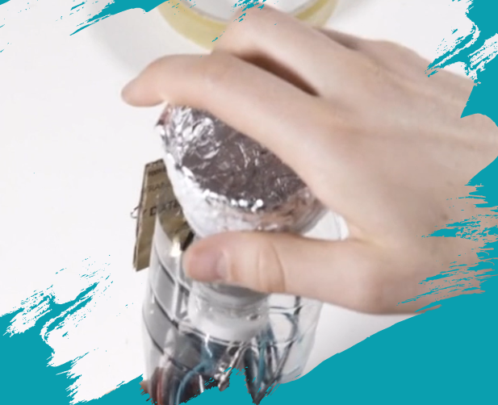
Computing: Scratch
Essential Knowledge

By the end of this unit children will ...

Pupils who are secure will be able to:
- Understand how to create a simple script in Scratch.
- Add or change a sprite and prevent it from rotating.
- Use decomposition to identify key features and understand how to decipher actions that make the quiz game work.
- Understand what a variable is and how to use the ‘say’ and ‘ask’ blocks.
- Create a variable and be able to use a variable to record a score.
- Understand what a variable is and how it works within a program.

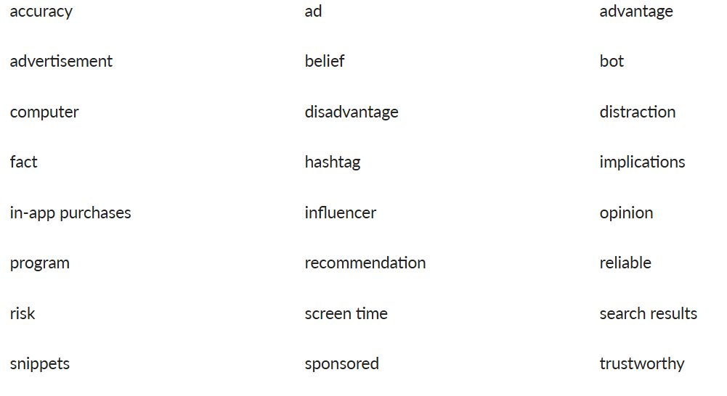
Vocabulary

Scratch

Students will use decomposition to solve a problem by finding out what code was used and to understand the purpose of a script of code. They will create algorithms for a specific purposes and make a simple coding game. They will Incorporate variables to make code more efficient and remixing existing codes.

Computing

Lesson 1
Focus: To recall the key features of Scratch.
Success Criteria:
- I can name the main areas of Scratch.
- I can recognise how to adjust my sprite’s orientation in Scratch.
- I can create a simple script for a new sprite to my stage.

Before starting this unit, you might want to check that the children can recall:
- An ‘algorithm’ is a series of instructions put in an exact order.
- ‘Decomposition’ means breaking a problem into manageable chunks.
- A ‘loop’ is a code tool to repeat something in a program.
- Scratch is a block programming language.
Display slide 1 of the Presentation: Scratch reminder and ask the children to discuss in pairs what they remember about Scratch.
Show slide 2 and hand out a whiteboard and pen to each pair. Ask the children to look at the Scratch code displayed and predict what will happen when the code runs. Instruct them to write their ideas on the whiteboard.
The children may suggest:
- The ‘when green flag clicked’ block runs the program and starts the sprites at a specific place on the stage.
- The arrow keys on the keyboard point the wizard’s sprite in different directions and move it forward.
- The unicorn sprite follows the mouse pointer but moves forward fewer steps than the wizard.
- A ‘time’ block starts at 0 and changes the time every second.
- The ‘say’ blocks allow the wizard to speak.
- When the unicorn touches the yellow colour, the game stops.
Display slide 3 and hand out devices with internet access (one between two).
Place the Download: Unicorn chase .sb3 file on the school network or use the link: Scratch - Unicorn chase and download the .sb3 file (see Teacher video: Sb3 files and creating Scratch projects). Share the project with the children and ask them to play the game with their partner.
Show slide 4 and ask the children:
- What does the wizard do? (The wizard moves in different directions using the arrow keys to catch the unicorn. The game ends once the wizard touches the unicorn with the wand.)
- What does the unicorn do? (The unicorn follows the mouse pointer but moves slower than the wizard. Once the unicorn touches the wizard’s wand, the game ends.)
Highlight what each sprite does and relate this to what the children wrote on their whiteboards when they looked at the code. Clarify that:
- The unicorn follows the mouse.
- The arrow keys control the wizard.
- The game ends when the wizard touches the unicorn.
- A timer counts how long it took to catch the unicorn.

Display slide 1 of the Presentation: Sprite positioning and orientation and ask the children what the numbers next to the ‘x’ and ‘y’ mean.
Using slide 2, explain that the numbers represent coordinates and relate this to similar work in maths. Explain that in Scratch, 0, 0 is in the middle of the screen and coordinates can become negative numbers. Demonstrate, using Scratch, that when a sprite is moved to a different place on the stage, the coordinates change to represent its current position.
Show slide 3 and ask the children what they think the number next to ‘direction’ represents. Using slide 4, explain that a dial pops up when the direction button is clicked. Ask the children where else they have seen the number shown in the direction dial. Explain that 180 represents 180 degrees; the number shows the angle the sprite faces.
Show slide 5 and look at the three icons underneath the direction dial. Ask the children to discuss with a partner what they think the three icons represent. Display slide 6 to explain how they control a sprite within Scratch.
Display the code blocks on slide 7 and ask the children to explain to a partner what the script does. (The sprite faces a different direction and moves 15 steps when the down arrow or right arrow key is pressed.)
Creating a sprite controlled by the arrow keys
Show slide 8 and explain the activity to the children. Remind them they have been given the script’s start but will need to work with a partner to write the rest. Ask the children to go to the Scratch website and create a new project (see Teacher video: Sb3 files and creating Scratch projects). Allow the children to complete the activity and play with the script they have created.
As the children are tinkering, remind them to:
- Create an events block for the keyboard arrow keys (up, down, right and left).
- Choose the mirror icon under the direction dial to prevent the sprite from rotating.
- Place a ‘point in direction’ block and use the dial to decide which way the sprite should face for each arrow key.
- Tinker with different numbers in the ‘move’ block to see how they affect the speed at which the sprite moves.
Creating a sprite that follows the mouse pointer
Using slide 9, challenge any children who have created a sprite controlled by the keyboard’s arrow keys to create a second sprite that follows the mouse pointer. Explain that they must utilise the ‘forever’ loop and the ‘point towards’ blocks. Allow the children to tinker with Scratch to determine what other blocks they require to code this second sprite.
As the children are tinkering, remind them to:
- Create a second sprite.
- Use a ‘when green flag clicked’ block to start the sprite’s movement.
- Select a ‘point towards’ block from the motion panel and ensure the sprite follows the mouse pointer.
- Use a ‘forever’ loop so the sprite continues to follow the mouse pointer rather than moving just once.
- Place a ‘move’ block within the ‘forever’ loop and play with different numbers to see how they affect the speed at which the sprite moves.

Ask the children to discuss their creations using the following questions:
- What have you created?
- Can you explain what you have made?
- Which blocks helped you achieve this?
Play the Pupil video: Scratchy rap to recap key coding terms and concepts.
Scratch is developed by the Lifelong Kindergarten Group at the MIT Media Lab.
Hand out a whiteboard and pen to each child. Display the Quiz: Scratch and ask the children to record their answers to the multiple choice questions on their whiteboards. Address any misconceptions.

Pupils needing extra support:
Could discuss what other directions the sprite will need to move in apart from down and right; could refer to slide 6 of the Presentation: Sprite positioning and orientation to help them prevent a sprite from rotating; could use the partially finished script on slide 8 when creating a sprite that is controlled by the arrow keys.
Pupils working at greater depth:
Should create a second sprite which follows the mouse; could add another sprite controlled by different keys.

Lesson 2
Focus: To understand how a Scratch game works by using decomposition to identify key features.
Success Criteria
- I can recognise that a sprite may contain more than one script.
- I can identify the parts of a Scratch game.
- I can explain the term ‘decomposition’.
Display the Presentation: Gimme five! and arrange the children in pairs. Allow time for paired discussion.
Take feedback on any key points they recalled from the previous lesson.
Play the Pupil video: Scratchy rap to recap key coding terms and concepts.

Display slide 1 of the Presentation: Scratch quiz game and arrange the children in pairs. Hand out devices with internet access (one between two).
Place the Download: Ice kingdom .sb3 file on the school network or use the link: Scratch - Ice kingdom and download the .sb3 file (see Teacher video: Sb3 files and creating Scratch projects).
Share the project with the children and ask them to play the game with their partner. Explain that the children should not click the ‘see inside’ button to view the code as they will decompose the game later in the lesson.
Using slide 2, encourage the children to think about how the game works and discuss the different features as a class.

Display slide 1 of the Presentation: Identifying what code does and ask the children if they have heard of the word ‘decomposition’. Click to reveal that decomposition means breaking a problem into smaller pieces.
Show slide 2 and explain that for a game to work, the computer needs to be told to perform several different actions.
Display slide 3 and explain to the children that they will decompose the quiz game into its parts to determine what code blocks might have been used. Click to reveal that the children will need to think carefully about what happens in the game and decide which code blocks each sprite might use.
Hand out the Activity: Scratch Ice kingdom (one between two) and allow time for the children to complete the activity.

Discuss what the children have written and display slides 4–6 of the Presentation: Identifying what code does to reveal some of the code blocks the different sprites use.
Show slide 7 and ask the children what other features they noticed in the game. Click to reveal some possible answers.
Allow the children time to look inside the project to discover what other code blocks have been used.
Show part of the code on the board and ask the children what they think the ‘broadcast’ block does. Take feedback and explain that it allows the sprites to communicate with one another and is used in this project to let the little boy know to ask a question about penguins when the penguin is clicked.

Pupils needing extra support:
Could be encouraged to investigate what happens when a user gets a correct answer compared to an incorrect answer; could use the Resource: Knowledge organiser: Programming: Further coding with Scratch for support on what the coding blocks are called and do.
Pupils working at greater depth:
Should have a greater understanding of how the sprites interact with one another; could open a blank Scratch project and try out different blocks to see if they can get a similar response.

Lesson 3
Focus: To recognise what a variable is.
Success Criteria:
- I can use the ‘ask’ block in Scratch.
- I can understand what variable means.
- I can create a variable in Scratch to store an answer.
Display the Presentation: Brain dump and hand out whiteboards and pens (one each).
Use the Download: Ice kingdom .sb3 file or the link: Scratch - Ice kingdom to show the children the game again if necessary.
Allow the children to write down their thoughts and then take feedback on any key points they recalled from the previous lesson.
The children may recall that:
- The ‘when green flag clicked’ block starts the program.
- The ‘say’ and ‘ask’ blocks allow the character to talk and ask questions.
- The ‘when this sprite clicked’ block allows the penguin and bear sprites to move and become bigger.
- The ‘hide’ block makes the sprite disappear.
- The broadcast blocks allow the sprites to communicate with one another.
Display slide 1 of the Presentation: What is a variable?
Ask the children to write the word ‘animal’ at the top of their whiteboard. Explain to the children they will move around the classroom and ask different children to name an animal. Instruct them to clear their whiteboard and write the new reply under the word animal whenever they receive a different answer.
Allow time for the children to receive multiple answers and then stop them. Show slide 2 and ask the children to read the sentence and use whatever word is written on their whiteboard to fill in the gap. Select a few children to read their sentences aloud.
Display slide 3 and ask the children to repeat the activity. Explain that this time, they will write ‘food’ at the top of their whiteboard and invite other children to name a food. Allow the children to receive multiple answers and then stop them.
Show the sentence on slide 4. Select a few children to read the new sentence aloud and use whatever word is written on their whiteboard to fill in the gap.
Use slide 5 to make the link between the children’s whiteboard and a variable in a computer program.
Show slide 6 and explain that variables can store many different data types; they are often used for words, numbers and sometimes for true or false statements.
As a class, discuss the following questions:
- How often did you have to rub off your whiteboard? (Answers will vary but the children should understand that the answer on their whiteboard can change based on new information like a variable.)
- How easy was it to change your answer? (Answers will vary but children should realise that variables are flexible and can be easily updated with new information like their whiteboard.)
- Does it matter what answer the person you ask gives you? (The children may say that it does matter. If someone had given them the name of an animal when they were looking for the name of a food, their sentence would not have made sense.)
- Was there a limit to how many times you could change the word on your whiteboard? (The children should understand the limitless changeability of the whiteboard and understand that variables can be continually updated with a program.)

Display the Presentation: Code inspection. Working in pairs, ask the children to look at the Scratch code on the board and discuss what it might do. The children may suggest:
- The ‘when green flag clicked’ block runs the program.
- The ‘ask’ blocks allow the program to ask the user questions.
- The ‘say’ blocks allow the program to speak to the user.
- The answer block enables the program to temporarily store and repeat the user’s name.
- The answer block allows the program to temporarily store the user’s answer to the maths question.
Make links between how the answer block is used and the children’s work with variables on whiteboards during the Attention grabber.
Either download the file Download: Variables part one .sb3 file to your school network and upload it to Scratch or use the link: Scratch - Variables part one (see Teacher video: Sb3 files and creating Scratch projects). Play the game to demonstrate how the code works.
Hand out the devices (one between two) and share the link: Scratch. The children can access Scratch as guests rather than setting up an account (see Teacher knowledge).
Ask the children to go to the Scratch website and create a new project.
Show the Pupil video: Conditional statements, which demonstrates the lesson activity.
As the children are tinkering, remind them of the following points (as shown in the Pupil video: Conditional statements):
- Scratch does not automatically add a space when joining two blocks of text. If the children want to join the word ‘hello’ with the variable ‘answer,’ they will need to add a space after the word ‘hello’.
- An ‘if/else’ block is a conditional statement and the program will react differently depending on which conditions are met.
- To compare two values, the children should use a green operators ‘=’ block. One side will have the variable ‘answer’ block to represent the user’s response; the other will have the correct numeral answer to the maths question.
- The children should place two ‘say’ blocks in the ‘if/else’ block, depending on whether the answer is correct. One will convey the sprite’s message to a correct answer; the other if the user’s answer is incorrect.
Allow time for the children to add code to ask the user their name and a simple maths question.
Explain that they should evaluate whether or not the answer is correct by ‘tinkering’ – exploring and playing with something to discover its key functions.
Rewatch the pupil video if necessary or use the Presentation: Conditional statements for further support.

Questions
- Why might we need variables in a program such as Scratch? (To capture and use data imputed by the user, such as their name or an answer to a quiz question; to store information such as a player’s score.)
- Can you locate the ‘ask’ block in Scratch? (In the sensing section.)
- What is tinkering? (Exploring and playing with something to discover its key functions.)
- Why is tinkering important? (Answers include: it allows programmers to explore, make mistakes and discover how code works.)
Allow the children to try each other’s quizzes to check that the code works. As a class, discuss the following questions:
- What issues did you find in each other’s codes?
- How can we help solve these issues?
Discuss any issues the children found in each other’s code and how the problems can be solved.
Demonstrate how to save the project as a download and ensure all the children have saved their work successfully to be used in the following lesson. Go to File > Save to your computer and select an accessible location to save the .sb3 file (see Teacher video: Sb3 files and creating Scratch projects).
Play the Pupil video: It’s a Scratch rap to recap key coding terms and concepts, including variables.

Pupils needing extra support:
Should watch the Pupil video: Conditional statements again; could be reminded where to find the ‘ask’ and ‘answer’ block; could view the step-by-step guide in the Presentation: Conditional statements for further support.
Pupils working at greater depth:
Should be encouraged to create different questions and think about ways to make sure responses are interesting for the player.

Lesson 4
Focus: To understand how to make a variable in Scratch.
Success Criteria:
- I can create a variable and use it to store information.
- I can ‘call’ a variable within my program.
- I can recognise that variables can be words or numbers.

Display the Presentation: Anagrams and working in pairs, ask the children to unscramble the words. If needed, the children can use whiteboards and pens for support.
Take feedback, asking the children to define any words they unscrambled.
The answers are as follows:
- Sprite – a visual object that can be manipulated through code (e.g. to move, respond, appear or disappear).
- Variable – a number or text that can change each time a program is run, often in combination with selection, to change the result of a program.
- Tinker – to explore and play with something to discover its key functions.
- Decompose – to break down something into smaller chunks.
Play the Pupil video: It’s a Scratch rap to recap key coding terms and concepts, including variables.

Display slide 1 of the Presentation: What is a variable? Working in pairs, ask the children to look at the Scratch code on the board and discuss what it might do.
The children may suggest:
- The ‘when green flag clicked’ block runs the program.
- The ‘ask’ blocks allow the program to ask the user questions.
- The ‘say’ block will enable the program to speak to the user.
- The answer block allows the program to repeat the user’s name to them later.
- The if/else block allows the program to display a different message depending on whether the user provides a correct or incorrect answer to the maths question.
- There is a block that sets the score to 0 and changes it if the user correctly answers the question.
Show slide 2 and play the games to demonstrate how they work. Either download the files Download: Variables part one .sb3 file and Download: Variables part two .sb3 file to your school network and upload them to Scratch or use the links: Scratch - Variables part 1 and Scratch - Variables part 2 (see Teacher video: Sb3 files and creating Scratch projects).
Using slide 3, explain that the sprite ‘remembers’ the name given at the beginning of the second project and says it back. This is because a new variable has been created to store the name called ‘name’.
Display slide 4 and ask the pupils to explain a ‘variable’ (a place to store temporary information within a program where the information written can be changed as the program runs).

Hand out the devices (one between two).
Explain that the children will adapt their Scratch project from the last lesson to create a simple maths quiz. Inform them that to make the quiz interesting, they will use variables to remember the player’s name and to keep the score.
Demonstrate how to open a downloaded project in Scratch. Ensure all the children can find their saved file from the last lesson and open it in Scratch. Go to File > Load from your computer and select the .sb3 file (see Teacher video: Sb3 files and creating Scratch projects).
Show the Pupil video: Making a variable, which demonstrates the lesson activity.

Allow the children to explore the variables panel and create a variable to track the score. They could also create a variable called ‘name’ to repeat the user’s name back to them.
Explain that they should tinker to add more questions to their quiz and ensure Scratch tracks the user’s score. As the children are tinkering, you may need to remind them (as shown in the Pupil video):
- Navigate to Scratch’s variables panel, click ‘make a variable’ and call the variable ‘name’.
- Put a ‘set [variable]’ block and set the variable to ‘name’ so the code will save the user’s name.
- Change the ‘answer’ blocks to a variable ‘name’ block.
- Navigate to Scratch’s variables panel, click ‘make a variable’ and call the variable ‘score’.
- Drag the ‘set [variable]’ block and place it below the first ‘when green flag ticked’ block in the scripting area. Set the variable to score and ensure it is set to 0.
- Drag a ‘change [variable]’ block and snap this underneath the purple ‘say’ block that provides feedback when the user’s answer to the maths question is correct.
- Ensure the score will increase by 1 when the user answers the question correctly.
Explain to the children that if they want to change their sprite, they will need to copy their code from one sprite to another before deleting the old sprite to ensure they do not lose their code.
Rewatch the pupil video if necessary or use the Presentation: Making a variable for further support.

Ask the children to swap seats with a partner and try out their quiz. Explain that although projects are unfinished, it is important to identify positives and suggest improvements.
Encourage the children to explain what they like about a project they have tried and suggest any improvements to consider for the next lesson.
Demonstrate how to save the project as a download and ensure all the children have saved their work successfully to be used in the following lesson. Go to File > Save to your computer and select an accessible location to save the .sb3 file (see Teacher video: Sb3 files and creating Scratch projects).

Pupils needing extra support
Could plan their questions in advance; could be provided with a printed sheet of useful blocks and be asked where they think they should go within the code; should discuss the program and explain what they think it does based on what blocks have been used; could rewatch the Pupil video: Making a variable; could view the step-by-step guide in the Presentation: Making a variable for further support.
Pupils working at greater depth:
Could try tinkering to tell the user their score at the end of the quiz using a ‘say’ block and a ‘score’ variable block.

Lesson 5
Focus: To create a quiz using variables.
Success Criteria:
- I can create a range of questions.
- I can use the ‘if/else’ block to check whether an answer is correct.
- I can use the ‘score’ variable to calculate the total number of correct answers.
- I can make my quiz engaging and exciting.

Display the Presentation: Explain the answer and allow time for paired discussion.
Possible answers may include:
- Variables allow a score to be kept in a game, making it more fun to play when you win points.
- Using a variable can allow a computer to speak to the player, ask their name and repeat it back.
- Variables can allow a game to ask the player questions and then change the game to their responses (e.g. which multiplier someone would like to be tested on).
- Variables can allow a project to use timers or countdowns, which add suspense.
Play Pupil video: It’s a Scratch rap to recap key coding terms and concepts, including variables.

Display slide 1 of the Presentation: Code inspection. Working in pairs, ask the children to look at the Scratch code displayed on the board and discuss what it might do.
The children may recall previous learning around the green flag and ‘say’ and ‘ask’ blocks. Highlight the following points:
- There is a new ‘ask’ block which requires the user to choose a number.
- There is a new variable called ‘Multiplier’.
- The answer the user provides to the question of picking a number is used to finish the times table question of ‘What is 3 x’.
Explain that the children will continue their Scratch project from the last lesson. Inform them that to make the quiz more interactive, they will use a variable to allow the user to choose the times table they want to be tested on.
Demonstrate how to open a downloaded project in Scratch. Ensure all the children can find their saved file from the last lesson and open it in Scratch. Go to File > Load from your computer and select the .sb3 file (see Teacher video: Sb3 files and creating Scratch projects).
Show the Pupil video: Times table project, which demonstrates the lesson activity.

Allow the children the remainder of the lesson to ‘tinker’ with their times tables project. Encourage them to be creative and imaginative within the parameters of the task.
As the children are tinkering, you may need to remind them of the following points (as shown in the Pupil video):
- Drag a green ‘join’ block and snap this inside the purple ‘say’ block that provides feedback when the user’s answer to the maths question is correct.
- Type their desired feedback (e.g. ‘Well done!’) in the first space of the join block and drag the variable ‘name’ in the second space.
- Add a space at the end of the typed feedback so the user’s name does not run directly into the message. Scratch will not do this automatically.
- Navigate to Scratch’s variables panel, click ‘make a variable’ and call the variable ‘multiplier’.
- Drag an ‘ask’ block from the sensing panel and snap it below the ‘set name to answer’ block. Type in ‘Pick a number!’.
- Drag the ‘set [variable]’ block and place it below. Set the variable to ‘multiplier’ and place an ‘answer’ block next to it.
- Drag a green ‘join’ block and snap this inside the maths question block. Type ‘3 x ’ in the first space and place a ‘multiplier’ variable block in the other.
- Drag a green ‘*’ block and snap this inside the number space of the ‘if/else’ block. Place a ‘multiplier’ variable block in the first space and type ‘3 x ’ in the second space. This ‘3’ relates to the maths question.
Rewatch the pupil video if necessary. Use the Presentation: Creating a variable to track the score for any children who are struggling to create a variable in Scratch (see Adaptive teaching).

Ask the children to play another pair’s game and think about ways to improve their project. Allow them time to alter their project.
Hand out the Activity: Times tables evaluation (one each) and ask the children to fill out the evaluation sheet.
Demonstrate how to save the project as a download and ensure all the children have saved their work successfully to be used in the following lesson. Go to File > Save to your computer and select an accessible location to save the .sb3 file (see Teacher video: Sb3 files and creating Scratch projects).
Optional – provide each child with the Quiz – pupil answer sheet and display the Unit quiz (see link: Assessment – Computing Y4: Further coding with Scratch). Read each question aloud and allow the children time to answer. Reveal the answers and ask them to self/peer mark their answer sheets.
If pupils completed the Knowledge catcher in Lesson 1, they can revisit them and add new information in a different colour.

Pupils needing extra support:
Could use the Presentation: Creating a variable to track the score to create a working program that displays a player’s score and has at least three questions.
Pupils working at greater depth:
Could try tinkering to change the costumes of their sprite depending on whether the user gives a correct or incorrect answer using the looks panel and selecting the ‘switch costume to’ block (see Teacher video: Changing costumes).

