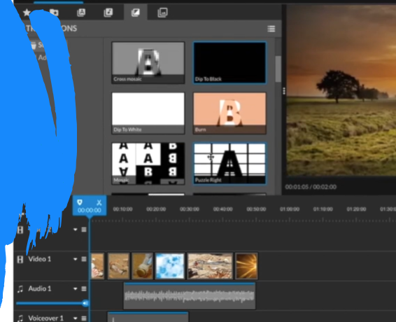
Computing: HTML
Pupils who are secure will be able to:
- Recognise the role of HTML in a web page.
- Add text between the heading and paragraph tags.
- Explore a web page using the inspect tool.
- Explain how they altered the HTML to create their posters.
- Alter the basic elements within a web page using the inspect tool.
- Replace the text and images in a webpage.

Essential Knowledge

By the end of this unit children will ...

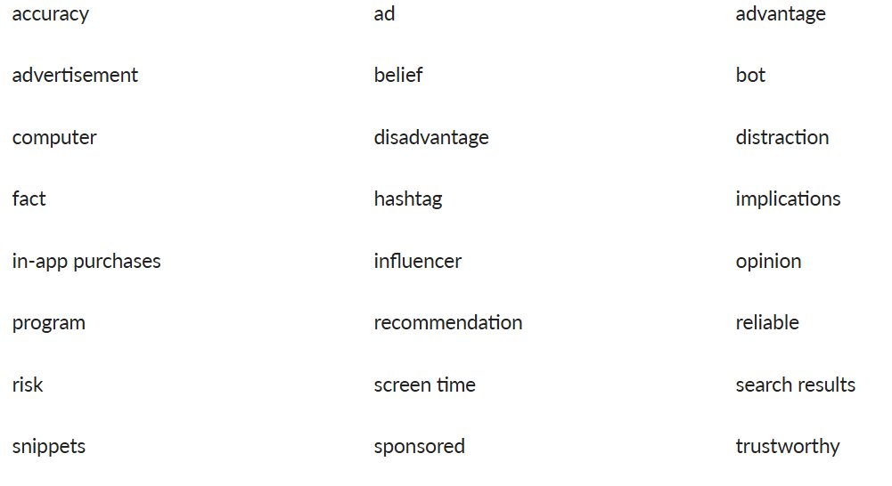
Vocabulary

The children will explore the HTML on a web page and learn how to remix the existing code. They will translate HTML into text and images and identify HTML tags. Furthermore, they will alter HTML on a live web page and replacing images on a web page. The children will recognise that information on the internet might not be true or correct and that some sources are more trustworthy than others.

Computing

Lesson 1
Focus: To recognise the role of HTML in a web page.

Success Criteria:
- I can identify that some web pages are built using HTML.
- I can make real-life connections by identifying how HTML is used in familiar websites.
- I can identify some HTML tags.
Before starting this unit, you might want to check the children can recall:
- That www stands for world wide web in a web address.
- The first or main page of a website is called the homepage.
- The text at the top of a website is known as a header.

Display slide 1 of the Presentation: What is HTML? and make links between the different types of programming that the children have already learned. Explain that the Bee-Bot is a form of physical programming, as they have to press buttons to make it move, and Scratch is block-based coding as it requires coding blocks to be connected.
Display slide 2 to introduce the term HTML. Ask the children:
- What is HTML? (HyperText Markup Language is the programming language used to create and design web pages.)
Explain it is a text-based programming language used for websites and tells the browser how to display the text and images. Remind the children that an internet browser is a software application used for accessing websites and the internet (e.g. Google Chrome, Mozilla Firefox, Microsoft Edge, Safari, etc.).
Hand out the devices (one between two) and direct the children to the link: Scratch. Explain that they will tinker with Scratch for a few minutes to remind them how it works. Set the children the challenge of adding a backdrop and moving a sprite. Display a timer as a visual countdown if needed.
Allow the children a few minutes to tinker and display the HTML code on slide 3. Ask them:
- What does it look like? (The children may suggest it has symbols, numbers and letters.)
- How is it different to Scratch? (The children may suggest that Scratch has coloured blocks and that HTML is just text.)
- How do you think it works? (The children may suggest that the computer can read the code.)

Play the Pupil video: What is HTML? and answer any questions.

Using a child-friendly website of your choice such as Kiddle, NASA or National Geographic Kids, demonstrate how to right-click and use the inspect tool as shown in the video.
Explain to the children that they will explore the HTML code of some websites using this process. Hand out the sticky notes to each pair and explain that they will need to note down any HTML tags. Allow the children to explore some websites and complete the activity.

Invite the children to discuss their findings and ask them:
- What tags did you find? (The children may suggest some common tags such as <h1>, <p>, <img>, <a>, <ul>, <li> and <br>.)
- What do you think they do? (The children may suggest seeing the <img> tag when there were pictures; <p> being used when there was a lot of writing; <h1 being used where the words look bigger or smaller, etc.)
When discussing with the children, encourage them to share their ideas about what they think the HTML tags do. Listen to their suggestions but remember not to reveal too much information. The detailed explanation of each tag and its function will be explored in the next lesson, where they will match the tags to their correct purposes.
Gather the children’s sticky notes with the HTML tags on a large sheet of paper ready for the next lesson.
Inform the children that a person who writes HTML and creates websites is a web developer. Link to some real-life websites that the children may use.
Watch the Pupil video: A Day in the Life of a Web Developer.

Discuss the video as a class and answer any questions.
Ask the children:
- What did you learn about web developers? (They are the people who create websites and apps; they have to plan, code, debug and make sure websites work correctly; they often use coding languages like HTML.)
- Why is HTML important for web development? (It is a special language that computers understand; it instructs computers about how a website should look and work.)
- Would you want to be a web developer? Why or why not?
Pupils needing extra support:
Should look for one or two specific HTML tags (e.g. <h1> or <p>); could re-watch the Pupil video: What is HTML? to recap the key concepts of HTML.
Pupils working at greater depth:
Should use the ‘highlight>right click>inspect’ process to focus on specific parts of the HTML; could try and identify how different tags are used.

Lesson 2
Focus: To change HTML code for a specific purpose.

Success Criteria:
- I can identify HTML tags.
- I can describe the purpose of some HTML tags.
- I can remix some parts of HTML code.

Display the Presentation: Brain dump and hand out whiteboards and pens (one each).
Allow the children to write down their thoughts and then take feedback on any key points they recalled from the previous lesson.
The children may recall that HTML:
- Stands for HyperText Markup Language.
- Is a text-based programming language.
- Is the code behind a web page.
- Uses a range of tags to structure a web page.
- Can be explored using the inspect tool in a web browser.

Display the children’s sticky notes from the previous lesson with various HTML tags. Ask them if they know what they might mean and what their purpose is on a web page.
Arrange the children into groups of four and hand out the Activity: HTML card game (pre-cut, one set per group). Explain to them that they need to match the HTML tag with its description.
Display the Presentation: HTML card game and drag and drop the definitions into the correct tag to check the children’s suggestions. Discuss each tag and address any misconceptions.

Play the Pupil video: Understanding HTML tags and answer any questions the children may have.

Display the image on slide 1 of the Presentation: Left side/right side. Explain to the children that this image shows the HTML behind a web page. Refer to the page as having a left side and a right side. Explain that the left side displays the HTML and the right side translates it into text and images.

Open the link: Trinket - Wanted Poster Project and explain to the children that they will be tinkering with HTML and remixing the code. Display the wanted poster and refer to the left side and right side as previously discussed.
Ask the children:
- What HTML tags can you identify on this poster? (The children may suggest <html>, <head>, <link>, <body>, <div>, <h1>, <h3>, <img> and <p>.)
Explain to the children that this poster incorporates different HTML elements contributing to its overall structure.
Ask the children:
- What would happen if you change the tags to <h5> from <h3>? (The children may suggest that they change size.)
- What do you think the <div> and </div> tags mean? (Div stands for division and is a way of grouping webpage sections so that they can be styled separately from other parts of the page).
Play the Pupil video: Remixing HTML and answer any questions the children may have.

Inform the children that they will work independently or in pairs (depending on the devices available) to tinker with the existing HTML code and see what tags they can adapt or change using their knowledge of HTML. Allow time for the children to explore and tinker with the code.

Invite the children to present their remixes and explain the changes they made. Encourage them to use specific HTML tag names in their explanations.
Ask the children to think about the following questions when explaining:
- Which tags did you find easiest to change?
- Which tags were confusing, if any at all?
- Did you add any more to the HTML?
- How did you feel when your HTML came to life on the right side?
Ask the children to save a copy of their work by taking a screen capture image or clicking the menu button and selecting download.

Play Pupil video: HTML rap to recap key terms and concepts

Pupils needing extra support
Could focus on a smaller area of the HTML by changing the headings in the poster so these skills are built upon gradually; could keep the matched-up HTML tags and definitions from the Activity: HTML card game in front of them.
Pupils working at greater depth
Should insert new headings and paragraphs to create a more complex structure; should write an explanation about the more complex changes they made to the HTML.

Lesson 3
Focus: To recognise the basics of HTML.

Success Criteria:
- I can translate HTML into text and images.
- I can identify HTML tags.
- I can explain how the HTML works.

Display the Presentation: Gimme five! and arrange the children in pairs. Allow time for paired discussion.

Take feedback on any key points they recalled from the previous lesson.
Play the Pupil video: Understanding HTML tags to recap key HTML concepts.

Open the link: Trinket - Wanted Poster Project and remind the children about the left side and right side.
Display the image on slide 1 of the Presentation: Left side/right side and ask the children to think about what the HTML would look like for the missing pet poster. Hand out whiteboards and pens and ask the children to write down what tags they think go where (e.g. <h1> Missing pet alert! and <img> is the image of the parrot, etc.).

Invite the children to share their suggestions before displaying the HTML on slide 2.
Discuss the poster and how the tags on the left side correspond to the text and image on the right side. Remind the children that this is how a real-life web page would work.

Unplugged HTML
Explain to the children that they will complete an unplugged HTML activity where they will write the HTML and then complete the corresponding right side. Remind them that unplugged means without a computer.
Hand out the Activity: Draw your own web page (one each) and ensure every child still has a whiteboard and pen. Explain to the children that they will first draft their HTML code on the whiteboard.
Guide the children in writing the HTML code for their poster. They should include:
- A title using <h1>.
- A few sentences about their topic using <p>.
- An image using <img src=”image.jpg”>.
Explain that they will draw the image later. Assist them in ensuring their HTML tags are correctly opened and closed.
Allow the children to complete the activity, including drawing the visual representation of their poster, once they are happy with their HTML code.
CSS
Bring the class back together and display the link: Trinket - My Story. Explain to the children that, as well as HTML, web pages use another type of code called CSS. Show them the style.css tab and explain that this is where the CSS code is written. Inform the children that CSS stands for Cascading Style Sheets. Explain that HTML sets up a web page layout and CSS makes it look appealing.
Arrange the children in pairs and hand out the Activity: Crack the CSS code (pre-cut, one between two). Ask the children to try to translate the CSS code. Leave the link: Trinket - My Story displayed on the board to help them relate the code to the image. Allow time for the children to complete the activity.
Display slide 1 of Presentation: CSS and take feedback. Discuss as a class.
See the Resource: Crack the CSS code (one teacher copy).

Using Trinket - My Story, demonstrate how tinkering with the CSS alters the overall style. Ask the following questions as you tinker:
- What will happen if the background colour is altered? (It will change from white to the altered colour).
- What will happen if the margin is altered? (It will become wider).
- What will happen if the width or height is altered? (The sun image will change width or height.)
- What will happen if the border is altered? (It will become thicker/thinner.)

Invite the children back together and ask them to name a website they think is visually appealing.
Explain to the children that CSS is important for websites as it controls the visual appearance, ensuring they are visually appealing and user-friendly.
Invite some children to share their HTML code and the corresponding drawn posters with the class, discussing how the HTML tags translated into the visual elements of their posters.

Play Pupil video: HTML rap to recap key terms and concepts.

Pupils needing extra support
Should use the Activity: Draw your own web page: support version and only focus on translating the HTML to the right side; could use the Resource: HTML example or slide 2 of the Presentation: Left side/right side to compare the code with the poster when designing their own.
Pupils working at greater depth
Could use a whiteboard to add additional headings or paragraphs to the poster; could annotate their poster to explain what function the HTML tags have and how they inform the appearance of the poster.

Lesson 4
Focus: To alter the HTML on a live web page.

Success Criteria
- I can use the inspect tool to alter content on a web page.
- I can recognise that the changes I have made to a web page are not permanent.
- I can identify a fake news story.

Display the Presentation: Anagrams and hand out a whiteboard and pen (one each). Ask the children to unscramble the HTML tags.
Take feedback and discuss what the HTML tags mean.
Answers:
- <h1> (Creates a very large heading, similar to a main title.)
- <div> (Stands for division and is a way of grouping webpage sections to be styled separately from other parts of the page.)
- <img> (Adds an image or a picture to the page.)
- <body> (Defines the body of the webpage and includes headings, paragraphs, images, hyperlinks, tables, lists, etc.)

Play Pupil video: HTML rap to recap key terms and concepts.

Ensure a standard and altered image of the school’s website has been uploaded to use in the Presentation: Website hacking (see Teacher knowledge).

Display slides 1 and 2 of the Presentation: Website hacking and ask the children:
- What differences do you notice between the two websites? (Encourage them to observe and articulate specific changes they see.)
- How do you feel about the changes made to the website? (Suggestions may include funny, confusing or concerning.)
- How could these changes impact someone visiting the website for the first time? (Altered content on a website can confuse and misinform first-time visitors, affecting their trust and impression of the site.)

Explain to the children that they will alter the headings and text of a live website by editing the relevant tags in the code.
Play the Pupil video: Website hacking and discuss with the children. Replay the video if needed.
Choose a website and demonstrate how to change the text inside the <h1> and </h1> tags by double-clicking on the HTML to edit the text (as shown in the video). Explain that these changes appear on the website when the enter key is pressed. Show the children how to modify the title and text. (If a mistake is made, refresh the page to return to the original version.)
Hand out the devices (one each) and ask the children to navigate to a website using the links: Kiddle, NASA or National Geographic Kids if needed.
Explain to the children that they will create a fake version of a web page by altering the code. Inform them that web pages with plenty of text and images work best for this as the HTML tags around videos can get confusing.
Ensure the children understand that editing the code will not change the actual website because as soon as the page is refreshed, it will revert to the original version (see Teacher guidance).
Ask the children to take a screenshot of the altered web page and save it in a shared folder or on the school’s network.

Invite the class to share the different pages they created and explain what they changed in the HTML (for example, the size of headings and the content of the text).
Ask the children:
- What is the impact of a web page being changed? (The children may suggest that it made the content more interesting; it updated the information on the web page.)
Watch the video using the link: CBBC Newsround - How do you spot fake news? and allow time for paired discussion.
Display the Presentation: Real news or fake news? Discuss slides 1–4 with the children, asking them to guess whether each online news article is real or fake (see Teacher knowledge). Please note that all of these examples are fake news stories.

Ask the children to consider the following when looking at each slide:
- Is the website and article well-written and professional-looking? (Check for spelling, grammar and overall professional design.)
- Do the photos and videos seem real and relevant to the story? (Look for realistic, related visuals in the news article.)
- Does the story cite credible sources or experts? (Check if the article references trustworthy sources or qualified experts to support its claims.)
Questions
- What does the word fake mean? (Not genuine, imitation or counterfeit.)
- What does the word news mean? (Newly received or noteworthy information, especially about recent events.)
- What is fake news? (False stories that appear to be factual news spread on the internet or other media.)
- What would you do if you visited a website and noticed something did not seem right?
Emphasise the need for ethical online behaviour to the children and explain that changing website headings can mislead people with false information. Remind them to use their new skills responsibly and always ask an adult if they are unsure about the content of a web page.

Pupils needing extra support
Should use National Geographic Kids when altering an image as it features many images alongside the text; could rewatch the Pupil video: Website hacking.
Pupils working at greater depth
Could be challenged to alter multiple elements within their webpage.

Lesson 5
Focus: To alter an image on a web page.
Success Criteria:
- I can use the inspect tool.
- I can alter the content in the <img> tag.
- I can use images that are permitted for reuse.

Display the Presentation: Using the Knowledge organiser. Arrange the children in pairs and hand out the Knowledge organiser (one between two), whiteboard and a pen (one each).

Play Pupil video: HTML rap to recap key terms and concepts.

Display the examples of web pages on slides 1 and 2 on the Presentation: Web page examples and ask the children to discuss what they observe. Encourage them to share their opinions and give feedback on the web pages. (The children may suggest the first example has no images and the text is not organised into paragraphs in the second example.)

Explain to the children that these are two examples of flawed web pages. Display slides 3 and 4, which show two examples of more appealing websites. Ask the children:
- Why are images important on a web page? (The children may suggest that it brings the content to life; makes the page clear; enhances the overall visual aesthetic.)
Explain to the children that images on a webpage are important because they make the page attractive, help explain ideas and make content easier to understand.

Explain to the children that as well as altering the HTML to replace the text on a web page, images can also be replaced. Ask the children:
- Why is adding or changing images on a web page important? (To make the web page more appealing and keep it up to date.)
Explain that web pages are often updated to ensure they have the latest content and to keep information current and relevant.
Play the Pupil video: Replacing images and discuss any questions the children may have.

Demonstrate the process shown in the video using your school’s website and a pre-chosen image from the link Photos for Class.
Inform the children that they will edit an online news article. Encourage them to think about the key aspects of the story: who, what, where, when and how.
Explain to the children that they can use the link: Photos for Class to choose images for their web page. Highlight that this website provides free-to-use images where permissions have already been granted.
Hand out a whiteboard and pen for the children to make notes and remind them that news stories with a mix of images and text are ideal for editing. Suggest a few websites they can choose from using the links: BBC Newsround example article, CBBC Newsround or NASA. Alternatively, they can search using Kiddle.
During the activity, the children may encounter challenges like copying the image address incorrectly or pasting it in the wrong place. Remind them to paste the image address between the quotation marks after ‘src’.
After completing the activity, ask them to take a screenshot of their work and save it in a shared folder or on the school’s network.
Questions
- Why do you have to ‘copy image address’ and not just copy? (So the image can be located from its existing location on the web.)
- How do you know where to paste the image address? (Look for ‘img src’ or ‘src’ and paste between the inverted commas.)

Hand out a sticky note to each child and encourage them to move around the classroom, observing their peers’ work. Ask them to leave a sticky note with their feedback on one device.
Invite the children back together and display slide 1 of Presentation: Copyright. Discuss the concept of copyright with the children, explaining that images may be owned by their creators which means permission is needed to use them.

Explain that there are some websites which provide free-to-use images where permissions have already been granted, for example, images on the link: Photos for Class.
Using slide 2, explain the importance of referencing image sources when using web-based images. Demonstrate this by searching an image, copying its address and noting its URL.
Optional – provide each child with the Quiz – pupil answer sheet and display the Unit quiz (see link: Assessment – Computing Y4: HTML). Read each question aloud and allow the children time to answer. Reveal the answers and ask them to self/peer mark their answer sheets.
If pupils completed the Knowledge catcher in Lesson 1, they can revisit them and add new information in a different colour.

Pupils needing extra support
Should use simpler website layouts such as the link: Kiddle; could rewatch the Pupil video: Replacing images or have it playing on loop in the background.
Pupils working at greater depth
Could be challenged to add additional text and images to a web page; should explain how changing images affects the web page.

