Computing – Programming: Scratch Junior –

Computing

Essential Knowledge

By the end of this unit children…

- Will know that coding is writing in a special language so that the computer understands what to do.
- Will understand that the character in ScratchJr is controlled by the programming blocks.
- Will know that you can write a program to create a musical instrument or tell a joke.
and creating a peg figure

Spring 2
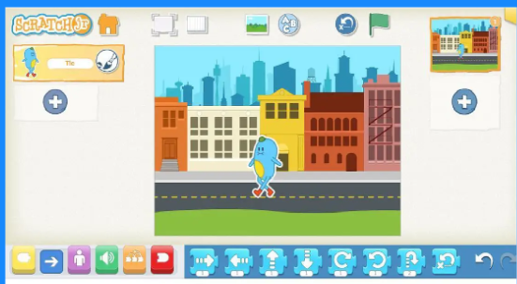
Computing – Programming: Scratch Junior
Vocabulary
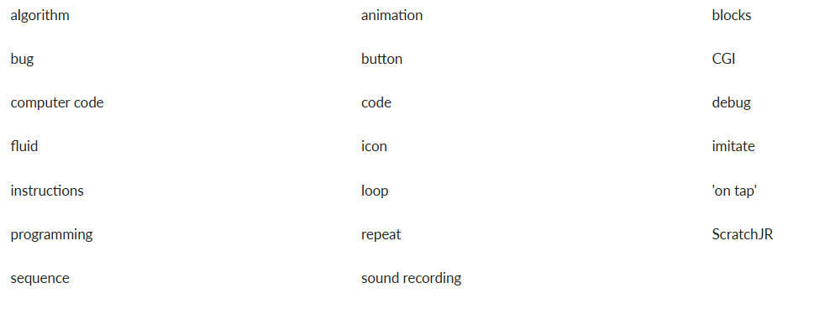

Key Objectives-  - I can use a range of instructions (e.g. direction, angles, turns).  - I can test and amend a set of instructions.  - I can find errors and amend. (debug)  - I can write a simple program and test it.  - I can predict what the outcome of a simple program will be (logical reasoning).  - I understand that algorithms are used on digital devices.  - I understand that programs require precise instructions.  - I can organise digital content.  - I can retrieve and manipulate digital content | Session 1  LO: To explore a new application.  - SC: I can predict what something new will do.  - I can explore something independently.  - I can explain what I found using ScratchJr.  Attention Grabber  Before the children begin, demonstrate how to start a new project and explain that they need a character to control and give instructions to.  Explain that when you open a new project on ScratchJr, you are always presented with a white background and a character.  Inform the children that they will now have a tinker to see what ScratchJr can do. Allow the children a few minutes to do this before gathering them back for feedback.  Once the children have had some time to explore ask the following:  - What did you find out about ScratchJr? (Discuss the different elements such as blocks, a character, a background etc.)  - What are the coloured blocks for? (These are the instructions.)  - What can the character do? (It moves when it is programmed using the blocks.)  - How do you get the character to move? (By creating an algorithm- a sequence of instructions.)  Main Event  Demonstrate some basic features on ScratchJr that the children will need for this unit.  Show the children how to add a background and a new character. If the children are sharing devices, they can always add a character each to the same project (See Teacher video: Introduction to ScratchJr). Once a character has been selected, introduce the ‘green flag’ block as the start of the program. Demonstrate that dragging blocks onto the green flag block builds the program. Explain that each block is another instruction that they need to clip together like a jigsaw.  Run the code so that the children can see the selected blocks in action. This could be movement, growing in size, disappearing and reappearing depending on the blocks.  Explain to the children that the aim of this lesson is not to put all the blocks on at once and press ‘go’, but instead to carry out a cycle of predict > test > review.  Children do not need to identify this formally but the process is described in the success criteria as predict, explore and explain.  Display the Presentation: Score sheet and hand out the Resource: Tinkering score sheet.  Explain to the children that they will receive points for different blocks and that every time they use one of the blocks in their program, they can circle it on their sheet.  Inform the children that they must explain what a block does and how it works to earn points. Adding blocks randomly won’t count. The more points a block has, the harder it is to understand its function.  Allow the children time to explore, tinker and challenge themselves to use blocks and work out what they do using the predict > test > review cycle.  Wrapping Up  Ask the children:  - Why are the blocks different colours? (Because they’re grouped by similar attributes.)  - How do you get rid of unwanted blocks? (Drag them back to the code bench.)  - Did anyone’s character do something unexpected?  - Did anyone lose their character entirely? (This is important as there’s a ‘hide’ block that can cause the children to worry their character is gone forever.)  Discuss with the children what they found out. For example, Who thinks they used some ‘one point’ blocks?  Ask the children to describe how they used the blocks and why. For example, did they use movement blocks to make their character spin or move side to side? Repeat this for blocks in different point bands. If none of the children acknowledged it, demonstrate it by tapping on the block in Scratch Jr where it it tells you what it does as a word.  Invite the children to explain a few from at least the first two points categories and leave the others until they are covered in the following lessons. They can then self-mark their points and share how many they felt they achieved.  Explain to the children that over the next few lessons they will learn about the blocks and build upon what they have tinkered with in this first lesson. | Session 2  LO: To create an animation.  - SC: I can use the programming blocks for a purpose.  - I can recognise a loop in programming.  - I can use my programming skills to represent an animal moving.  Recap and Recall  Children to recall everything they did last lesson.  Attention Grabber  Ask the children how a fly moves. Demonstrate walking across the room in a straight line – is this similar to a fly? Invite the children to do their best impression of a fly. Hopefully, some children will start ‘bobbing’ in the air, changing directions regularly, darting aimlessly in one direction after another and then suddenly zooming with purpose.  Open the link: ScratchJr and demonstrate to the children, step by step how to create a simple program with a fly (see Teacher knowledge).  Ask the children if they can identify what’s wrong with the fly that has been programmed (it’s not moving like a fly because it’s moving too straight.) Using their knowledge of ScratchJr from Lesson 1:Using ScratchJr, the children may be able to suggest how to add different movement blocks. Encourage the children to suggest blocks to use – implementing and testing their suggestions.  Keep adjusting the blocks until the children are satisfied that the fly is moving as a ‘real’ fly would. As they make suggestions, keep adding the blocks onto the existing program so that all of it is connected to a single green flag.  Main Event  Explain to the children that a more fluid movement can be achieved when you give the computer two (or more) instructions to do at the same time.  Demonstrate this by opening a new ScratchJr project and adding in the fly character once more. Create the code as shown in example two in the Resource: Fly code.  Ask the children to compare their first fly project with this one, noting how the first may seem more disjointed due to the blocks running sequentially. Discuss which version they prefer and why. Review the second fly’s code together, suggesting improvements, such as using fewer arrows by adjusting numbers.  In ScratchJr, show the children the second row of code, can they spot a pattern? Change the numbers to three – does it work? Explain that it doesn’t work because then it tips forward three times and then backwards three times instead of rotating forwards, backwards and then forwards again, etc.  Introduce the children the orange loop block and the red repeat ‘forever’ block and explain their functions (see Teacher knowledge). Demonstrate how to use these in ScratchJr.  Explain to the children that when animators make films with CGI animals, they spend a lot of time watching real-life animals to make sure the CGI animals move realistically. Inform them that this is their challenge and that they will use the pre-drawn characters in ScratchJr and aim to make them move realistically.  Recap how some animals move: snakes slither; birds swoop; butterflies flutter, etc. This will influence the children’s understanding of how to create movement in ScratchJr as well as the process of predict > test > review.  Display the Presentation: Animal animations and explain to the children that they can create either a land or underwater scene.  Go through slides 1 and 2, giving the children some suggestions.  Explain to the children that they should add one animal at a time to their scene trying to get the movement as realistic as possible. Explain that they should be using forever loops in their code so that the movement will never end.  Wrapping Up  Invite the children back together and identify some interesting animal movement patterns the children have created and ask them to share these with the class. They can also explain how they programmed the code to make it move in that way.  Ask the children:  - Is this movement realistic?  - Which blocks make it move like this?  - Did you try more than one way to make your animal move?  Explain to the children that it’s fine if they didn’t get the movement right in their first attempt. Highlight the need for testing and review and not getting it right the first time – making a mistake is an opportunity to learn more. | Session 3  LO: To use characters as buttons.  - SC: I can design a musical instrument.  - I can program code to run ‘on tap’.  - I can select appropriate blocks for my purpose.  Recap and Recall  Display the Presentation: Spot the mistake and allow time for a paired discussion. The mistake is that the code doesn’t create a fluid, realistic movement for the fly as it is programmed to move in a straight line.  Children may also mention the following:  - There isn’t a loop and the programme will not repeat.  - Too many arrow blocks have been used and a number could have been added instead.  - There isn’t a variety of blocks used.  Attention Grabber  Invite the children to imagine themselves as musical instruments and explore the different sounds they can create. Encourage them to practice making a specific sound repeatedly, like ‘boom, boom, boom’ or ‘zip, zip, zip’.  Choose a few children to act as these instruments by holding out their hands. When their hands are tapped or pointed at, they should produce their chosen sound. This is like ‘playing’ the volunteers as if they were instruments.  Prompt the children to reflect on how they are controlling the ‘human instruments’, drawing a parallel to how they program characters in Scratch Jr.  Ask the children:  - Could we make something similar in ScratchJr?  - How would it work?  - What blocks would we need?  - Can you try to explain what would/could happen?  Main Event  Inform the children that in ScratchJr, buttons act like characters. If they program it correctly, pressing the button will make it play a sound, turning their project into a musical instrument.  Inform the children that they will be creating their own buttons but should think outside the box and not just use animal sounds. Refer to the Resource: Code example.  Remind them of how in the Attention Grabber, pressing a button (tapping a volunteer’s hand) made a sound. This is what they’re aiming for with their buttons in ScratchJr.  Inform the children that they can either use an existing character for their button or design a new one. Encourage them to share ideas about what their button might look like.  Open the link: ScratchJr and show the children the pre-recorded musical instrument in ScratchJr (see Teacher knowledge).  This can be a simple shape background with some different coloured button characters on top. Explain that it won’t look like a guitar but a musical instrument is anything that is used to make music (see the Teacher video: Making a musical instrument).  Invite the children to predict what will happen when the button is tapped, then show them, focusing on the green sound blocks. Explain they can make their own sounds by tapping the dotted microphone icon, leading to the blue recording screen where they press ‘red’ to record. Mention that their voices imitating instrument sounds or tapping surfaces will be saved with a number in the sound icons. Highlight that sounds can be removed by pressing and holding them.  Demonstrate how to use the ‘start on tap’ block, clarifying it plays sounds attached to a character when that character is pressed, without waiting for a green flag. Demonstrate drawing a background, then guide the children to design their instrument’s outline as a background, adding their created button. Remind them to complete their character and background drawings before starting to program.  Wrapping Up  Invite the children to swap devices and share their musical instruments with a partner.  Display the Presentation: Musical instrument evaluation and ask the children to evaluate their partner’s instrument.  Allow some time for the children to feedback to each other before making improvements to their projects.
Session 4  LO: To follow an algorithm  - SC: I can use an algorithm to help with my programming.  - I can sequence the blocks appropriately.  - I can explain what each block in the program does.  Recap and Recall  Tell your partner 5 things you remember from last lesson.  Attention Grabber  S how the children the pre-prepared program created in ScratchJr (see Teacher knowledge).  Explain to the children that they will be creating their own joke today but first, they need to try and figure out how the pre-prepared program was coded.  Questions  - How was the program created?  - What blocks do you think have been used? Why?  Remind the children that when a new project is created, a white background is displayed with either the cat character (tablet version) or the blue character (laptop/desktop version). Ask the children how they think the joke was created in Scratch Jr.  Give the children some time to discuss with a partner before asking them for feedback.  Main Event  Explain to the children that an ‘algorithm’ is a set of instructions that allow a person to make a computer do something. Inform them that in this lesson they need to take these instructions and turn them into ‘code’ so that the computer can understand them.  Hand out the devices (ideally one each) and allow the children some time to load ScratchJr before going through the following steps as a class:  - Show the children how to delete the cat/blue character (hold your finger on it until an ‘x’ appears).  - Add one or two new characters that are relevant to the joke that the children have chosen, for example, a starfish and seaweed. If the children can’t find the character they want, they can draw their own by pressing the paintbrush at the top of the character selection screen.  - Select the green flag block and drag it into the coding area.  Explain to the children that they are now going to record their voices saying the first part of a joke. Ask the children to suggest where they might find these blocks, thinking back to Lesson 3: Making a musical instrument (the blocks needed are the green sound blocks).  Demonstrate recording the sound, using the record button and repeat for the second part of the joke.  Inform the children that to finish the program, they can add some movement appropriate to their characters, for example, a fish bobbing in the water or a giraffe walking across the screen.  As the children are working on their projects, you may want to ask open-ended questions to prompt their thinking.  Questions  - What joke are you planning to tell with your animation, and why did you choose that one?  - What kind of actions do you think will make your character funny?  - What can happen at the end of your joke to make everyone laugh?  Wrapping Up  Ask them to share their projects with a partner. Encourage them to describe how they used different blocks to create actions and ask them what they think would happen if they changed the order of these blocks.  Finish the lesson by asking if any of the children used a loop block to make their character move after the joke was told (as they learned about in Lesson 2, Creating an animation).  Ask the children:  - Which blocks are being repeated by the addition of the loop? (Sound blocks.)  - Does using a loop make this program more effective? (Yes, as the program repeats itself.) | Session 5  LO: To plan and use code to create an algorithm  - SC: I can explain what an algorithm is.  - I can choose the code to match my algorithm.  - I can use an algorithm to write a computer program.  Recap and Recall  Speak like an expert. Spend one minute talking to your partner about creating programs in scratchjr. Act like you are an expert.  Attention Grabber  Open the pre-prepared program (as shown in the Resource: ‘The Three Little Pigs’ example code) and display it on full screen. Show the children the program, but not the code. When the green flag is pressed, the program should tell the first part of the Three Little Pigs story.  Ask the children to discuss which blocks they think have been used in this program.  Arrange the children into pairs and hand out the Activity: ScratchJr blocks (one between two). Ask the children to work together to circle any blocks that they think are used in the program.  Display the Presentation: ‘The Three Little Pigs’ algorithms.  Main Event  Ask the children about the term ‘algorithm’ that was introduced in the last lesson. Can they remember what it meant or how they used it? Remind the children that it is a clear set of instructions that they turn into code and give to the computer as a program.  Explain that today’s algorithm involves four characters, making it more complex. Tell the children they’ll start with an unplugged ‘cut and paste’ activity using ‘The Three Little Pigs’ algorithms to help them build their program in ScratchJr.  Display the Presentation: ScratchJr blocks.  Display slide 1 showing the four blocks they will be using (and the green flag used to start all of the programs). Ask them if they know what each block does and go through their functions on slide 2.  Hand out the Activity: ‘The Three Little Pigs’ algorithms (one each) and read through it together. Can the children work out which of the blocks need to go into each character’s program? Allow time for discussion and for the children to cut and stick the blocks into place (the answer to the ‘The Three Little Pigs’ algorithms can be found on page three of the activity).  Once this is completed, hand out the devices (one each) and ask the children to use the algorithm and code blocks to create their own version of the story, ‘The Three Little Pigs’ on ScratchJr.  Wrapping Up  Invite the children back together to share their project with someone at their table. They can suggest two things that they like and one thing that could be done to improve the project.  As a whole class, discuss what algorithms are and how they are helpful when we are programming.

