Art – Drawing: Tell a story
This unit focuses on helping pupils develop their ability to tell a story through drawing. It includes lessons on creating textures, observational drawing, character expression, and storytelling through illustrations, enhancing pupils' mark-making techniques, observational skills, and imagination in art.

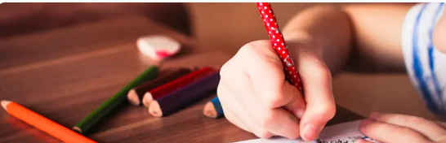
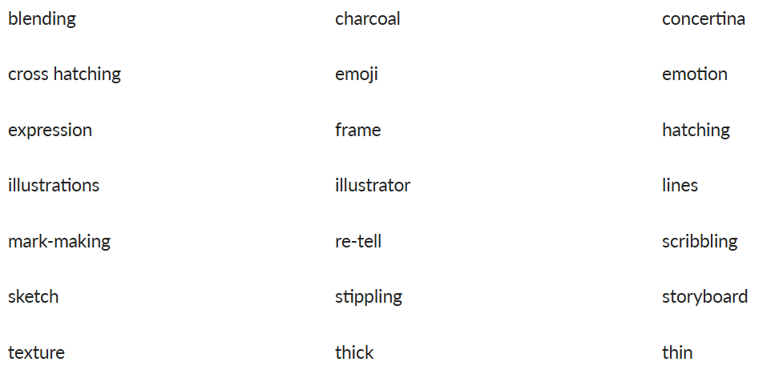
By the end of this unit children will….

- Suggest ways to draw a word through marks.
- Use relevant language to describe how an object feels.
- Suggest ways to create different textures through drawn marks.
- Freely experiment with different tools, receiving encouragement when needed.
- Describe and then draw shapes that make up an object.
- Use good observational skills to add details to their drawing.
- Use an interesting range of marks that show an understanding of how to draw different textures.
- Make sketches, which may be of basic stick-like figures or may imply more shapes.
- Develop sketches into a character, with some support, adding details to enhance their character.
- Demonstrate an understanding of how drawing facial features in different ways conveys expressions.
- Recount a story and select key events to draw.
- Create scenes from their own imagination, with some support.
faces are portray art: looking at the work of a number of artists, using their bodies to form shapes, creating collages, drawing portraits and creating a peg figure

Vocabulary

Art -figure
Toy story/ Human Form – Exploring how faces are portrayed in art.
Key Objectives-  To develop a range of mark making techniques.  To create a self-portrait  - National Curriculum -  - To use drawing, painting and sculpture to develop and share their ideas, experiences and imagination  - To develop a wide range of art and design techniques in using line, shape, form and space  - About the work of a range of artists, craft makers and designers, describing the differences and similarities between different practices and disciplines, and making links to their own work  - To use a range of materials creatively to design and make products  - Be taught about the work of a range of artists, craft makers and designers, describing the differences and similarities between different practices and disciplines, and making links to their own work | Session 1  Charcoal Mark Making  - To develop a range of mark making techniques.  - I can experiment with charcoal to draw different marks.  - I can understand a word and explain how I can draw it.  I can express the meaning of words using charcoal mark making techniques.  . Use the Pupil video: Charcoal mark making, or model yourself how to make different marks with charcoal.  2. Give the children some time to experiment with charcoal to see how many different types of marks they can create, either on large pieces of paper or in their sketchbooks.  White chalk can be used as an extension to this activity to explore the effects this creates.  Key questions  - Does the way you hold the charcoal affect the marks you make?  - How many different ways can you hold the charcoal?  Can we break or shape the charcoal to create different effects?  Choose from the following methods to suit your class:  - Display the list of words on slide 2 of the Presentation: Charcoal mark making on the interactive board for the children to choose from.  - Click on each word individually (the word is said out loud for you) and respond to each word, one at a time as a class.  - Use the Activity: Word cards to allow children to select a word as a lucky dip, laying a selection of cards upside down on their table.  You may want to use a combination of methods as differentiated activities for different groups.  - The children should use the charcoal in different ways to express the meaning of the words in an abstract way (not as pictures – just marks), making eight samples that fill a page in their sketchbooks.  Pupils needing extra support: Can be shown how to break the charcoal and shape the end to make different types of marks. May benefit from a demonstration of how to hold the charcoal in different ways and to move their hand in different ways to vary their marks. May need words read aloud or explained to them; alternatively, record an adult saying the words on a talking tin or tablet device.  Pupils working at greater depth: Can experiment with adding marks in chalk or removing charcoal with a rubber, using the rubber as a drawing tool. Could be given phrases to convey through marks. | Session 2  To create texture  - To explore and experiment with mark-making to create textures.  - I can describe how an object feels.  - I can try out different drawing materials.  I can experiment with making different marks to make texture.  . Use the Presentation: Make a mark to show children a range of different marks and the terms used to describe them. Reveal each slide one at a time, and ask children to recreate this mark in their sketchbooks.  Lesson presentation: Make a mark  Display on your interactive whiteboard:  5. Explain to the children how making marks can make patterns and create surface textures.  Key questions  - How would you describe this mark?  - How could you create it using a pencil?  : Recreating texture from a picture  1. Lay on the children’s tables a selection of photographs from the Activity: Texture photos. Alternatively, source your own images of textures to link to another area of the curriculum or story that your class is using.  2. The children select one image to stick in the centre of a double page in sketchbooks. You may want to support the children in this exercise by giving them objects and materials that feel the same or similar to the photographs so that the children can touch them while looking at the images.  3. Explain to pupils that they are going to use the space around the image to recreate the texture they can see. They select and explore materials to use and experiment with different marks around the page. Some can try drawing on different surfaces that they have stuck in their sketchbooks.  Pupils needing extra support: may require time to describe objects verbally to another child or adult to support thinking about the textures they will create. These words could be collected in sketchbooks and a mark made next to them as a reminder of what it is. If working from an image of a texture, these children will benefit from being able to touch something similar to it.  Pupils working at greater depth: should be encouraged to explore drawing materials they have not used before. Can experiment using different surfaces to draw on and explain how they enhance or inhibit the texture they are trying to create. This can be recorded in sketchbooks | Session 3  - . To develop observational drawing.  - I can recognise and describe shapes in an object to start a drawing.  - I can look carefully to add details.  I can use mark-making techniques to add texture.  1. Show the children your own soft toy and explain to them its importance or special meaning. Choose a few pupils to introduce their toys to the class too.  2. Ask the class what shapes they see in your toy. Use your finger to draw the shapes over your toy in the air to show the children what you mean.  3. You can use the Presentation: My toy story to illustrate this idea. Invite the children to ‘air draw’ the shapes they can see over their toys.  Presentation: My toy story  Display on your interactive whiteboard:  3. Show children how they will draw their toy by modelling drawing your own toy.  4. Use an HB pencil to show them how to draw the toy by sketching in the basic shape outlines only, starting with the largest in the middle of paper.  5. While you are drawing, explain to the class that sketching means holding the pencil lightly and using the natural movement of the wrist to draw lines. Demonstrate how this is done. Explain that it is okay to draw more than one line as they try things out because extra lines will be drawn over or rubbed out later.  Make it clear to the children that when they start their drawings, they should not miss this first stage of drawing the shape outlines.  6. Show the children how you add detail and textures by using a range of different marks.  Key questions  - What shapes can you see in my toy?  - Can you use your hands and finger to draw these shapes?  - What colours do you see?  - Is there any texture? Where?  How could I draw this texture?  Children to draw their own toys.  Pupils needing extra support: Support children by drawing the basic shapes with them and then allow them to focus on adding the details and textures. Use a photograph of a toy (or of their own) and take a light photocopy of this. Children can work on top of the photocopy so that they can focus on observing and drawing the texture and details with mark making.  Pupils working at greater depth: Encourage these children to work in colour and to use marks to imply tone.
Session 4/5  Research Julian Opie  Show pupils how to access the interactive website of Julian Opie - by typing ‘Julian Opie website’ into a search engine - www.julianopie.com  Show pupils how to access the interactive website of Julian Opie – by typing ‘Julian Opie website’ into a search engine – www.julianopie.com.  Ideally, children would have independent access to the site and view it at their own leisure. However, if this is not possible, view it on the interactive whiteboard (IWB) as a class and take children’s direction with regard to your navigation of the site  Ask them to practise tracing the contours of their face picture with their fingers to find similar lines to the ones Julian Opie uses.  When they feel they are ready, ask them to draw their face in an Opie style with a black broad-tipped marker pen. Remind them not to include details and only draw the absolute minimum as follows:  - lines for the outline of the face, shoulders, neck and hair  - dots for nostrils  - straight lines for the mouth  - dots with half circles over the top for eyes  - straight lines for eyebrows  This may take a few attempts to get right, so keep replacing the plastic wallet as necessary.  When the portrait is satisfactorily drawn, you might put coloured paper inside the plastic wallet to get a true Opie effect. The more advanced artists in your class may want to try cutting out the shapes of the face and hair etc using different coloured paper.  Pupils needing extra support:  Some pupils will struggle to trace the outlines of their own face accurately. Encourage them to keep trying and not to give up if their first few attempts fail. All artists fail and this is how we learn.  Pupils working at greater depth:  Other pupils may produce confident images very easily and could progress onto cutting coloured paper shapes for their portraits. They might look at more of Julian Opie’s work and go on to taking other portraits with different facial expressions or produce full body images as Opie did. | Session 6  Show case childrens artwork. Children to peer evaluate and discuss.  Children evaluate their own art.  Pupils with secure understanding indicated by: Successfully producing a self portrait. They will know and remember the work of Julian Opie and have taken part in an evaluation about his work and compared it to their own in simple terms.  Pupils working at greater depth indicated by: Having made more sophisticated outcomes – either reproducing a self portrait in the style of of Julian Opie, explaining the similarities or alternatively veering away from her style and explaining the differences.

