What should I already know?
- - a variety of everyday materials including wood, plastic, glass, metal and rock.
-the physical properties of a variety of everyday materials (including those that are transparent) and to compare and group materials based on these properties.
-how materials are suitably used based on their properties
-some materials which are magnetic.
-hoe shapes of solid objects can be changed by squashing, bending, twisting and stretching.
-materials that are solid, liquid and gases and their particle structure
-some materials change state when they are heated or cooled and the temperature in which this happens.
-the roles of melting, evaporation and condensation in the water cycles and the role the temperature has on the rate of evaporation.
-some rocks are permeable.
What will I know by the end of the unit?
How to group materials based on heir properties. | 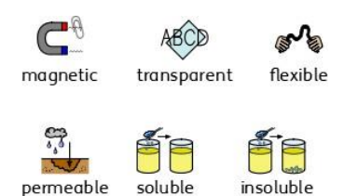
What are thermal insulators and conductors? | - Materials which are good thermal conductors allow heat to move through them easily.  - Thermal conductors are used to make items that require heat to travel through them easily, such as a saucepan which requires heat to travel through to cook food.  - Thermal insulators do not let heat travel through them easily.  - Examples of thermal insulators include woolen clothes and flasks for hot drinks.
What is dissolving? | - When the particles of a solid mix with the particles of a liquid, this is called dissolving.  - The result is a solution.  - Materials that dissolve are soluble.  - Materials that do not dissolve are insoluble.  - 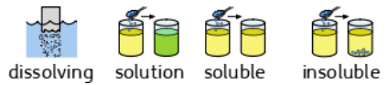
Can materials be separated after they have been mixed? | - Some materials can be separated after they have been mixed based on their properties- this is called a reversible change.  - Some methods of separation include the use of a magnet, a filter (for insoluble materials), a sieve (depending on the size of the solids) and evaporation.  - When a mixture cannot be separated back into the original components, this is called an irreversible change. Example of this include when materials burn or mixing bicarbonate of soda with vinegar.
Sieving | 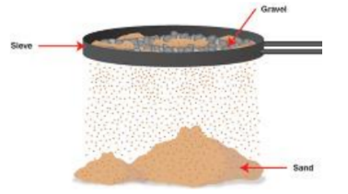  A mixture of different sized solid particles can be separated with a sieve.
Filtering | 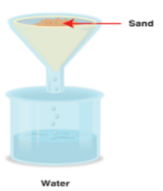  An insoluble solid can be separated from a liquid when passed through a filter. The liquid passes through the solid particles are trapped on the filter.
Evaporating | 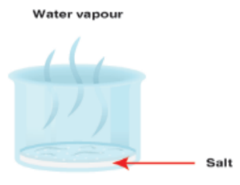  If a solution is boiled (heated) the water will evaporate into gas and the solid will be left behind.

Key Vocabulary
dissolves | when a substance is mixed with a liquid and the substance disappears
filtering | a device used to remove dirt or other solids from liquids or gases. A filter can be made of paper, charcoal, or other materials with tiny holes in it.
insoluble | impossible to dissolve especially in a given liquid
irreversible change | impossible to reverse or turn back its original state
permeable | a material which allows a gas or liquid to pass through
properties | the way in which an object behaves
reversible change | able to reverse or turn back to its original state
soluble | able to be dissolved
solution | a mixture that contains two or more substances combined evenly
thermal conductor | a material which allows heat to pass through it
thermal insulator | a material which does not allow heat to pass through it
transparent | you can see through it

Comparing and grouping
- Materials can be compared and grouped together according to their properties, including:
- - Hardness- how hard or soft a material is
- - Solubility- whether a material can dissolve
- - Transparency- whether it allows light to pass through
- - Conductivity- (electrical or thermal)- whether it allows heat or electricity to carry through
- - Response to magnets- whether it is magnetic

