What should I already know?
- - we have four seasons (autumn, winter, spring and summer)
- - the Sun is a source of light but the Moon is not
- - know that a shadow is caused when an object blocks light from passing through it
- - to know the history of space travel
- - the properties of a sphere
What will I know by the end of the unit?
What causes day and night? | - The Earth rotates on it axis anti-clockwise and make a complete rotation over 24 hours (a day).  - This makes it appear as if the sun moves through the sky but the Earth’s rotation causes day and night.  - - Different parts of the Earth experience daylight at different times- this mean that it is morning, afternoon and night in different places. This is also the reason why we have time zones.  - Because of Earth’s tilt, the poles experience 24 hours of sunlight in the summer, and very few hours of sunlight in the winter.  - As Earth rotates, shadows that are formed change in size and orientation.
Year length and the seasons | - The Earth takes 365 and a quarter days to orbit the Sun.  - Because of the extra quarter days it takes to orbit the Sun, every four years on Earth is a leap year!  - It is the Earth’s tilt that causes the seasons.  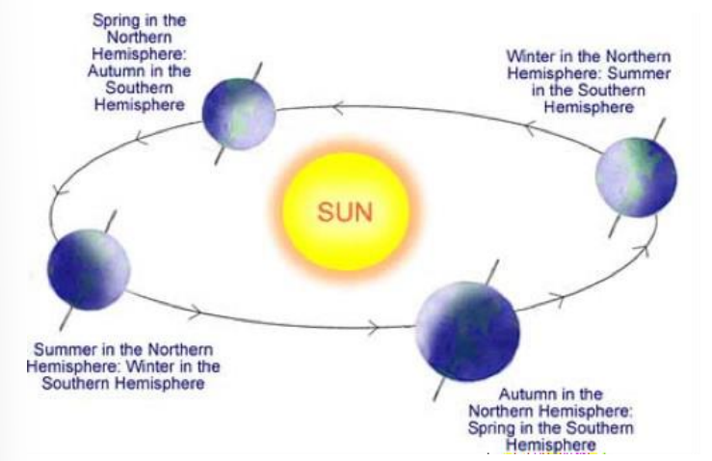
The Moon | - The Moon orbits the Earth anticlockwise and takes approximately 28 days.  - The Moon spins once on its axis every time it orbits Earth. This mean that we only see one side of the Moon.  - The Moon has different phases depending on where it is in its orbit.  - The Moon’s gravity causes high and low tides.
What is the Solar System? | - There are 8 planets in our Solar System.  - Pluto is a dwarf planet  - All planets orbit the Sun, which is a star, and they all have moons.  - The first four planets are relatively small and rocky while the four outer planets are gas or ice giants.  - There are asteroids, meteoroids and comets in the Solar System.  - The galaxy is in the universe.

Key Vocabulary
asteroids | a rock that orbits the Sun in a belt between Mars and Jupiter
acis | an imaginary line through the middle of something
comet | a bright object with a long tail that travels around the Sun
galaxy | an extremely large group of stars and planets. Our galaxy is called the Milky Way.
gravity | the force which causes things to drop to the ground.
leap year | a year which has 366 days. The extra day is the 29th February. There is a leap year every four year.
meteorite | a rock from outer space that has landed on Earth.
orbit | the curved path in space that is followed by an object going round and round a planet, moon or star.
shadow | a dark shape on a surface that is made when something stands between a light and the surface.
Solar System | the Sun and all the planets that go round it.
sphere | an object that is round in shape like a ball
star | a large ball of burning has in space
time zones | one of the areas into which the world is divided where the time is calculated as being a particular number of hours behind or ahead of GMT (Greenwich Mean Time)
universe | the whole of space and all the stars, planets and other forms of matter and energy in it.


