Key Events
1939 | 1st September | German troops invade Poland.
1939 | 3rd September | Britain and France declare war on Germany.
1940 | 10th May | The Battle of France begins.
1940 | 26th May | Allied forces are evacuated from Dunkirk in France.
1940 | 10th July | The Battle of Britain begins.
1940 | 7th September | The Blitz begins.
1941 | 22nd June | Germany invades the USSR (Soviet Union)
1941 | 7th December | Japan bombs Pearl Harbor in the US.
1943 | 16th and 17th May | The Dambusters bombing raid is carried out.
1944 | 6th June | The D-Day landings.
1945 | 7th May | Germany surrenders to the Allies.
1945 | 6th and 9th August | The US drops atomic bombs on two cities in Japan.
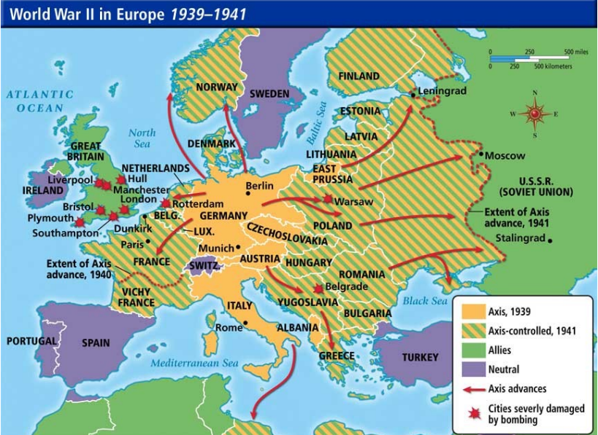
World War 2 Knowledge Organiser
How did World War II start?
The leader of Germany, Adolf Hitler, had plans to take over other countries. In March 1938, Germany invaded and annexed Austria, which made other countries worried. On 29th September 1938, British, French, German and Italian leaders signed a treaty called the Munich Agreement. This allowed Hitler to annex the Sudetenland (an areas of Czechoslovakia) if he agreed not the invade anywhere else, However, in August 1939, Hitler broke the agreement and invaded the rest of Czechoslovakia, followed by Poland on 1st September. Britain, France and Poland had made a pact to support each other, so Britain and France declared war on Germany.

Key Facts:
- The war lasted 6 years and 1 day.
- The war began when Germany invaded Poland.
- Hitler had extreme anti- Semitic beliefs which meant he wanted to eradicate Jewish people.
- Great Britain was bombed heavily during the Blitz.
- It is estimated the 55 million people die during the war.
- The Battle of Britain was the first ever battle to be fought on in the air using airplanes.
- Great Britain ad two Prime Ministers during the war: Neville Chamberlain and Winston Churchill.
Rationing
Rationing was the system of limiting people’s access to food, clothes and fuel. This was put in place because of shortages as a result of the war which meant production and trade was hindered and affected.
Germany attempted to weaken Britain by cutting off supplies to food and other goods by using submarines to attack many of the ships that brought food to Britain.

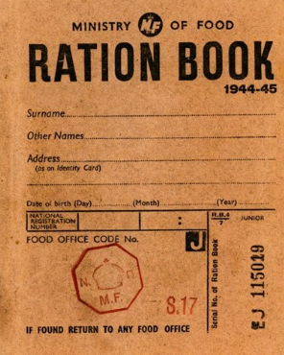
Key Vocabulary
Allies | The United Kingdom, France and Poland later joined by other countries, including the USSR (Soviet Union), the United States of America and China. | Nazi Party | A German political party with racist and anti-Jewish ideas, led by Adolf Hitler. | annex | to take another country’s land and make it part of your country.
Axis | The Axis Power were originally Germany, Japan and Italy, Other countries joined them later. | atomic bomb | a very high-energy bomb made of radioactive material | propaganda | Information designed to promote a political idea or opinion

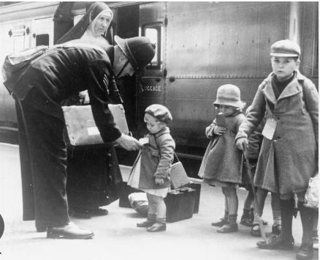
Under the operation name “Operation Pied Piper”, the effort began on 1st September 1939 and officially relocated 1.5 million people.
Evacuation
During the war, people (mainly children) were evacuated to the countryside to protect them from the aerial bombing of cities.

