Key Vocabulary
legacy | things or ideas that are passed down from one generation to another
culture | the beliefs, customs, arts etc. of a particular time, society, place or group
government | the system used for being in charge of a country
democracy | when decisions are made by the majority of its people
architecture | the art and science of designing and creating buildings
philosophy | ideas about knowledge, right and wrong, reasoning and the value of things
Olympics | a series of athletic challenges that takes place every four years
Athens | the largest and most powerful city-state
Sparta | a military city-state surrounded by mountains to protect it from invaders
empire | many countries that are ruled by one leader
Parthenon | an important Greek temple (religious building) in Athens
Ancient Greece Knowledge Organiser
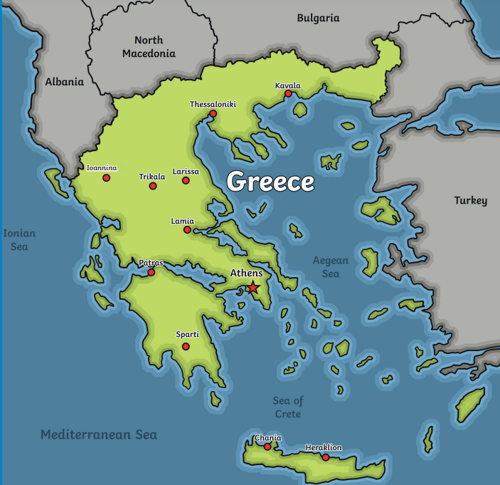
Key Questions:
- Who were the Ancient Greeks?
- Why were Athens and Sparta so different?
- What was Alexander the Great’s impact on the Greek empire?
- Why did a small Greek army win the Battle of Marathon?
- What were the Ancient Greek gods known for?
- What happened at the Ancient Greek Olympic Games?
- What were the Ancient Greek philosophers famous for?
- Did the events of the Trojan Horse story really happen?
- What was daily life like for children in Ancient Greece?
- How significant is the legacy of Ancient Greece for life today?
Key Facts:
- Greece is situated in southeast Europe
- It is made up of the mainland and many islands
- Its position by the sea meant that Greeks were seafaring people.
- It is the 15th largest country in Europe.
- Its capital city is Athens
- Greece is made up of thousands of islands
- Today it has a population of approximately 10.7 million people.

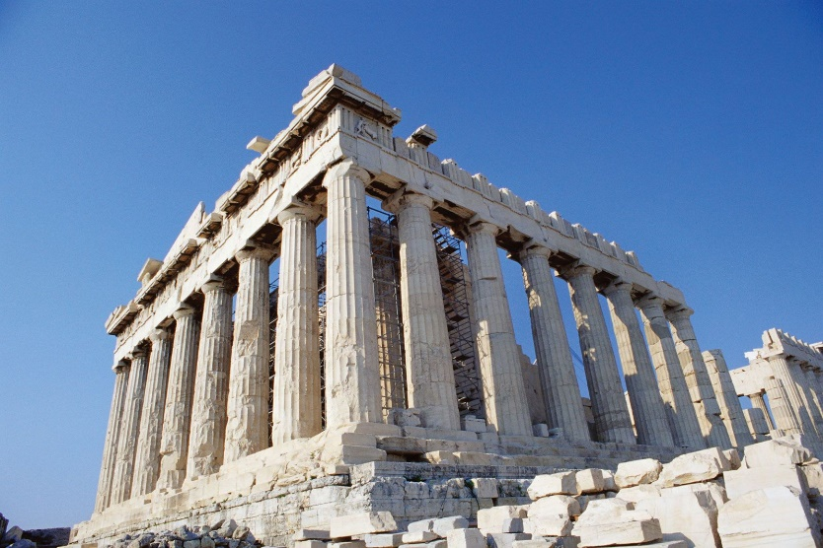
The Parthenon
The Parthenon, in Athens, is a temple to the goddess Athena. It was built on a hill called the Acropolis between 447 and 432 BCE. The Parthenon was a symbol of power and wealth of Athens.

776BC | 750BC | 570BC | 508BC | 450BC | 432BC | 336BC | 146BC
The first Olympic Games takes place | Early Greek culture thrives Homer writes The Iliad and The Odyssey. | Pythagoras is born. He make major breakthroughs in science and maths. | Democracy begins in Athens, giving greater power to the people. | Athens becomes a powerful city and controls an empire | The Parthenon, the most famous building in Athens, is completed | Alexander the Great is king an helps the Greek Empire expand further | Rome conquers Greece, making it part of the Roman Empire

