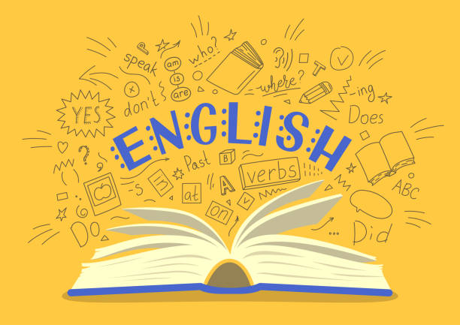
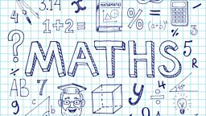
Year 5
Curriculum Newsletter
Spring Term 2025

Our first math focus will be geometry and measure. We will finesse our 3D shape knowledge by identifying properties of 3D shapes as well as how to recognise them from 2D representations. Lots of our Maths will focus on fractions including adding, subtracting and multiplying fractions as well as converting them from improper to mixed numbers. We will reintroduce statistics to the children and look at interpreting data from a variety of graphs, tables and charts and solve comparison, sum and difference problems from data presented in line graphs.
Multiplication Tables
It is more important than ever to make sure multiplication tables can be recalled accurately and at speed. We will continue to regularly test multiplication tables and it is imperative that the children learn them. If your child has a good knowledge of their multiplication tables we ask they practice the related division facts and work on answering the questions with accuracy and speed.
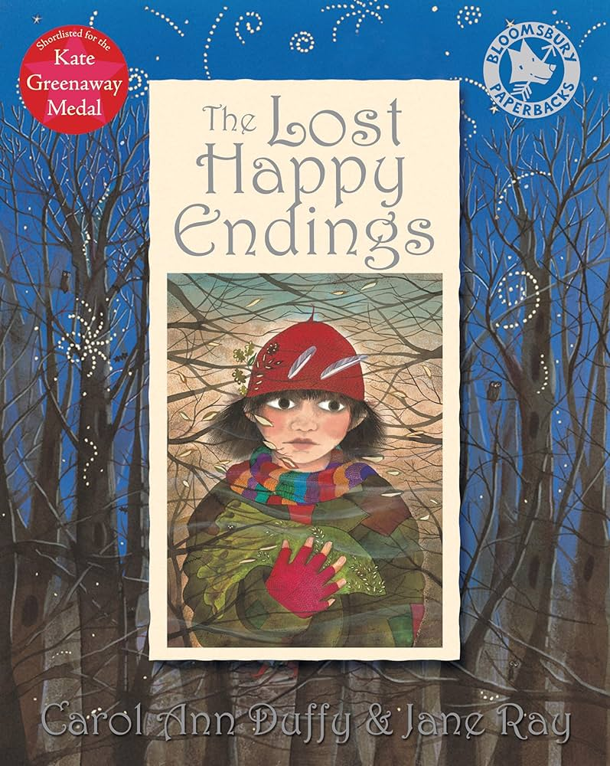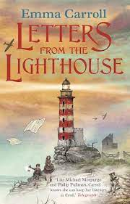
We begin the Spring term with a visit to some familiar and fairytales… The Three Little Pigs, Little Red Riding Hood, Goldliocks, Cinderella. All ended happily ever after but, what would have happened had they not? We will look at how the happy endings were lost and write a prequel to the book which includes one of the main characters. Our second book will connect with our history and tells the tale of 2 young children who are evacuated from London to the Devonshire coast only things aren’t quite what they seem! Our wriiting will centre around the mystery that unfolds; letters, discussions about evacuatuon and the impact of war will all be included in this exciting unit of work.

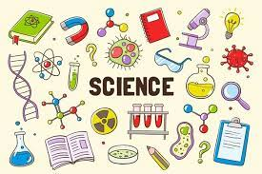
Over the next two terms, we will be continuing our learning about space which will be swiftly followed by building upon our knowledge of reversible changes from our materials unit to look at amazing irreversible changes; a unit which encapsulates children in a variety of hands on and rather exciting scientific investigations. After half term, our attention with turn exploring forces and machines, starting with gravity before studying friction forces, including air and water resistance before investigating how simple machines work.

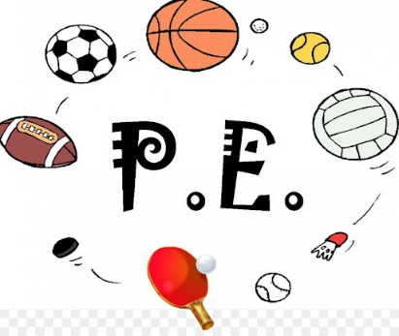

PE DAYS – MONDAY & FRIDAY
In our first half term, we will be developing skills in tag rugby and outdoor adventurous activity centered mainly around developing orienteering; units that have been enjoyed by all in previous years or terms! After half term we will be enjoying the hopefully warmer and dryer weather and take out PE outside more regularly developing our tennis skills and a skill set transferrable to outdoor adventurous activity including map reading!
World War 2 will be our topic for the term and we will explore key events of the war, significant individuals involved and the impact of the conflict in great depth. We are fortunate enough to have some amazing out of school learning experiences planned across this unit. More details will follow about these!




In RE we will be exploring and describing why Christianity does not always look the same. Children will be able to give examples of how Christianity spread as a religion, identify feature of a Catholic Church, identify some reasons why people began practicing in different ways and organize different Christian practices according the their impact on believers.
Computing will explore how digital images are made up of pixels and explore how the Mars Rovers send compressed images to Earth using binary code. Children will then move on to explore Micro-bits and program these for specific functions.
This term in DT, our attention will turn to cooking and nutrition. Children will learn how beef, the main ingredient of a Bolognese is farmed, taste and compare two supermarket sauces and their nutritional value, research and adapt a recipe to create a healthier alternative before working together to prepare and cook their very own Bolognese sauces in which they will design packaging for promoting their creation as a healthy choice!
In art, we will extend a drawn self- portrait and explore how a background can change the finished effect. Children will take portrait photographs to develop a drawing into finished prints using a range of techniques. We will then extend our ideas and learning about the purpose of self- portraits and compare work by a range of artists in different mediums including mixed media. Children will consider how a self-portrait could represent something important about an artist.

