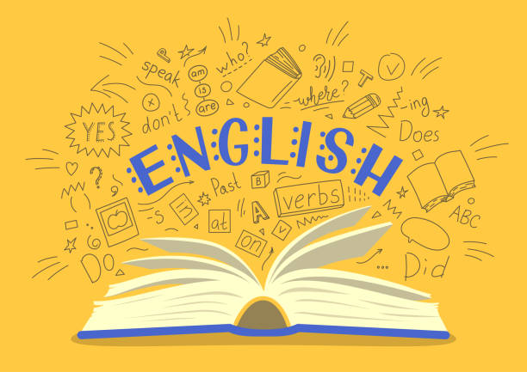
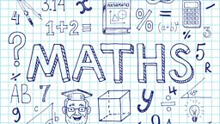
Year 5
Curriculum Newsletter
Autumn Term 2024

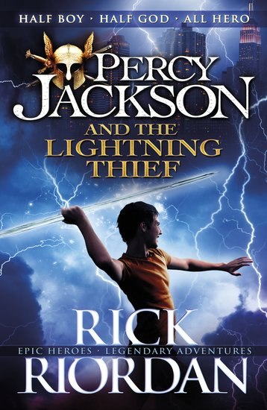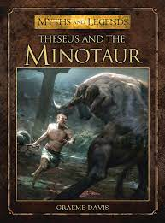
Percy Jackson will give us the perfect way into our English this year allowing us to explore heroes by writing a diary entry using the exciting adventures of this young Greek God! Following on from this, our attention will turn to a classic Greek Myth, Theseus and the Minotaur, allowing us to explore this genre of writing and equipping us with the skills to write our own! The Raven will be our poetry focus thinking about imagery and structure. As Christmas approaches, we will explore one of the fabulous Christmas adverts for inspiration!
Our first math focus will be place value and how to use place value to multiply and divide by 10/100/1000. We will look at the value of digits in numbers up to 1,000,000 and recap rounding. Addition and subtraction methods will be recapped along with multiplication and division. They will then be applied to written word problems.
Multiplication Tables
It is more important than ever to make sure multiplication tables can be recalled accurately and at speed. We will continue to regularly test multiplication tables and it is imperative that the children learn them. If your child has a good knowledge of their multiplication tables we ask they practice the related division facts and work on answering the questions with accuracy and speed.

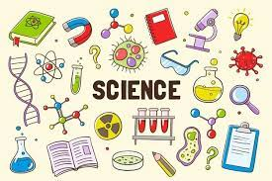
Over the next two terms, we will be learning about different materials and then space. Our first topic will explore materials and their uses. The children will also explore the different uses and how materials change. First they will test the properties of materials before looking at how materials dissolve, what a solution is and evaporation. Finally, children compare reversible and irreversible changes. After half term, our attention will turn to the sky and the wonders that lie above our Earth. Starting with the Solar System, they look next at how ideas about space have changed over time before they explore what causes us to experience night and day on Earth.

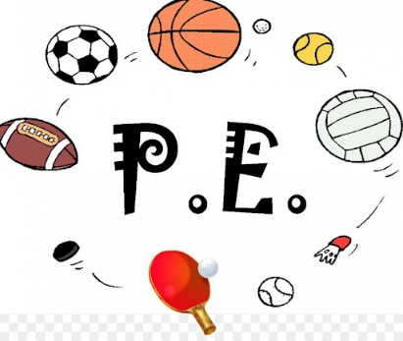

PE DAYS – MONDAY & THURSDAY
In our first half term, we will are lucky to be working with Coach Jimmy “Jumpshot” Smith on our basketball skills. We will develop our passing and shooting skills culminating in some competitive games! We will also be improving our gymnastics skills and exploring different ways of moving our body with control and co-ordination! Inspired by the women’s World Cup, our attentions will turn to football with a focus on passing skills and tactics again ending with some small competitive games.
The Ancient Greeks will be our topic for the term and we will be exploring their lives in great depth. Linking beautifully with our DT and science, we will look at how the Greek civilization began and the discoveries they made! A timeline of events will help us understand their era more clearly!

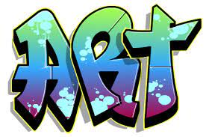

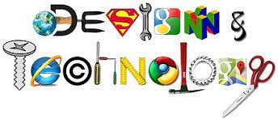
In RE we will be exploring and describing a range of different beliefs, symbols and cations so that we can understand different ways of life and ways of expressing meaning. We will observe and consider different dimensions of religion so that we can explore and show understanding of similarities and differences within and between different religions and worldviews.
Computing will focus on online safety and the way we communicate with others online! We will explore different methods of online communication, app permissions, the integrity of the internet and the use of gifs, memes and emojis. In our discussions, we will talk about how online communication can sometimes be misinterpreted.
To enhance our History work on Ancient Greece, the children will research, design and make their very own Greek sandals. They will create a proto type sandal first before making the final adjustments and producing a sandal fit for a Greek civilian in 800BC! Following their creations, they will evaluate their final product and make amendments as necessary! A new trend could be hitting Belton Lane corridors! Watch this space!
In art, we will look at illustrations from the ‘Space race’ era; exploring how imagery was used and how it influenced art and design; We will explore art created using different processes and consider artists decisions; experimenting with materials and tools. Using Teis Albers’s piece ‘Moonwalk’ as inspiration we will consider how drawing can be developed through printmaking and creating a collagraph printing plate. Children will think about what the future might look like and plan their own creation!

