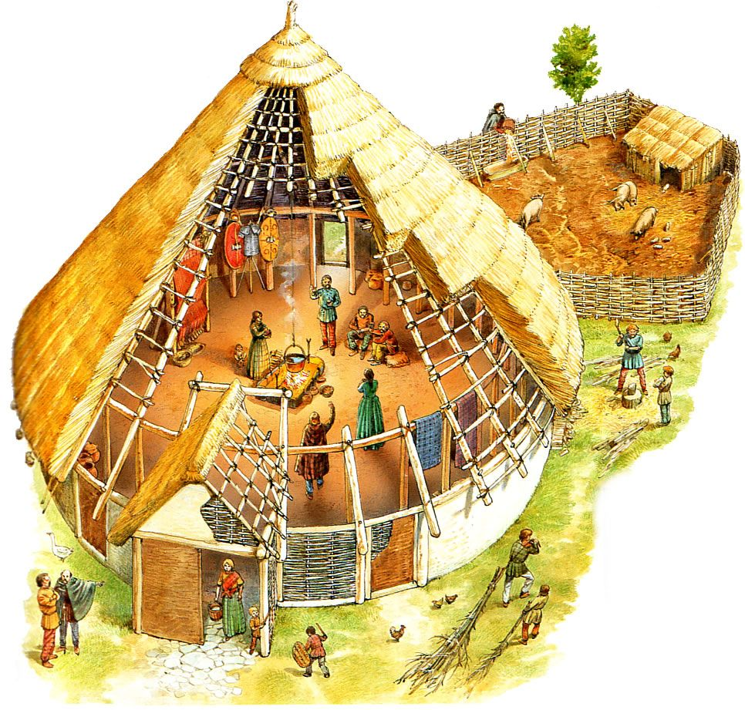
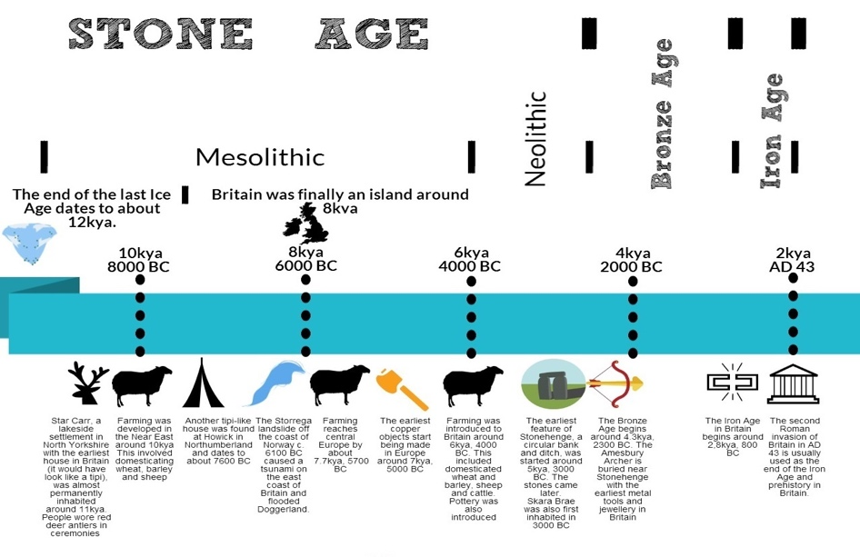
Stone Age – Iron Age
What will we learn?
- About the period of prehistory in Britain which refers to the time before written records began. It begins when the earliest hunter- gatherers came to Britain from Europe around 450,000 BC and ends with the invasion of the Romans in AD 43.
- How daily life was different during the Stone Age through to Iron Age
- How people hunted/ gathered
- How settlements were different and how they changed
- About some of the animals, tools, weapons, materials and food of the time

Find out what these words mean…

AD Flint Skara Brae
Agriculture Mesolithic Stonehenge
BC Neolithic
Chronology Palaeolithic
Crop Settlement
What are we building on…?
- Knowledge that anything left over from the past is a source of evidence. This is called historical evidence.
- Understanding that evidence we find from the past can be in the form of paintings, skeletons, remains of buildings and sometimes books or pieces of paper
- Understanding of chronology
- Knowledge of society and where individuals were born and family life
- Knowledge of location and where in the world individuals made their name
- Knowledge of conflicts and wars that took place

We will continue to be using sources of information and artefacts to help us understand these key concepts.
We will continue to develop our ability to communicate information about the past.

What should we be able to do?
- Examine how evidence is gathered about prehistoric Britain.
- Describe the challenges faced by early humans and explain why tools were important.
- Name and describe some of the food that hunter- gatherers would have eaten (fruit, nuts, seeds, veg and lentils).
- As archaeologists, examine evidence to learn about how stone age people used to live.

The children will take a cross-curricular approach to writing and include the main features of a discussion text within their city-state work.

