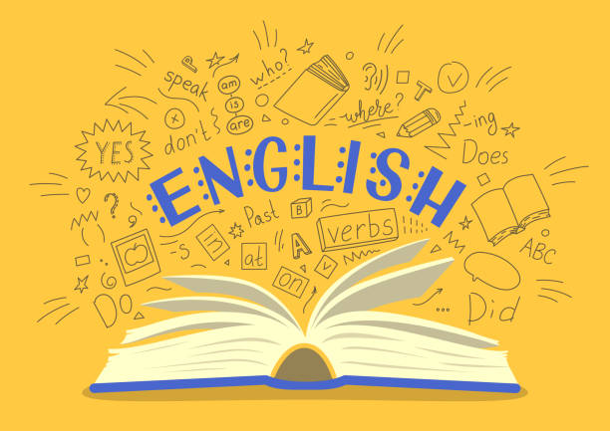
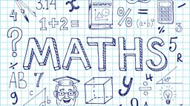
Year 4
Curriculum Newsletter
Autumn Term 2026

Our English starts with a focus on Aesop’s fables with some classics such as The Hare and the Tortoise and The Goose who laid a Golden Egg being read and explored. We will think about the lessons we can learn from the fables before writing our own using The Lion and the Mouse as a stimulus. Following on from fables, our attention will turn to the classic book “Wind in the Wllows” where we will explore the different characters with a focus on the wonderful Mr Toad! He will provide a stimulus for our writing when we contemplate the events that happened prior to his car ending up in the lake! Some great fun to be had with this piece of work! We will explore poetry through reading The Pied Piper of Hamlin and follow his journey through the streets with the rats dancing to his merry tune!
Our first maths focus will be place value. We will look at the value of digits in numbers up to 1,000 ordering and comparing them. We will develop our addition and subtraction knowledge by learning new methods which will help us to calculate more efficiently. Throughout the term, we will be applying our fluency knowledge to reasoning and word problems as well. We will study shape and measure, looking at different shapes and how we measure length and mass accurately.
Multiplication Tables
It is more important than ever to make sure the children are practicing our multiplication tables. They will be completing multiplication tables daily and need to be on TTRS at home at least 4 times per week. It is also useful for the children to learn their multiplications by rote reciting them out loud. We will be testing the children regularly on their tables.

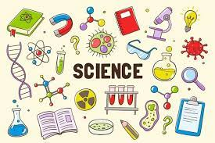
Over the next two terms, we will be learning about States of Matter exploring solids, liquids and gases. We will delve into their features and think about their uses. The children will complete some practical investigations applying the knowledge that they have learnt. After half term, our attention will turn to sound and the children will learn how sounds are made on a variety of instruments and how they can be changed in volume, pitch and over distance. They will explore making sounds on a range of objects that aren’t instruments in order to investigate how sounds are created to make music.

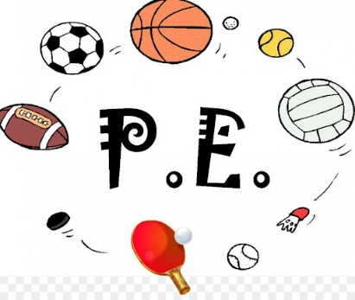
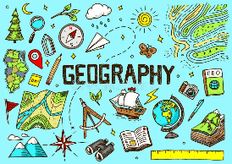
In geography, our focus will be River and Mountains. We will learn how rivers are formed and look at the life of a river from source to mouth. We will learn about mountains ranges and identify where they are in the world.
PE DAYS – TUESDAY AND FRIDAY
Throughout the term, the children will experience different sports with cricket and yoga being the first two. In cricket, children will develop their throwing, catching, batting and fielding skills. They will learn how to bowl accurately, strike a ball with control and work effectively as part of a team. Our yoga sessions will provide calm and a time for reflection. We will explore our breathing and different poses, creating and understanding that sport can be good for the body and mind.

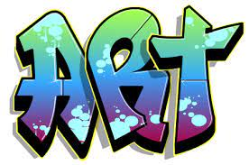

Our Topic will be based on food this term. The children will work in groups to adapt an existing biscuit recipe, whilst considering the cost of the ingredients and other expenses against a set budget.

In RE, we will be exploring the origins of religious texts and considering their value to some followers. The children will be exposed to the values and beliefs of a variety of religions and asked to discuss their views in a respectful and thoughtful way. We will look at the connections we can make between different religions showing unity between faiths.

Computing will focus on online safety and the way we communicate with others online! We will explore the accuracy of the internet and how we can find information that we trust. We will discuss search engines and the results that we may get depending on the search criteria that we enter.



The children will create drawing using different pencil tones. They will consider how to use shading to show a simple 3D effect of an object. They will also explore how holding a pencil in different ways can have various effects. Following that, the children will try out multiple arrangements of cut images (collage) to decide on their final composition and then using different tools they will create marks and patterns when scratching into a painted surface.

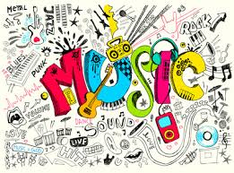
The children will learn to listen to changes in pitch, tempo and dynamics. They will link their Geography learning to represent the stages of a river through vocal and percussive rhythms to create a group performance.

