Geography
Geography- Exploring the Seaside Environment.
By the end of this unit children will know...

Vocabulary

Year 1 Summer 2 – Summer Time

To be able to tell the difference between a physical and human feature. To distinguish between physical and human features at a UK beach.
To be able to observe weather changes over the four different seasons in the UK. To observe and describe the weather associated with the different seasons.
To be able to identify the four countries within the United Kingdom. To be able to identify the surrounding seas around the United Kingdom. To be able to identify human and physical features on the surrounding seas and to begin comparing to other seas.
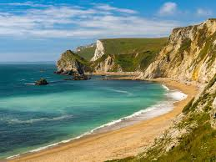

Seaside, coast, coastal area, human feature, physical feature, sea, ocean,

Intention

In this unit children will recap human and physical features with a focus on coastal environments. They will revise the UK seas and compare the and English seaside to that of another county.

Exploring the Seaside Environment- Previous Learning
Previous Learning

During Spring 2 the children learnt about human and physical features in the U.K. When the children were in Reception they shared their experiences of holidays.

Learning Links
This unit builds directly on children’s previous learning about human and physical features, allowing them to deepen their understanding of how landscapes vary across the United Kingdom. As outlined in the National Curriculum, pupils in Key Stage 1 should develop knowledge about the UK and their locality, as well as begin to understand basic physical and human geographical vocabulary. Through exploring coastal environments, pupils revisit and apply key locational knowledge such as naming the four countries of the UK and identifying surrounding seas, supporting curriculum expectations for learning continents, oceans and the countries of the United Kingdom. They extend their understanding of place by comparing a familiar UK beach to a contrasting seaside environment in a hotter country, reflecting the requirement to study similarities and differences between UK and non-European locations. In addition, children develop their understanding of seasonal and daily weather patterns through observing and discussing how weather affects coastal areas, linking to statutory content on weather and climate in KS1 geography.

Geography- Exploring the Seaside Environment
In this unit children will recap human and physical features with a focus on coastal environments. They will revise the UK seas and compare the and English seaside to that of another county.
Knowledge Progression Across the Unit:  Lesson 1 – Differences between human and physical features.  Lesson 2 The four counties of the United Kingdom and the surrounding seas.  Lesson 3- Comparing a UK beach with a beach in a hot place,  Key Objectives:  To be able to tell the difference between a physical and human feature. To distinguish between physical and human features at a UK beach.  To be able to observe weather changes over the four different seasons in the UK. To observe and describe the weather associated with the different seasons.  To be able to identify the four countries within the United Kingdom.  To be able to identify the surrounding seas around the United Kingdom.  To be able to identify human and physical features on the surrounding seas and coastal areas of the UK and to begin comparing to other seas and a coastal area in another country.  The National Curriculum:  To understand geographical similarities and differences through studying the human and physical geography of a small area of the United Kingdom, and of a small area in a contrasting non-European country.  To use basic geographical vocabulary to refer to: key physical features, including: beach, cliff, coast, forest, hill, mountain, sea, ocean, river, soil, valley, vegetation, season and weather key human features, including city, town, village, factory, farm, house, office, port, harbour and shop.  To name, locate and identify characteristics of the four countries and capital cities of the United Kingdom and its surrounding seas. | Lesson 1- Physical and Human Features  Foundational Skills:  Communication and Language – listening, understanding vocabulary, expressing ideas  PSED – turn-taking and cooperating with partners  Physical Development – fine motor control for sorting and simple construction  Literacy – using new vocabulary and simple written labels  Understanding the World – observing, comparing and naming features  Learning Objective:  To be able to tell the difference between physical and human features. To distinguish between physical and human features at a UK beach.  Success Criteria:  I can recognise different physical and human features. I can label human and physical features and draw them. I can identify those features at a UK beach and label a beach. I can write a sentence saying what features I can see.  Recap and Recall:  Quick Recall Activity:  “What do you remember?”  Show three photos on the board (e.g., a house, a cliff, the sea).  Ask children to turn to a partner and say one thing they already know about physical or human features.  Then ask a few children to share: “Is this feature made by nature or by people?”  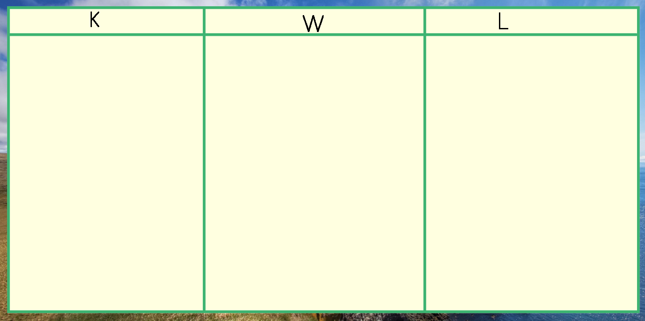  Starter:  Work through Human and Physical features PowerPoint, video and Sea and Coasts slides. Can we add any more to our KWL grid?  Split the children into pairs HA/LA sort human and physical features out.  Main:  Children to complete their worksheet according to ability.  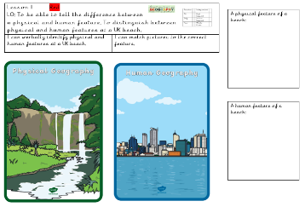  Reds-  Yellows-  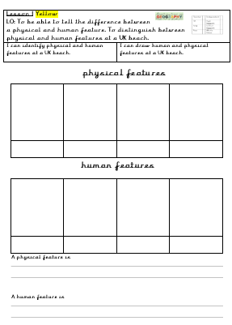  Greens and Blues-  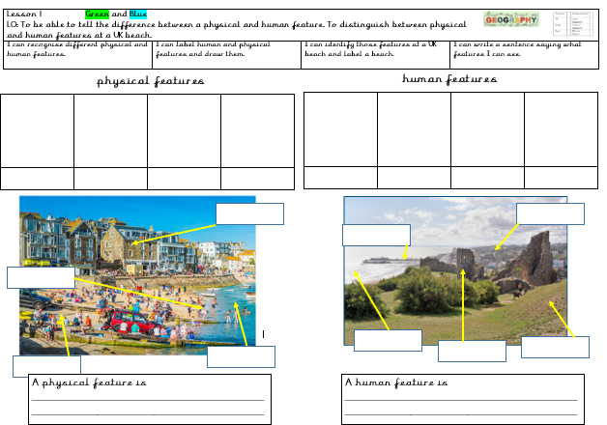  Plenary:  Children to build a beach out of construction. Label different features human and physical. QR code for books. |  | Lesson 2 – The UK and Seas  Foundational Skills:  Communication and Language – using locational vocabulary and answering questions  PSED – confidence recalling knowledge, working respectfully with others  Literacy – reading and interpreting map labels  Mathematics – using positional language and spatial awareness  Understanding the World – recognising places on maps and exploring environments  Learning Objective:  To be able to identify the four countries within the United Kingdom. To be able to identify the surrounding seas around the United Kingdom. To be able to identify human and physical features on the surrounding seas and to begin comparing to other seas.  Success Criteria:  I know the four countries in the United Kingdom and locate them on a map. I know how to use simple geographical vocabulary to describe features or location e.g. hill, local, road coastline woods.  Recap and Recall: “Pass the Globe Recall”  Pass a globe or UK map around.  When the music stops, the child holding it must name one country in the UK or one fact they remember about the UK from the Autumn term (e.g., a capital city).  Very short, very fun.  Starter:  Explain today we’re going to be recapping the countries in the UK and its seas. Can the children tell you anything of what they remember in the Autumn term?  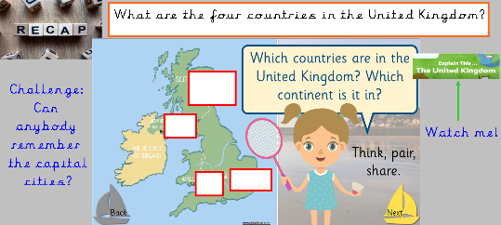  Go through notebook discussing each slide.  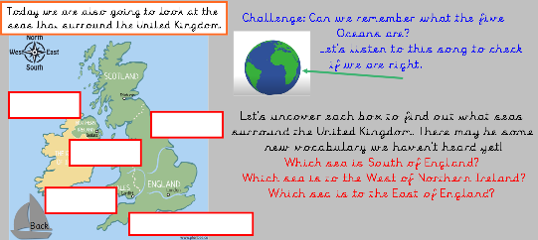  Main:  Red and Yellows  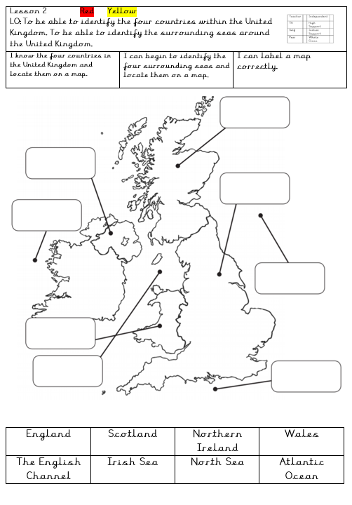  Verbally explain where the seas are. QR code for books.  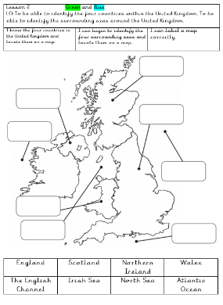  Green and blue  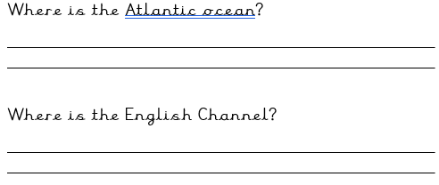  Extension  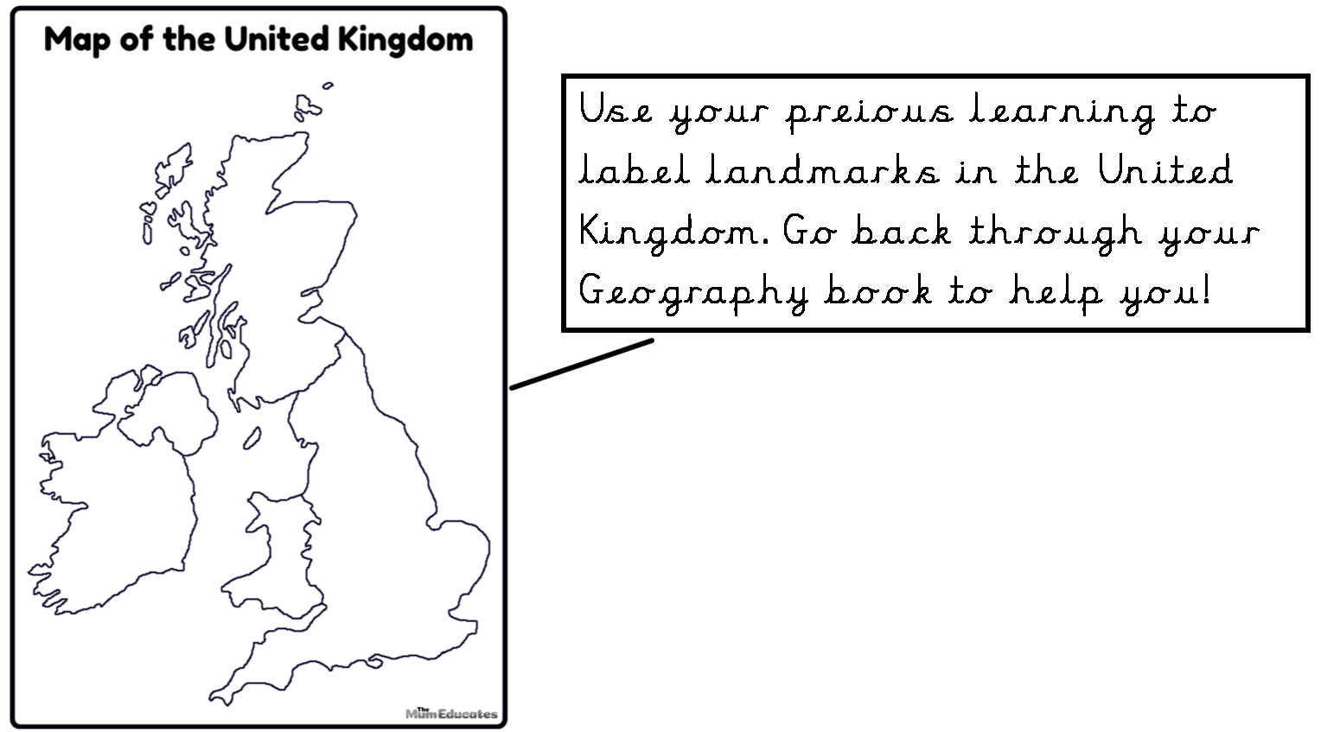  Plenary:  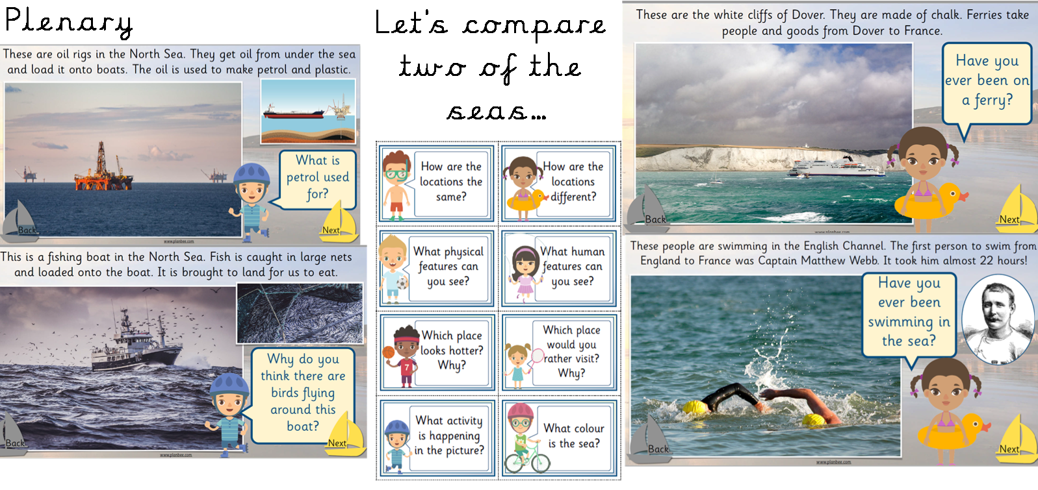 | Lesson 3 – Comparing UK beach with a beach from a hot place  Extended Writing Opportunity:  Write a recount about their trip to Rutland Water.  Foundational Skills:  Communication and Language – asking and answering questions, describing differences  PSED – sharing ideas and listening to peers  Literacy – writing simple comparative statements  Mathematics – interpreting simple visual and spatial information  Understanding the World – recognising environmental similarities and differences  Expressive Arts and Design – drawing simple beach landscapes (extension)  Learning Objective: To be able to identify human and physical features. To be able to compare a UK beach and a beach in a hot place.  Success Criteria:  I can identify human and physical features at a UK beach and European beach. I can compare the two beaches and say what is similar and different. I know how to answer geographical questions such as: Where is this place? What is it like?  Recap and Recall: Recap the countries, capital cities and seas of the UK.  “Same or Different?”  Show two quick images on the board:  - A UK beach (e.g., Skegness)  - A hot-country beach (e.g., one with palm trees)  Ask pupils to tell their partner one thing they remember about UK weather, seas, or features from the last lesson.  Then ask: “Which beach do you think belongs to the UK and why?”  Starter:  Explain today we’re going to be comparing a UK beach like Skegness to a beach from another country that is a lot hotter than the uk!  Go through slides.  Children write down questions they may have about the different beaches on strips of paper. on strips of paper.  Work through the information discussing the different beaches.  Have all your questions been answered?  Discuss Human and Physical features from the 2 different beaches.  Main:  Red, Yellows, Greens (teacher to support Reds) -  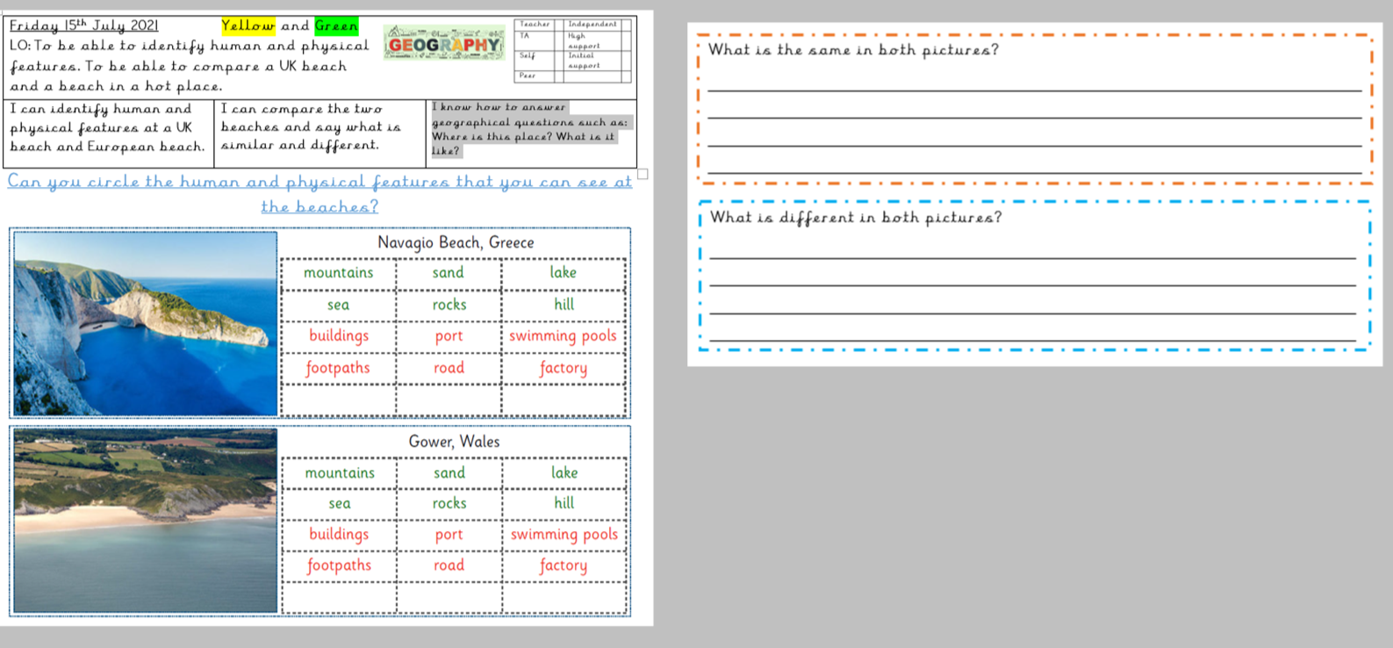  Blue  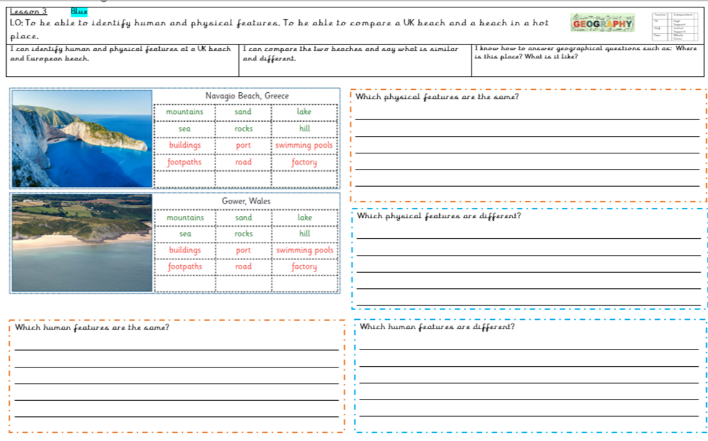  Extension-  To draw a UK beach and a beach from a hot country.  Plenary: Bring children back together, share what we have learned and drawings. QR codes for books.
Learning Challenge Week:
Visit Rutland Water man-made beach to give the children a hands on experience of visiting a beach.

Cross Curricular Links:  Maths – Shape  English – Descriptive language  Art- Drawing beaches |  | Through this unit of work the following essential skills will be developed:  Maths:  Understanding positional language.  English:  Using descriptive language to describe the beach landscape and textured surface.  Ask relevant questions.  Write understanding in well-formed sentences.  Art:  Become familiar with various images of different beaches.
Assessment
Children who are expected will be able to
- I can name the four countries in the United Kingdom.
- I can name the surrounding seas.
- I can explain what a human and physical feature is.
- I can give examples of human and physical features.
- I can compare two different beaches.

