Geography
Geography- Hot and Cold Places
By the end of this unit children will know...

Vocabulary

Year 1 Summer 1 - On Safari

• The name, location and characteristics of the continent of Africa.
• The name, location and characteristics of the country of Kenya.
• The name, location and characteristics of the continent of Antarctica.
• Similarities and differences of a hot country and a cold country in different continents.
• Geographical vocabulary to describe different countries and compare hot and cold places.
• How to keep a weather chart and answer questions about the weather.
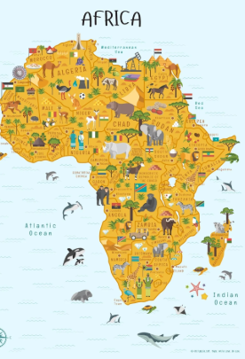 • 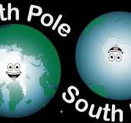

Africa, Continent, Country, Equator, Desert, Jungle, Humid, Heat, Arctic, Antarctica, Poles, Polar Regions, Ice, Human Feature, Physical Feature, Location, Globe, Seasons.

Intention

Children will learn where the equator and North and South Pole are on a globe. They will look at how animals in the North and South poles keep warm and which clothes people should wear in hot and cold places. We will discuss why people tend to like hot places for their holidays.

Hot and Cold Places- Previous Learning
Previous Learning
In Reception the children explored globes. In Spring 1, our science unit was ‘Polar Adventures’, in this unit the children looked at the position of the North and South Pole on a globe.

Learning Links
This Geography unit, Hot and Cold Places, builds directly on children’s earlier experiences in Reception, where they explored globes and began developing an awareness of the world around them. It also links to prior learning from the Spring 1 Science topic Polar Adventures, where pupils gained early knowledge of the polar regions and how animals survive there. Throughout the unit, children extend this understanding by learning to name, locate and identify characteristics of the continents of Africa and Antarctica, and the country of Kenya, while also comparing hot and cold places across the world. This work supports the Year 1 Geography National Curriculum, which requires pupils to name and locate the world’s seven continents, identify hot and cold areas of the world in relation to the Equator and the North and South Poles, and observe seasonal and daily weather patterns using simple geographical vocabulary.
Through rich links to video clips, maps, globes and first-hand weather observations, pupils develop skills in using atlases, creating weather charts, and making geographical comparisons between contrasting environments. This complements and builds upon their earlier knowledge of the UK, previously studied in geography, allowing children to situate new learning within a growing mental map of the world. As they explore how climate affects animals, people, clothing and environments, pupils deepen their understanding of human and physical features and begin to use these terms confidently to describe different places. The unit also reinforces enquiry skills developed in EYFS and Science—observing, asking questions, identifying similarities and differences, and using real data (such as weather) to draw conclusions. In doing so, it lays secure foundations for future geography learning by helping children recognise patterns across the world and understand their place within it.

Geography- Hot and Cold Places
Children will learn where the equator and North and South Pole are on a globe. They will look at how animals in the North and South poles keep warm and which clothes people should wear in hot and cold places. We will discuss why people tend to like hot places for their holidays.
Key Objectives-  - To be able to name, locate and identify characteristics of the continent Africa.  - To be able to name, locate and identify characteristics of the country Kenya.  - To be able to name, locate and identify characteristics of the continent of Antarctica.  - To be able to compare a hot country and a cold country.  National Curriculum –  Pupils should be taught to  -Name and locate the world’s seven continents and five oceans.  - Understand geographical similarities and differences through studying the human and physical geography of a small area of the United Kingdom, and of a small area in a contrasting non-European country.name, locate and identify characteristics of the four countries and capital cities of the United Kingdom and its surrounding seas Place knowledge.  -Identify seasonal and daily weather patterns in the United Kingdom and the location of hot and cold areas of the world in relation to the Equator and the North and South Poles.  - Use world maps, atlases and globes to identify the United Kingdom and its countries, as well as the countries, continents and oceans studied at this key stage. | Lesson 1- The Hook- To begin to gain knowledge of Africa.  Foundational Skills: Listening and attention: In the lesson, children listen to music, video clips and instructions to gather information about African environments and animals.  Speaking and vocabulary: In the lesson, children describe the weather, animals and environment using new geographical vocabulary.  Understanding the world: In the lesson, children observe and talk about differences in places, linking to prior experiences of globes and environments.  Expressive language: In the lesson, children share ideas, answer questions and explain what they know about Africa.  Learning Objective: To become familiar with images of Africa.  Success Criteria: I can describe the environment in Africa. I can describe the weather conditions in Africa. I can name some animals from Africa.  Recap and Recall:  Show three pictures: a globe, the UK, and an animal from Africa. Ask: “Which one did we learn about in Reception?” Children point and explain one thing they remember about globes or different places.  Starter:  Play the following African music.  https://www.youtube.com/watch?v=9b81mWYIyTo  Play:  Carmen Twillie, Lebo M. - Circle Of Life (Official Video from "The Lion King") (youtube.com)  Ask- What film is it from? Where is the film set?  Do you already know anything about Africa?  Complete KWL grid with children and put in books.  Main:  Watch some clips from a documentary by David Attenborough (a famous environmentalist and documentary maker.)  https://www.bbc.co.uk/iplayer/episode/p010jc6r/africa-1-kalahari  Watch to 1 minute 16 seconds.  Ask- What new words did you hear?  What does the weather look like?  What animals did you see?  Watch from 16 minutes- 18:37.  Ask- What animals did you see?  Watch from 1:27-3.26  Ask- What was the environment like in this clip?  Activity:  Yellow, Green and Blue Groups- Children to draw and write a sentence explaining what the weather, animals and environment is like in Africa. Then write a sentence to explain what they have learnt about Africa.  Red Group- Children to draw and then add the missing words to the sentences to explain what the weather, animals and environment is like in Africa.  Plenary:  Share ideas with class. | Lesson 2- Where is Africa  Foundational Skills: Listening and attention: In the lesson, children listen carefully to videos and teacher explanations about continents and characteristics of Africa.  Understanding of maps and space: In the lesson, children revisit Reception globe learning while locating Africa on maps and globes.  Speaking and vocabulary: In the lesson, children use geographical vocabulary to describe what they know and want to learn.  Early enquiry skills: In the lesson, children gather and share facts using post-it notes, building curiosity and questioning.  Learning Objective: To be able to name, locate and identify characteristics of the continent Africa.  Success Criteria: I can find where Africa is on a map. I can talk about characteristics of the continent Africa. I can recall facts about the continent of Africa. I can create an informational video about Africa.  Recap and Recall:  Play a quick “Finish the Sentence” game:  “Africa is a ___.”  “In Africa I saw a ___ in the video.”  “The weather in Africa is often ___.”  Children complete each sentence using facts learned in Lesson 1.  Recap that last term we learnt about UK in geography. Discuss- In Grantham we have…  Recap where Grantham is on a map of the U.K.  Starter: Add new knowledge KWL grid in different colour. What do you know about Africa? What do you want to find out?  Main: Tell the children that we are going to be finding out all about Africa and some of the characteristics of Africa.  Watch and discuss the following videos: Come explore...Africa with Lonely Planet Kids - YouTube https://www.youtube.com/watch?v=K6DSMZ8b3LE https://www.youtube.com/watch?v=PSYHMWmyVfo  Give children some post stick notes ask them to make notes about Africa on them. Then read through and discuss the Africa PowerPoint.  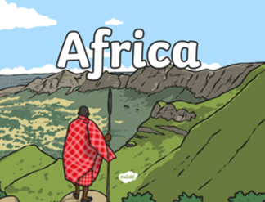  Add further notes to post stick notes.  Tell the children that Africa is a continent, there are 7 continents on the planet. Watch video and list the 7 continents.  Activity:  Children to use their post stick notes to add facts about Africa to poster. Encourage children to use the fact cards to get more information.  Red Group- Children to draw 4 pictures to demonstrate fact about Africa. Teacher to scribe the children’s facts  Yellow, Green and Blue Group- Children to draw 4 pictures to demonstrate fact about Africa. Then write a sentence for each picture.  Plenary:  What did you find out? Talk to each other while you work and share your new knowledge. Read posters. Record on Seesaw. Add QR code to books. | Lesson 3-Kenya Fact File  Extended Writing Opportunity- Write Fact file about Kenya.  Foundational Skills: Listening and attention: In the lesson, children listen to videos and information about Kenya’s landmarks, animals and weather.  Observation skills: In the lesson, children notice features of a contrasting country and record important details.  Early writing skills: In the lesson, children create a simple fact file using drawn images and key facts.  Expressive language: In the lesson, children talk about what they have learned and explain their chosen facts.  Learning Objective: To be able to name, locate and identify characteristics of the country Kenya.  Success Criteria: I can locate Kenya on a map. I can research to discover facts about Kenya. I can talk about the weather in Kenya. I can talk about landmarks and characteristics of Kenya.  Recap and Recall:  Hold up three fact-cards from Lesson 2 (continent, animals, weather). Ask:  “Which of these did we learn about Africa last lesson?” Children touch their heads if it’s a fact about Africa, or shoulders if it’s not sure.  Then ask one child to explain a remembered fact about Africa.  TTYP – What did we learn about Africa last week? Create a mind map on notebook with facts learnt last lesson. Snip mind map and add to books.  Starter: Explain that today we are going to learn about a country in Africa called Kenya.  Main: Read and discuss the Kenya Power Point.  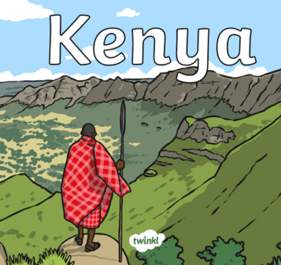:  Watch videos and discuss:  Go Jetters - Series 1: 46. Maasai Mara National Park, Kenya - BBC iPlayer  What Fills My Heart? | Amazing Road Trips  Mount Kenya National Park, Kenya [Amazing Places 4K]  As children watch the videos and discuss PowerPoint ask them to make notes on post stick notes.  Activity:  Work in mixed ability groups to read the fact cards and the fact file to find out more information about Kenya. Ask the children to circle important  information.  Children to use the information they have gathered to create their own fact file about Kenya.  Red Group- Put the flag, location, capital and language on fact file.  Yellow, Green and Blue Group - Put the flag, location, capital, significant people, interesting facts, plants, animals and language on fact file.  Plenary:  Children to share the fact files created.
Lesson 4-Comparing Antarctica and Kenya  Foundational Skills: Listening and attention: In the lesson, children listen to videos and explanations about cold and hot climates.  Comparing and contrasting: In the lesson, children recall information from previous lessons to identify similarities and differences between two environments.  Understanding physical and human features: In the lesson, children sort images and describe features of both places.  Speaking and reasoning: In the lesson, children explain why clothes, temperatures and environments differ.  Learning Objective: To be able to compare a hot country and a cold country in different continents. To be able to use geographical vocabulary to describe a hot country and a cold country.  Success Criteria: I can compare the seasons in Antarctica and Kenya. I know what clothes I would wear in a hot country and a cold country. I can recognise physical features and human features in different countries.  Recap and Recall:  Play “Hot or Cold?”  Say a word (e.g., penguin, desert, glacier, lion, snow, savannah).  Children move:  Hands on head = cold place  Hands on knees = hot place  This revisits key knowledge from Kenya and Antarctica learning.  What can we remember about Antarctica?  What can we remember about Kenya?  Where in the world is Antarctica?  Where in the world is Kenya?  Starter:  Watch the following 2 videos to find out more.  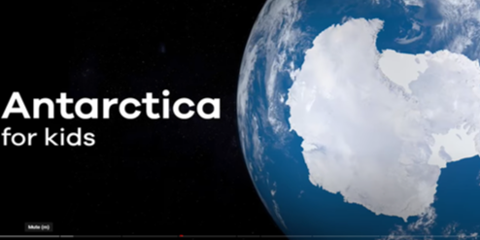  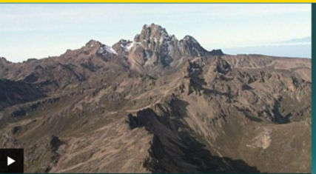  Recap- What did we learn about polar regions in science? Record children’s ideas on mind map on notebook.  Ask- What are the seasons in Antarctica?  How many seasons are in Kenya?  Main: Show the children pictures of the seasons in each location on notebook.  Ask- Why is it warmer in Kenya than Antarctica?  What would you wear in these two places? Why? What is similar and what is different?  What is a human feature? What is a physical feature?  Look at and discuss photos of human and physical features of Antarctica and Kenya.  Activity:  Children to complete sheet on seasons.  Red Group- Draw a picture for each season. Then draw and label an outfit that would be suitable for each place.  Yellow, Green and Blue Group- Draw a picture for each season and label. Draw and label a human and physical feature for each place. Then draw and label an outfit that would be suitable for each place.  Plenary:  Children to share their outfits. | Lesson 5- Recording a 5 Day Weather Chart  Foundational Skills: Listening and attention: In the lesson, children listen to weather explanations and observe real daily weather conditions.  Observation and enquiry: In the lesson, children monitor the weather each day and record what they see and hear.  Early data handling: In the lesson, children use weather symbols and simple notes to record and interpret information.  Speaking and vocabulary: In the lesson, children describe weather patterns using appropriate geographical terms.  Learning Objective: To be able to describe the weather in the United Kingdom. To recognise different weather signs.  Success Criteria: I can record the weather in Grantham over a week.  Recap and Recall: Show four weather symbols. Ask: “Which symbol did we see in our last video?”  Then ask children to describe yesterday’s weather in one word, practising observation and vocabulary  Starter: Ask the children what they know about the weather. Ask the children to think about the weather in different countries. Record on Seesaw. Add QR codes to books.  Read information and watch-  Explore weather and climate - BBC Bitesize  Ask- What is the weather like in the UK?  Main: Look outside, what's the weather like today?  Show the children the weather chart and explain what it is for. Look at each of the weather symbols and talk about what weather each symbol represents.. Which symbol best represents the weather for today? Model listening and looking and recording what you find for the videos on the PowerPoint.  Work through PowerPoint and fill in weather chart.  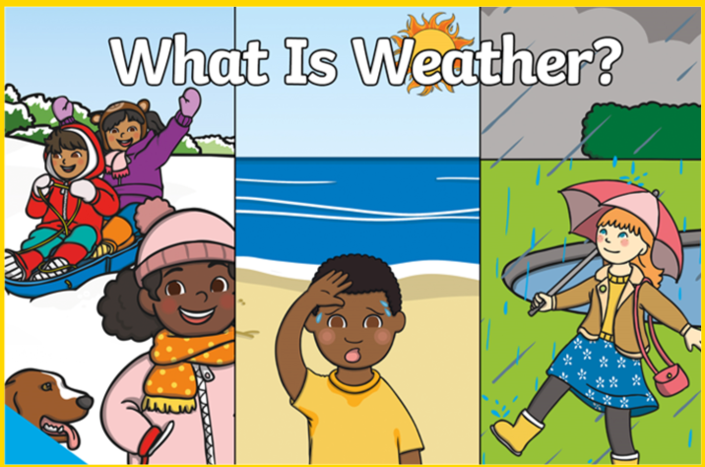  Yellows, Blues and Greens – Children to record the weather each day using the correct symbol and write observations of what they can see and hear.  Work through powerpoint and fill in weather chart.  Show the children the weather chart and explain what it is for. Look at each of the weather symbols and talk about what weather each symbol represents. Think about the weather today, look outside to check the weather. Which symbol best represents the weather for today? Model listening and looking and recording what you find.  Activity – Keep a 5-day weather chart.  Red Group– Children to draw the correct weather symbol to record the weather each day.  Yellow, Blue and Green Group – Children to record the weather each day using the correct symbol and write observations of what they can see and hear.  Plenary: Watch a weather report. Then pretend to be a weather forecaster saying what the weather will be like in different areas of the UK. Record for Seesaw and QR code for books.
Cross curricular links:  Science – Polar Explorers  Computing – Using Seesaw/iPads to create Video Fact Files.  PSHE – Working collaboratively as a group. | Through this unit of work the following essential skills will be developed:  - I can find where Africa is on a map. I can talk about characteristics of the continent Africa. I can recall facts about the continent of Africa. I can create an informational video about Africa.  - I can locate Kenya on a map. I can research to discover facts about Kenya. I can talk about the weather in Kenya. I can talk about landmarks and characteristics of Kenya.  - I can find where Antarctica is on a map. I can talk about characteristics of the continent Antarctica. I can recall facts about the continent of Antarctica. I can create an informational video about Antarctica.  - I can compare the seasons in Antarctica and Kenya. I know what clothes I would wear in a hot country and a cold country. I can recognise physical features and human features in different countries.  - I can monitor and record the weather for 5 days. I can record the correct symbol to represent the weather daily.
Assessment:
Pupils with secure understanding are able to:
- Observe and describe daily weather patterns.
- Suggest appropriate clothing and activities for each season.
- Give examples of human and physical features.
- Compare 2 areas in terms of weather and characteristics.
- Share facts about Kenya and Antarctica.
- To locate Africa and the North and South Poles on a globe.

.

