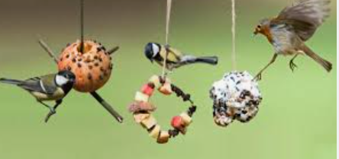
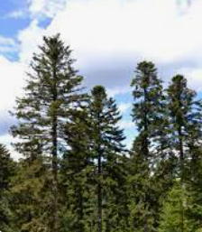

Spring 2 Plants and Animals

Essential Knowledge

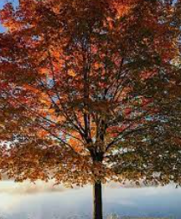
By the end of this term, children will demonstrate independently how to...

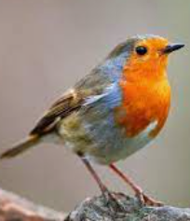
Identify and name a variety of common wild and garden plants, including deciduous and evergreen trees.
Identify and name a variety of common animals including fish, amphibians, reptiles, birds and mammals.
Identify and describe the basic structure of a variety of common flowering plants, including trees.
Describe and compare the structure of a variety of common animals including fish, amphibians, reptiles, birds and mammals
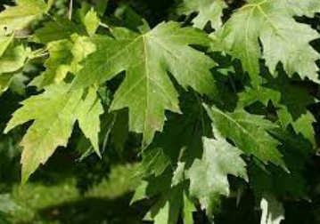

Vocabulary

Intention
The children will learn about different types of flowers, plants and trees, gaining a good understanding of the differences between coniferous and deciduous trees. The children will also learn about different birds and their habitats. They will research how to encourage birds to come into their gardens. In Science Week, they will make their own bird feeders.

Deciduous trees, Coniferous trees, Evergreen trees, Birds, Reptiles, Amphibians, Mammals, Fish, Carnivores, Herbivores and Omnivores

The children will build on their previous learning about animal groups, including the classification of carnivores, herbivores and omnivores. They will also revisit their knowledge gained when exploring the garden area in the continuous provision and when they learnt about animals and habitats as part of the ‘Spring has Sprung’ topic in Reception.

Plants and Animals- Previous Knowledge

Learning Links
In this unit, children will build on their prior learning about plants and animals by making meaningful links to what they already know while continuing to develop key foundational skills. They will revisit their understanding of different animal groups, including carnivores, herbivores and omnivores, and use this knowledge to help them identify and describe animals in more detail. Alongside this, pupils will strengthen essential skills such as observing closely, asking simple questions, grouping and classifying, and communicating their ideas using basic scientific vocabulary. This learning will also connect to their previous experiences exploring the garden area during continuous provision, where they observed living things in a natural environment, helping them to develop their ability to notice changes and patterns over time. In addition, children will draw on their work from the ‘Spring has Sprung’ topic in Reception, recalling what they learnt about animals and their habitats. By linking these experiences together, pupils will deepen their understanding of how plants and animals live, grow and survive in different environments while building confidence in working scientifically.

Science- Plants and Animals
The children will learn about different types of flowers, plants and trees, gaining a good understanding of the differences between coniferous and deciduous trees. The children will also learn about different birds and their habitats. They will research how to encourage birds to come into their gardens. In Science Week, they will make their own bird feeders.
Key Objectives-  To identify different trees and say what is different between them.  To identify different species of birds.  To use a laptop for research purposes.  To research what birds like in a bird feeder.  To make bird feeder.  To collect leaves then create a leaf rubbing.  To classify different animal groups and say what they have learnt. | Lesson 1- Identifying different trees  Foundational Skills:  Observing closely – used when children look carefully at trees, birds, and their features  Asking simple questions – used in TTYP prompts about trees and animals  Classifying – used when identifying differences between coniferous and deciduous trees  Communicating ideas – used when children write or share facts about trees and birds  Learning Objective: To identify and name a variety of common wild and garden plants, and deciduous and evergreen trees. To identify and name a variety of common animals including fish, amphibians, reptiles, birds and mammals.  Success Criteria: I know the differences between a conifer and a deciduous. I can label a tree. I can label a bird.  Recap and Recall:  Ask the children if they know anything about different plants and animals. Complete the KWL grid as a class.  Starter: Explain that we are going to explore different trees and find out what type of animals live in different trees/areas.  TTYP: What type trees do you know?  TTYP: What animals live in or around trees?  Watch Woodland Trust video and discuss.  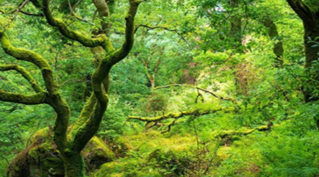  Note down facts on flip chart paper for working wall.  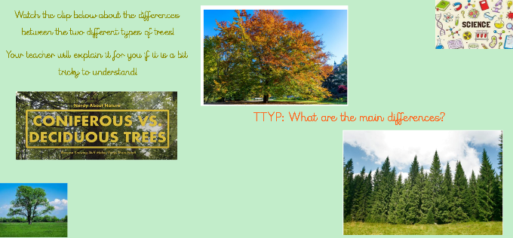  Watch videos and discuss coniferous and deciduous trees. Record ideas for working wall.  Give each child a picture of a tree. Ask them to work with a partner to label the parts of the tree.  Tell the children that we are going to look at the types of animals that live in trees. Look at and discuss the photos of birds.  TTYP: What they have in common? Where do they live? What else do you know about birds?  Watch to 3 minutes 44 seconds of the video clip to find out more information about birds and their song.  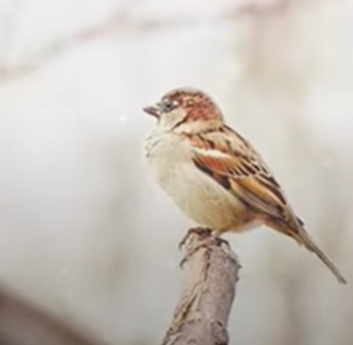  As a class look at the picture of a pigeon.  Ask: What type of bird is this?  How do you know?  What do birds have that other animals do not?  What do birds have that is the same as some other animals?  Main:  All label the parts of a tree. Red group to match the label to the part.  Then:  Blue and Green Group- Write a fact about trees and a fact about birds.  Yellow Group- Write a fact about trees. Then write down the name of the animal that lives in a tree.  Red Group: Draw and label a bird. Use the words on the sheet to support.  Plenary:  Bring the children back together and share key facts from each child. Explain any misconceptions. | Lesson 2- Bird Watching  Foundational Skills:  Identifying and naming – used as children recognise and name different UK birds  Collecting data – used when completing tally charts during birdwatching  Interpreting data – used when reading tally charts and bar graphs as a class  Drawing and labelling – used when children draw and label birds from observation  Learning Objective: To identify and name a variety of birds in the UK. To collect data whilst Birdwatching. To draw and label a bird.  Success Criteria: I know the differences between different species of birds. I can collect data by using a Tally. I can draw and label a bird using the correct labels.  Recap and Recall: Ask: What is science? What did we learn last term in science?  Recap from last week. Use working wall to recap main facts.  Explain we are going to learn how to identify different birds.  TTYP- What different birds do you already know?  Watch and discuss video showing the most common of wild birds in the UK.  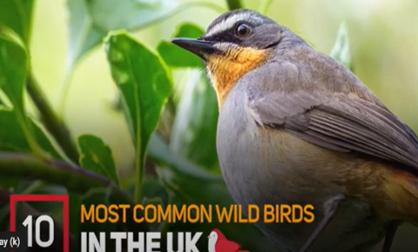  Starter:  Discuss the similarities and differences between different birds.  Recap on the main parts of a bird. Look the picture of a pigeon.  Ask: What type of bird is this?  How do you know?  What do birds have that other animals do not?  What do birds have that is the same as some other animals?  Look at a picture of a blackbird and a robin.  Ask: What are these birds called?  How do you know?  What is the same/ different about these birds?  Explain we're going to go bird watching.  We're going to first record our data in a Tally chart, then put our data together in a Bar graph.  Show the children a picture of a tally chart. Explain that the children carried out a bird watch in their school. Ask:  Which bird did they see the most time? Which bird didn’t they see?  Look at the bar graph. Ask: How many blackbirds/ robins did they see? Which bird did they see most times?  Main:  Explain that in pairs, we're going bird watching and we are going to spend 15 minutes outside and record by using a tally when you see a bird from the list. Use the pictures on the sheet to help you identify correctly.  Ask: Does anyone know how to draw a tally if  you see 5 or more of the same bird? Demonstrate how to complete a tally chart.  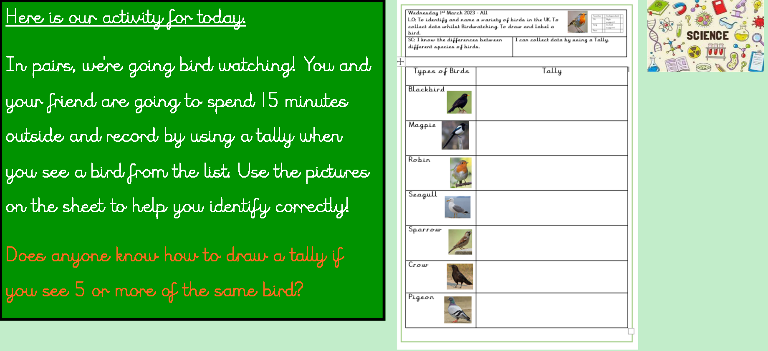  Plenary:  Create a bar graph as a class and stick in their books.  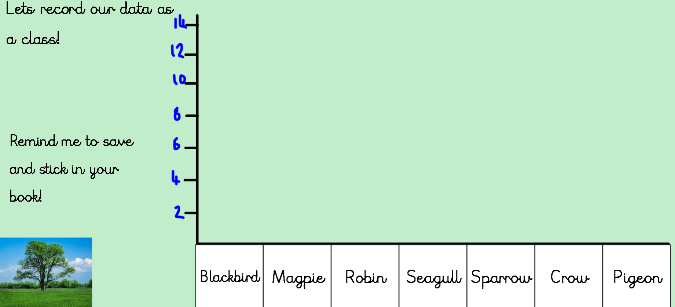 | Lesson 3- Researching Bird Feeders  Foundational Skills:  Using technology – used when researching bird feeders on laptops or iPads  Asking research questions – used when children generate questions to investigate  Understanding bird needs – used when creating a list of what birds eat  Recording information – used when writing findings on paper during research  Learning Objective: To identify and name a variety of birds in the UK. To know what a bird feeder is. To research how to make a bird feeder.  Success Criteria: I know the differences between different species of birds. I can use an Ipad/laptop to research how to make a bird feeder. I can say what birds like to eat and create a whole class shopping list.  Recap and Recall: Ask: What is science? What did we learn last term in science?  TTYP: Can you remember any of the birds we saw last week?  Starter: Watch and discuss video showing the most common of wild birds in the UK.  Explain that today we are going to think of ideas to bring more birds into the school grounds.  How do we encourage birds into the playground? Share and discuss ideas. Record on notebook.  Main:  Explain to the children that today we will be using laptops to conduct our own research about bird feeders and how the encourage birds to our outside area. We are going to research why bird feeders are useful for our school grounds and what we need to make one.  In pairs, log on to the laptops and use Google to research. One of you will type, the other will write on the paper what we have learnt.  Before we start researching, lets think of questions to type in...  Teacher to write children’s questions on notebook.  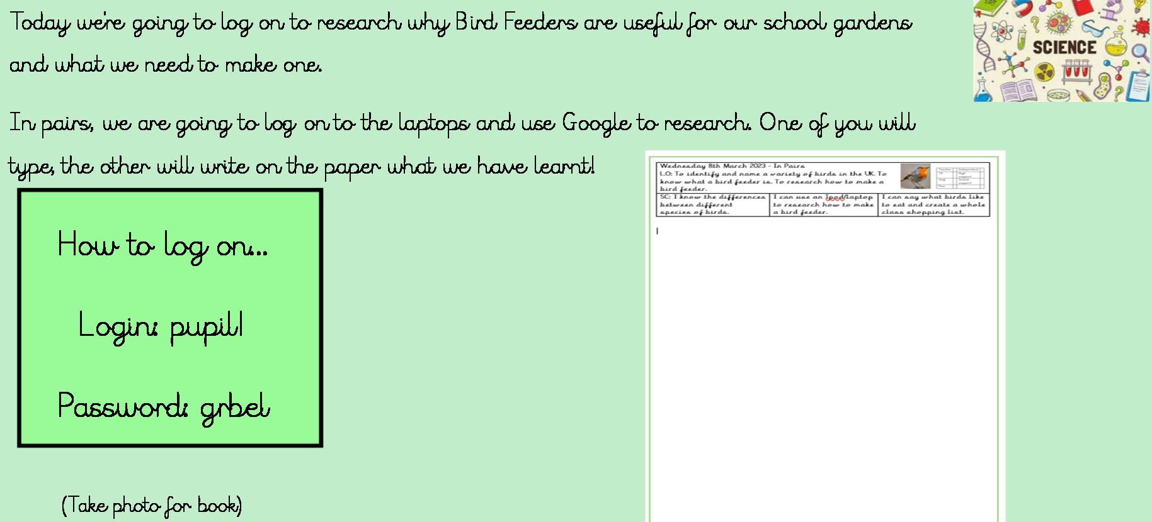  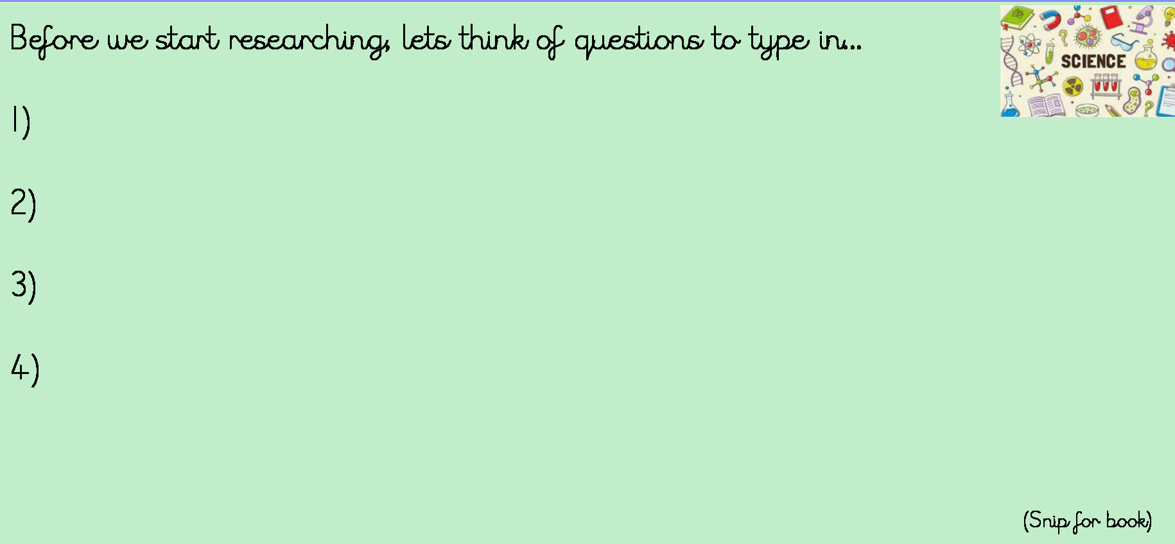  Plenary: Bring the children back together and discuss our findings. Create a shopping list for next week’s lesson.  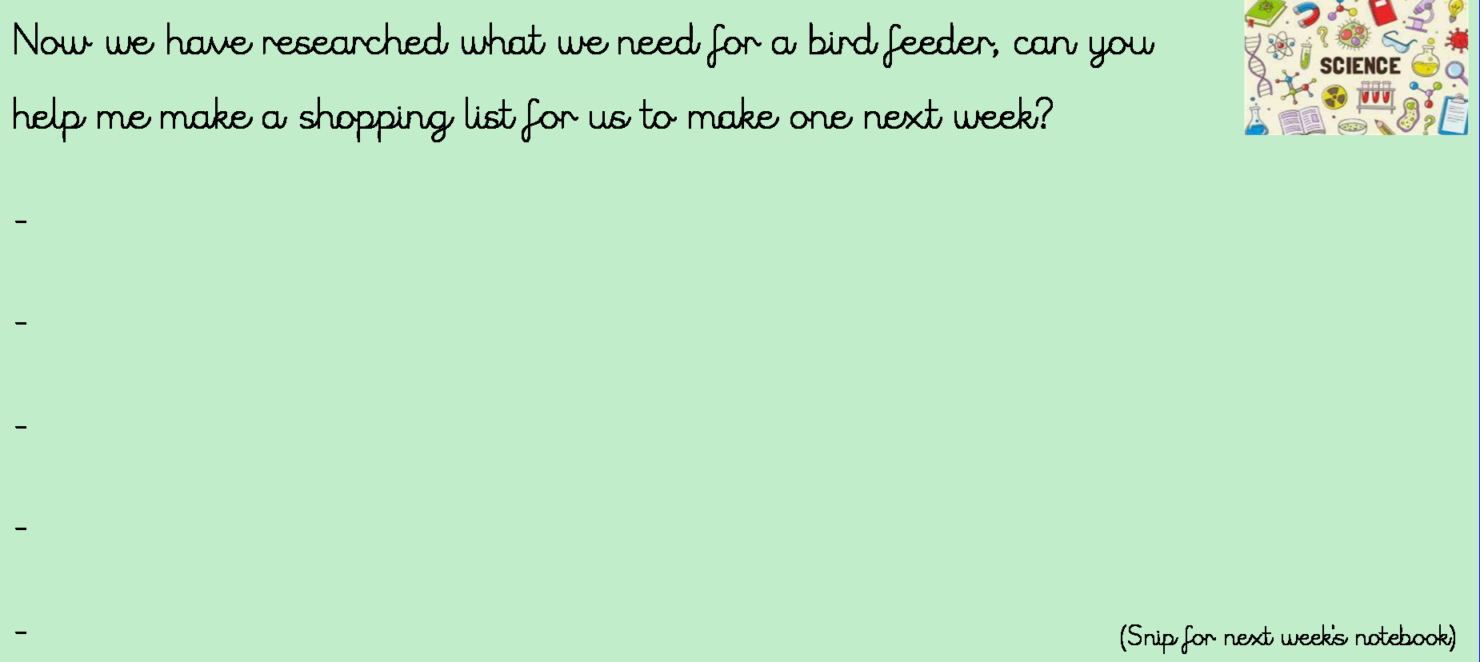
 | Lesson 4 – Making Bird Feeders  Extended Writing Opportunity-  Children to write a set of instructions how to make a bird feeder.  Foundational Skills:  Following instructions – used when following the steps to make a bird feeder  Using previous learning – used when applying last week’s research to the task  Fine motor skills – used during construction of the bird feeder  Evaluating – used when verbally evaluating the finished feeder with a partner  Learning Objective: To use previous research to make a bird feeder.  Success Criteria:  I know the differences between different species of birds. I can use my research and follow instructions to make a bird feeder. I can place the bird feeder outside to encourage more birds into the school grounds.  Recap and Recall:  Ask: What is science? What did we learn last term in science?  Discuss previous learning and last week’s research on the laptops. Ask: What did we learn last week? Record children’s previous learning and add QR code.  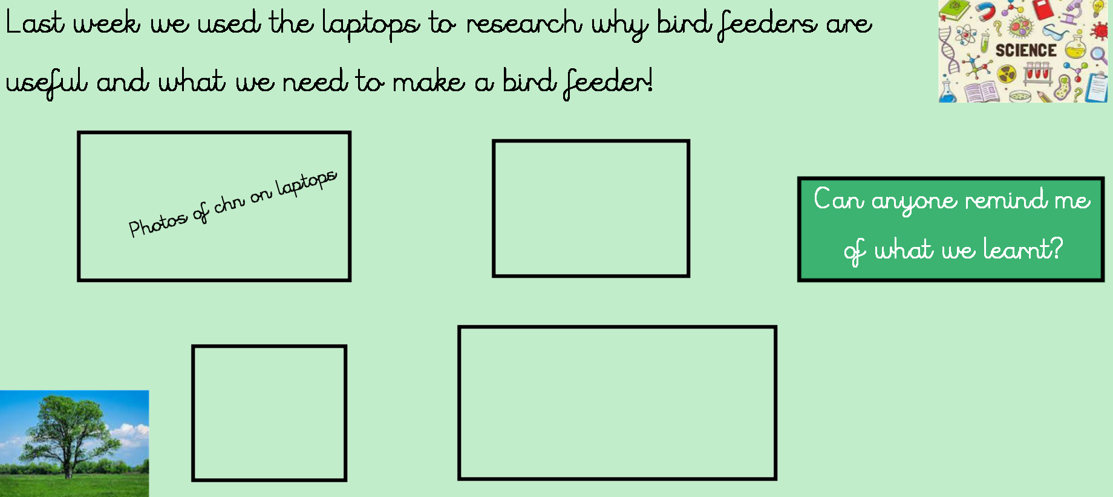  Starter:  Watch video to give children some ideas how to make a bird feeder.  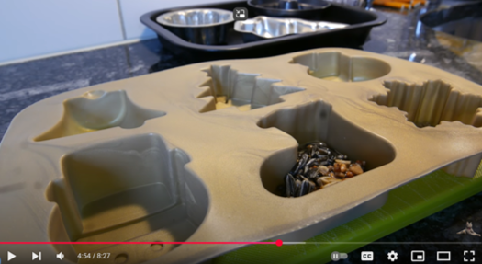  Main:  In small groups create bird feeder and then hang on the trees outside.  Plenary:  Children take a photo of their bird feeder for Seesaw. Children to verbally evaluate their bird feeder to their friend.  Children to then write a set of instructions how to make a bird feeder. | Lesson 5- Mothers’ Day  Foundational Skills:  Understanding plant needs – used when discussing what plants need to grow  Using tools safely – used when planting a bulb using gardening equipment  Sequencing steps – used when following the video instructions to plant the bulb  Communicating understanding – used when explaining what bulbs need to grow  Learning Objective: To plant a bulb and to understand what plants need to grow well.  Success Criteria:  I can say what plants need to grow to be healthy. I can use gardening tools to plant a bulb. I can say what a bulb is.  Recap and Recall:  TTYP: What is Mother's Day?  Explain to the children that a mummy figure can be another family member or a grown-up friend. Not everybody has a mummy and that is ok. Also, not everyone celebrates Mother's Day, if that is you, you will be making a gift to send love to all your family.  Starter:  Explain that Mother’s Day is a time when children pay respect to their mothers and children often give a card and a gift to their mothers. Explain that Mother’s Day is always on a Sunday and it is also known as Mothering Sunday. In Britain, it is celebrated on the fourth Sunday of Lent.  Tell the children that no-one is certain exactly how the idea of Mothering Sunday began. However, it is known that on this day, about four hundred years ago, people made a point of visiting their nearest big church. (Their mother church).  Young British girls and boys ‘in service’ were only allowed to visit their families on this day.  Discuss how spring flowers and other gifts are often given. In other parts of the world.  Main:  Explain that today we are going to be planting a lily bulb for our special grown up.  Watch:  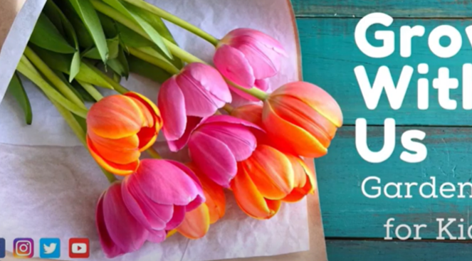  Plenary: Children to plant lily bulb following the steps on the video.  Take photos for Seesaw. Video children saying what bulbs need to grow. Add QR code to books. | Lesson 6- Leaves  Foundational Skills:  Asking simple questions – used with the ‘question wristband’ activity outdoors  Observing closely – used when exploring and comparing leaves  Recording findings – used when creating leaf rubbings and writing a fact  Classifying – used when discussing similarities and differences in leaves  Learning Objective: To identify and name a variety of common wild and garden plants, and deciduous and evergreen trees. To identify and describe the basic structure of a variety of common flowering plants, including trees.  Success Criteria:  I can ask simple questions and recognise that they can be answered in different ways.  Recap and Recall:  Ask: What is science? What did we learn last term in science?  Recap previous learning using the KWL grid/ pictures of bird feeders.  Watch Coniferous and Deciduous Trees video and discuss the differences. 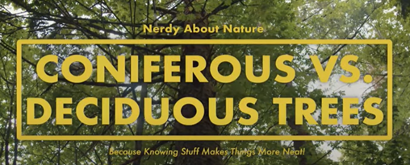  Starter:  Explain to the children that we going to be focusing on identifying and asking key questions about plants and leaves!  First we're going to create a 'Question Wristband' which we will be using for todays  learning.  Ask children to colour each question starter in a different colour, then cut it out.  Then with a friend stick on the strip of paper and glue the two ends together to make a wrist band.  Look at some pictures of some different leaves.  (Silver birch, holly, sycamore and ash)  Ask: How are they the same/different?  Children to put their question wrist band on and to go outside and gather as many leaves as possible in 1 minute. Remind the children is to answer the question on their wristband with their partner.  Give examples of question to ask:  What colour is your leaf?  Where did you find it?  Which plant did it come from?  How far did it fall from the tree?  Why does it have a hole in it?  Red group to discuss as a group. Record on Seesaw add QR code to sheet.  Main:  Use leaves and wax crayons to create leaf rubbings. Then ask the children to write a fact next to it.  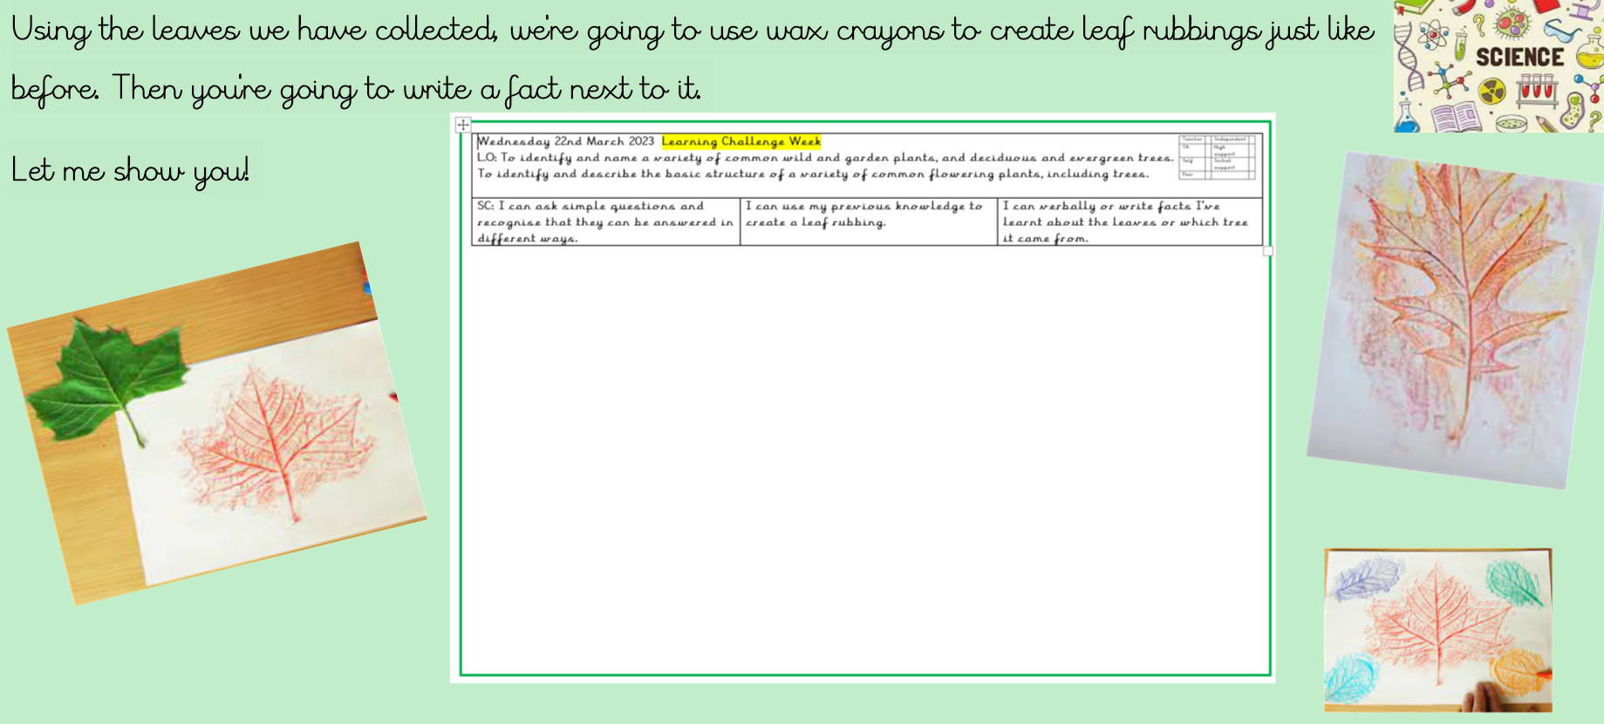  Plenary: Bring children back together to share learning. Record findings for Seesaw.
 | Lesson 7- Animal Groups  Foundational Skills:  Identifying and naming – used when sorting animals into groups  Classifying – used when grouping animals by characteristics and diet  Comparing – used when explaining differences between animal groups  Communicating ideas – used when explaining findings verbally or in writing  Learning Objective:  To identify and name a variety of common animals including fish, amphibians, reptiles, birds and mammals.  To identify and name a variety of common animals that are carnivores, herbivores and omnivores. To Identify and classify.  Success Criteria: I can name the different animal groups. I can sort the animals in the correct groups. I can say why and how the animals are different.  Recap and Recall:  Ask: What is science? What did we learn last term in science?  Recap of this half terms learning. Look at photos of work done. TTYP: What have we learnt?  Sing the tree song:  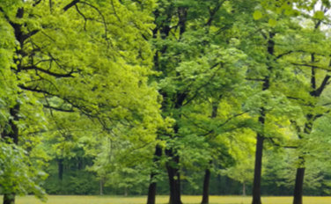  Starter:  Explain to the children that today we are going to explore animal groups. Ask: Do you know any animal groups?  Watch and listen to the animal classes song:  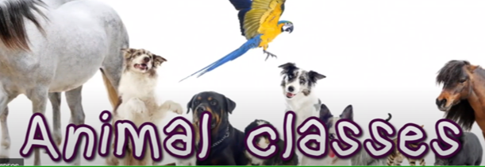  Read through and discuss the ‘Variations in Animal Group’ PowerPoint. Put different animals around the classroom. Give the children 2 minutes to put them in the correct animal group.  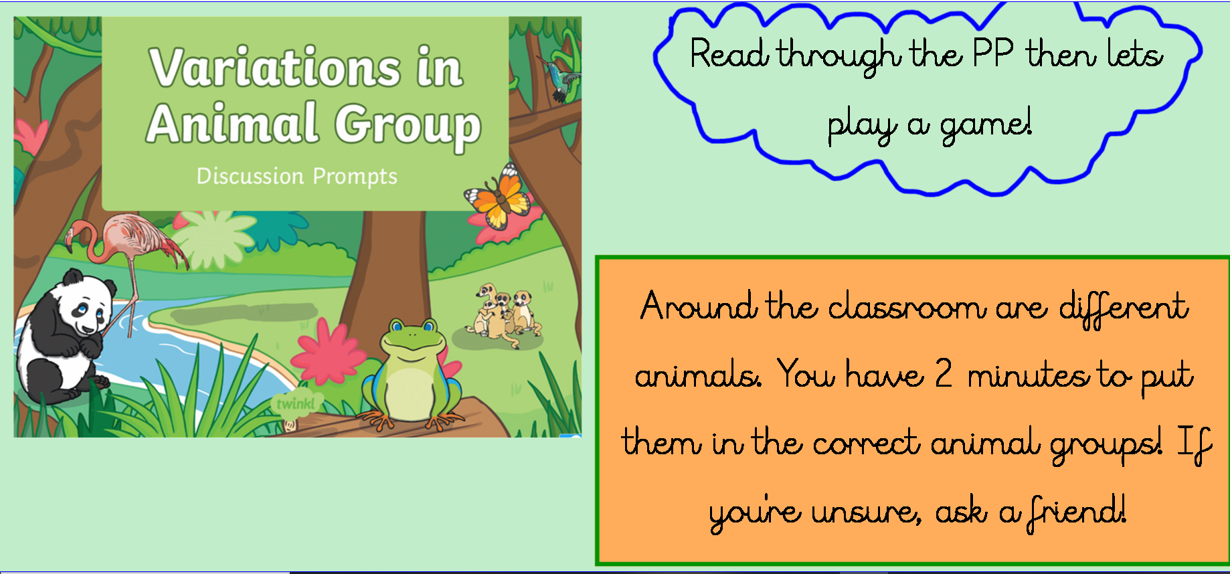  Main:  Ask the children to cut out the pictures and stick them in the correct animal group then write a sentence in the green box.  (Differentiated sheets)  Blue and Green Group to label pictures then write a sentence to explain the differences.  Yellow Group to write a sentence to explain what they have found out.  Red Group- To verbally say what they have found. Record on Seesaw and add QR code to sheet.  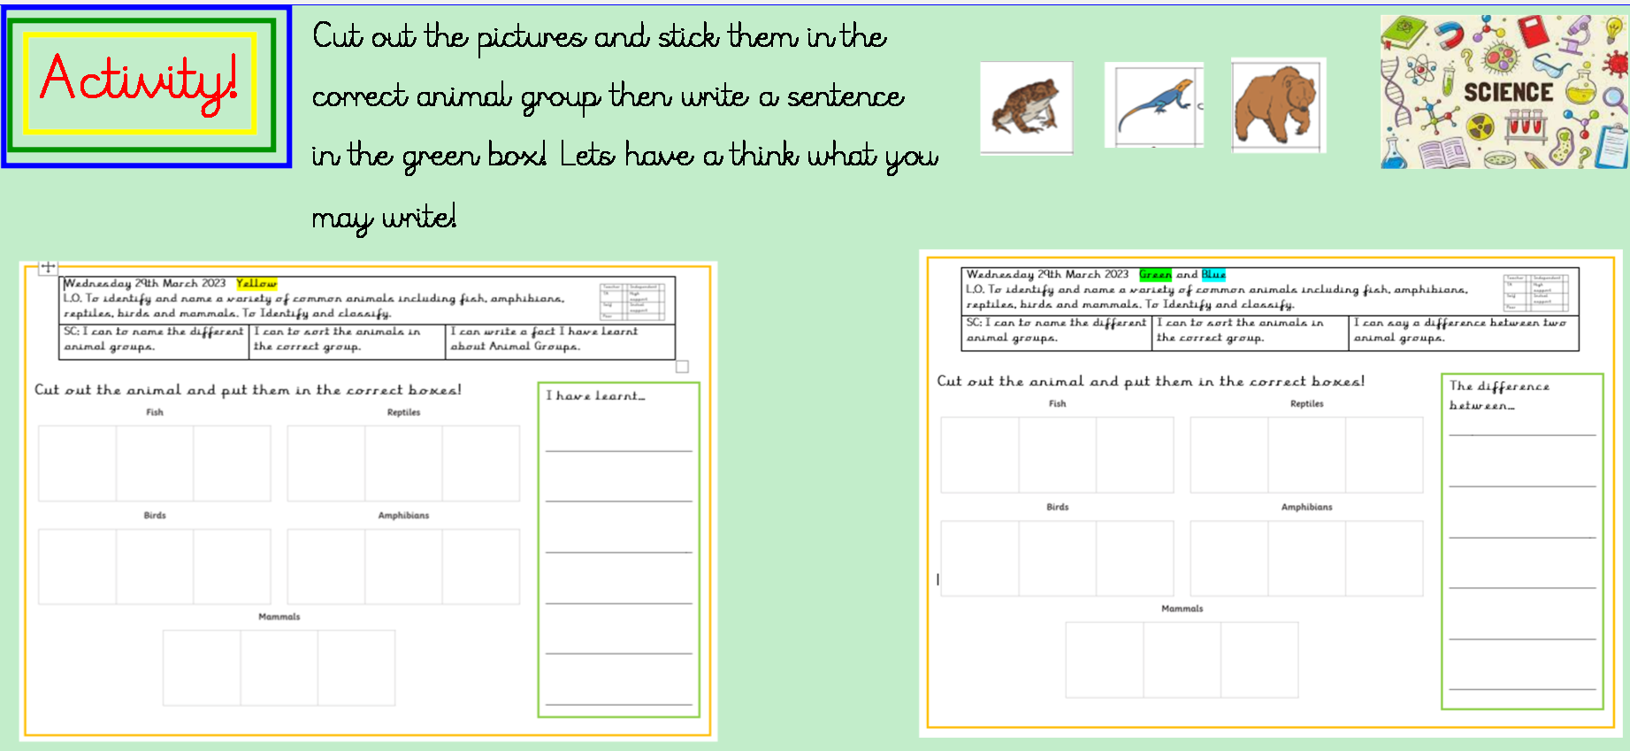  Plenary:  Children to share what they have found out and discuss. | Lesson 8- Science Week- Litter Pickering  Foundational Skills:  Understanding environmental impact – used when discussing why we pick up litter  Keeping safe – used when following safety rules with jackets and litter pickers  Observing environment – used when noticing the types of rubbish found  Reflecting – used when discussing what was found and what could be recycled  Learning Objective:  To understand and explain why it is good for the environment when we litter pick.  Success Criteria: I can explain how we can help our environment. I can litter pick around School. I am safe when I litter pick.  Recap and Recall:  Explain that we are going to go litter picking, but before we go we need to understand why we need to do it.  TTYP: Why do people pick up litter?  Starter:  Tell the children that we litter pick to help the environment, and make sure the area around us is safe for other people and animals.  Every year, an estimated 8 million tonnes of litter enters the world’s oceans. Plastic poses the biggest threat to marine wildlife as it doesn’t just disappear; it simply breaks down into smaller and smaller pieces, and has detrimental effects on food chains, working its way up from the tiniest plankton into the bodies of sharks, whales and dolphins.  But it’s not just our marine life at risk from litter. Mammals like hedgehogs and birds like swans frequently suffer injuries as a result of getting caught up in waste.  Watch the video- explaing what plasics do to our oceans.    Read ‘The Messy Magpie’ to the children.  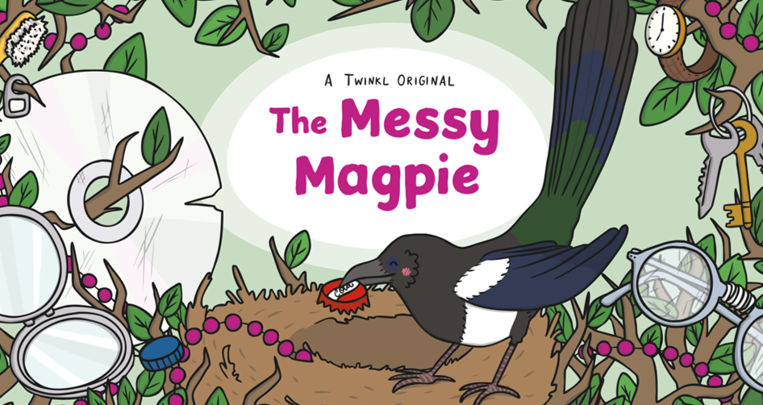  Talk through the dos and don’t of litter picking:  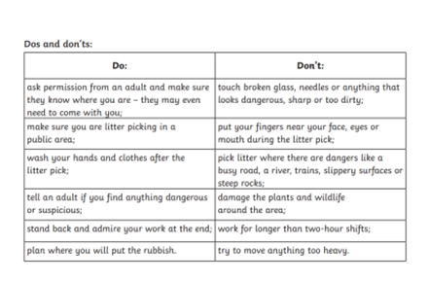  Main: Put coats and high vis jackets on. Give children and binbags and litter gripers. Go outside to litter pick.  Come back in and all wash hands.  Plenary:  What rubbish did we find?  What was the strangest piece of rubbish?  What rubbish could be recycled? | Lesson 9- Science Week- Music Makers  Foundational Skills:  Understanding environmental impact – used when discussing why we pick up litter  Keeping safe – used when following safety rules with jackets and litter pickers  Observing environment – used when noticing the types of rubbish found  Reflecting – used when discussing what was found and what could be recycled  Learning Objective:  To understand that different sized containers with different amounts of water in can create different sounds.  Success Criteria: I can experiment with different containers and amounts of water to make different sounds.  Recap and Recall:  Watch video to explain how glass bottles can be used to make music.  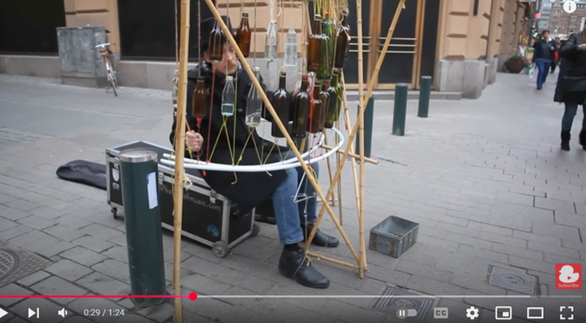  Using just glass bottles to begin with. Have a look at all the different bottles we have collected. Try tapping them genitally with a metal spoon or a wooden spoon. Ask- what do you notice?  Now add some different amounts water to the bottles. Ask- What happens?  Line them up with the bottle with the most water in at the start, going down to the bottle  with the least in at the end. Ask- What do you notice? Can you make a tune?  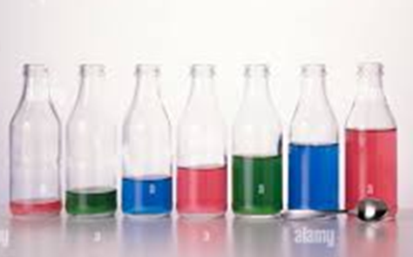  Try using other containers made from different materials (E.g. plastic bottles). Ask- What do you notice?  Watch video:    Plenary:  Discuss what we have found out this lesson.
Lesson 10- Playground Games
Foundational Skills:
Understanding inclusion – used when thinking of adaptations for disabilities
Problem-solving – used when modifying games for fairness
Teamwork – used when creating new inclusive games in groups
Communicating ideas – used when explaining new game designs to others

Learning Objective: To think of ways that children with disabilities could be included in playground games.

Success Criteria:
I can think of ways to include children with disabilities in games.

Recap and Recall:
Recap- What have we learnt in science week?

Starter:
Watch the video and discuss with the children the variety
of disabilities they can see and how they are being
overcome.


Main:
Play throwing the beanbag in the hoop. Ask the children, if someone in a wheelchair was taking part in this game would it be fair? What could we do to make it fair?

Allow the children a chance to play the game sitting in a chair. Then repeat the game but this time using a low visual simulator for some children. Ask them, is this fair? How could we make it fair?
Allow the children a chance to play the game with everybody blindfolded.
Give the children a variety of different playground equipment and put them in groups of three. Explain to them they need to invent a new game that includes somebody who cannot see. Repeat for someone in a wheelchair.
Plenary:
Give the children time to explain their different game ideas to one another. If time let the children have ago at each other’s games.
Record ideas on Seesaw.

