Geography
Religious Education – Why Should we Care for the World?
Vocabulary

Year 1 Spring 2 -The Journey

By the end of this unit children will know...

Some people believe that humans have a special relationship with God.
Creation stories provide people with possible answers as to why we are here.
Followers often read religious stories.
Some religious and non-religious stories may guide people to care for animals and the planet.
Religious teachings often encourage gratitude for what God created (e.g. others and the planet) and a responsibility to look after it.
The way people treat animals and nature reflects their worldview.
People with similar worldviews often work together to care for the world and for others.

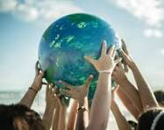

Ahimsa, Belief, Brahman, care, Christian, Christian Bible, creation, creator, God, Hindu, Humanist, Jewish, religion, responsibility, stewardship, scripture, Torah, worldview,

A Journey Topic Intention
Intention

Children will build on their understanding of creation stories; children explore beliefs about the relationship between humans and nature. 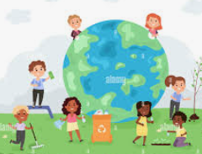

In Reception the children talked about looking after nature. They looked at minibeasts and their habitats and discussed how important it is not to disturb their habitats. The children planted spring bulbs and took care of them. They discussed how plants need watering regularly and need sunlight. The children regularly go on litter picks and talk about how important it is to keep our environment clean and tidy. The children also discussed how we can recycle our rubbish. In Wellbeing lessons the children have discussed how to be kind and how to be a good friend.

Why Should we Care for the World? - Previous Learning

Learning Links

Children will enhance their knowledge of why we should care for the world. They will look at how different world views believe the world should be cared for. They will discuss stewardship, drawing on their experiences from the discussions in reception. They will deepen their understanding that some people believe they have a special relationship with God and that creation stories offer possible answers to why we are here. They will look at how different worldviews believe the world was created and how they take responsibility to look after it. They will discuss the way people treat animals and nature. They will also recognise that people with similar worldviews often work together to care for the world and for others.

R.E- Why should we Care for the World?
This unit builds on the children’s understanding of creation stories. Children explore beliefs about the relationship between humans and nature.
Key Objective:  To understand the importance of everyone caring for the world. | Lesson 1- Who might own the world?  Foundational Skills:  Communication and Language – Children listen, discuss creation stories and answer questions  PSED – Children share ideas respectfully and think about caring for things that are not theirs  Literacy – Children look at the knowledge organiser, write ideas, and record key words  Understanding the World – Children explore beliefs about creation and who might own the world  Learning Objective:  To explore who might own the world through a creation story.  Success Criteria: I can identify that some people believe that the world is a gift.  I can recognise from creation stories who some people believe created the world.  I can express my understanding of who these creation stories suggest owns the world.  Recap and Recall:  Discuss:  Some people believe that God exists.  Some people believe God created the world.  Creation stories explain how the world began.  Read through and ask children to share the keyword on the presentation :What is the keyword? (Kapow)  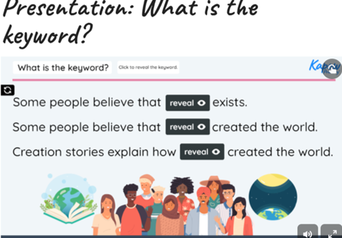  Starter:  Look at the Knowledge Organiser with your friend what can you see? What do you think it means?  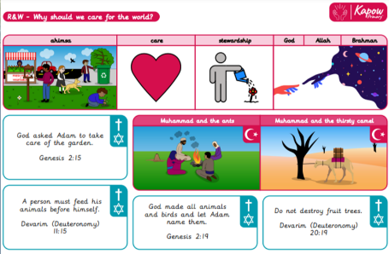  Write down your ideas:  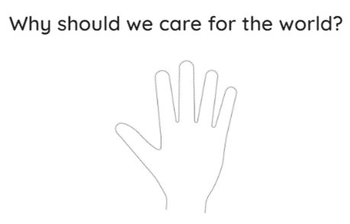  Main:  Discuss:  What is your favourite thing you own and who gave it to you?  If it was a gift, does that mean you care for it less or more? (Various answers may include: If it is a gift, you should care for it more because someone gave it to you with love; to show you are grateful; to keep it nice.)  If a friend lends you a toy, should you look after it even though you do not own it? (Various answers may include: yes because; our friend trusts us with their toy and we do not want to break it; it is kind and respectful to take care of things that belong to others; so that it lasts longer and other children can play with it again.)  Why is it important to care for the things you do not own in your home or classroom? (Various answers may include: so that they last longer; because it shows we care for our things; to keep our home and classroom tidy; so that everyone can use and enjoy them; to make sure we do not lose anything important; so that other children can also use them in the future.)  Discuss how to treat a gift and drag and drop the words to describe this around the gift.  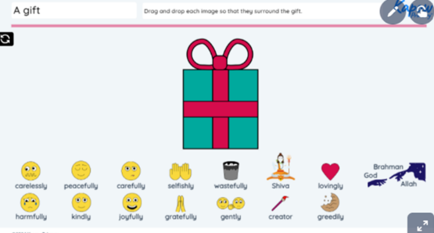  What do many Hindus call God when he creates? (Brahma.)  What were the similarities between the Hindu creation story and the Christian and Jewish creation story? (Answers may include: God is the creator; there was nothing in the beginning; it has a similar order of creation.)  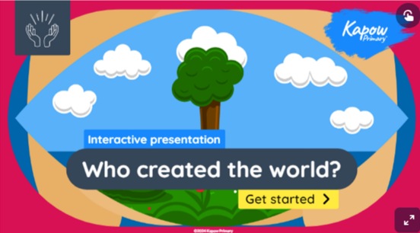  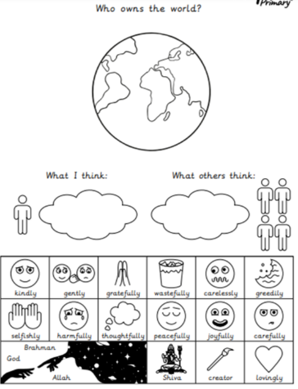  Ask them to draw or write their ideas in the bubbles that help them to answer:  What I think: Who owns the world?  What other people might think: Who owns the world?  Ask the children to use the word bank to write some words around the world in a different colour to describe how some people might treat the world if they believe it is a gift from God.  Plenary:  Discuss: Why should we care for the world? (Children may suggest: some people believe God created the world as a gift so we should care for it so that other people can enjoy it; to show we are thankful to God; so that it lasts longer; because it is wonderful; so that we can show that we appreciate it.)  Display the Presentation: Why should we care for the world? and hand out the Activity: Hand outline used in the Attention grabber.  Invite the children to add a further idea to answer the question by writing or drawing on one of the fingers on the hand.  Keep the children’s copies of the Activity: Hand outline to use in the Wrapping up of subsequent lessons in the unit. | Lesson 2 – Is the world a gift?  Foundational Skills:  Communication and Language – Children discuss why some believe humans were created last and answer questions  PSED – Children reflect on responsibilities humans may have and compare human/animal qualities  Literacy – Children use the presentation and record ideas on Seesaw  Understanding the World – Children explore creation stories and differences between humans and animals  Learning Objective:  To investigate why some people believe God created humans last in the creation story.  Success Criteria:  I can identify differences between animal and human qualities.  I can give reasons why humans might have been created last.  I can express my own thoughts on humans’ role in looking after the world.  Recap and Recall:  Discuss:  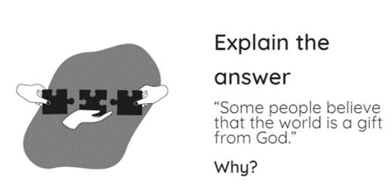  Record children’s ideas on Seesaw.  Starter:  Ask the children:  What do some people believe God created last? (Humans or people)  Why do you think God may have created humans last? (Various answers might include: God wanted to get everything ready for humans so that they had a home; so that humans could care for everything in the world; so that humans could learn from other creatures.)  Look at the Kapow presentation- Creation Story  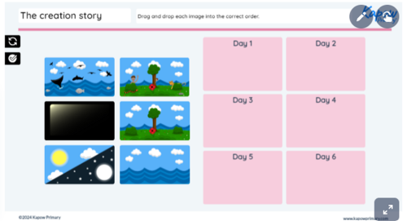  Main:  Watch the video:   https://www.kapowprimary.com/subjects/religion-and-worldviews/religion-and-worldviews-key-stage-1/year-1/why-should-we-care-for-the-world/lesson-2-who-can-care-for-the-world/  What can humans do that animals cannot? (Various answers include: talking in sentences, making things, thinking about right and wrong, helping others and asking questions.)  Who can care for the world? (Humans.)  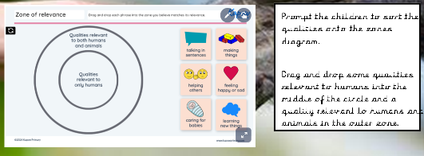  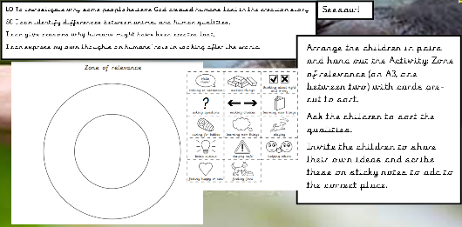  Plenary:  What makes humans unique?  Why could another type of animal not care for the world instead of humans?  What do humans have that animals do not?  Are there any qualities that both animals and humans have?  Do you think there is a reason God made humans (when he already made animals)?  Who might some people believe should care for the world?  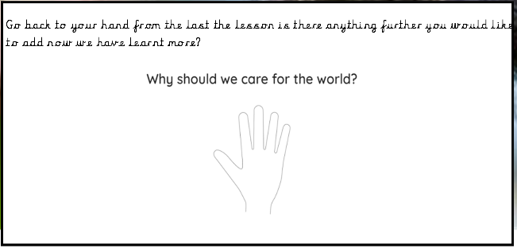 |  | Lesson 3 – Stewardship  Foundational Skills:  Communication and Language – Children discuss quotes and share sorting decisions about creatures  PSED – Children think about kindness, responsibility, and how to treat living things  Literacy – Children read quotes and draw examples linked to the text  Understanding the World – Children learn what stewardship means and apply it to caring for creation  Learning Objective:  To understand the meaning of stewardship through exploring quotes.  Success Criteria: I can explain what stewardship means.  I can discuss the difference between ownership and stewardship.  I can express my own thoughts about looking after the world.  Recap and Recall:  Discuss:  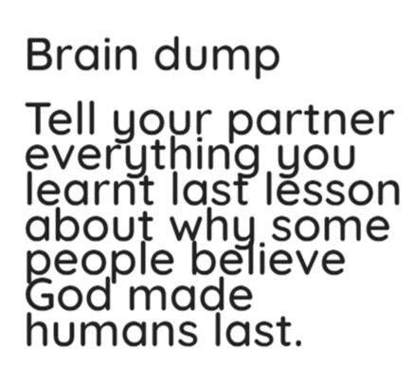  Starter:  Ask the children to look at the living creatures in the pictures and sort them in any way they wish based on the living creatures we should care for.  Invite pairs to share how they have sorted the living creatures and ask:  Should we look after living creatures even if they can hurt us?  Which living creature do you think we should look after the most? Why?  Is it important to look after all living creatures? Why? (Various answers may include: yes, because living creatures have feelings; we want them to be happy; we need to be kind to them; because God created them as a gift so we should show our thanks and love.)  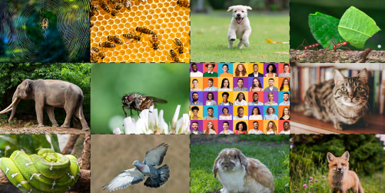  Main:  Read the top two quotes-  Explain that just like they care for their toys or pets, Adam had a role to do.  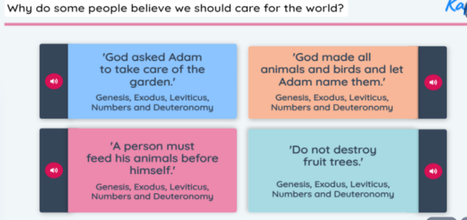  Introduce the word stewardship, which means taking care of something thoughtfully and responsibly. Compare this to people looking after pets even though they did not create them.  What do these quotes tell us about our role in taking care of the world? (Children may suggest: the quotes tell us that we should be kind to the world and the animals; we need to look after them.)  If a stray cat started to live in the school playground, what should we do? (Various suggestions include: we should tell an adult about the stray cat so they can help us decide what to do; we should look after the cat  because it might be hungry and scared; we could give it some food and water; we should give it somewhere to sleep; we should be kind to the cat and not scare it away.)  Quote carousel - Pic Collage for SeeSaw  Hand out the Resource: Quotes (one quote per table group) and a large sheet of sugar paper (one between two).  Read the quote to each table group then give the children five minutes to work in pairs to draw an example of the  quote in the first box.  Swap the quotes around so each table has a different one and repeat the drawing activity in the following box.  Repeat until each table has drawn an example of each quote.  Ask each table to swap their large sheets of sugar paper with another pair to see if they can spot any drawings  which match each of the quotes on the presentation.  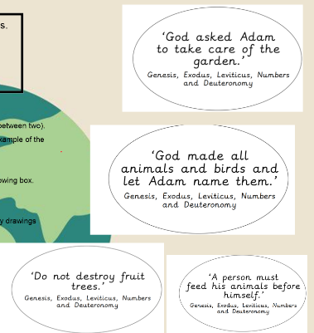  Extension-  Blue and Green Group answer in a sentence  Who should care for the world and why?  Record Red and Yellow group answering question verbally. Add QR code to book.  Plenary:  Why should we care for the world? (Children may suggest: some people believe God asked them to care for the world.)  Display the Presentation: Why should we care for the world? and hand out the children’s copies of the Activity: Hand outline.  Invite the children to add further ideas to the answer on one of the fingers.  Keep the children’s copies of the Activity: Hand outline to use in the Wrapping up of each lesson.
 | Lesson 4- What do some Muslim people believe about caring for the world  Foundational Skills:  Communication and Language – Children discuss stewardship and respond to questions about Muhammad’s stories  PSED – Children consider kindness to all creatures and reflect on their own actions  Literacy – Children match stories, colour-code information, and work with story titles  Understanding the World – Children learn Muslim beliefs, stories of Muhammad, and examples of stewardship  Learning Objective: To investigate what some Muslims believe about caring for the world by exploring stories from Muhammad.  Success Criteria:  I know that Muhammad is a very special person for Muslim people.  I can recognise examples of stewardship in some stories from Muhammad.  I can suggest why some people may want to follow Muhammad’s example and be good stewards.  Recap and Recall:  Display the Presentation: Why do some people believe we should care for the world? and hand out the drawings from Lesson 3 (cut up, one set between two).  Read each quote and ask the children to work in pairs to hold up the drawing they think best matches.  Starter:  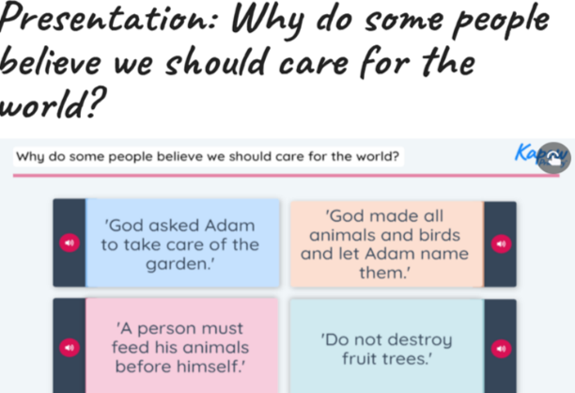  Display the Presentation: Stewardship.  Discuss: What does stewardship mean?  What are some of the ways of showing it?  Drop and drag the pictures to show stewardship.  Main:  Recap that people who follow the Muslim worldview generally believe in one God  (Allah in Arabic) and are guided by the Qu’ran (Muslim scripture).  Stories from Muhammad  Explain to the children that they will listen to two stories. The first is about a man named Muhammad, who is a very important person to many Muslims. In the second story, Muhammad tells a story about another man who was also a prophet.  Watch:  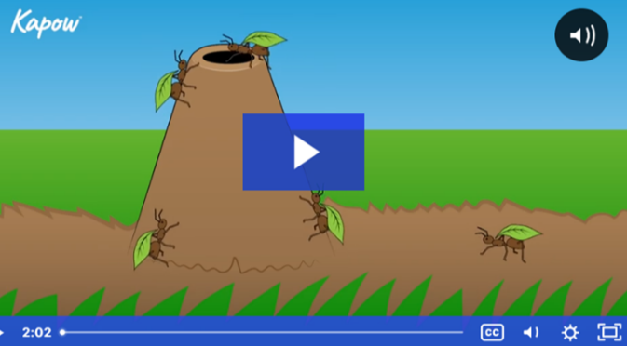  What might Muhammad say people should do to care for the animals and plants around us? (The children may suggest: give them water, do not hurt them and plant more trees and flowers.)  Why is it important to be kind to even the smallest creatures, like ants? (Answers include: because they are living things too; they are part of nature and important; so they do not get hurt.)  How did Muhammad show an example of stewardship? (Answers include: by being kind to a thirsty camel; ensuring the camel was given water; caring for and protecting all living creatures, no matter how small; telling the story of the ants to show how important it is to be kind to all animals.)  Can you think of a time when you showed stewardship?  Hand out the Activity: Showing stewardship and two different coloured pencils to each pair.  Ask the children to discuss which stories match which picture in pairs. They should then colour in the story titles using the two  different colouring pencils and then circle the pictures that match each story with the corresponding colour.  Then, ask the children to match the quotes (from Christian and Jewish scripture in the previous lesson) to the stories with the corresponding colour.  How might some Muslim beliefs about caring for the  world be similar to what people who follow other  worldviews believe?  Plenary:  Ask the children:  Why should we care for the world? (The children may suggest: some people might want to show stewardship by caring for all living creatures, like Muhammad did.)  Display the Presentation: Why should we care for the world? and hand out the children’s copies of the Activity Hand outline.  Invite the children to add further ideas to the answer on one of the fingers.  Keep the children’s copies of the Activity: Hand outline to use in the Wrapping up of each lesson. | Lesson 5- What other reasons are there for caring for the world?  Foundational Skills:  Communication and Language – Children discuss Hindu beliefs and answer questions about the salt-and-water demonstration  PSED – Children explore kindness, not hurting creatures, and empathy through ahimsa  Literacy – Children read examples of ahimsa and write sentences according to group level  Understanding the World – Children learn about Brahman, living things, and Hindu beliefs about care  Learning Objective:  To recognise why some people believe it is important to care for the world by exploring ahimsa.  Success Criteria:  I can explain what ‘ahimsa’ means.  I can recognise examples of caring for the world which reflects ahimsa.  I can discuss why some people believe looking after all living creatures is important.  Recap and Recall:  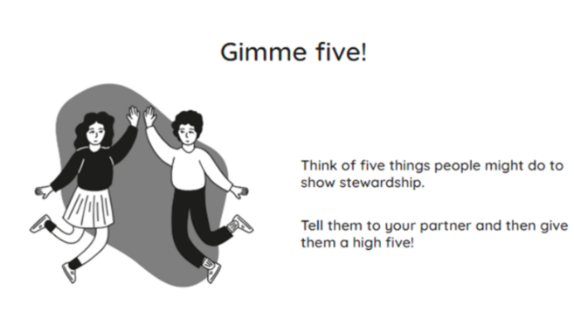  Starter:  Remind the children that people who follow the Hindu worldview generally believe in one God (Brahman) who can take on many forms and created the world and everything in it in the form of Brahma, the Creator.  According to some Hindus, God did not only create the world as Brahma but is also a part of it and exists in all living things.  Show the transparent bowl containing water (warm if possible). Slowly add some salt to the water, stirring it with the spoon.  Ask- What happens to the salt? Does it stay in one place? Can you see it? How do we know it is still there?  Explain that this idea symbolises the Hindu belief that there is a God whom some call Brahman and the essence and power of Brahman is in every living creature. People from different worldviews may also believe that there is a special power in all living creatures and do not always call this Brahman.  Why might people who believe there is a special power, spirit or essence in all living creatures want to take care of them? (Answers include: they think that every creature is important and special; they feel that taking care of every living thing is like taking care of that special power.)  Compare this belief to the salt in the water – even though you cannot see this special thing inside every living creature, it is there.  Main:  Share the definition:  Ahimsa- Being kind and not hurting any living creatures.  Read and discuss the Ahimsa in action presentation.  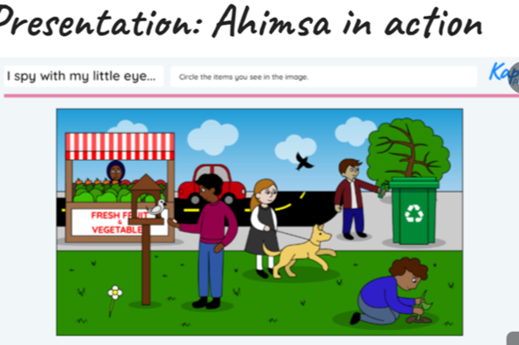  Then circle examples of ahimsa on sheet.  Discuss- How are these ideas similar to caring for the world?  Extension-  Blue Group– Write 3 sentences how to care for the world.  Green Group- Write 2 sentences how to care for the world.  Yellow Group- Write 1 sentence how to care for the world.  Red Group- Write 1 sentence how to care for the world (supported.)  Plenary:  Ask the children:  Why should we care for the world? (The children may suggest: because there is something special in all living creatures; it is important to care for them and avoid hurting anything.)  Display the Presentation: Why should we care for the world? and hand out the children’s copies of the Activity Hand outline.  Invite the children to add further ideas to the answer on one of the fingers.  Keep the children’s copies of the Activity: Hand outline to use in the Wrapping up of each lesson.  Lesson 7- The Easter Story  Extended Writing Opportunity:  Children to re-tell the Easter Story  Foundational Skills:  Communication and Language – Children listen attentively, respond to what they hear with relevant comments, questions and actions, and engage in back-and-forth conversations.  Children participate in small group discussions, offer explanations and express their ideas using full sentences.  Literacy – Children demonstrate understanding of what has been read to them by retelling stories and narratives using their own words and recently introduced vocabulary.  Children write recognisable letters and simple phrases or sentences that can be read by others.  Recap and Recall:  Display the Presentation: Easter pairs. Ask the children to discuss which pictures match.  Take feedback and click to reveal the answers.  How do the pictures connect to the Easter story? (Answers may include: lambs are a sign of new life; bulbs grow into flowers in spring showing new life; the cross is a reminder that Jesus died and the empty tomb shows he came back to life on Easter Sunday.)  Starter:  Explain that Easter is a Christian festival celebrating the life, death and coming back to life of Jesus.  Ask the children to discuss in pairs:  - What do some Christians believe about Jesus? (Answers include: baby Jesus was God’s son and God on Earth; as an adult, Jesus shared God’s love and teaching; Jesus had the special power to do miracles).  Display the Presentation: The Easter story and tell the story on slides 1 to 8.  Remind the children that this is a story from the Christian Bible (scripture believed by many Christians to be the word of God). Many Christians believe it happened but not everyone believes it is a true story.  Ask the children to discuss in pairs:  Why did people wave palms on Palm Sunday? (The children may suggest: they were happy to see Jesus; they thought he was a king; they wanted to welcome him into the city; they were showing love for him.)  What was important about the Last Supper? (The children may suggest: Jesus shared bread and wine with his friends; he told them to remember him.)  Why do many Christians think Good Friday is important, even though it is sad? (The children may suggest: it is when Jesus died on the cross to help people; Christians believe he took away all the bad things in the world.)  What happened on Easter Sunday that made Jesus’ friends happy? (The children may suggest: Jesus came back to life; the angel told them he had risen; it showed them God’s promise of new life.)  Main:  Display slide 9 of the Presentation: The Easter story.  Ask the children to work in pairs to suggest how to arrange the story in the correct order. Take feedback, dragging and dropping the events into the correct order.  - What do you think is the most important part of the Easter story? Why? (The children may suggest: when Jesus comes back to life because it makes people happy; when Jesus shared the meal to show he loves his friends.)  What does the Easter story tell some Christians about Jesus? (Answers include: Jesus died to help people; Jesus came back to life; Jesus forgives people and brings new life and hope.)  Either: Allocate each table group with one of the key events of the Easter story (Palm Sunday, The Last Supper, Good Friday or Easter Sunday).  Hand out the materials (see Lesson organisation in Teacher knowledge) and ask the children to work in pairs to create an Easter garden. The children can use natural materials and craft items to create their scenes.  Alternatively: Hand out the Activity: Easter story scenes and A3 white paper or colourful sugar paper (one between two). Ask the children to cut and stick the pictures onto backgrounds to create an Easter scene.  Keep slide 9 of the presentation on the board for children to refer to.  Invite each group to display their scenes in the correct order of events in the story.  Display slide 9 and invite volunteers to use the pictures and words to help retell each part of the story.  In pairs, ask the children to discuss the following questions:  Which part of the Easter story might some Christians find the most hopeful? (The children may suggest: when Jesus came back to life.)  Plenary:  Display the Presentation: Wrapping up words.  Presentation: Wrapping up words  Ask the children to discuss in pairs:  - Why is Easter celebrated? (Answers may include: to remember Jesus; because it is a happy time; because Jesus came back to life and showed God’s love; to celebrate new life.)  Take feedback. |  | Lesson 6- Why should we care for the world?  Foundational Skills:  Communication and Language – Children discuss Humanist beliefs and talk through sorting statements  PSED – Children consider responsibility, respect for creatures, and reasons for caring for the world  Literacy – Children read the story, find reasons, and sort written statements  Understanding the World – Children compare worldviews and identify similarities across beliefs  Learning Objective:  To understand the importance of taking care of the world from different worldviews.  Success Criteria:  I can recognise why people care for the world.  I can identify similarities in viewpoints about caring for the world.  I can explain why I think it is important to care for the world.  Recap and Recall:  In pairs look at the knowledge organisers. Discuss- why should we care for the world? Record children’s previous learning on Seesaw. Add QR code to books.  Starter:  Read through and discuss the humanist belies:  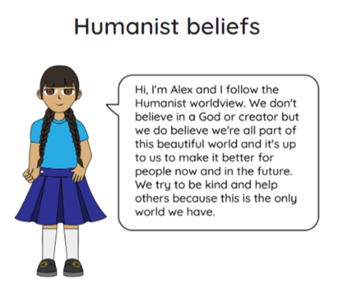  Why do people who follow the Humanist worldview believe it is important to care for the world?  (Answers include: they believe that we are all part of the world; it is our responsibility to look after the world for everyone now and in the future.)  Main:  Read through and discuss- The park clean up adventure.  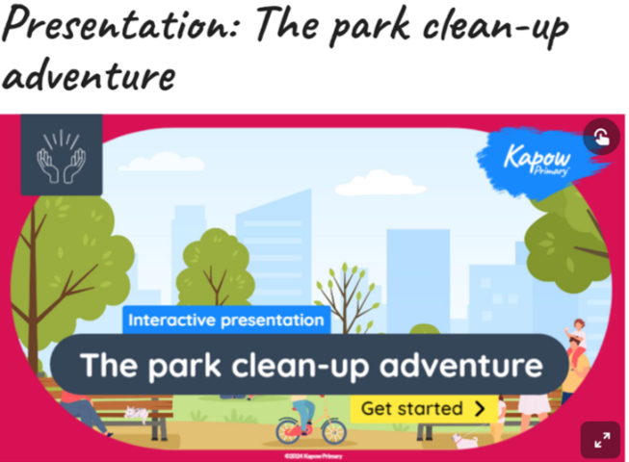  Reread the story and ask the children to find a reason why a Humanist might clean up the park. Click to highlight this on the Presentation: The park clean-up adventure.  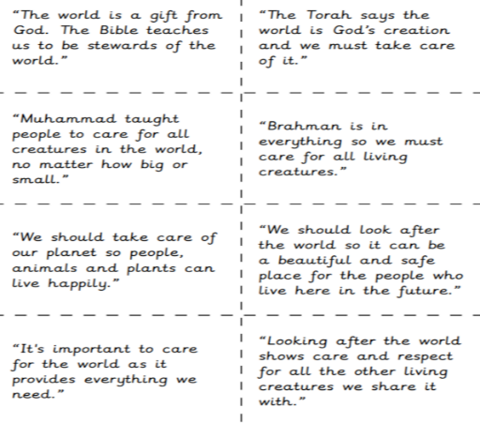  Read the statements and sort into two categories-  ‘Connected to a belief in God’ and ‘Not connected to a belief in God.’  Can you give a reason that is connected to a belief in God as to why someone might think it is important to care for the world?  Can you give a reason that is not connected to a belief in God as to why someone might think it is important to care for the world?  Now re-order you two piles in from most to least important.  Discuss children thoughts.  Plenary:  Ask the children:  Why should we care for the world? (Children may suggest: to show care and respect for all the other living creatures we share the world with.)  What do you think the most important reason for caring for the world is?  Display the Presentation: Why should we care for the world? and hand out the children’s copies of the Activity: Hand outline.  Invite the children to add further ideas to their own ideas from Lesson 1 in the centre of the hand.
Cross curricular links  PSHE – Understanding how to take care of our world and others. |  |  | Through this unit of work the following essential skills will be developed:  - Understand that different beliefs believe that God created the world for humans.  - To understand we need to care for the world.  - To understand the meaning of stewardship.
Assessment:
Pupils with secure understanding indicated by:
Explain different beliefs about who owns the world. Recognise the belief that humans were created last for a reason. Recognise why only humans can care for the world. Identify the belief that God created humans as stewards over nature through scripture. Recognise what some stories about Muhammad tell us about looking after the world. Express why stewardship is important to some Muslim people. Identify why people who believe in ahimsa may think it is important to look after all living creatures. Identify reasons why it is important to care for the world.

