Geography
Geography- The United Kingdom
By the end of this unit children will know...

Vocabulary

Year 1 Spring 2 -The Journey

That the UK is short for ‘United Kingdom’. That the United Kingdom is made up of four countries and their names. The name of the country they live in. The four seasons of the UK. The names of the capital cities of the four countries. Some local landmarks. The names of the seas around UK. How to pin-point holiday destinations.
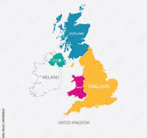

.
Autumn, England, compare, explore, environment, journey, locate, Northern Ireland, Scotland, season, spring, summer, United Kingdom, Wales, winter, human feature, physical feature

Intention

Children develop geographical ideas and skills by studying the UK. They will learn what countries are within the UK, and what seas surround the land. They will study maps and use these to help them find places where they have been. They will learn the name of the capital city of the UK and some famous building within it.

Previous Learning
In the Autumn, the children found Grantham on a map of the U.K.
The United Kingdom- Previous Learning

Learning Links
Building on their learning in Reception, where children explored their local area of Grantham and identified features of a town, pupils will continue to develop their geographical understanding by connecting prior knowledge to the wider United Kingdom. In the previous term in Year 1, children learned about their local area in more detail, including using simple compass points, identifying different types of houses such as semi-detached and detached homes, and understanding their own addresses. This secure knowledge of where they live will now support them in learning that the UK stands for the United Kingdom and that it is made up of four countries: England, Scotland, Wales and Northern Ireland.
Children will learn the name of the country they live in and begin to identify the capital cities of each of the four countries. They will explore the four seasons of the UK and consider how seasonal changes affect both their local area and other parts of the country. Pupils will identify the seas surrounding the United Kingdom and develop their mapping skills further by locating and pin-pointing holiday destinations. By linking their understanding of local landmarks, compass directions and addresses to the wider national context, children will develop a clearer sense of place and how their town fits within the United Kingdom.

Geography – The United Kingdom
This unit focuses on aspects of local features, land use and environment. Children develop geographical ideas and skills by studying the UK. They will look closely at where the UK is on the world map, what countries are within the UK, and what seas surround the land. They will study maps and use these to help them find places where they have been. They will learn the name of the capital city of the UK and some famous building within it.
Key Objectives  To locate the UK on a world map.  To be able to identify and name the countries within the United Kingdom.  To be able to name the capital cities within the United Kingdom.  To be able to name the surrounding seas of the United Kingdom.  To be able to locate and identify places that have been visited.  To be able to name the seasons and identify weather patterns in the United Kingdom.  National Curriculum  Locational knowledge  Pupils should be taught to:  Name, locate and identify characteristics of the four countries and capital cities of the United Kingdom and its surrounding seas.  Geographical skills and fieldwork  Pupils should be taught to:  Use world maps, atlases and globes to identify the United Kingdom and its countries, as well as the countries, continents and oceans studied at this key stage.  Use simple fieldwork and observational skills to study the geography of their school and its grounds and the key human and physical features of its surrounding environment.  Use simple compass directions (north, south, east and west) and locational and directional language [for example, near and far; left and right] to describe the location of features and routes on a map.  Human and physical geography  Pupils should be taught to:  Identify seasonal and daily weather patterns in the United Kingdom and the location of hot and cold areas of the world in relation to the Equator and the North and South Poles.  Use basic geographical language to refer to:  key physical features, including: season and weather. |  | Lesson 1- The United Kingdom  Foundational Skills:  Listening and attention skills – used when watching the video and listening to map explanations  Understanding of spoken language – used when following instructions to find countries and capitals  Secure phonic knowledge – used when reading and labelling names of countries and cities  Early reading skills – used when identifying labels on the map  Early writing skills – used when writing captions about a country  Understanding of people, communities, and differences – used when learning that the UK is made of four different countries  Awareness of the natural world – used when recognising the UK as an island nation  Ability to explore materials and media – used when working with printed or cut-and-stick map activities  Learning Objective:  To name, locate and identify characteristics of the four countries and capital cities of the United Kingdom and its surrounding seas.  Success Criteria: I can label the four countries in the UK.  I can name the capital cities in the UK.  I can write a caption about one of the four countries.  Recap and Recall:  Create a KWL grid showing what children already know about the United Kingdom. Discuss questions that children would like answered about the UK.  Starter:  Show the children where the UK is on a globe.  Explain to the children that the United Kingdom is the country we live in. There are four countries within the UK.  TTYP: Does anyone know what the four countries are?  Explain that the UK is made up of 4 smaller countries. Do they know their names? Introduce children to the names of the 4 countries – England, Wales, Scotland and Northern Ireland. Show children where they are on a map of the UK. Watch and discuss the following video to find out more:  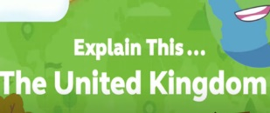  Explain that each country has a capital city.  TTYP: What is a capital city?  Play the capital city song:  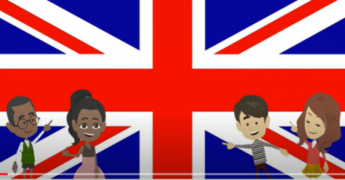  Show the children where London, Edinburgh, Cardiff and Belfast are on a map of the UK.  Activity:  Yellow, Green and Blue Group- Label the 4 counties and capital cities on a UK map.  Red group- Cut out the names of the 4 countries of the UK and stick in the correct place on map of UK.  Plenary:  Share answers under visualizer and discuss. | Lesson 2- Surrounding Seas  Foundational Skills:  Listening and attention skills – used during recap discussions and video re-watch  Understanding of spoken language – used when interpreting facts about the seas  Secure phonic knowledge – used when reading sea names  Early reading skills – used when matching sea names to locations on a map  Early writing skills – used when writing short captions about learning  Understanding of people, communities, and differences – used when learning about the UK’s connection to other countries through seas  Awareness of the natural world – used when understanding the UK as an island and learning sea facts  Ability to explore materials and media – used when labelling seas on the map or cutting and sticking labels  Learning Objective:  To name, locate and identify characteristics of the four countries and capital cities of the United Kingdom and its surrounding seas.  Success Criteria: I can label the UK surrounding seas. I can write a caption about what I have learnt about the seas.  Recap and Recall:  Recap that this half term we are learning about the United Kingdom.  TTYP: What do you already know about the UK?  Recap the United Kingdom is the country we live in. There are four countries within the UK.  Ask- can anyone remember the names of the countries? Can you remember where they are? Show on a map of the UK.  Re-watch the video:  Recap that each country has a capital city. TTYP- What is a capital city? Play the capital city song:  Ask the children where London, Edinburgh, Cardiff and Belfast are on a map of the UK.  Starter:  Today we are going to explore the seas around the UK.  TTYP: What doyou know about the sea around the UK? Do you know what they are called?  Uncover the names of the seas surrounding the UK.  Share with the children some facts about the seas:  - The UK is an island nation in Western Europe just off the coast of France.  - The Channel Tunnel bored beneath the English Channel, now links the UK with France.  - The UK is made up of several islands. The only land border connecting the UK to another country is between Northern Ireland and the Republic of Ireland.  -No one in the UK lives more than 120 km (75 miles) from the sea!  Main:  Yellow, Green and Blue Group- Use the map on the notebook to label the seas around the UK.  Challenge: Can you write a caption about what you have learnt today?  Red Group- Cut and stick the names of the seas on the map.  Plenary:  Discuss any misconceptions. | Lesson 3- The Seasons  Foundational Skills:  Listening and attention skills – used when listening to discussions about seasons and weather  Understanding of spoken language – used when answering questions about the Equator and climate  Secure phonic knowledge – used when reading season names  Early reading skills – used when recognising captions and vocabulary for seasons  Early writing skills – used when writing sentences explaining why some countries are hotter  Understanding of people, communities, and differences – used when comparing weather in different countries  Awareness of the natural world – used when identifying seasonal changes and exploring signs of spring  Ability to explore materials and media – used when drawing seasonal trees  Curiosity and enquiry skills – used when asking and answering questions about weather patterns  Learning Objective:  To identify seasonal and daily weather patterns in the United Kingdom and the location of hot and cold areas of the world in relation to the Equator and the North and South Poles.  Success Criteria: I can name the four seasons. I can draw pictures to show each season. I can explain why some countries are warmer than others.  Recap and Recall:  Recap that the United Kingdom is the country we live in. There are four countries within the UK. Ask the children if they can remember the 4 countries and the 4 capital cities.  Recap that we have also been learning about the seas around the UK. Can anyone remember what they are called?  Watch : "United Kingdom Song" with signing | Primary School Geography | Al Start  Starter:  Explain to the children that today we are going to be exploring seasons around the UK.  TTYP: What are the seasons? Uncover the names of the seasons and discuss what the children know about each season.  Watch seasons video to find out more:  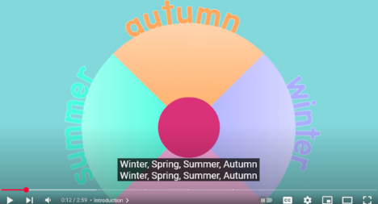  TTYP: Why are some countries warmer than others? Does anyone know what the red line is on the picture?  (Equator- See picture on notebook.)  Discuss with children the seasons in the UK. What weather do we experience in each season? What order are the seasons in (starting from January)?  Read and discuss the following points:  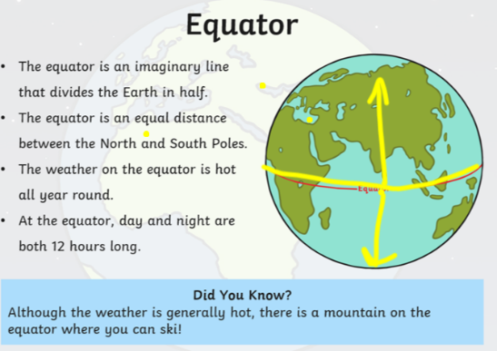  Ask- What season are we in now? What season will be next?  Go and look outside for signs of the season. Point out spring flowers growing and leaves coming on the trees.  Main:  Yellow, Green and Blue Groups- Children to draw the same picture of a tree but adding different details on for each of the Seasons. Label each season.  Challenge: Can you write a sentence to explain why some countries are hotter than others?  Red Group- Children to draw a tree for each of the seasons.  Plenary:  Explain that we will ne talking about holidays next week.  Send message to parents asking where the children have been on holiday.
Lesson 4- Places we have Visited  Extended Wtiting Opportunity- Write sentences to describe places they have visited in the U.K.  Foundation Skills:  Listening and attention skills – used when hearing where others have been on holiday  Understanding of spoken language – used when following map-based instructions  Secure phonic knowledge – used when reading place names  Early reading skills – used when locating holiday destinations on the map  Early writing skills – used when labelling destinations (if required)  Understanding of people, communities, and differences – used when recognising different places children have visited  Awareness of the natural world – used when locating UK and world destinations  Ability to explore materials and media – used when marking destinations on world and UK maps  Curiosity and enquiry skills – used when comparing where children have travelled  Learning Objective: To be able to locate and identify places that have been visited.  Success Criteria: I can say where I have been on holiday. I can pinpoint my holiday destination on a map.  Recap and Recall:  Recap that the United Kingdom is the country we live in. There are four countries within the UK. Ask the children if they can remember the 4 countries and the 4 capital cities.  Recap that we have also been learning about the seas around the UK. Can anyone remember what they are called?  TTYP: What are the seasons?  Watch seasons video to find out more:  TTYP: Do you know what Season we are in now?  TTYP: Why is it warmer in some countries and not others?  Teaching:  Explain that we are going to be exploring where we have been on holiday in the UK and around the World. Some of your grown-ups have sent in messages to tell  us where you have been on holiday. Altogether, we are going to pin point where your destinations are on the map of the UK and a World map.  Show children where the teachers have been on holiday on the world map and UK map.  Activity:  Children to label on a world map places they have been holiday. |  | Lesson 5- UK Landmarks  Foundation Skills:  Listening and attention skills – used when listening to explanations about human and physical landmarks  Understanding of spoken language – used when discussing human versus physical features  Secure phonic knowledge – used when reading landmark names  Early reading skills – used when identifying landmarks and associated cities  Early writing skills – used when writing a sentence about a chosen landmark  Understanding of people, communities, and differences – used when learning about landmarks in the four UK countries  Awareness of the natural world – used when distinguishing natural landmarks from human features  Ability to explore materials and media – used when choosing, placing, or constructing landmarks on maps  Curiosity and enquiry skills – used when exploring landmark photos and asking questions  Learning Objective: To name and recognise some landmarks of the UK.  Success Criteria: I can identify some landmarks of the UK and say in which city you could find them.  Success Criteria: Recap that the United Kingdom is the country we live in. There are four countries within the UK. Ask the children if they can remember the 4 countries and the 4 capital cities. Record children’s previous learning on Seesaw and add QR code to books.  Recap and Recall:  Recap that the United Kingdom is the country we live in. There are four countries within the UK. Ask the children if they can remember the 4 countries and the 4 capital cities.  Recap that we have also been learning about the seas around the UK. Can anyone remember what they are called?  TTYP: What are the seasons?  Starter:  Share the vocabulary for lesson with the children:  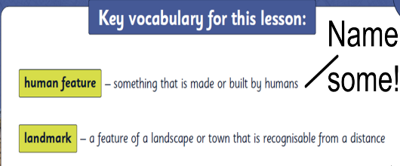  Read through the information about a geographer:  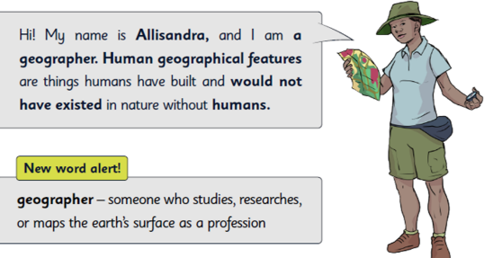  Add the word ‘geographer’ to the working wall.  Main: Show the children a selection of photos of human features (on notebook). Ask – What are these?  TTYP- Where you live are there any human features? Share ideas.  Ask- What is a human landmark? Show children photos of human landmarks. (On notebook) Explain that these are human features. Ask- What is the difference between human and physical features?  Explain that will be using this map and adding man-made and natural landmarks to the map.  Look at some key human landmarks in Scotland. (On notebook)  Watch video on Scotland:  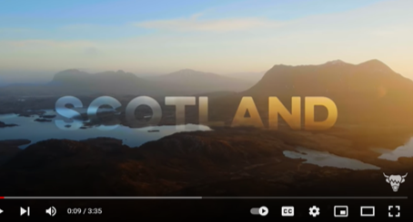  Ask children to choose their favourite 2 landmarks and add them to Scotland on the map.  Repeat for Wales, Northern Ireland, and England.  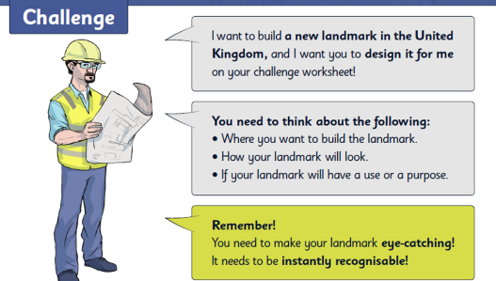  Plenary: HA- Write sentence about their landmark.  LA and MA- Answer questions above verbally. Build landmark using construction. Evaluate landmark verbally. Record on Seesaw and QR codes to books.
Learning Challenge Week
To identify Human and Physical features in Wyndham Park.
Cross curricular links  - Geography – human and physical features of the UK (Autumn 1 and Spring 2).  - Consolidating positional language (Maths, Spring 1).  - Human and Physical features of UK and capital cities (Geography, Autumn 1/Spring 2). | Through this unit of work the following essential skills will be developed:  - To be able to identify physical and human features of the local area.  - To be able to identify and classify plants and animals.  - To be able to locate and identify places that have been visited.  - To locate the UK on a world map.
Assessment
Pupils with secure understanding indicated by:
- Name and locate the four countries on a map of the UK.
- Identify the country they live in.
- Identify the four seasons and the current season and describe some seasonal changes.

