eography
Religious Education- How Did the World Begin?

By the end of this unit children will know...

Vocabulary

Year 1 Autumn 1- Super Me


What they and their families think and believe in relation to content be learnt.
Where some of their beliefs have come from.
It is natural for people to think and behave differently from one another. Their ideas might change over time. Some people believe God exists as a powerful, non-human being. Some religions, followers believe in one supreme being or God who is loving. There are different names for God. Some spoken and written words are important to people. Creation stories provide people with possible answers as to why we are here. There are different types of questions (e.g. those with simple factual answers and those with opinions or ideas). Stories, images and objects can help us learn about beliefs. Similarities and differences help us understand worldviews better. We all notice different things in stories and sources. It is helpful to ask questions about sources. It is important to only use positive language when discussing others’ beliefs.

Belief, believe, Brahman, Christian, Christian Bible, creation, creator, God, Hindu, idea, Jewish, proof, religion, respect, scripture, Torah, worldview

Intention

The children will explore a range of creation stories and scientific ideas about how the world began in imaginative ways. They present their own ideas using art and language. They consider how creation stories help some people understand what God is like.
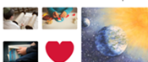

Previous Learning
In Reception the children learnt about the story of the birth of Jesus at Christmas time and the story of the death of Jesus at Easter.

Religious Education – How Did the World Begin?
Children will exploring a range of creation stories and scientific ideas about how the world began in imaginative ways, children present their own ideas using art and language. They consider how creation stories help some people understand what God is like.
Key Objectives-  To show respect when talking about big ideas.  To understand what creation means in relation to the natural world.  To know that some people believe God created the world as described in Genesis. | Lesson 1- What do I Believe?  L.O: To show respect when talking about big ideas.  S.C: I can listen to the ideas of others.  I can talk about why I think something is true or not.  I can talk about believing or not believing things that have no proof.  Teaching:  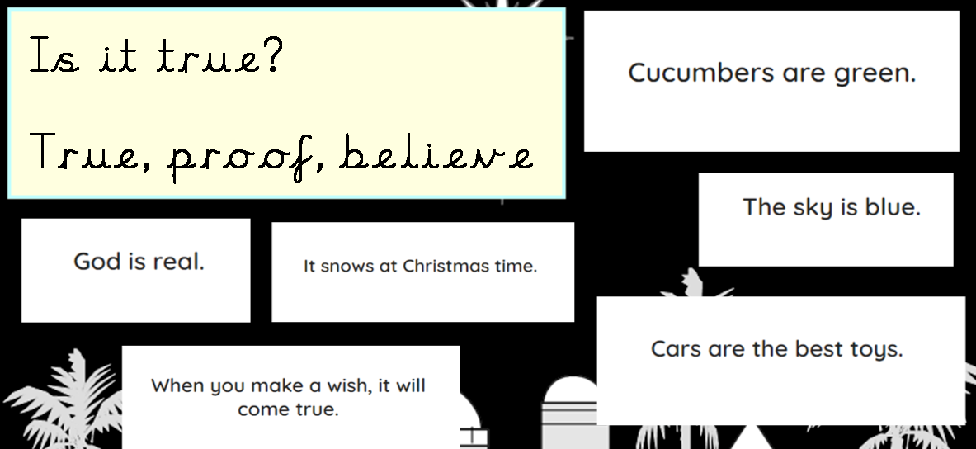  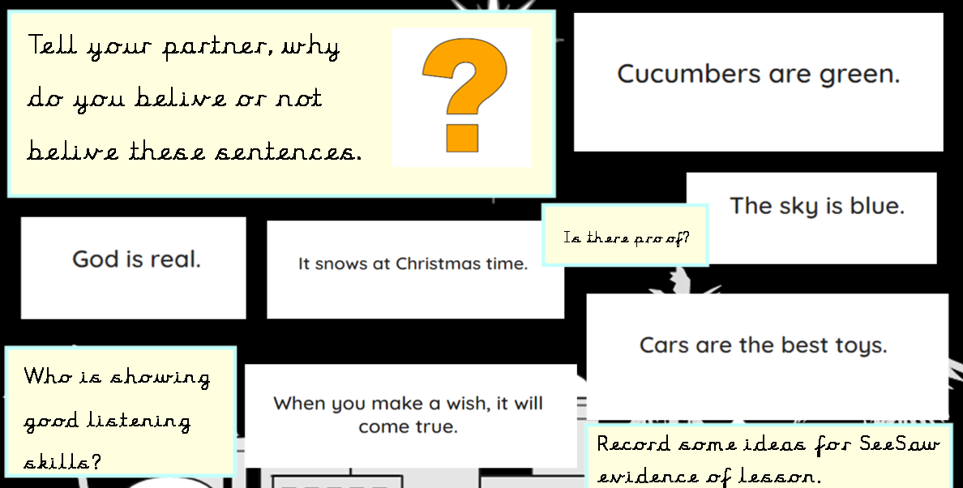  Talk about what the children think and believe about the sentences on notebook. Record on Seesaw and add QR code to sheet.  Activity/ Plenary:  Introduce the Wonderbox to the children. Explain if they have any wonders they can write them on a sticky note and put them in the box.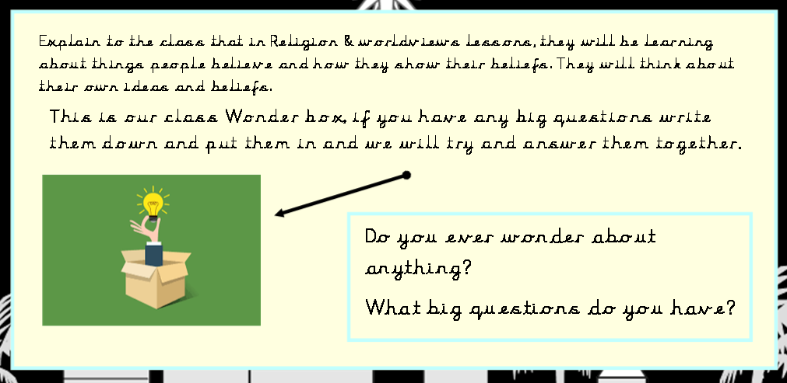 | Lesson 2 What is Creation?  L..O: To understand what creation means in relation to the natural world.  S.C: I can identify things which are made by humans and natural.  I can use adjectives to describe a creator.  I can explain my ideas through talking or writing.  I can talk about where my ideas come from.  Teaching:  Discuss- Is it true? Read the statements from notebook and ask if it is true or not. Discuss children’s ideas.  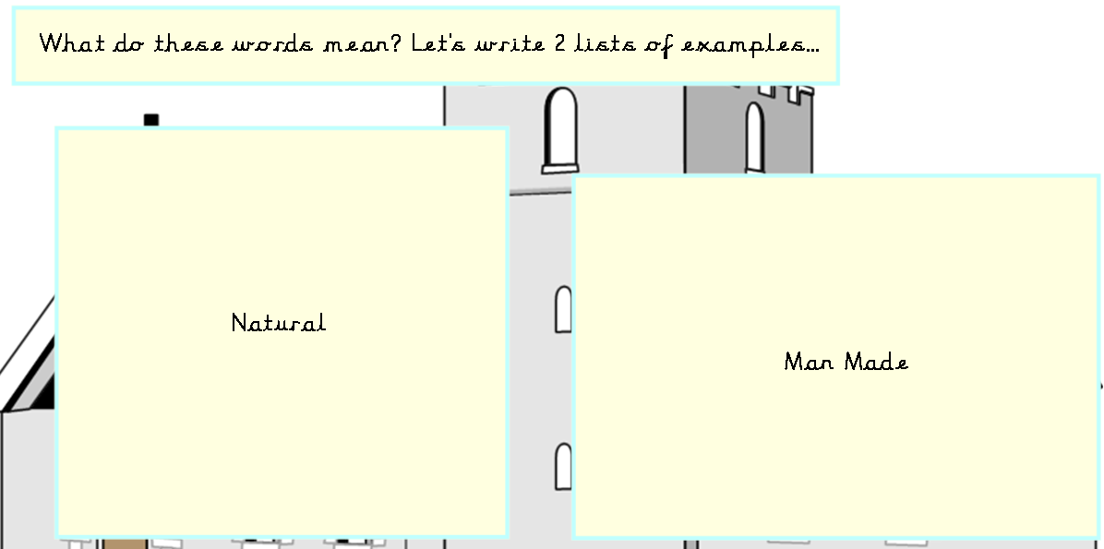  Pair children up, go outside and draw/list natural and manmade creations in the school environment.  Use the best ones to create a class list.  Show children the Kapow presentation of picyures of people creating things. qqDiscuss the following questions.  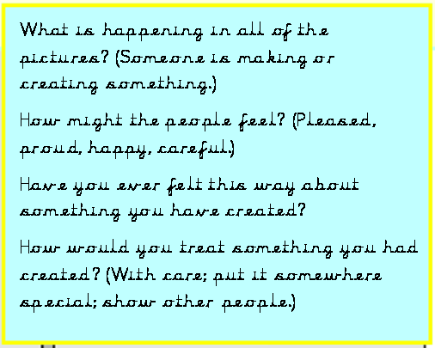  Activity:  Children to use a range of crafting, drawing and painting equipment to make something-anything. Explore how their creations grow.  Have the children look at one another’s work to see how they develop over the time.  Plenary:  Look through Natural wonders presentation:  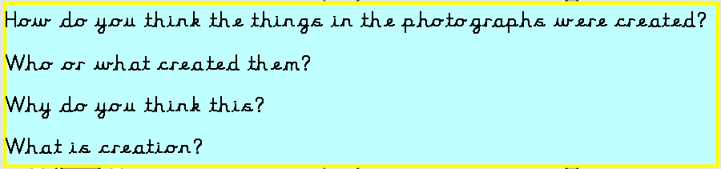 | Lesson 3- The Story of Creation  L…O- To know that some people believe God created the world as described in Genesis.  SC- I can retell a creation story in my own words.  I can say what a creation story shows about what a creator is like.  I can say what some Jewish and Christian people believe about creation.  Teaching:  Recap previous learning by discussing what natural, manmade and creation mean.  Show photos of a web, daisy, playground and butterfly. Discuss which is the odd one out. Repeat with other pictures.  *Remind the children that natural things are not made by humans. Man made things are.  Tell the children that both the Christian and Jewish  special texts are very long, so they  are split into sections. Compare this to chapters in a book or a box set of books or a book with more than one story in.  Show the children a Bible and a Torah.  Explain that some Jewish people read the Torah. This is one of their special texts and has five parts. Discuss how the Torah can be read from scrolls and sometimes these words are printed in a book that people can read at home.  Explain that people who are Christian often read the Bible, which is a special book for Christians. The  first five books of the Bible are the same as the five books of the Torah.  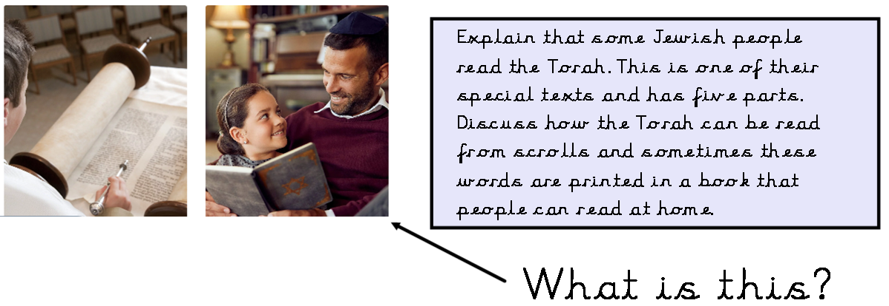  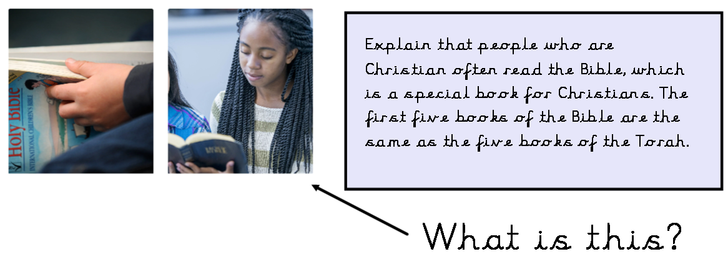  Explore the different Bibles and Torah together.  Activity:  Explain to the children both the Torah and the Bible begin with the story of creation. Watch the Kapow video of the creation story. Teacher retell the story and use props.  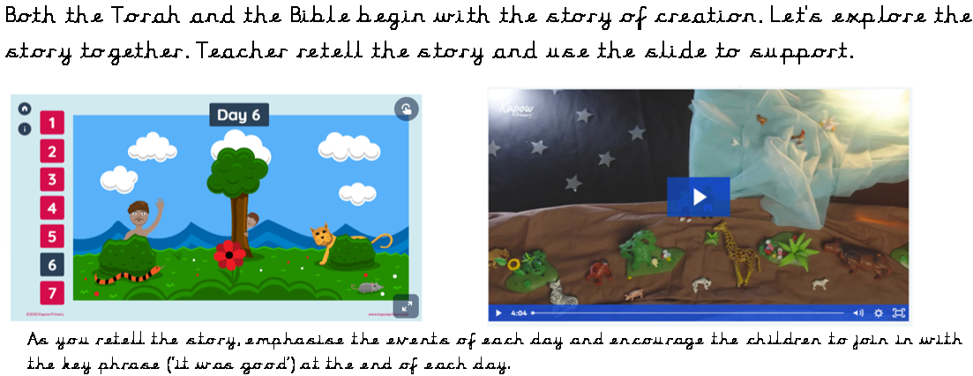  Discuss:  What does the story show was created on each day? (Day one – light; day two – water and sky; day three – land, sea and plants; day four – the Sun, Moon and stars; day five – sea creatures and birds; day six – animals and humans.)  What did God do in this story when he had finished? (Rested.)  Who might believe this story accurately describes the creation of the world? (Some Jewish and Christian people; some of the children may say that they or someone they know believe this story.)  What is God like in this story? (Children may suggest: creative, clever, powerful or tired.)  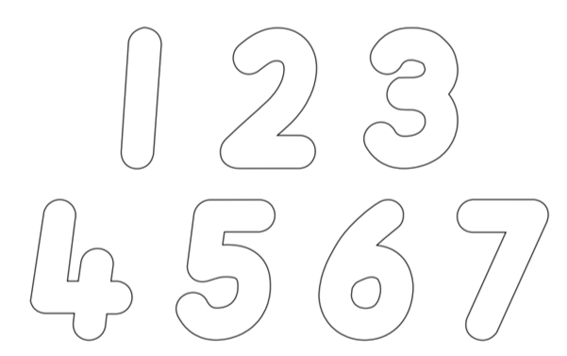  Ask the children to decorate the numbers to show what happened on each day of the creation story.  For example, the children could colour the number one yellow and black to show that on day one light and dark were created; the number five could be coloured in blue and decorated with sea creatures to show that on day five, God created creatures in the sea.  Plenary:  Ask the children to retell the Jewish and Christian creation story with a partner using their decorated numbers to help them.
Lesson 4- Hindu Story of creation  L.O- To recognise that there are different creation stories to explain how the world began.  S.C- I can correctly order the key events of a Hindu creation story.  I can say how the story is similar to other creation stories.  I can say how the story is different from other creation stories.  Teaching:  Recap previous learning by discussing what natural, manmade, creation story and creation mean.  Discuss the link between each photo.  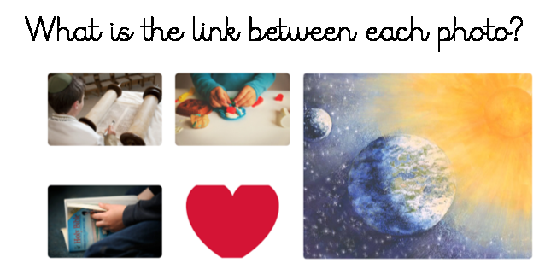  Tell the children that the Torah and Bible are both holy books. The child creating with playdough is like God creating the world. The heart links with the creation image because God loves the world and everything in it. The Torah and Bible both contain a creation story.  Watch the story Hindu story creation.  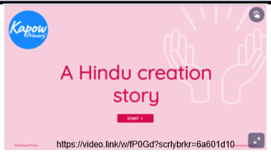  Activity:  Story Sequencing  Ask the children to cut up the pictures and arrange them in the correct order. Encourage the children to discuss the story with their partners and compare their ideas. Once they are happy with their story sequencing, invite the children to stick them into their books.  Ask the children: What do Hindus call God when he creates? (Brahma.) Can you remember the other names for God? (Vishnu and Shiva.) What powers do the different names represent? (Brahma – creation; Vishnu – caring for the world; Shiva – recreating or replacing the world.)  Plenary  Draw three columns on flipchart with the headings: ‘Christian and Jewish’, ‘Hindu’ and ‘Both’.  Ask the children to identify which story the images are from and if any could appear in both. As a class, sort the pictures into the correct columns.  Ask the children to use this comparison table to discuss similarities and differences between the two creation stories studied so far.  Similarities: the order of creation; creator God; started from nothing.  Differences: God has different forms; what the world is created from; people are not mentioned in the Hindu story; the timescale for creation | Lesson 5- What might a creator be like?  L.O- To express ideas about what a creator might be like.  S.C- I can explain that stories help some believers to understand what God might be like.  I can say what a story might show about God.  I can use adjectives to describe a creator.  Teaching:  Discuss- What do creation stories suggest to some people about God?  Recap last week’s Hindu story of creation.  What can you remember about the story?  What did the story tell Hindus about God?  (God was there before anything else; God created the world; God will create, look after and destroy many universes; God is creative and powerful.)  Look at picture of an artist. Discuss what do you think her talents are? What do you think her personality is like? Why?  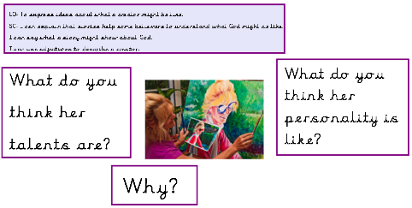  What do stories tell us about God the creator?  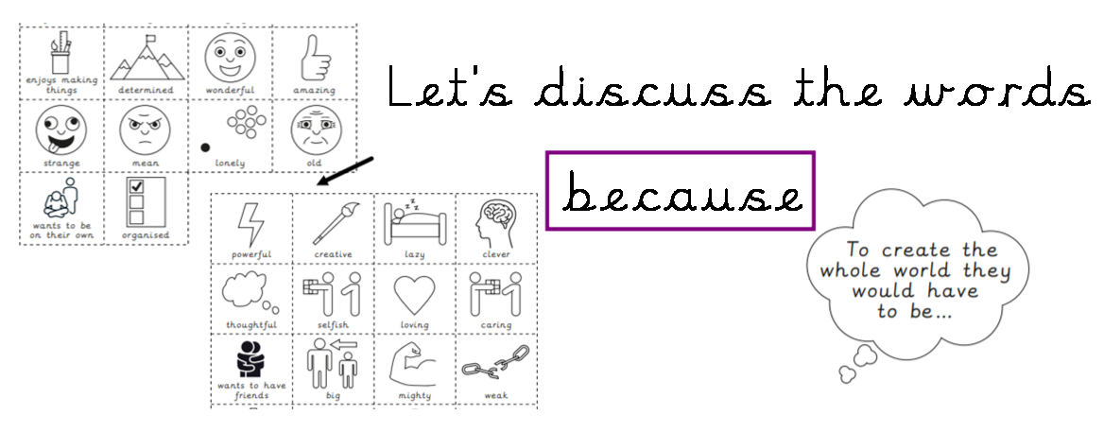  Activity:  What do you need to be a creator?  Ask the children to choose 10 words that you think you need to be able to create the world.  Plenary  Discuss-  Do you have any words which are the same as your partner?  Are there any words your partner has chosen which you have not chosen?  Which of your words do you think is the best for describing a creator god? | Lesson 6- What does creation look like?  L.O-To explore and express ideas about creation.  SC-I can use art to show how I think the world began.  I can explain my ideas through talking or writing.  I can discuss where my ideas come from.  Teaching:  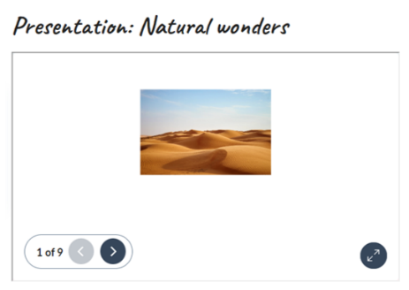  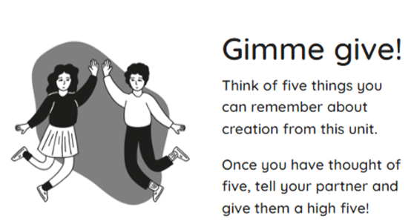  Show the children the Natural Wonders presentation.  Look through the pictures and answer the questions.  Where did this natural wonder come from?  Who or what do you think created the world?  How do you think the world was created?  Which is your favourite picture and why?  Show the children the selection of art resources and explain that they will use them to create a piece of artwork which shows how they think the world began. Children may choose to express their ideas in one of the following ways: Depicting one of the stories they have heard during this unit. Basing their art on a story or theory they have heard elsewhere. Representing creation in a more abstract way using colour and shape.Focusing on the Being responsible for creation.  Plenary:  We are now going to pretend we are in an Art Gallery. Study each other’s work, what do you think your friend works show? Record children’s ideas on seesaw and add QR code to pic college. Take photos of art work to make pic college,  Work through the quiz together.  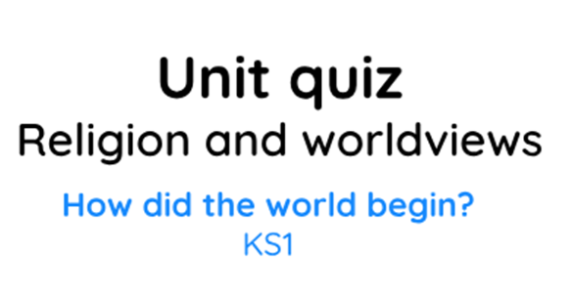
Cross Curricular Links:  English: Spoken language, reading.  Science: Everyday materials, working scientifically.  Maths: Number – number and place value.  Geography  Art and design  RSE |  | Through this unit of work the following essential skills will be developed:  Sharing opinions respectfully about what is important to them and what is important to others. Expressing their own ideas and opinions based on personal experience and the beliefs of family members. Using various art forms to express their ideas. Asking their own questions about the world around them. Talking about simple ideas and things that puzzle them about belief in God. Sharing opinions respectfully about what is important to them and what is important to others. Expressing their own ideas and opinions based on personal experience and the beliefs of family members. Using various art forms to express their ideas. Asking their own questions about the world around them. Asking questions about things that interest them. Beginning to ask ‘big’ questions (e.g. Why are we here? What is real?). Listening to stories and discussing what happens in them.Beginning to notice important information (e.g. first-hand accounts and photos). Retelling stories in their own words. Recognising lessons or teachings within stories and relating to their own experiences. Finding religious symbols in stories and other sources. Recognising some religious terminology in sources. Beginning to notice similarities and differences within and between religions and worldviews. Listening to others’ ideas and comparing them to their own.Talking about what their answer to a question is based on. Identifying things that are important to people. Noticing differences and using respectful language to discuss them. Talking about their own experiences in relation to their learning. Sharing things that make them wonder and what they think about these things. Talking about what they believe. Respectfully sharing opinions about what is important to them and what is important to others. Sharing what they have learnt. Expressing their ideas using symbols, drawings and choosing appropriate words.
Assessment
Pupils who are secure will be able to:
Identify things which are natural and man-made.
Discuss ideas about how natural things were created.
Recall the key elements of the Jewish and Christian creation story in the correct order.
Understand that some Christian and Jewish people believe the story explains how the world was created.
Correctly order the key events of a Hindu creation story.
Make some links between the Hindu creation story and the Christian and Jewish creation story.
Choose appropriate adjectives and adjectival phrases from a selection to describe what people might think about God.
Share their own ‘I wonder’ questions.
Recognise that Humanists use evidence to understand how the world began.
Create a thoughtful representation that reflects the Humanist belief of how the world began.
Use art to express their ideas about how they think the world began.

