eography
Geography- Our Local Area- What is it like Here?
By the end of this unit children will know...

Vocabulary

Year 1 Autumn 1- Super Me


That the UK is short for ‘United Kingdom’.
That a country is a land or nation with its own government.
The name of the country they live in.
That an aerial photograph is a photograph taken from the air above.
That atlases give information about the world and that a map tells us information about a place.
That a map is a picture of a place, usually drawn from above. That symbols are often used on maps to represent features. Simple directional language (e.g. near, far, up, down, left, right, forwards, backwards)
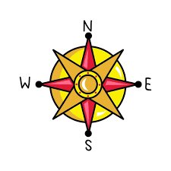

Aerial photograph, aerial view, atlas, city, country, directional language, distance, features, globe, improve, key, land, locate, location, map,place, questionnaire, sea, survey, symbol, town, village, physical feature, human feature, North, South, East, forwards, backwards, left, right, near, far

Intention

Children will locate where they live on a map and recognise features within a local context. They will learn about the 4 compass points and create maps using classroom objects before drawing simple maps. They will learn to sort features into human and physical features. The children will learn about different types of houses and have a walk around the local area.

In Reception the children explored the local area when they walked take their Santa letters to the post office. They also visited parks, local shops, St Wulfram’s Church and Belton House. The children talk about people who help us in Grantham such as police, firefighters and have parents and visitors in from the local area to talk about their jobs.

The children also experimented with Beebots. We

Our Local Area- What is it like Here? – Previous Learning
[Grab your reader’s attention with a great quote from the document or use this space to emphasize a key point. To place this text box anywhere on the page, just drag it.]

Children will build on their previous learning from exploring the local area understanding of direction and navigation. Their earlier experiences of using Beebots will support their understanding of movement and simple directional commands. In this learning, pupils will listen carefully to instructions about compass directions and begin to understand the meaning of North, East, South and West. Through discussion, children will develop expressive language by describing directions using geographical vocabulary. Through active learning opportunities, pupils will practise using and applying directional vocabulary, linking their previous experiences of navigating their environment.
Learning Links

Geography- Our Local Area - What is it like Here?
Through this topic, the Geography unit focuses on aspects of local features, land use and environment. Children will learn about the features of their school and the town of Grantham. They will look at the land use of the local area and be able to identify buildings and use vocabulary to describe e.g. road, local, house, office, shop, field. Children will talk about what they like and don’t like about the place they live in. They will know where they live and be able to tell someone their address.
Knowledge Progression Across the Unit:  Lesson 1 – Learn about compass directions (North, South, East, West).  Lesson 2 – Explore the local area and recognise landmarks.  Lesson 3 – Learn about different types of housing.  Lesson 4 – Use maps and Google Earth to locate where we live.  Lesson 5 – Understand how maps use symbols and keys.  Lesson 6 – Identify human and physical features in the local area.  Key Objectives:  To explore North, East, South and West.  To recognise a compass.  To be able to answer geographical questions about my locality including, ’where do I live?’ ‘What is Grantham like?’ and ‘What will I see in this place?  To use world maps (Google Earth) to identify where we live in the United Kingdom.  To recognise human and physical features in the context of the children’s own locality.  To understand what a map is and know how to use a key.  To be able to devise their own map and use a simple key.  To identify and describe the main human and physical features of your local area. Recap and Recall  Activity – Direction Dance: teacher calls directions and pupils move North, South, East or West.  Questions:  • What are the four compass directions?  • Why do we use a compass?  National Curriculum:  Pupils should be taught to:  Use basic geographical language to refer to:  key physical features, including: beach, cliff, coast, forest, hill, mountain, sea, ocean.  key human features, including: city, town, village, factory, farm, house, office, port, harbour and shop.  Use aerial photographs and plan perspectives to recognise landmarks and basic human and physical features.; devise a simple map, and use and construct basic symbols in a key.  Use simple fieldwork and observational skills to study the geography of their school and its grounds and the key human and physical features of its surrounding environment.  Use simple compass directions (North, South, East and West) and locational and directional language [for example, near and far; left and right], to describe the location of features and routes on a map. | Lesson 1- Compasses and Direction  Foundational Skills:  Listening and attention – pupils listen carefully to instructions about compass directions.  Understanding – pupils learn the meaning of North, East, South and West.  Expressive language – pupils describe directions using geographical vocabulary.  Physical development – pupils move in different directions during outdoor activities.  Active learning – pupils practise using directional language.  Learning Objective: To explore North, East, South and West.  Success Criteria: I can recite North, East, South and West in order.  I can point our which way is North, East, South and West.  I can recognise a compass.  Recap and Recall:  Activity – Direction Dance: teacher calls directions and pupils move North, South, East or West.  Questions:  • What are the four compass directions?  • Why do we use a compass?  Starter:  Show the children a real compass and explain that there are 4 points to the compass.  Main:  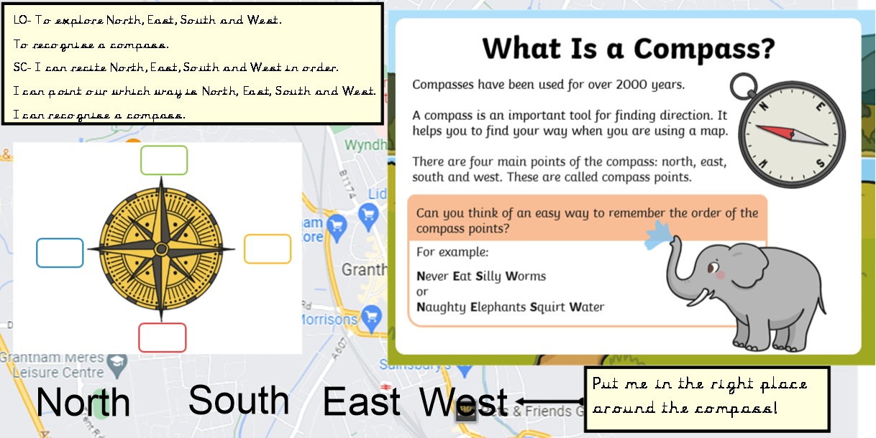  Point out North, South, East and West with your finger. Children to complete own compass sheet.  Activities:  Go outside and chalk a compass on the floor so that the children know which way North is. Give the children instructions to move in different directions. Take photos for pic college.  Use the visualizer to show the children how to input instructions into Beebot. Show the children how to move North, South, East and West.  Children to use the Beebots to move North, South, East and West. Take pictures for pic collage.  Plenary:  Can the children remember the 4 parts of the compass and point in each direction. |  | Lesson 2- My Local Area  Foundational Skills:  Listening and attention – pupils listen to instructions about exploring the local area.  Understanding – pupils learn what a locality is.  Expressive language – pupils describe places they know in Grantham.  Personal and social development – pupils work together during the local walk.  Active learning – pupils observe their surroundings.  Learning Objective:  To be able to answer geographical questions about my locality including, ’where do I live?’ ‘What is Grantham like?’ and ‘What will I see in this place?  Success Criteria: I know how to answer questions like what it like is to live in this place.  I know where I live. I can draw and label three things I know about our local area.  I can draw and label three places I know and like to visit in Grantham.  Recap and Recall:  Activity – Landmark Guess: show pictures of local places and pupils guess where they are.  Questions:  • What is our local area called?  • What places do we know in Grantham?  Starter:  TTYP-‘What did we learn last week in geography?’ Show children compass picture and recap the 4 points of a compass. Ask, ‘What is geography?’  Starter: Watch ‘What is geography?’ video.  Main: Watch ‘How to follow a map?’  Explain that this term we will be learning about the Local Area. Ask the children ‘What is our local area? (Grantham). Ask ‘What do we know about where we live?’  Go on a walk in the local area to explore the local environment. Talk to the children about keeping themselves and each other safe. Take pictures for seesaw.  Activities:  Children to draw and label three places that they have been to in their local area.  Reds- to work in a group with Teacher/TA.  Plenary:  Children to share the places they have labelled on their map. | Lesson 3- Different Types of Housing  Extended Writing Opportunity-  Children to write a description of their house.  Foundational Skills:  Listening and attention – pupils listen to explanations about different homes.  Understanding – pupils learn the names of different housing types.  Expressive language – pupils describe similarities and differences between houses.  Personal and social development – pupils collaborate when building models.  Create and think critically – pupils design and build model houses.  Learning Objective:  To identify different types of housing in our local area.  Success Criteria: I can name 3 different types of housing in my local area.  I can explain some differences between these types of houses.  I can design and build a type of home using construction materials, working co-operatively in a group.  Recap and Recall:  Activity – House Match: pupils match pictures of houses with their names.  Questions:  • What types of houses have we seen?  • How are houses different?  Starter  Look at Key Words.  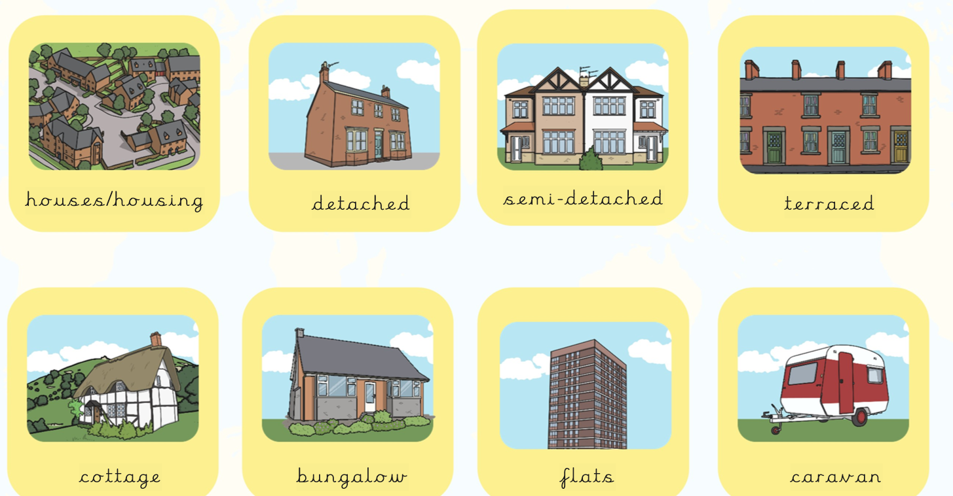  Discuss characteristics of each type of home. How do you know?  Main:  Walk around the school grounds and name the different types of homes you can spot. On sheet label the different types of home.  Children to label the different types of homes on the sheet. Blue group to write labels on sheet. Green and yellow groups to cut and stick labels onto sheet. Red group to work as a group with adult to cut and stick labels on sheet.  Work together using Lego, wooden blocks or Duplo to build a model of a home. What type of home have you built? Where can you find this type of home in our local area?  Plenary:  Discuss what type of house do you live in? How do you know?
Lesson 4- Where I live- My Address  Foundational Skills:  Listening and attention – pupils follow instructions when using Google Earth.  Understanding – pupils learn where they live within the UK.  Expressive language – pupils describe their address and location.  Active learning – pupils explore digital maps.  Create and think critically – pupils interpret maps to find locations.  Learning Objective: To use world maps (Google Earth) to identify where we live in the United Kingdom.  Success Criteria: I know where I live and can tell someone my house number and street name. I can answer questions about where my friends live.  Recap and Recall:  Activity – Map Quiz: pupils identify places on a simple map.  Questions:  • What is a map?  • What did we learn about our local area?  TTYP- What did we learn about last week?  What places in Grantham can you think of? Create a QR code of our previous learning- places in Grantham.  Starter:  Explain to the children what Google Earth is. Use Google Earth to find our school. Tell the children that we are going to use Google Earth to find where they live.  Main:  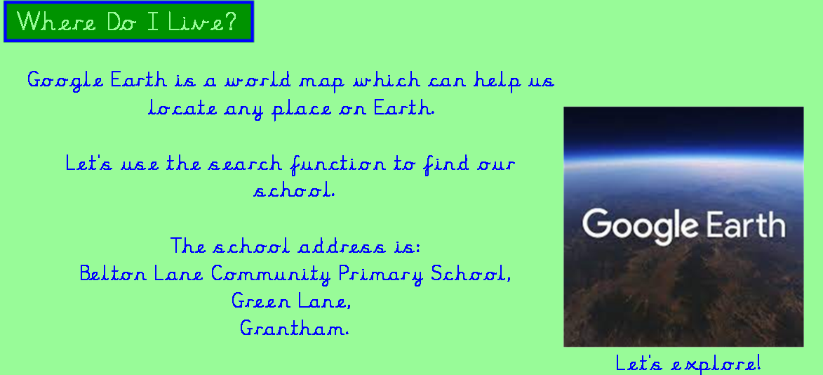  Use google Earth to show where different streets the children live are. Discuss- Who lives the furthest away? Who lives the nearest? Who lives nearest to you? Who lives the furthest away from you?  Activities:  Children to use construction boxes to build their own house.  Plenary:  Use a large piece of backing paper to locate ‘school’ use the snip of Google Earth to build the children’s house around school so they can see in 3D who lives close by etc. | Lesson 5- Map Reading  Foundational Skills:  Listening and attention – pupils listen to explanations about map symbols.  Understanding – pupils learn that maps use keys and symbols.  Expressive language – pupils describe symbols on maps.  Fine motor control – pupils draw maps and symbols.  Create and think critically – pupils design their own map keys.  Learning Objective: To devise a simple map and create basic symbols as a key.  Success Criteria: I can draw a map of a street using a key.  Recap and Recall:  Activity – Symbol Detective: pupils identify symbols used on maps.  Questions:  • What does a key do on a map?  • Why do maps use symbols?  Starter:  Discuss: What is a map? When do we use maps? What did we use to see maps last week?  Watch ‘How to follow a map?’  Explain that all maps have key, which are symbols or little pictures that help you locate places on a map. Ask the children to use the key to say what they can see on the map.  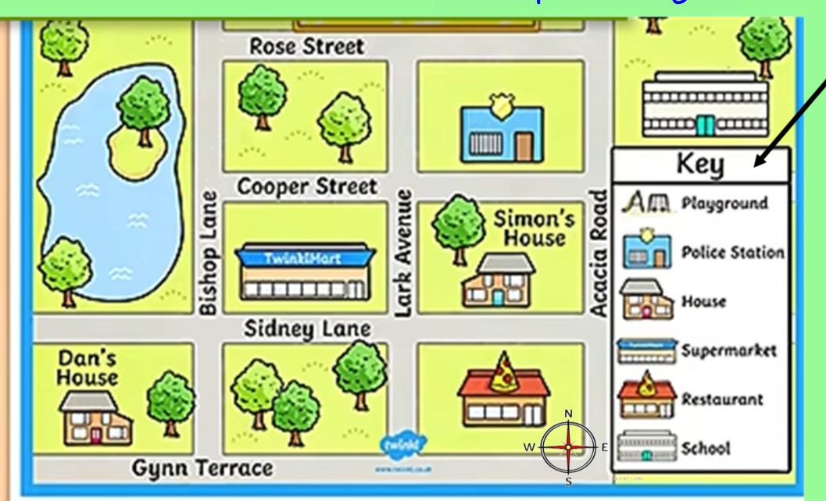  Drag the symbols to the correct place on the key.  Main:  Create a model street with a hospital, carpark and a school. On whiteboards children to create a map using the correct symbols. Ask if there is anything else we could add. What symbol would we need to draw?  On sheet children to create a map using the key. Red and yellow group add places to streets.  Green and blue group draw streets and add places.  Plenary:  Children to show the maps they created and point to the symbols saying what each symbol represents.  Activity – Symbol Detective: pupils identify symbols used on maps.  Questions:  • What does a key do on a map?  • Why do maps use symbols? |  | Lesson 6- Human and Physical Features  Foundational Skills: Listening and attention – pupils listen to explanations about human and physical features.  Understanding – pupils learn the difference between human and physical features.  Expressive language – pupils describe features in their local area.  Active learning – pupils observe and classify features.  Create and think critically – pupils sort features into categories.  Learning Objective: To understand what is a human and what is a physical feature. To identify and describe the main human and physical features of our local area.  Success Criteria: I can sort features of my local area into human and physical.  Recap and Recall:  Activity – Human or Physical Game: pupils hold up cards to show which feature type it is.  Questions:  • What is a human feature?  • What is a physical feature?  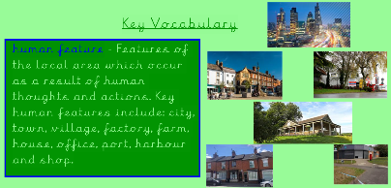  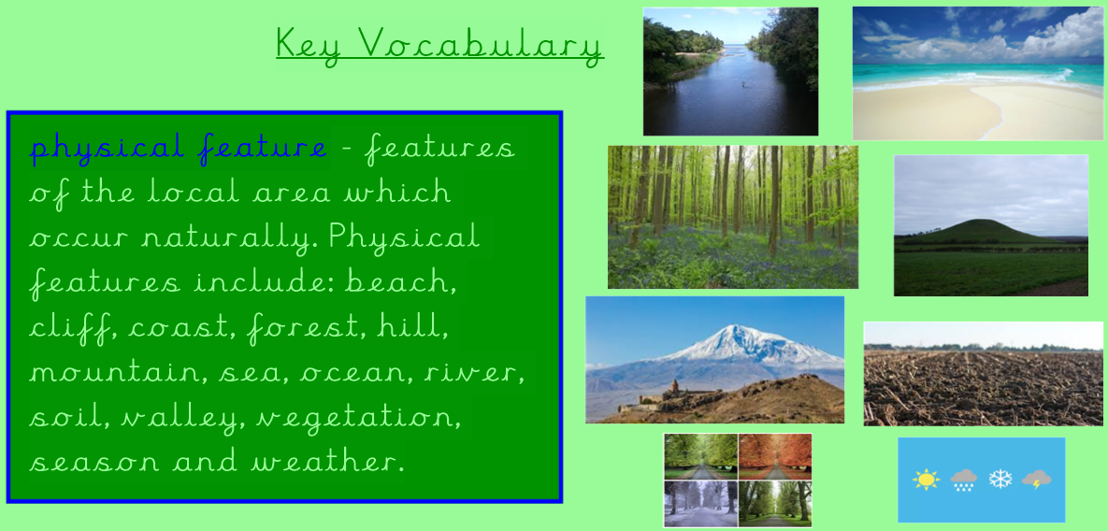  Starter:  Show the children each picture of a feature of the locality and ask the children to identify what each landmark is. Have they been there? What is it called? Where is it? (near or far?) Is it a human or physical feature?  Main:  Use the ppt to say if the feature from the wider world is a human or physical feature.  Activity 2:  Cut out pictures of features in the local area. Sort the pictures into physical and human features.  Red group to work as a group.  Plenary:  Recap the class list of features of the local areas from Lesson 2. Add with they are human or physical features.
Learning Challenge Week:
Walk around local area following a map with key.

Cross curricular links  English  Maintain attention and participate actively in collaborative conversations, staying on topic and initiating and responding to comments.  Listen and respond appropriately to adults and their peers.’ |  | Through this unit of work the following essential skills will be developed:  Recognising some physical features in their locality. Recognising some human features in their locality. Using an atlas to locate the UK. Using directional language to describe the location of objects in the classroom and playground. Using directional language to describe features on a map in relation to other features (real or imaginary). Responding to instructions using directional language to follow routes. Recognising local landmarks on aerial photographs. Recognising basic human features on aerial photographs. Recognising basic physical features on aerial photographs . Drawing freehand maps (of real or imaginary places) using simple pictures or symbols. Drawing a simple sketch map of the school and local area using simple pictures, colours or symbols to represent features. Using simple picture maps and plans to move around the school. Asking questions about the world around them. Commenting on the features they see in their school and school grounds on a walk around the respective places. Asking and answering simple questions about the features of their school and school grounds. Drawing some of the features they notice in their school and school grounds in correct relation to each other on a sketch map. Using a simple recording technique to express their feelings about a specific place and explaining why they like/dislike some of its features.
Assessment:
Pupils who are secure will be able to:
Locate three features on an aerial photograph of the school and know the name of the country and village, town or city in which they live.
Make a map of the classroom with four key features, using objects to represent the distance and direction of features in the classroom.
Recognise four features in the school grounds using a map.
Explain how they feel about three areas of the playground and find out how others feel by looking at the results of a survey.

