Geography
Computing- Creating Media- Digital Imagery
By the end of this unit children will know...

Vocabulary

Year 1 Spring 2 -The Journey

Adjust, Angle, Arrange, Background, Blurred, Camera, Capture, Clear, Create, Collage, Combie, Crop, Delete/Deleting, Device, Digital, Digital Camera, Download, Drag and drop, Edit/Editing, Editing software, Filter, Image, Import, Improve, Internet, Keyword, Light, Observe, Online, Orientation, Organise, Photograph/Photos, Props, Resize, Save as, Screen, Search Engine, Select, Sequence, Software, Tablet, Storage space, Visual effects
How to understand and create a sequence of pictures. That holding the camera or device still and considering angles and light are important to take good pictures. You can edit, crop and filter photographs. How to search safely for images online. How to create a sequence of pictures. How to take clear photos. How to edit photos. How to search for and import images. How to create a photo collage.

.

Intention
Intention

Using creativity and imagination to plan a miniature adventure story and capture it using developing photography skills. Learn to enhance photos using a range of editing tools as well as searching for and adding other images to a project, resulting in a high-quality photo collage showcase.

Creating Media- Digital Imagery- Previous Learning
Previous Learning

In Reception the children recorded a dinosaur story.

Building on children’s understanding of people who help us from the EYFS and earlier history learning, pupils will use digital technology to explore images of people in the past and present, such as firefighters and police officers. They will learn how digital images can support their drawing and painting by helping them to observe physical features more carefully. Children will develop their computing skills by creating and organising a sequence of pictures to tell a simple story or show information clearly. They will learn how to take clear photographs by holding a device still and thinking carefully about light and angle. Pupils will also learn how to search safely for images online, import pictures, and use simple editing tools such as crop and filter to improve their work. These experiences will help children to develop digital literacy, creativity and safe technology use.
Learning Links

Computing – Creating Media- Digital Imagery Using creativity and imagination to plan a miniature adventure story and capture it using developing photography skills. Learn to enhance photos using a range of editing tools as well as searching for and adding other images to a project, resulting in a high-quality photo collage showcase.
Key Objectives:  To understand and create a sequence of pictures.  To understand that holding the camera or device still and considering angles and light are important to take good pictures.  To know that you can edit, crop and filter photographs.  To know how to search safely for images online.  To understand and create a sequence of pictures.  To take clear photos.  To edit photos.  To search for and import images.  To create a photo collage.  National Curriculum  Pupils should be taught to:  Use logical reasoning to predict the behaviour of simple programs.  Use technology purposefully to create, organise, store, manipulate and retrieve digital content.  Recognise common uses of Information technology beyond school.  Identify where to go for help and support when they have concerns about content or contact on the internet or other online technologies. | Lesson 1 – Planning a Photo Story  Foundational Skills:  Listening and attention skills  Secure phonic knowledge Early reading skills Familiarity with technology Curiosity and enquiry skills Creativity and imagination Ability to explore materials and media  Learning Objective: To understand and create a sequence of pictures.  Success Criteria: I can explain what is happening in a pictorial story.  I can recognise the importance of sequencing  I know that sequencing is important in computing.  I can plan my own pictorial story.  Recap and Recall:  Before starting this unit, you might want to check that the children can recall:  A photograph is an image taken by a camera.  Photographs can be taken on any device with a camera (e.g., tablet).  A photograph which is special to them.  Starter:  Introduce the children to the idea of telling a story without words. Ask them how they can understand what is happening without text.  Display the Presentation: Photo story.  Display slides 1–8 and go through the pictorial story. Discuss what is happening in each part. Use the story in the Presentation: Photo story or a popular picture book (see Teacher knowledge. Use cross-curricular links with English to encourage the children to identify what is happening in each picture using appropriate vocabulary. Ask the children to predict what might happen next to develop their comprehension skills.  Ask the children the following questions while making clear links between sequencing and computational thinking:  Why is it important that these pictures are in the correct order? (To tell the story in the right order.)  If we changed the order, would it change the story? (Yes, the story would change as the order would be different.)  Main:  Inform the children that they will be creating their own pictorial story.  Ask the children:  What sort of pictures need to be at the start? (Make cross-curricular links to story structures like characters and settings).  What needs to happen in the middle? (Something exciting).  What needs to happen in the end? (Any dilemmas need to be resolved.)  Display the Presentation: Sequence the story.  Adaptive Teaching:  Pupils needing extra support: Tell the children that their story is going to be an animal chasing the character. The children should plan the pictures to tell the story. Word banks could support children to write what is happening in each picture.  Pupils working at greater depth: You may wish to offer Activity: 5 box planning sheets, so that the children can plan a more complex story. Children could discuss where they would place the characters in the photo for dramatic effect, e.g. a dinosaur just in the background at first.  Plenary:  Choose some children to show their plan and explain the story.  Ask the children to discuss the following questions:  Who are the characters?  What is the exciting middle scene?  How have you shown the ending? | Lesson 2 – Taking Photos  Foundational Skills:  Listening and attention skills Familiarity with technology Curiosity and enquiry skills Creativity and imagination Ability to explore materials and media Fine motor control (hand strength, dexterity)  Learning Objective: To take clear photos.  Success Criteria: I can get down to the level of my character  I can look at the screen and check what is in frame.  I can press the button carefully to ensure nothing changes.  I understand that moving can create a blurred image.  I can ensure that my surroundings are bright enough.  Recap and Recall:  Display the Presentation: Gimme five! and arrange the children in pairs. Read the slide and allow time for paired discussion.  Starter:  Show the children the camera device they will use to take their photos. Explain that before they learn how to use a camera, they need to look at what a good photo looks like.  Display the Presentation: Good or bad?  Show the images on the slides and ask the children to identify if each image is a good or bad example of a photograph. Proceed to the following slide to view the answers.  Discuss the lighting, how much space the characters fill, whether they are blurred, etc.  Can you explain why this is a good photo?  Can you explain why this is a bad photo?  How can we make a photo even better?  How do the photos show what is happening?  Why might some be blurred?  How close should you be to the objects? How much light is there?  Main:  Show the children the device they will be using again and demonstrate how to turn it on, use the screen to focus on what they are capturing and take the photo.  Hand out the children’s completed planning sheets from Lesson 1: Planning a photo story and arrange them into groups of four. Inform the children that although they are helping each other, they should create their own story and take their three photos as planned on their sheet.  Display the Presentation: Taking photos.  Display slides 1 and 2 and discuss the expectations of working in a group.  Take the children into an outside space if possible as this activity works best outside. Putting small characters on a playground or field immediately creates the setting of wilderness, as the grass and flowers are tall compared to the character. If this is not possible, source some props to give an idea of scale.  Display slide 3 and discuss the success criteria. Explain to the children that they should aim to take a few good-quality photos rather than just clicking away. Encourage them to arrange the objects’ position before taking the photo as this reduces time. Ask the children to look at their planning sheet from the last lesson to remind them of the photos they need to take.  Demonstrate the following once outside:  Placing a character on the ground and bringing the camera close to it. Explain that it is better not to zoom in on the camera or tablet as zooming in can make the photo less clear.  Looking at the screen to check the picture, ensuring that the character fills it and moving the camera closer if it does not. Explain the importance of noticing what is behind the character and inform the children that if anyone is in their shot, ask them to move aside politely. Remind them to think about the light; if it is too bright, they might want to change their position.  The importance of keeping the camera steady. If using a tablet, remind the children to hold it with both hands. Explain that they can always ask someone else in their group to press the button to take the picture.  Hand out the Resource: Success criteria checklist and the cameras to each group. It may be useful to signal how many photos they should have taken at different points of the activity.  Return to the classroom once the children have taken their photos.  Adaptive Teaching:  Pupils needing extra support: May need support working in a group. Making the roles, rules and expectations explicit gives these children structure.  Pupils working at greater depth: You could group these children together to give them more opportunity to work on their longer stories. You could also model how to discuss improving photos as they’re taking them, asking:  Would it be better if..?  Could we put the character..?  How can I do..?  Plenary:  Select one of the camera devices and connect it to a computer or projector to show some of the photos that the children have taken. Ask the class to evaluate them against the Resource: Success criteria checklist. | Lesson 3 – Editing Photos  Foundational Skills:  Listening and attention skills Familiarity with technology Curiosity and enquiry skills Creativity and imagination Ability to explore materials and media Fine motor control (hand strength, dexterity)  Learning Objective: To edit photos.  Success Criteria: I can explain that photos can be changed after they have been taken.  I can identify ways to improve my photo.  I can crop, resize and add a colour filter to my photo.  Recap and Recall:  Display the Presentation: What do you remember? and arrange the children into pairs.  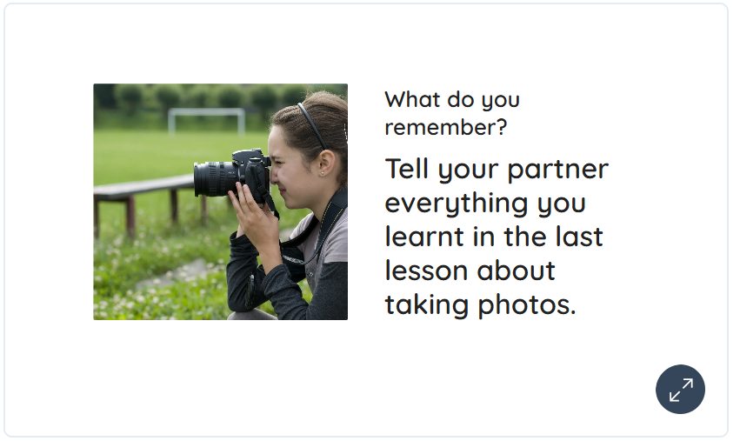  Starter:  Display the Presentation: What has changed?  Display slides 1–5 and go through the before and after photos, asking the children to discuss their differences and what has happened to them.  Encourage the children to give answers such as one has more sparkles or one is darker. The aim is for them to recognise that the image has changed.  Introduce the term editing to the children and explain that editing is changing a photo to make it look better or different. Explain that this might involve changing the colours, cropping the picture to focus on a certain part or adding effects to make the photo more interesting. Explain that editing can help tell a story with photos or show something in a new way.  Main:  Explain to the children that they will explore editing with the photos they took in the last lesson using either the Google Photos app or Google Photos online software (see Teacher knowledge).  Open the links: Google Photos App or Google Photos. Demonstrate how to edit using simple effects and the cropping tool using a photo taken during the last lesson.  Explain to the children that they will explore editing one photo together and that they need to focus on the following:  Changing colour-effects.  Cropping.  Arrange the children into groups or pairs, depending on the number of devices available, and allow them time to tinker with the app’s features before starting their edit.  While the children work, note any exciting effects they use and refer back to the best effects at the end of the lesson.  Adaptive Teaching:  Pupils working at greater depth: Should discuss why they would make changes to a photo and the impact this has and be able to apply a wider range of effects to their photo, experimenting with new editing tools. They should then create a guide called ‘How to edit an image’ in a document of their choosing.  Plenary:  Invite the children to share any effects that they particularly liked. Ask them:  When would it be a good time to use that effect and why?  Does it make it look older or more vibrant?  Does it focus attention on a smaller part of the image?
Lesson 4- Searching for Images  Foundational Skills:  Listening and attention skill Familiarity with technology Curiosity and enquiry skills Creativity and imagination Ability to explore materials and media Fine motor control (hand strength, dexterity)  Learning Objective: To search for and import images.  Success Criteria: I know images can be found online.  I can think of a keyword to search with.  I know what to do if I find something uncomfortable.  Recap and Recall:  Display the Presentation: Speak like an expert and arrange the children into pairs.  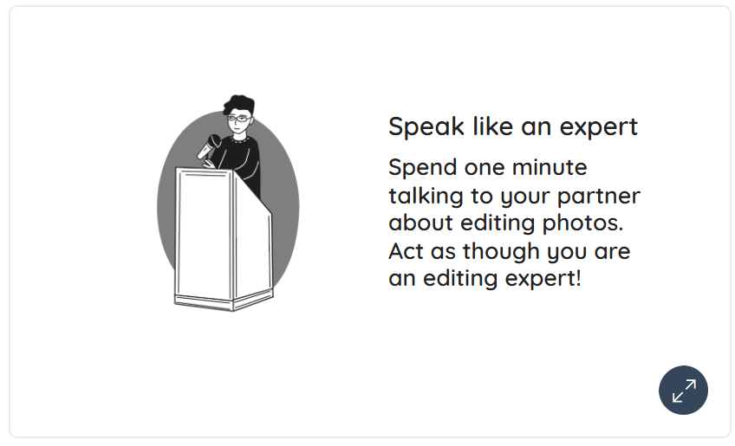  Starter:  Display the Presentation: Editing images and ask the children to identify the changes made to the original image.  Ask the children:  Why do you edit a photo? (The children may suggest making it look better; adding effects.)  Do you think some of the photos on the internet might be edited? (The children may suggest that some photos do not look real if they are unrealistic.)  What should you do if you see something online that makes you unhappy? (Telling a trusted adult or turning a device off.)  The children might express ideas based on obvious alterations like unusual colours or cartoon-like appearances in images, indicating their understanding that not everything they see online is a true representation of reality. Use this as a talking point about online images, highlighting that they might not always be real and could have been altered. Discuss with the children what steps they should take if they encounter images online that make them uncomfortable or uneasy.  Main:  Explain to the children that they will search and edit an image. Inform them that they will add props using the clipart tool to give the photo more detail and alter its appearance.  Display the link StoryboardThat - Photos for Class. Discuss how to search for images safely at school or home by explaining the importance of using websites suitable for children. Demonstrate how to use specific keywords that help find the right images and talk about asking an adult for help if they are unsure whether a site or image is appropriate. Encourage them to always report uncomfortable images to a trusted adult.  Demonstrate searching for an image and saving it. Explain that when an image is saved, the computer stores it in its memory so that it can be retrieved later.  Open the link: Sketchpad and demonstrate how to retrieve the file that was just saved. Continue demonstrating how to edit the image before moving on to the clipart tools to add some props.  Alternatively, display the Presentation: Editing in Sketchpad and go through the steps on each slide.  Adaptive Teaching:  Pupils needing extra support: May need an alphabet sheet to match upper and lowercase letters to help them use the keyboard more easily.  Pupils working at greater depth: Can manipulate the image to suit a purpose and explain why the size is important. Should find and use png images to avoid a white box blocking their original image.  Plenary:  Invite the class back together and ask the children:  What edits did you make to your photo? (Some children may suggest that they changed the colour, the temperature, the brightness, etc.)  What props did you add? (The children may suggest items, such as trees, animals, etc.)  Explain to the children that they will walk around the class and look at each other’s work, like a gallery. Ask them to consider the following:  What do you like about your classmates’ work?  Can you find something interesting that you did not think of?  How is your work similar or different? What could you say to give a kind compliment or a helpful suggestion?  Invite the class back together and allow the children time to feedback to each other. | Lesson 5 – Photo Collage  Foundational Skills:  Listening and attention skills Familiarity with technology Curiosity and enquiry skills Creativity and imagination Ability to explore materials and media Fine motor control (hand strength, dexterity)  Learning Objective: To create a photo collage.  Success Criteria:  I can download the photos I want.  I can organise them onto the page.  I can resize and change the orientation of my images.  I can add numbers to show their order.  Recap and Recall:  Display the Presentation: 3, 2, 1 and arrange the children into pairs.  Presentation: 3, 2, 1  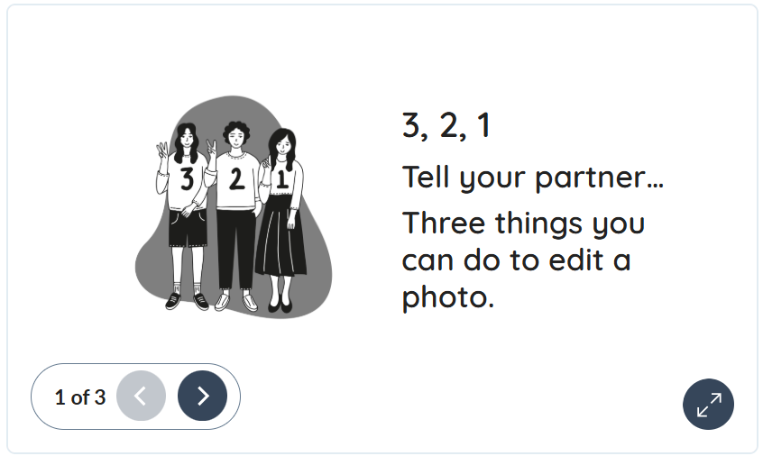  Starter:  Display the Presentation: Photo story and go through slides 1-4. Remind the children of the photo story from the beginning of the unit.  Ask the children what a collage is and explain that multiple photos are arranged on one page to tell a story or show a particular theme or topic.  Display slide 5 and show the example of a collage. Inform the children that, so far, they have learnt to take photos, edit them and add extra props. Explain that they will combine all their photos to make their story a collage.  Main:  Open the link: Sketchpad and discuss its features with the children. Recap how to edit a photo using the tools in the clipart section.  Explain to the children that they will be creating their collage in Sketchpad. Inform them that the first step is to retrieve and open their photos.  Hand out the devices (one between two) and demonstrate how to find the photos (see Teacher knowledge). If tablets were used to save the edited photos, make sure each group has the same device so they can access their images. Inform the children that they must choose at least three photos for their collage story and do not have to worry about which child took the photo.  Allow the children to retrieve their photos and open them in Sketchpad. Walk around the room to support any children if needed.  Invite the class back together once the children have at least three photos and open in Sketchpad.  Demonstrate how to start creating a collage and ask the children:  How can the photos be resized so they are not on top of each other? (Use the corner handles to drag and resize).  How can we make the order of the photographs clearer – what could we use? (The children may suggest numbers or text.)  Explain that making the photos smaller will give them more space on the page and prevent them from overlapping.  Demonstrate how to add a text box next to a picture to type a number showing its order. Show the children how to add a final box with their names somewhere on the page.  Allow the children time to arrange their pictures.  Adaptive Teaching:  Pupils needing extra support: May need help navigating to the right page and downloading the files so they can then work independently on their collage.  Pupils working at greater depth: Could add in further decoration such as shapes and use ‘fill’ to add colour to them.  Plenary:  Explain that the classroom is now a gallery and they will walk around and look at the different photo stories.  Set the expectation that they are not to touch any of the computers. Ask them to look for clear stories where they can tell what is happening from the photos as they walk around.  Gather the children together and ask them:  Whose work impressed you? Why?  What have you learnt during this topic?  What was your favourite bit?  Hand out a sticky note to each child and allow some time for them to reflect on their own collages. Ask them to write down their favourite thing about this unit (taking photos, editing, creating a collage, etc.) and to share them with a partner. Collect these and display them somewhere or keep them as evidence.  Optional – provide each child with the Quiz – pupil answer sheet and display the Unit quiz (see link: Assessment – Computing Y1: Digital imagery – Microsoft version). Read each question aloud and allow the children time to answer. Reveal the answers and ask them to self/peer mark their answer sheets.  If pupils completed the Knowledge catcher in Lesson 1, they can revisit them and add new information in a different colour.
Learning Challenge Week
Using iPads to take photos of our school trip.
Cross curricular links  English Reading  - making inferences on the basis of what is being said and done.  - predicting what might happen on the basis of what has been read so far.  - participate in discussion about books, poems and other works that are read to them and those that they can read for themselves, taking turns and listening to what others say.  RSE:  Pupils should be taught to:  - the rules and principles for keeping safe online, how to recognise risks, harmful content and contact, and how to report them  Education for a Connected World  Health, wellbeing and lifestyle  - I can explain rules to keep us safe when we are using technology both in and beyond the home.  Copyright and ownership  - I understand that work created by others does not belong to me even if I save a copy  Managing online information:  - I can give simple examples of how to find information using digital technologies, e.g. search engines, voice activated searching).  - I know how to get help from a trusted adult if we see content that makes us feel sad, uncomfortable worried or frightened.  Art:  Pupils should be taught:  to use a range of materials creatively to design and make products  Education for a Connected World:  I know/understand that we can encounter a range of things online including things we like and don’t like as well as things which are real or make believe/a joke. |  | Through this unit of work the following essential skills will be developed:  - Learning how to explore and tinker with hardware to find out how it works.  - Learning where keys are located on the keyboard.  - Learning how to operate a camera to take photos and videos.  - Developing the skills associated with sequencing in unplugged activities.  - Using a basic range of tools within graphic editing software.  - Taking and editing photographs.  - Developing control of the mouse through dragging, clicking and resizing of images to create different effects.  - Developing understanding of different software tools.  - Searching and downloading images from the internet safely.  - When using the internet to search for images, learning what to do if they come across something online that worries them or makes them feel uncomfortable.
Assessment
Pupils with secure understanding indicated by: Explaining what is happening in a photo story. Planning three distinct parts of a photo story. Identifying clear photos from less clear photos. Taking their own photos. Acknowledging that images can be changed after being taken. Suggesting changes that can be made to photos. Knowing that images can be found on the Internet. Explaining what to do if they see something they don’t like. Recognising that a collage means several photos on a page. Adding both images and text. Resizing and dragging images around the page.

Pupils working at greater depth indicated by: Explaining how their photos will show their story. Discussing where characters will be placed. Explaining what they’ve done to make their photos clearer. Describing what creates a blurred photo. Understanding that zooming in creates a lower quality image and it is better to get physically closer when possible. Suggesting reasons for changing photos. Experimenting with a range of image editing tools. Resizing images appropriate to scale, e.g. a tree isn’t smaller than a dinosaur. Understanding the importance of using a png file. Considering layout – resizing and adding decoration appropriately.

