Using t
By the end of this term, children will know….

Science - Polar Adventures
Vocabulary

Spring 1 – Shiver Me Timbers

materials, glass, plastic, wood, fabric, metal, waterproof, insulated, Arctic, Antarctic, Polar Regions, ice, snow, expedition, dehydration, herbivore, carnivore, omnivore, adapt, weather, camouflage, freezing, icy, slippery, snowy, cold

How to describe the simple physical properties of a variety of everyday materials.
How to compare and group together a variety of everyday materials on the basis of their simple properties.
How to describe and compare the structure of a variety of common animals (fish, amphibians, reptiles, birds and mammals, including pets).
How to identify and name a variety of common animals that are carnivores, herbivores and omnivores.

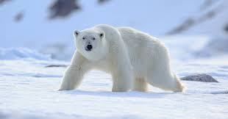
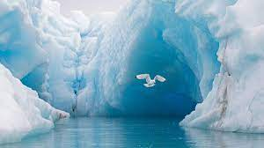
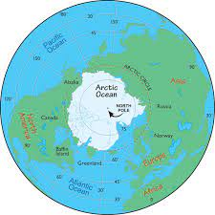
Intention
In this unit the children will learn where the polar regions are, what equipment an explorer would need to take on an expedition to the Arctic and what materials keep humans safe in these environments. They will also learn what animals live in these areas and how humans have adapted to living in the Arctic.

Polar Adventures – Previous Knowledge
In this unit the children will revisit knowledge gained when exploring ice in the continuous provision in EYFS. They will also build on knowledge gained when learning about animals and habitats in the EYFS ‘Spring has Sprung’ unit of work. They will use knowledge gained from reading and discussing 'Lost and Found' in EYFS, which about a penguin who sails to the South Pole. The children made comparisons between the South Pole and Grantham. The children learnt about polar regions through other stories such as ‘Jonty Jentoo: The Adventures of a Penguin’ and played in the small world play with ice and polar animals. Earlier in year 1 they leant about properties of materials and sorted objects based on the material they were made of.

Learning Links
Children will enhance their knowledge the Arctic regions. They will also develop an understanding of materials and consider the best clothing for Arctic explorers to wear. They will draw upon their experience of understanding texts, listening and attention foundational skills. They will need to understand the spoken language, including some subject specific vocabulary. The children will also build on their awareness of the natural world and their understanding of people, communities and differences. The children will need to use their reading skills to gain information to create a fact file. They will need to work with their peers when carrying out an experiment to find out the best pair of gloves for an Arctic explorer.

Science– Polar Adventures
Children will learn where the polar regions are, what equipment an explorer would need to take on an expedition to the Arctic and what materials keep humans safe in these environments. They will also learn what animals live in these areas and how humans have adapted to living in the Arctic.
Key Objectives-  To understand what a Polar Region is.  To write about Polar Regions.  Describe the simple physical properties of a variety of everyday materials. Identify and classify.  Ask simple questions and recognise that they can be answered in different ways.  To be able to identify and name a variety of common animals that are carnivores, herbivores and omnivores. To be able to identify and classify.  Use their observations and ideas to suggest answers to questions. | Lesson 1- Arctic and Antarctic  Foundational Skills:  Listening and attention skills – used when listening to stories, videos and class discussion about the polar regions.  Understanding of spoken language – used when following explanations and answering questions about what the Polar Regions are.  Expressive language – used when talking about new facts and sharing ideas with partners or the class.  Ability to form relationships – used when working with partners to read fact files.  Confidence, resilience, and independence – used when sharing facts and contributing to class discussions.  Phonological awareness – used during reading activities and sounding out unfamiliar vocabulary.  Secure phonic knowledge – used when reading information in fact files and non-fiction books.  Early reading skills – used when locating information in texts.  Leaning Objective: To understand what the Polar Regions are. To write about what we have learnt.  Success Criteria: I can talk about what I have learnt about the Polar Regions. I can write about what I have learnt about the Polar Regions.  Recap and Recall:  Discuss children’s experiences of being outside in the snow and ice. Remind the children of the time they played with ice in continuous provision in EYFS and the texts ‘Jonty Jentoo: The Adventures of a Penguin’ and ‘Lost and Found’.  Teaching:  Ask the children if they have ever heard of the Polar Regions? Complete the KWL grid as a class.  Explain to the children that they are going to become researchers and find out about the polar regions.  Work through the slides and videos noting down key facts and information on working wall/ flip chart paper.  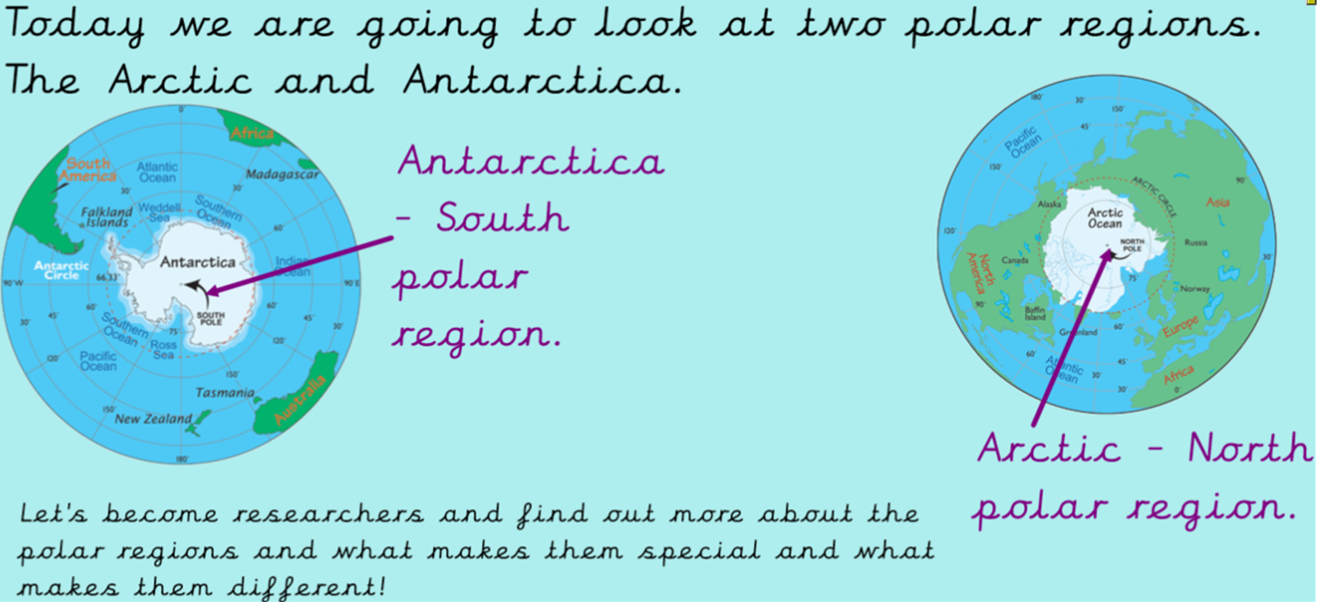  Look at a globe and show the children where the Arctic and Antarctic are.  Watch video below to find out more about Antarctic.  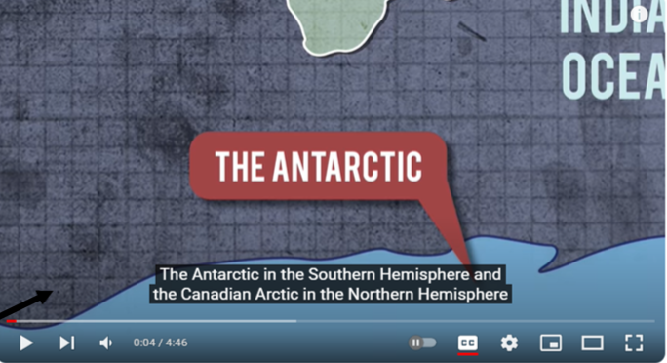  Stop video and through out to write down new learning.  Put children in pairs (HA with MA) Give each pair a polar regions fact file. With their partners read through. Red group to work with teacher. Ask the children if they can tell you any new facts. Then add any new facts to flip chart. Then read the fact file again together as a class.  Look through non-fiction books. Ask can you find any new information. Add to flip chart.  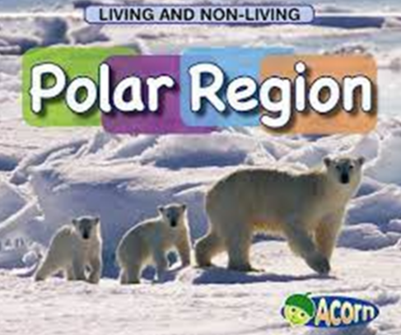  Plenary:  Bring the children back together and share key facts. Record on Seesaw. Discuss any misconceptions. | Lesson 2- Preparing for a Polar Expedition  Foundational Skills:  Listening and attention skills – used when listening to the “letter” and the teacher's explanations about preparing for an expedition.  Understanding of spoken language – used when responding to questions and following instructions.  Early writing skills – used when writing sentences to explain clothing choices.  Understanding of people, communities, and differences – used when discussing how explorers live and travel.  Awareness of the natural world – used when exploring climate conditions and what equipment is needed  Leaning Objective:  To describe the simple physical properties of a variety of everyday materials. Identify and classify.  Success Criteria: I can use my knowledge to show what I would need to take on an expedition.  Recap and Recall:  Explain to the children that we are going to remind ourselves about the 2 polar regions we learnt about last week. Which 2 polar regions did we learn about? What can you tell me about the Arctic and Antarctica?  Recap key facts by using knowledge organiser and working wall.  Teaching:  Show the children the letter from the Polar Adventurers society (on notebook) and read together. Tell the children that we are going to get prepared for the polar expedition. Ask the children to think about where the polar regions are. Ask: How will we travel there?  Explain to the children that they are going to think like scientists. Show the children a photo of the tents that polar explorers stay in (on notebook). Explain that polar explorers take food that is quick and easy to make. They cook on a small stove inside the tent. Ask: What do you think they take with them to eat? Where do you think they get water from for drinking and cooking?  Show the children a photo of a scientist working in Antarctica (on notebook). Explain that scientists found out interesting facts about Antarctica and sometimes they travel in snow mobiles.  Say to the children- Let’s take a walk in the Arctic to help us with our research! Think about the climate and what we will need for our expedition... Watch:  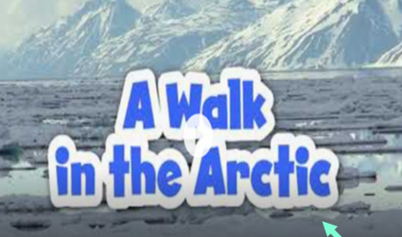  Watch video below to give us cluses about what to take with us.  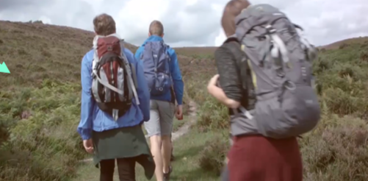  Discuss as a class what you would take with you emphasis explaining why would chose these things- focus on waterproof, warm, dehydration.  Look at photos of polar explorers. Ask: What are they wearing? What do they have with them? How are they travelling? Do we have everything we need?  Yellow, Green and Blue Groups- Children to draw and label what they would take on a polar adventure. Then draw a picture of themselves dressed ready for a polar adventure. Children to write a sentence to explain why they have chosen the clothes.  Red Group: - Children to draw what they would take on a polar adventure. Then draw a picture of themselves dressed ready for a polar adventure. Children to explain why they have chosen the clothes. Record children’s ideas on Seesaw.  Continuous Provision:  Work in groups of 2-3 to use Lego to create a mode of transport to get you around the Arctic/Antarctic.  Role play being explorers. Use the tent and the equipment around you. Ask: What would explorers say? What would they do?  Plenary:  Children to share what they would take on a polar adventure and what they would wear. Ask the children to share the reasons for their choices. | Lesson 3- Glove Experiment  Foundational Skills:  Listening and attention skills – used when listening to instructions for the experiment.  Understanding of spoken language – used when understanding how to carry out each test.  Secure number sense – used during comparisons, such as counting blocks, ice cubes or observing quantities.  Ability to form relationships – used when working together in groups and sharing results.  Understanding of people, communities, and differences – used when discussing how different materials meet human needs in extreme climates.  Awareness of the natural world – used when exploring material properties and the effect of ice and water.  Fine motor control – used when building towers, writing names and picking up objects  Leaning Objective: To Describe the simple physical properties of a variety of everyday materials. Identify and classify.  Working Scientifically: Use their observations and ideas to suggest answers to questions.  Success Criteria: I can write up my findings from an experiment and explain what I have learnt.  Recap and Recall:  Remind the children that we have learnt about 2 polar regions. Which 2 polar regions have we learnt about? What can you tell me about the Arctic and Antarctica?  Recap key facts by using knowledge organiser and working wall.  Have a look at some photos of some polar explorers (on notebook). Ask: What are they wearing? What properties do the materials they're wearing have to have?  Teaching:  Explain to the children that today we will be conducting a real experiment to find out which pair of gloves would be best to wear for a polar expedition.  Show the children the various gloves and discuss the different materials and their properties.  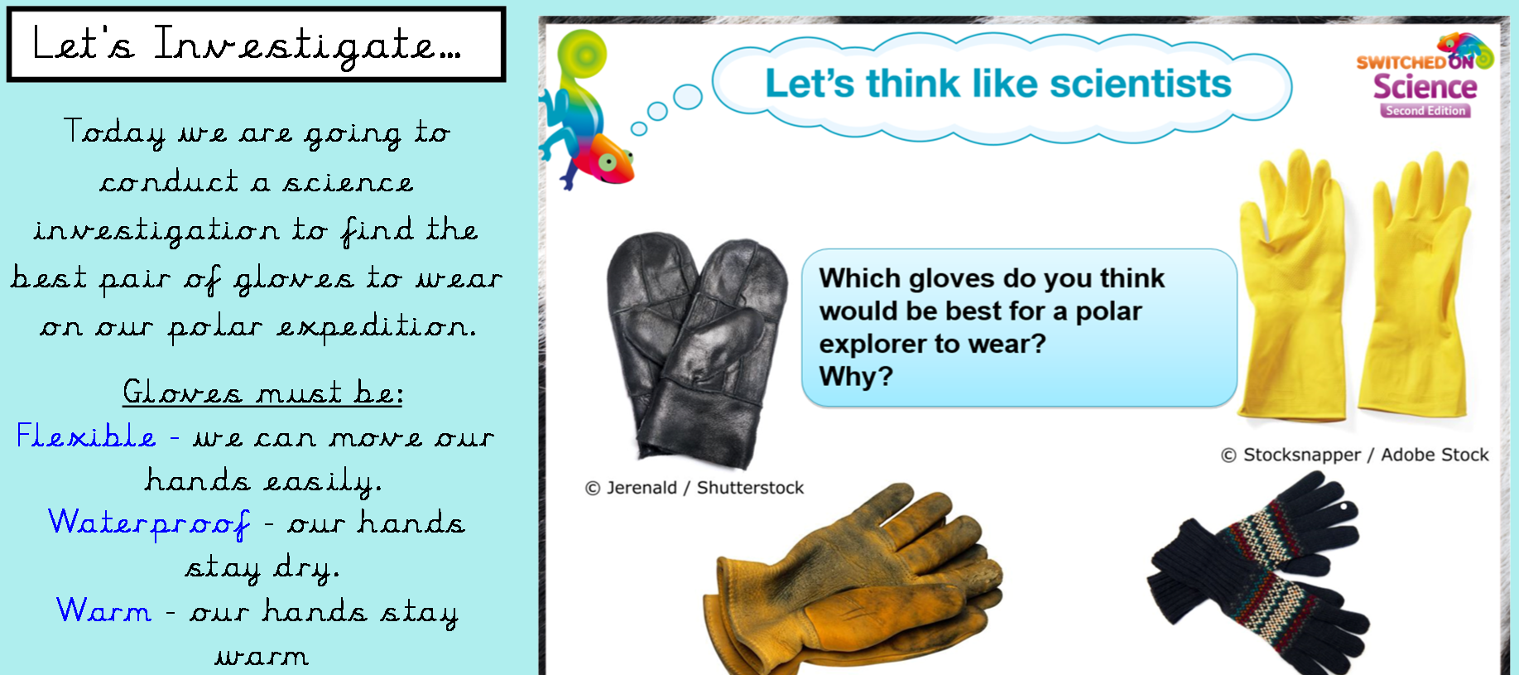  Explain that gloves must be: Flexible - we can move our hands easily. Waterproof – so our hands stay dry. Warm - our hands stay warm  Ask: How can we test this?  Carry out 3 tests with each pair of gloves:  - Flexible- Build a tower of blocks. Then write your name.  - Warm- Pick up some ice cubes.  - Waterproof- pick something out of the bowl of water without getting wet.  Ask children carry out the tests ask them to complete their results table.  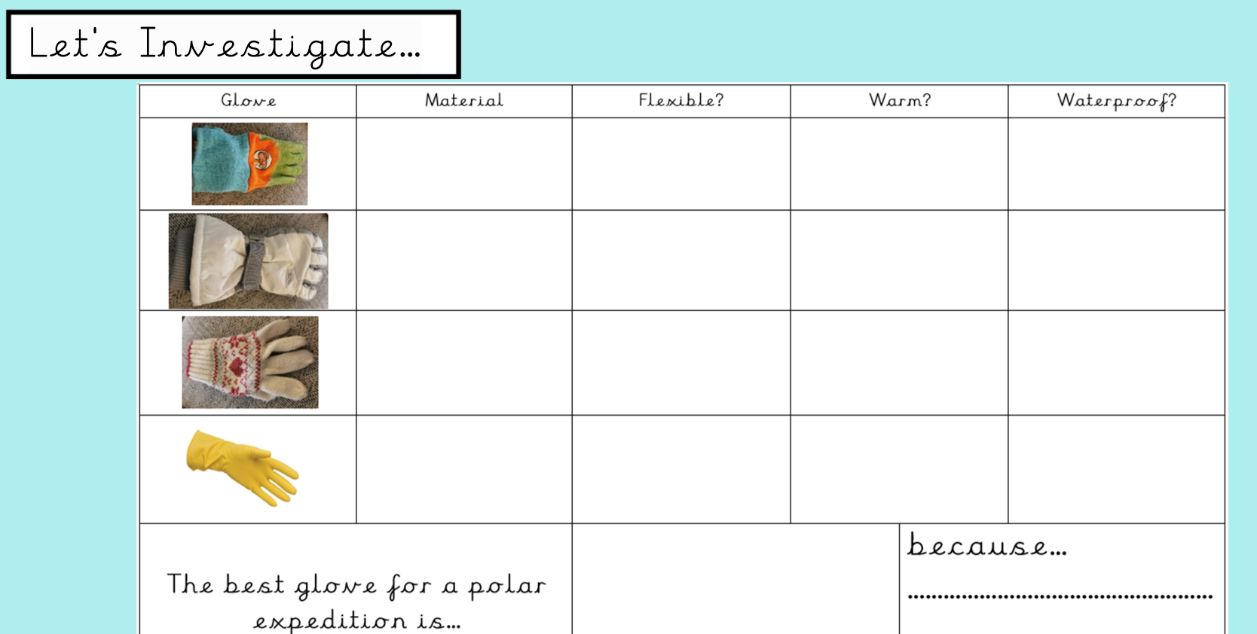  Plenary:  Bring the children back together and discuss our findings.
 | Lesson 4- Classifying Animals  Foundational Skills:  Listening and attention skills – used when listening to information about animals.  Understanding of spoken language – used when comprehending explanations of carnivores, herbivores and omnivores.  Expressive language – used when naming and describing animals and explaining choices.  Understanding of people, communities, and differences – used when exploring animals’ needs in different habitats.  Awareness of the natural world – used when classifying Arctic and Antarctic animals.  Fine motor control – used when cutting out animals and sticking them in categories.  Learning Objective: To be able to identify and name a variety of common animals that are carnivores, herbivores and omnivores. To be able to identify and class.  Success Criteria: I can identify different animals by their observable features and say what they eat.  I can sort the animals into carnivore, herbivore and omnivore.  I can write a sentence about food chains in the Polar regions.  Recap and Recall:  Discuss previous learning- All children to write one thing on their whiteboard that they have learnt about polar regions.  Teaching:  Explain that today we will be learning about the animals in these places.  Tell the children that carnivores eat meat, herbivores eat plants and omnivores eat both. Ask- Can you think of any carnivores/ herbivores/ omnivores? Tell the children that we are going to be sorting the animals into these categories.  Watch the 2 videos to find out more.  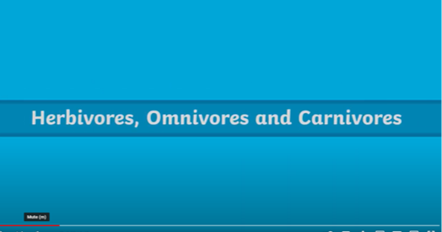  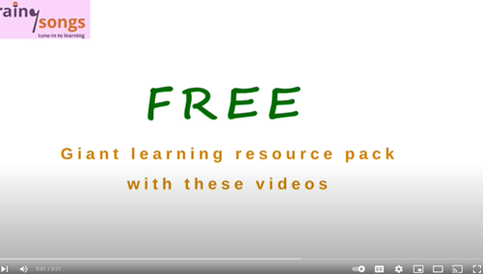  Read through and discuss the herbivores, omnivores and carnivores PowerPoint and the arctic animals PowerPoint.  Activity:  Children to cut out the animals and stick into the correct box. Green and blue groups then write some sentences about what polar animals eat.  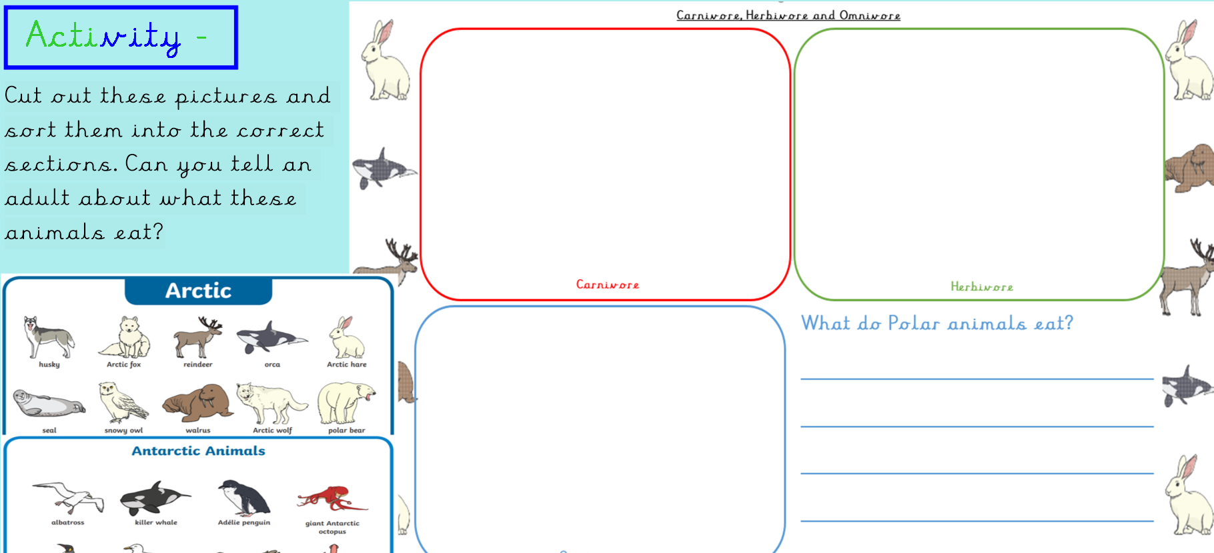  Plenary: Children to self-mark as teacher works through classifying using A3 sheets. | Lesson 5- Animal, Adaptions, Camouflage  Foundational Skills:  Listening and attention skills – used when watching videos about camouflage and adaptations.  Understanding of spoken language – used when understanding explanations about survival features.  Expressive language – used when discussing how animals adapt to survive.  Understanding of people, communities, and differences – used when learning how humans and animals adapt differently.  Awareness of the natural world – used when identifying adaptations in foxes, penguins and other polar animals.  Fine motor control – used when labelling diagrams and sorting pictures.  Learning Objective: To be able to identify and name a variety of common animals including fish, amphibians, reptiles, birds and mammals. To be able to identify and name a variety of common animals that are carnivores, herbivores and omnivores.  Success Criteria:  I can show how animals adapt to their surroundings in the Polar Regions to survive. I can label the parts of a penguin and write a sentence about how they survive in the Polar Region.  Recap and Recall:  Recap- What is a carnivore/ herbivore/ omnivore. Then complete the carnivore quiz.  Teaching:  Explain that lots of animals in the Polar Regions are prey to the many predators that live there so staying hidden is crucial to their survival, so they don't end up as dinner. Lots of animals use camouflage. What is camouflage? Watch video to find out.  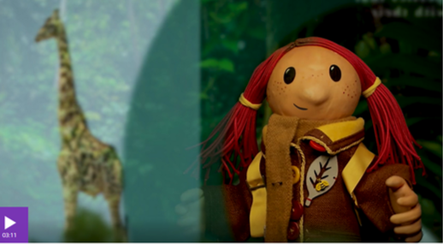  Then watch video below to find out how the Arctic Fox adapts to its surroundings to stay safe from larger predators and stay hidden when hunting its prey. What do you notice about the colour?  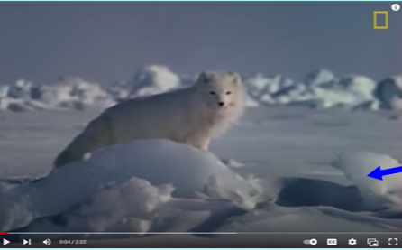  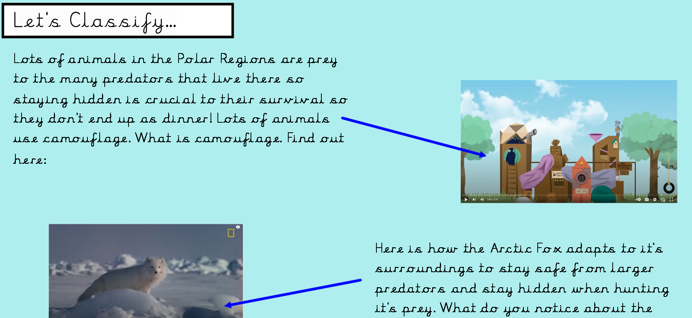  Explain that penguins also have had to adapt to survive the extreme weather conditions in Antarctica. Read through and discuss the ways in which penguins have adapted (on notebook).  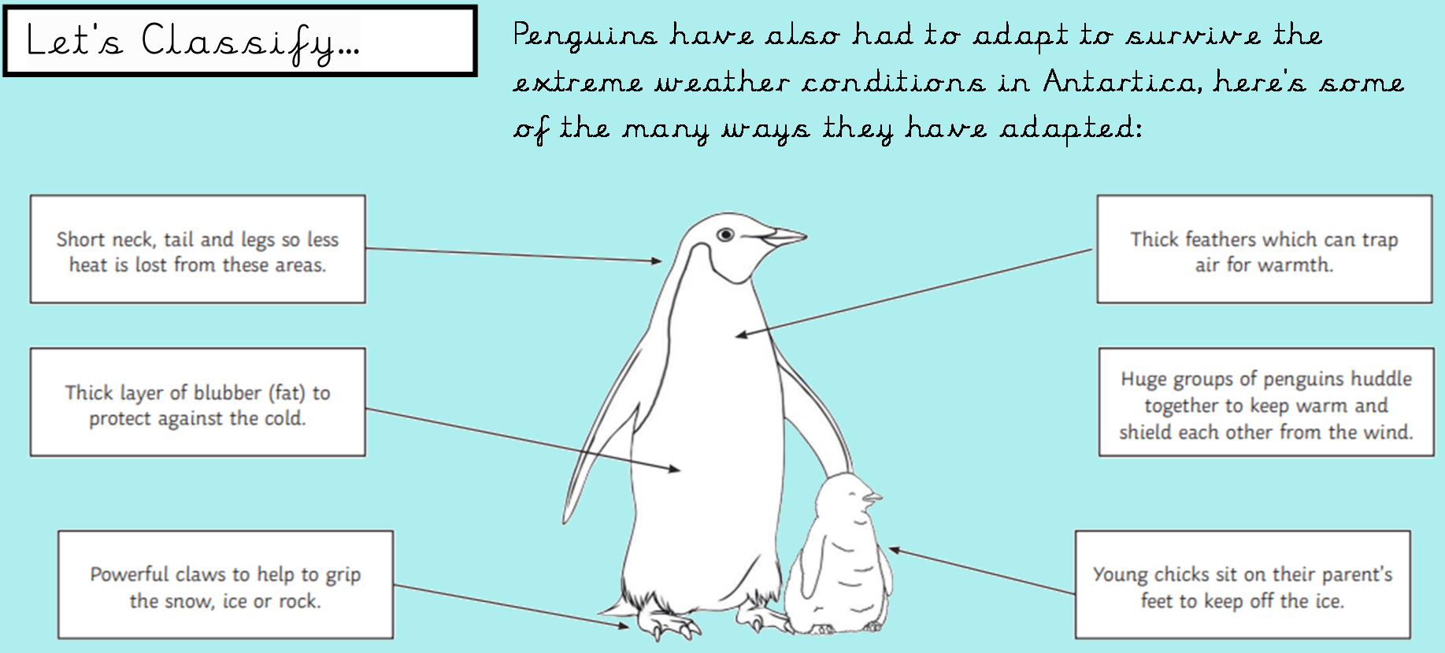  Model writing sentences to explain what they have learnt about penguins.  Activity:  Children to label the penguin (red group to stick labels). Then sort the pictures into Arctic land in summer and Arctic land in winter.  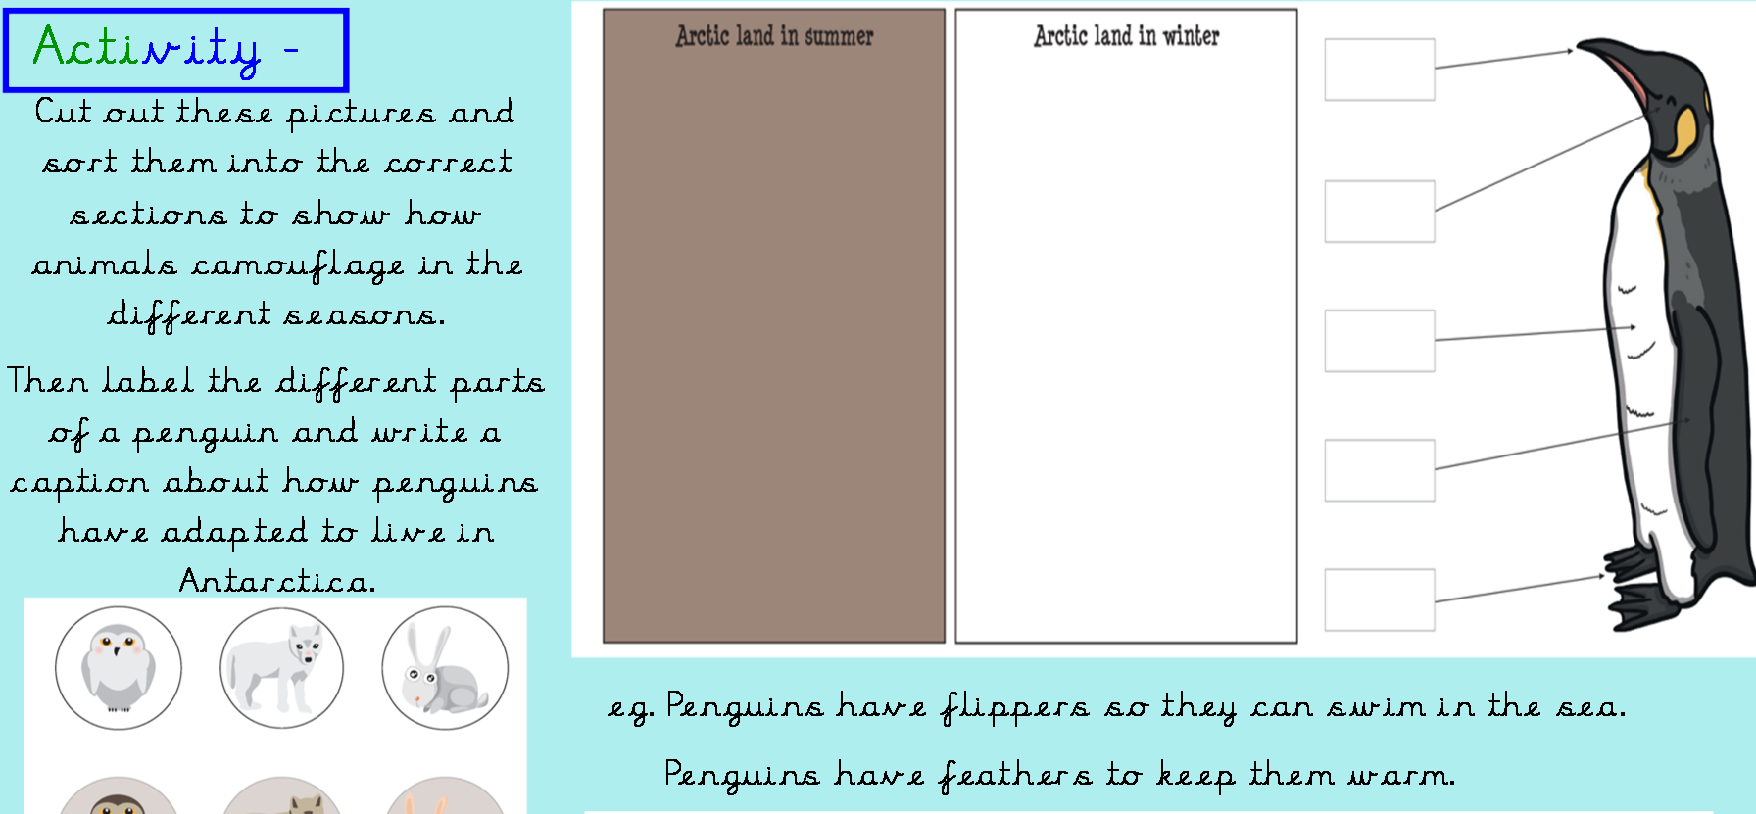  Plenary:  Bring children back together to share learning.  Add what the children now know about polar regions to the KWL grid.

