Key Words
Equator | An invisible circle around the middle of the Earth
Desert | An area of land that is dry. Very few animals or plants live there.
Jungle | A forest with lots of rain and is humid.
Humid | The air is damp.
Heat | Something that is hot.
Arctic | Very cold area around the North Pole.
Antarctica | An area around the South Pole covered by ice.
Poles | Top and bottom of the Earth..
Polar Regions | North and South Pole.
Ice | Frozen water.
Human Feature | Something that has been made by man.
Physical Feature | Something that is created by nature.
Location | A place or position.
Globe | The Earth.
Seasons | Each of the four divisions of the year to show weather.
Where do animals live?

Geography: Hot and Cold

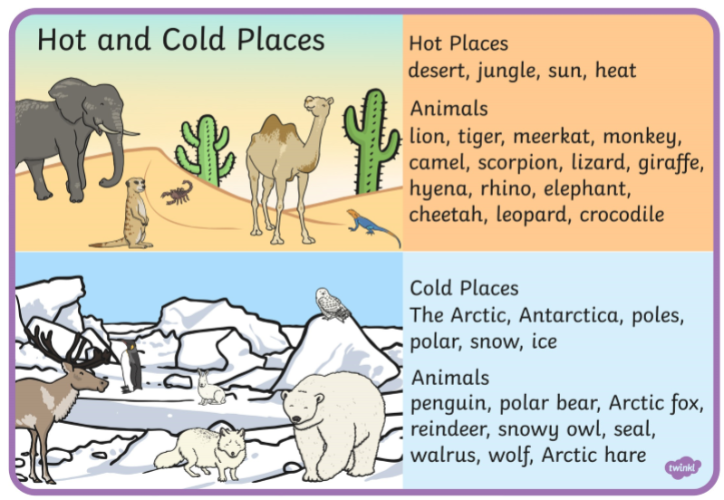
What are we building on?
- Hot and cold locations
- Human and physical features of different locations
- Different clothes for the weather
- What the seasons are
- To find the North and South Pole and the equator on a globe
What would I pack to go to a hot country?

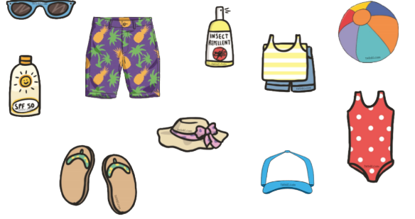

What is a human and physical feature?
Human features are something that has been made by man. E.g. city, village, town, farm and office.

Physical features are something that is created by nature. E.g. river, cliff, forest, beach and coast.

What are the different seasons?

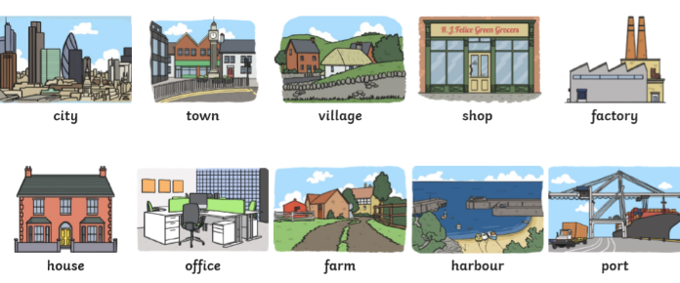

Spring
March to May

Winter
December to February

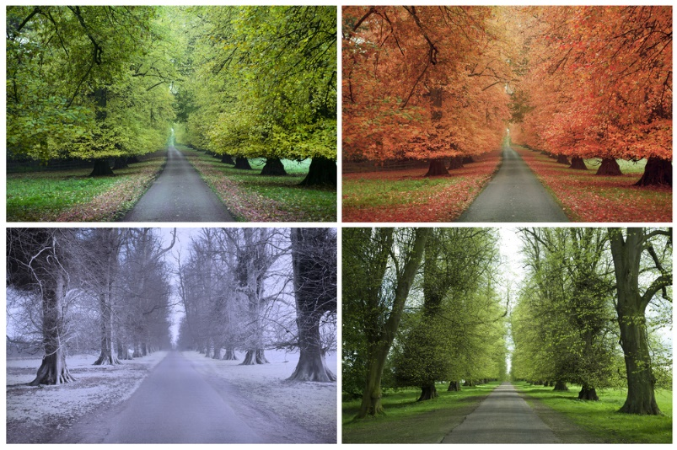

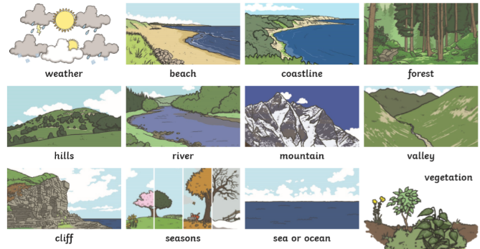
Where is the Equator, North and South Pole?

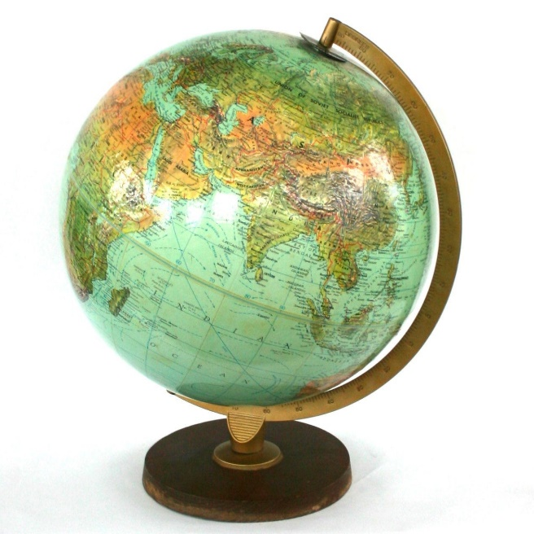
North Pole

Summer
June to August
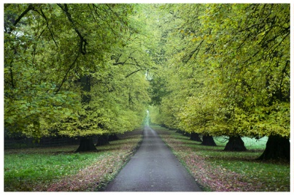

Autumn
September to November
What should we know?
- How the weather changes throughout the year and know how to name the seasons.
- Some of the main things that are in hot and cold places.
- What clothes that I would wear in hot and cold places.
- What I like and do not like about the place I live in.
- How to recognise how places have become the way they are.

Equator

South Pole

